# Percentile

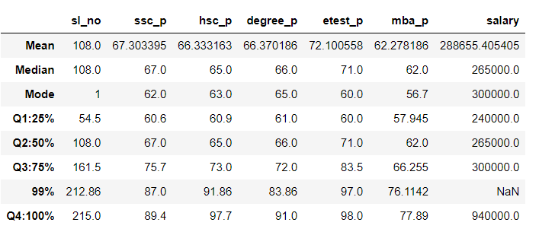

1.10th pass mark is Q1 to Q2 Data difference = 7%

2.10th pass mark is Q2 to Q3 Data difference = 8 %

3.10th pass mark is Q3 to 99% Data difference = 12 %

4.10th pass mark is Q3 to Q4 Data difference =14%

5.10th pass mark is 99% to Q4 Data difference =2%