**Name:- Prajwal Santosh Mankar**

**Rollno:- 96**

**Practical no.:-7**

**Practical Name:-Use git branch to create a new branch and git checkout to switch to the branch**

**___________________________________________________________________**

Admin@DESKTOP-EAH8S6B MINGW64 ~

$ cd MCA95

Admin@DESKTOP-EAH8S6B MINGW64 ~/MCA95 (main)

$ git init MCA95

Reinitialized existing Git repository in C:/Users/Admin/MCA95/MCA95/.git/

Admin@DESKTOP-EAH8S6B MINGW64 ~/MCA95 (main)

$ git branch secondbranch

Admin@DESKTOP-EAH8S6B MINGW64 ~/MCA95 (main)

$ git checkout secondbranch

Switched to branch 'secondbranch'

Admin@DESKTOP-EAH8S6B MINGW64 ~/MCA95 (secondbranch)

$ touch Rfile2.txt

Admin@DESKTOP-EAH8S6B MINGW64 ~/MCA95 (secondbranch)

$ git add Rfile2.txt

Admin@DESKTOP-EAH8S6B MINGW64 ~/MCA95 (secondbranch)

$ git status

On branch secondbranch

Changes to be committed:

(use "git restore --staged <file>..." to unstage)

new file: Rfile2.txt

Untracked files:

(use "git add <file>..." to include in what will be committed)

MCA95/

Admin@DESKTOP-EAH8S6B MINGW64 ~/MCA95 (secondbranch)

$ git commit -m "secondbranch commit"

[secondbranch ee8a5f3] secondbranch commit

1 file changed, 0 insertions(+), 0 deletions(-)

create mode 100644 Rfile2.txt

Admin@DESKTOP-EAH8S6B MINGW64 ~/MCA95 (secondbranch)

$ git push -u origin secondbranch

Enumerating objects: 9, done.

Counting objects: 100% (9/9), done.

Delta compression using up to 8 threads

Compressing objects: 100% (6/6), done.

Writing objects: 100% (7/7), 796 bytes | 398.00 KiB/s, done.

Total 7 (delta 1), reused 0 (delta 0), pack-reused 0

remote: Resolving deltas: 100% (1/1), done.

remote:

remote: Create a pull request for 'secondbranch' on GitHub by visiting:

remote: https://github.com/Rinamali14/MCA95/pull/new/secondbranch

remote:

To https://github.com/Rinamali14/MCA95.git

* [new branch] secondbranch -> secondbranch

branch 'secondbranch' set up to track 'origin/secondbranch'.

Admin@DESKTOP-EAH8S6B MINGW64 ~/MCA95 (secondbranch)

$

* **Before Pull and merge on remote repository:**

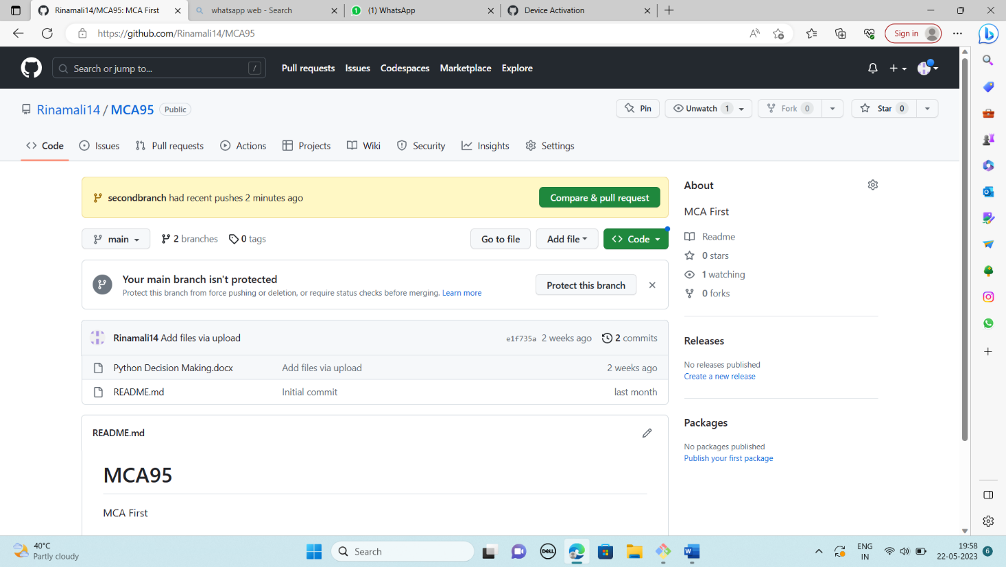

* 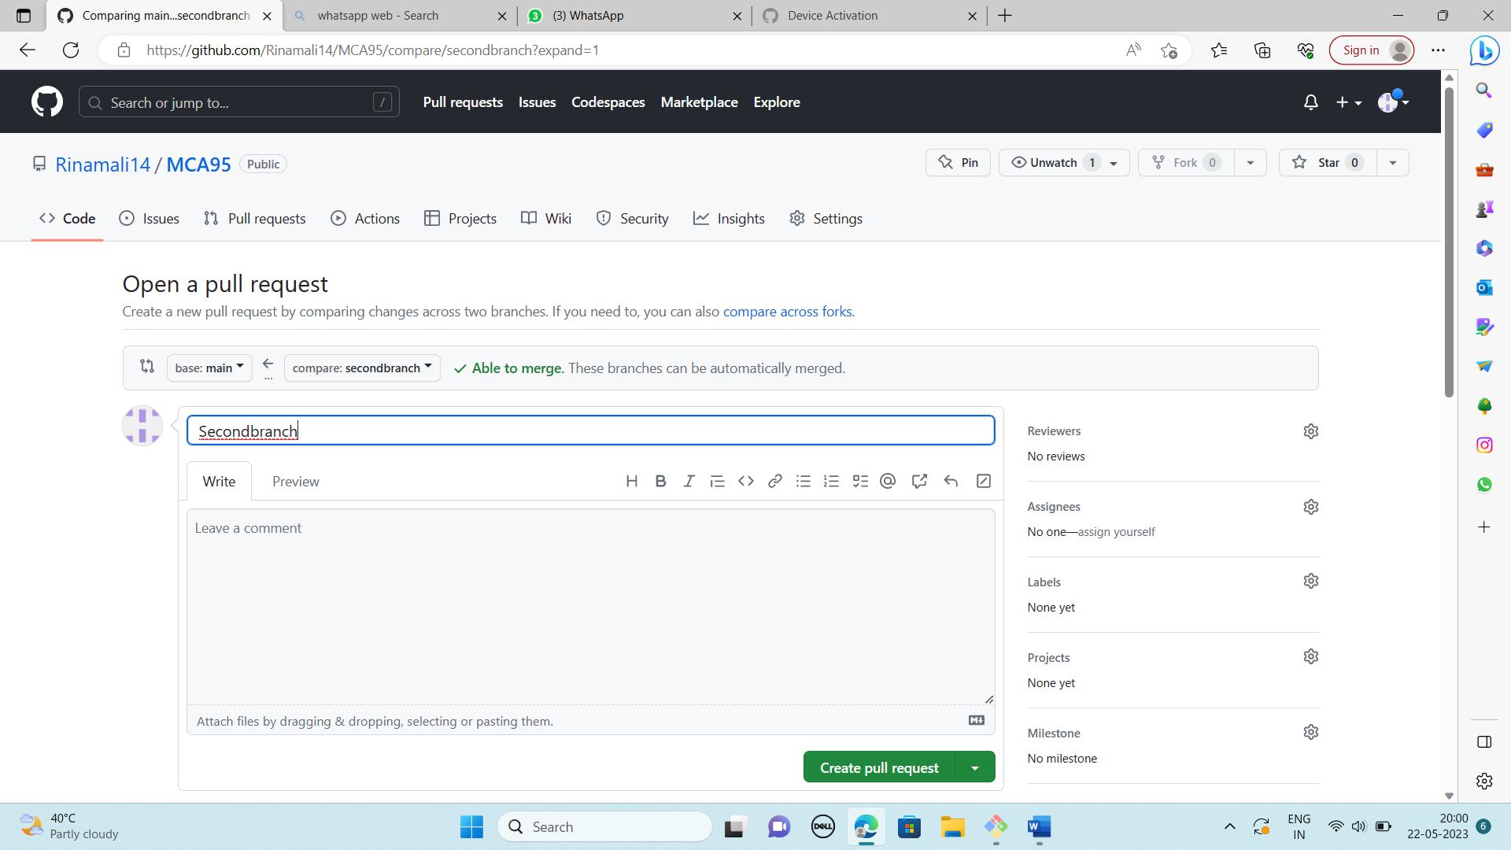**Performing Pull request:**
* 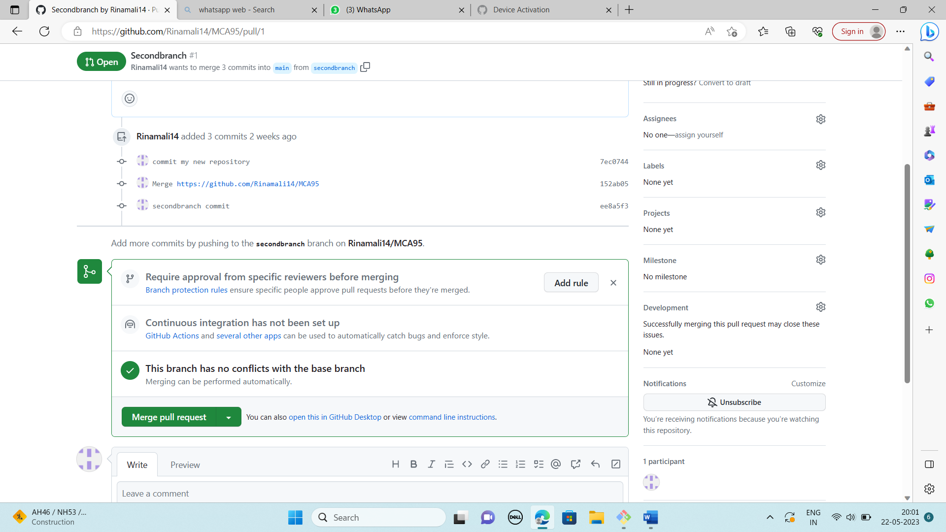**After Pull performing Merge on remote repository at primary branch (master):**
* **After Merge from branch2 to primary branch (master) on remote repository:**

