Contact Us 

RAMPAGE v2.6







24 Hours · One Pulse · Infinite Chaos








Organized by

 +91 9440833355 / 8341075672
 rampage.klhb@gmail.com  ieee.website.kohl.vercel.app

KLH Bachupally Campus


KLH Bachupally Campus

IEEE SB – KLEF , GFG, Algorand BlockChain club In Association with CSIT/CSE/AIDS/ECE
V 2.6
📅 23 & 24 January 2026
⏰ 09:00 AM (Fri) – 09:00 AM (Sat)
📍 KLH Bachupally Campus

About Rampage 
Hackathon initiative originated at KLH University, Bachupally

Launched in 2025 with a vision to redesign hackathon experiences

Conducted annually, with every edition evolving in structure and impact

RAMpage v2.5 focused on AI-assisted development and innovation

RAMpage v2.6 reflects a more refined, immersive, and participant-focused design

Vision
Move beyond traditional
elimination-based hackathons Ensure fair, continuous, and
transparent evaluation. Keep every team engaged throughout the 24 Hours.
Balance competition with learning and inclusivity.






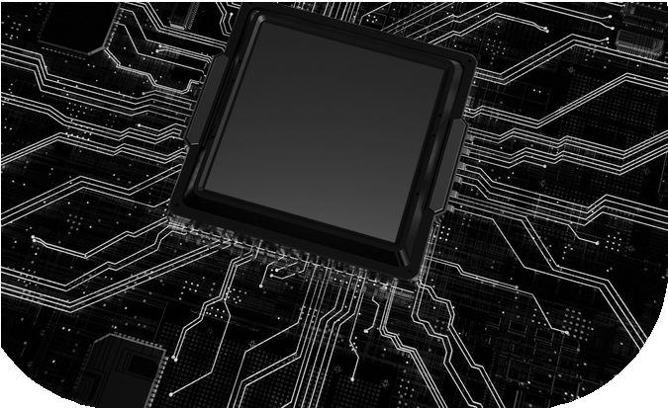
Hackathon Format
Event Flow


Who Can  Participate
⏱ Duration: 24 Continuous Hours
❌ No Elimination Rounds
📊 Continuous Evaluation Model
🤖 AI-Assisted Judging with Expert Review
📈 Live Dynamic Leaderboard

Problem Domains 
Day 1 – 23 January
Registration & Check-in

Inauguration & Problem Statement Release Ideation & Development Begins Mentorship Sessions
Overnight
Continuous development Evaluation checkpoints Live leaderboard updates

ľeam Size
ľeamsize:2–4 members

Inter-college teams are allowed
Cybersecurity & Blockchain






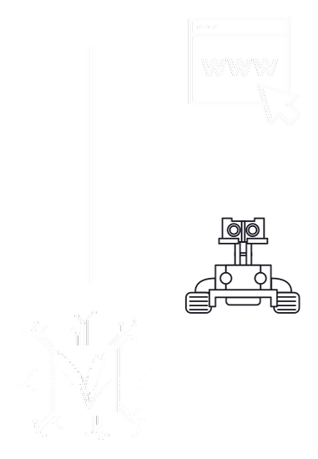
AI / ML
Open to UG and PG students
Students from all colleges across India Recommended domains:
Computer Science & Engineering Information Technology
AI & Data Science
Electronics & Communication Allied technical disciplines

Agri Tech
Web Devlopment

IoT ,VLSI &
Robotics

Day 2 – 24 January
Final submissions & demos Jury evaluation
Valedictory & Prize Distribution











Why Participate in RAMPAGE v2.6
Industry-focused problem statements Continuous mentorship from experts Exposure to professional evaluation systems
Hands-on product development experience Networking with peers, mentors, and industry professionals
Engaging activities throughout the event

🍽 Lunch, Dinner & Breakfast Provided
📜 Participation Certificates for All

Judging Criteria
Innovation & originality Technical implementation Practical relevance Team collaboration Presentation & demo quality

Prizes & Recognition
₹50,000 Worth Prize Pool Winner & Runner-up awards
Domain-specific excellence recognition Certificates for all participants
Many More.

Registration Details

800 if all participants of team have valid IEEE membership Id.

1000 if all even one participant from team is non-IEEE member.

All the members of the team to register individually with a single payment as a team.

Once verified a mail with QR code ticket will be sent as an approval.
Venue &

Contact
📍 KLH Bachupally Campus Instagram:
@ieee.klefb @algorand_klhb @geeksforgeeks_klh

Registration QR

