# Working with Cassandra Create KeySpace :

CREATE KEYSPACE Student WITH REPLICATION =

{'class':'SimpleStrategy','replication_factor':1};

# Describe the existing Keyspaces:

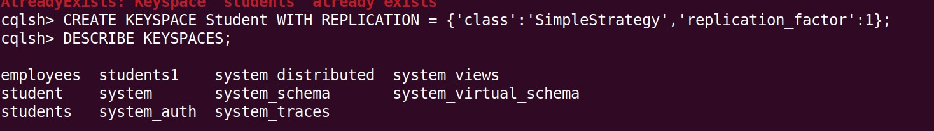DESCRIBE KEYSPACES;

# For More details on existing keyspaces:

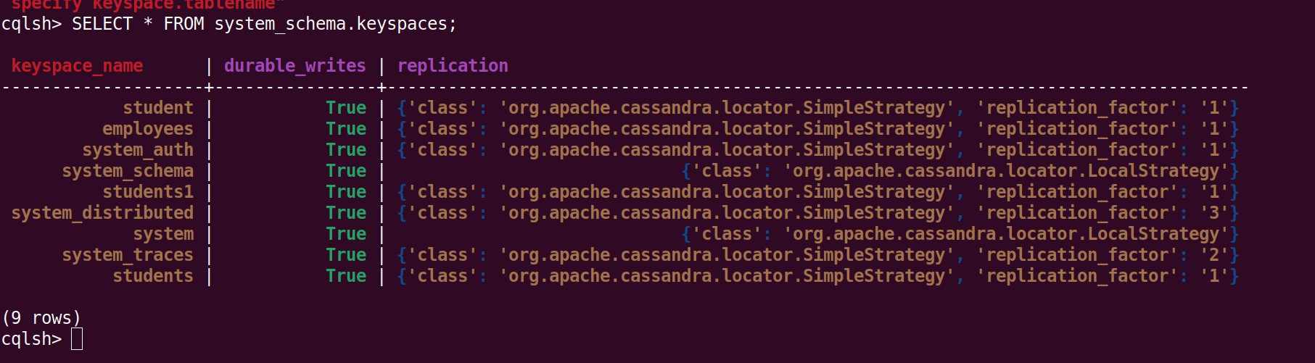SELECT * FROM system_schema.keyspaces;

# use the keyspace “Student”:

USE Student;

# To create table (column family) by name Student_Info:

CREATE TABLE Student_Info (Roll_No int PRIMARY KEY, StudName text, DateOfJoining timestamp, last_exam_Percent double);

# Lookup the names of all tables in the current keyspaces

DESCRIBE TABLES;

# Describe the table information

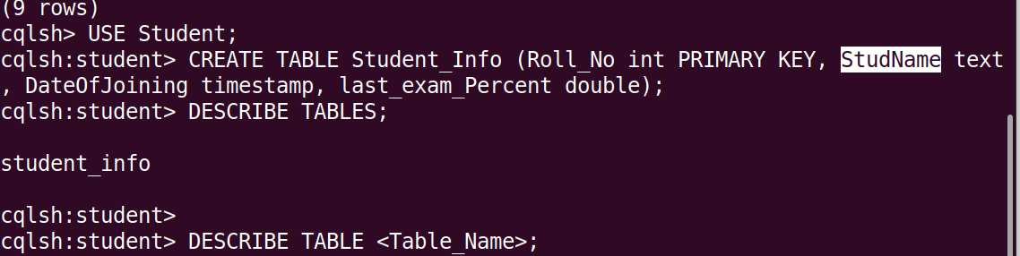DESCRIBE TABLE <Table_Name>;

**CRUD**

# Insert :

BEGIN BATCH

INSERT INTO Student_Info(Roll_No, StudName, DateOfJoining, last_exam_Percent) VALUES (1,'Asha','2012-03-12',79.9)

INSERT INTO Student_Info(Roll_No, StudName, DateOfJoining, last_exam_Percent) VALUES (2,'Krian','2012-03-12',89.9)

INSERT INTO Student_Info(Roll_No, StudName, DateOfJoining, last_exam_Percent) VALUES (3,'Tarun','2012-03-12',78.9)

INSERT INTO Student_Info(Roll_No, StudName, DateOfJoining, last_exam_Percent) VALUES (4,'Samrth','2012-03-12',90.9)

INSERT INTO Student_Info(Roll_No, StudName, DateOfJoining, last_exam_Percent) VALUES (5,'Smitha','2012-03-12',67.9)

INSERT INTO Student_Info(Roll_No, StudName, DateOfJoining, last_exam_Percent) VALUES (6,'Rohan','2012-03-12',56.9)

APPLY BATCH;

# View data from the table “Student_Info”

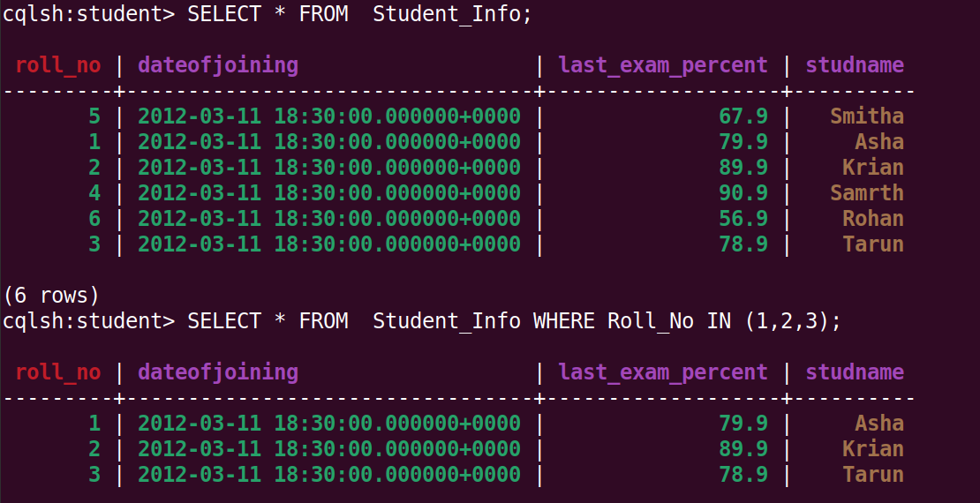SELECT * FROM Student_Info;

# View data from the table “Student_Info” where Rollo column either has a value 1 or 2 or 3

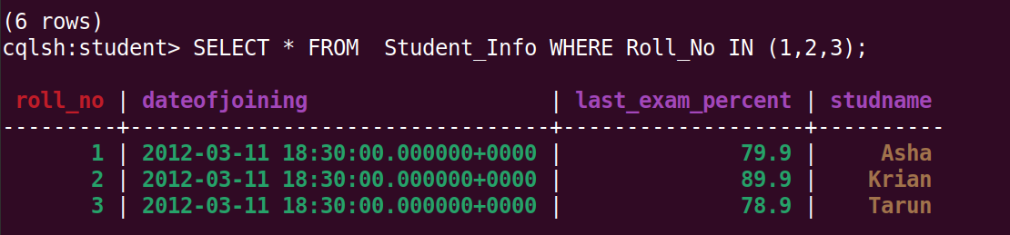SELECT * FROM Student_Info WHERE Roll_No IN (1,2,3);

# To execute a non primary key - will throw an error

select * from Student_info where Studname= 'Asha';

# So create an INDEX on the Column as below:

**To create an INDEX on StudName Column of the Student_Info column family**

CREATE INDEX ON Student_Info ( StudName);

# Now execute the query based on the INDEXED Column:

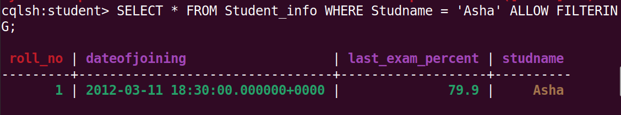select * from Student_info where Studname= 'Asha';

# To specify the number of rows retured in the output

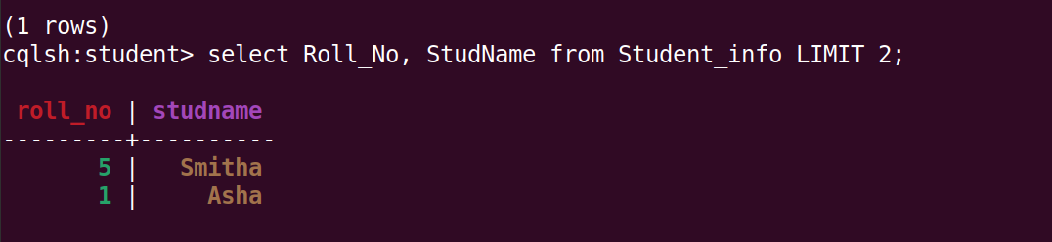select Roll_No, StudName from Student_info LIMIT 2;

# Alias for Column:

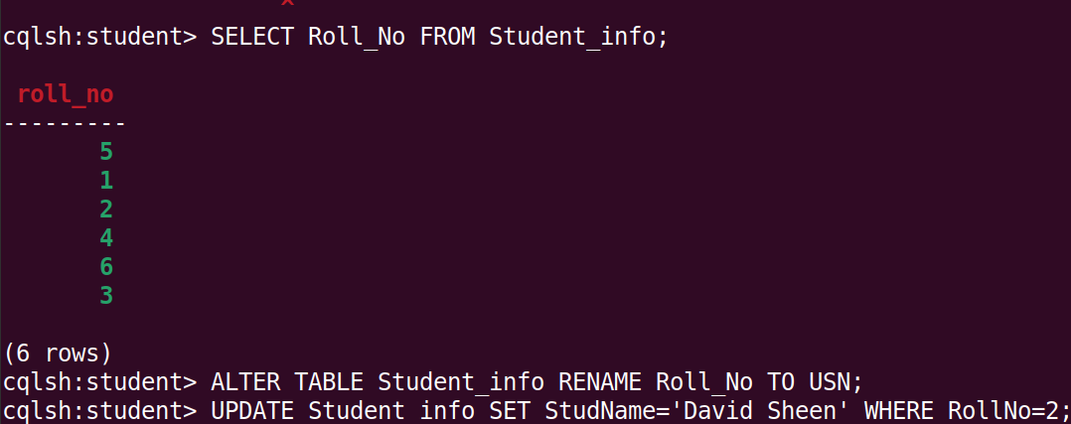Select Roll_No as “USN” from Student_info;

**UPDATE**

UPDATE Student_info SET StudName='David Sheen' WHERE RollNo=2; Lets try to update the primary key

UPDATE Student_info SET Roll_No=6 WHERE Roll_No=3;

DELETE

DELETE LastExamPercent FROM Student_info WHERE USN=2;

Delete a Row

DELETE FROM student_info WHERE USN=2;

Set Collection

A column of type set consists of unordered unique values. However, when the column is queried, it returns, it returns the values in sorted order. For example, for text values, it sorts in alphabetical order.

ALTER TABLE Student_info ADD hobbies set<text> List Collection

When the order of elements matter, one should go for a list collection. ALTER TABLE Student_info ADD language list<text>;

UPDATE Student_info

SET hobbies=hobbies+{'Chess,Table Tennis'} WHERE USN=1;

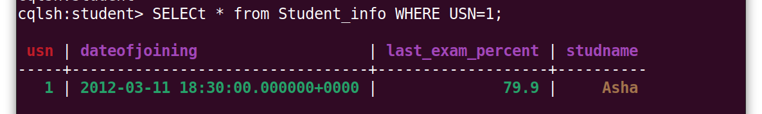SELECt * from Student_info WHERE USN=1;

UPDATE Student_info

SET langusge=language+['Hindi,English'] WHERE USN=1;

Note: You can remove an element from a set using the subtraction(-) operator.

**USING A COUNTER**

A counter is a special column that is changed in increments. For example, we may need a counter column to count the number of times a particular book is issued from the library bythe student.

CREATE TABLE library_book(counter_value counter, book_name varchar, stud_name varchar, PRIMARY KEY(book_name,stud_name));

**Load data into the counter column**

UPDATE library_book SET counetr value=couner_vale+1 WHERE book_name='Big data Analytics' AND stud_name='jeet';

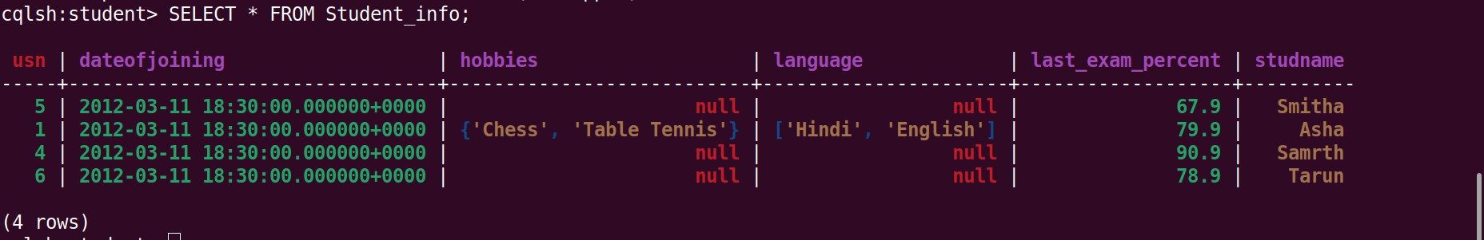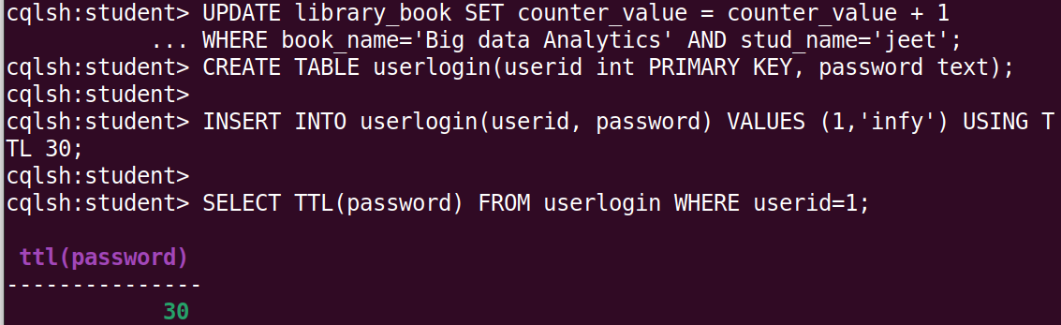

**TIME TO LIVE**

CREATE TABLE userlogin(userid int PRIMARY KEY, password text); INSERT INTO userlogin(userid, password) VALUES (1,'infy') USING TTL 30; SELECT TTL(password) FROM userlogin WHERE userid=1;

**IMPORT and EXPORT**

**Export to CSV**

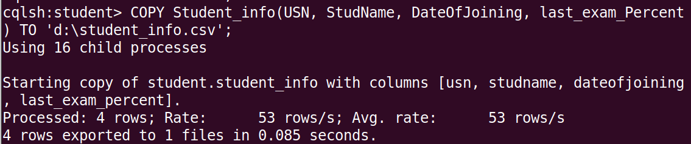**COPY elearninglists(id,course_order, course_id,courseowner,title) TO 'd:\elearninglists.csv';**

**Import from CSV**

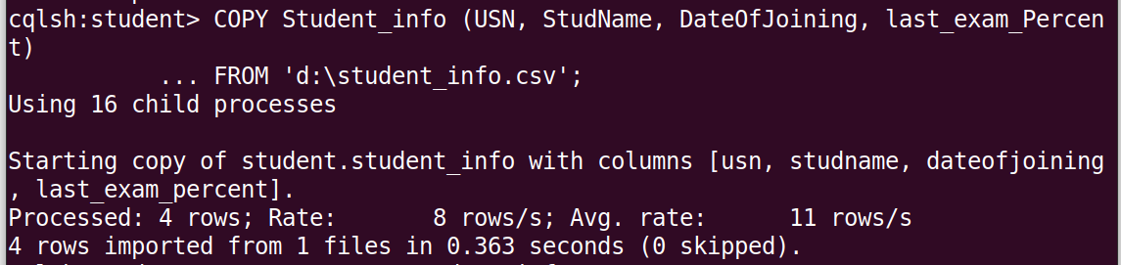**COPY elearninglists(id,course_order, course_id,courseowner,title) FROM 'd:\elearninglists.csv';**

**Import FROM STDIN**

**COPY persons(id,fname,lnmae)FROM STDIN;**

**Export to STDOUT**

**COPY elearninglists(id,course_order, course_id,courseowner,title) TO STDOUT;**