# Step 1: Create Keyspace Library

CREATE KEYSPACE Library WITH replication = { 'class': 'SimpleStrategy',

'replication_factor': 1

};

# Step 2: Create Column Family Library_Info

CREATE TABLE Library.Counter_Table ( Stud_Id int PRIMARY KEY, Counter_value counter

);

CREATE TABLE Library.Library_Info ( Stud_Id int,

Stud_Name text, Book_Name text, Book_Id text, Date_of_issue date,

PRIMARY KEY (Stud_Id, Book_Name)

);

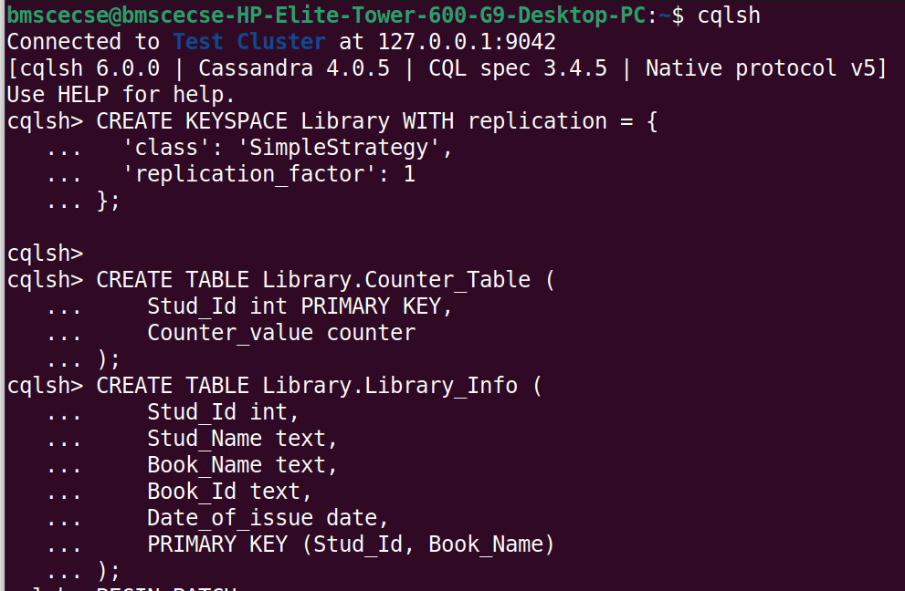

# Step 3: Insert Values into the Table in Batch

BEGIN BATCH

INSERT INTO Library.Library_Info (Stud_Id, Stud_Name, Book_Name, Book_Id, Date_of_issue)

VALUES (112, 'Alice', 'BDA', 'B101', '2025-04-01');

INSERT INTO Library.Library_Info (Stud_Id, Stud_Name, Book_Name, Book_Id, Date_of_issue)

VALUES (113, 'Bob', 'DBMS', 'B102', '2025-04-02'); APPLY BATCH;

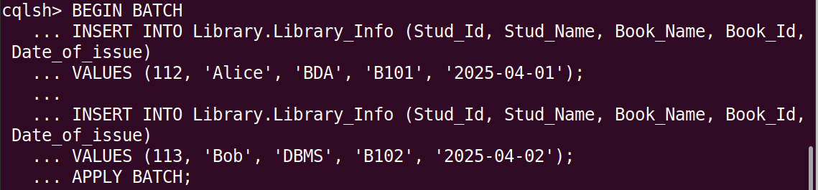

UPDATE Library.Counter_Table SET Counter_value = Counter_value + 1 WHERE Stud_Id = 112;



# Step 4: Display Table Details and Update Counter

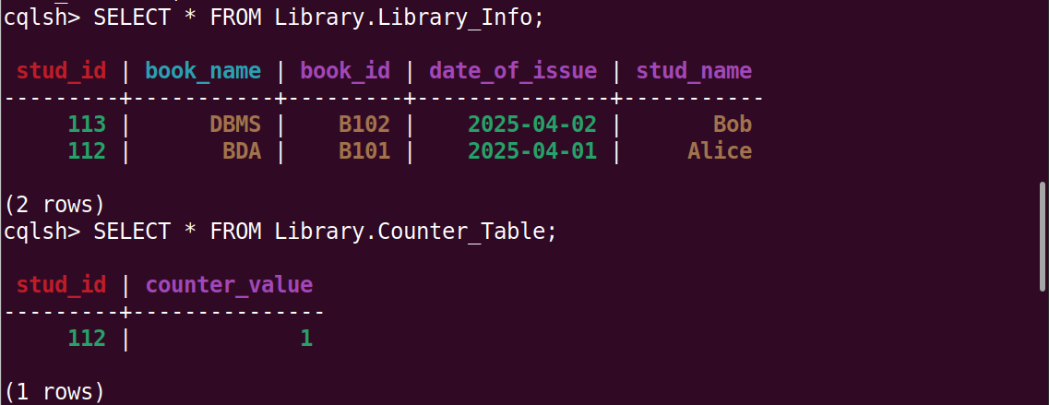SELECT * FROM Library.Library_Info; SELECT * FROM Library.Counter_Table;

## To increase counter value

UPDATE Library.Counter_Table SET Counter_value = Counter_value + 1 WHERE Stud_Id = 112;



# Step 5: Show a Student with ID 112 has Taken Book "BDA" 2 Times

SELECT * FROM Library.Counter_Table WHERE Stud_Id = 112;

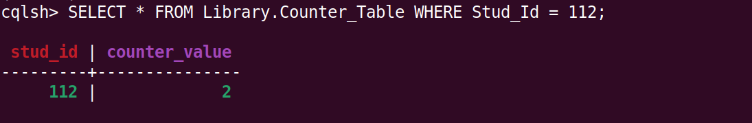

# Step 6: Export Table to CSV and Import the CSV

1. Exit cqlsh: cqlsh> exit

## Then in your system terminal run:

1. Export data to CSV:

cqlsh -e "COPY Library.Library_Info TO 'Library_Info.csv' WITH HEADER = true;"

1. Import data from CSV:

cqlsh -e "COPY Library.Library_Info FROM 'Library_Info.csv' WITH HEADER = true;"

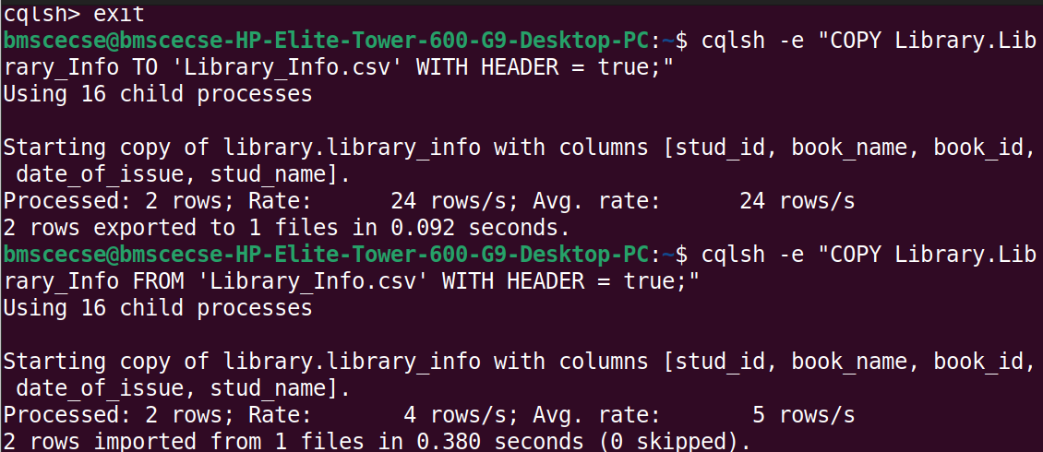

# Step 7: Show Imported Data

1. 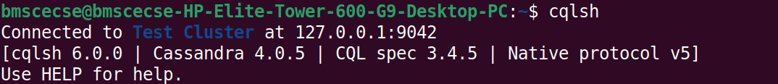Open cqlsh: cqlsh
2. Use your keyspace:

USE Library;

1. Run a SELECT query to view the data: SELECT * FROM Library_Info;

