Execution of HDFS Commands for interaction with Hadoop Environment.

Example Scenario for Execution:

1. **Start Hadoop (make sure to use the correct user, in this case hduser):**

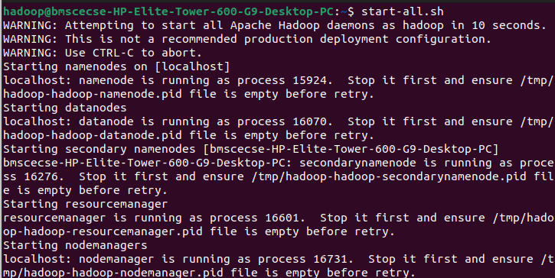$ start-all.sh

1. **Create Directory in HDFS (create a directory named /bda_hadoop):**

$ hdfs dfs -mkdir /bda_hadoop

1. **List Contents of HDFS Root (list the files and directories at the root of HDFS):**

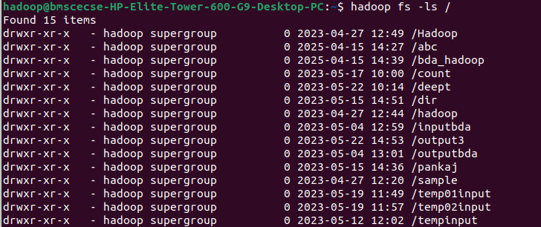$ hadoop fs -ls /

1. **Put Local File into HDFS (copy a local file from**

/home/hduser/Desktop/bda_local.txt to HDFS as /bda_hadoop/file.txt):

$ hdfs dfs -put /home/hadoop/Desktop/Welcome.txt /bda_hadoop/file.txt



1. **Display Contents of the File (display the contents of the file /bda_hadoop/file.txt on HDFS):**

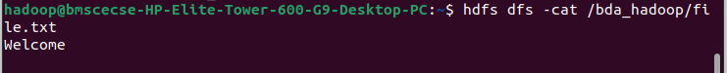$ hdfs dfs -cat /bda_hadoop/file.txt

1. **Copy File from Local File System to HDFS (using copyFromLocal to copy a local file into HDFS):**

$ hdfs dfs -copyFromLocal /home/hadoop/Desktop/Tee/bda_hadoop/file_cp_local.txt

1. **Retrieve a File from HDFS to Local (use get to copy a file from HDFS to the local filesystem):**

$ hdfs dfs -get /bda_hadoop/file.txt /home/hadoop/Downloads/downloaded_file.txt

1. **Move Directory in HDFS (move the directory /bda_hadoop to /abc in HDFS):**

$ hadoop fs -mv /bda_hadoop /abc

1. **Verify Directory Move (check that the directory /bda_hadoop has been successfully moved to /abc):**

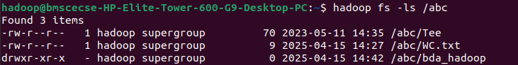$ hadoop fs -ls /abc

1. **Copy Directory in HDFS:**

Copy a file from /abc/bda_hadoop/file.txt to another location, say /abc/file_copy.txt:

$ hadoop fs -cp /abc/bda_hadoop/file.txt /abc/file_copy.txt

Copy an entire directory (e.g., /abc/bda_hadoop) to /copy_bda_hadoop:

$ hadoop fs -cp /abc/bda_hadoop /copy_bda_hadoop

Verify Copy:

Directory:

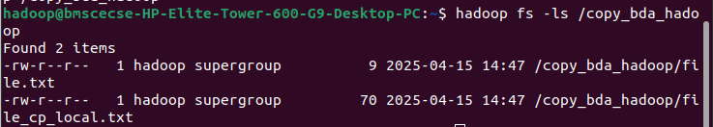$ hadoop fs -ls /copy_bda_hadoop

File:

$ hadoop fs -cat /abc/file_copy.txt