Preparing Atlas for SURFEX
Philippe Marguinaud,
CNRM/GMAP, May 2020

Table of contents
1 Introduction 2
2 Direct improvements to Atlas 2
3 Operators 2
Interpolation “box averaging” 3
Four points interpolation 4
First order finite differences gradient 5
First order finite differences half-gradient 6
Rotation of a gradient field 6
4 Conclusion and acknowledgments 7

Introduction
Atlas is a library developed by ECMWF and its partners for parallel data-structures supporting unstructured grids and function spaces, with the aim to investigate alternative more scalable dynamical core options for Earth System models, and to support modern interpolation and product generation software
Atlas is predominantly C++ code, with main features available to FORTRAN through a F2003 interface.
SURFEX is the surface scheme used by operational NWP models run at Météo-France. It includes tools to prepare climatology data and initial conditions, and a library to perform 1D calculations.
This document describes the modifications that have been applied to Atlas and the low-levels operators based on Atlas which have been implemented for use in SURFEX pre- and post-processing tools. These operators have been implemented in C++, with FORTRAN bindings for direct access from the SURFEX code.
It is worth mentioning that SURFEX pre-processing tools work with data on very large grids: currently 40000x20000, but there are plans for extending the size of this input grid.

Direct improvements to Atlas
Most of these contributions consist of bug fixes or minor improvements to the Atlas library. They are visible here :
https://github.com/ecmwf/atlas/issues?page=1&q=author%3Apmarguinaud
Most of these contributions are unrelated to SURFEX issues, but we list here the two main contributions we consider essential to the migration of SURFEX to Atlas:
- efficient use of large grids; currently 40000x20000 and larger grids are not handled efficiently by Atlas
- a Jacobian method for projections; this is required for gradient rotation

Operators
All these operators, but the gradient rotation operator make use of MPI communications, and have been implemented in C++; having them implemented in FORTRAN using bindings provided by the Atlas library would have probably been possible, but this would have been at the expense of performance and clarity, as the C++ language is definitely better to handle the required level of complexity.
FORTRAN bindings are, however, provided for all these operators; the cost of this FORTRAN interface is almost zero in terms of performance, but will require maintenance.
Our work is limited to structured grids; please look at Atlas documentation to understand what is meant here by “structured grid”. Let us simply recall that regulars lat/lon grids, Gaussian grids of any kind (stretched/rotated or not, reduced or not, etc.), grids used in AROME (Lambert projection with regular grid) fall in the category of structured grids.
Atlas does not work directly with grids and distribution, but rather makes use of functionspace objects which have the understanding of both the grid and the distribution, and provides high levels functions such as halos, gather/scatter, etc. Again look at Atlas documentation for the exact definition of a functionspace.
The functionspace of choice for our purpose is the StructuredColumns functionspace. It is cheap and can work with all structured grids. We have used this class in all our operators.

Interpolation “box averaging”
This interpolation is meant to be used when going from a very fine grid (such as the geophysical databases) to a coarser grid (such as the operational model grid).
The basic principle is to draw a rectangle around a point on the target grid, find the points of the origin grid which fall in this rectangle and make the average of the values held by the origin points lying in this rectangle.
This is implemented in the class interpolationA.
The constructor of this class creates the mapping between the source and the target grids: for each point of the target grid, all points of the source grid lying in the rectangle attached to this point, are listed, and stored in the interpolation object for later use. For each point of the source grid, the remote MPI task which holds this point is also stored.
The following picture explains this selection process (the target grid is red, the source grid is made of small squares, the green rectangle shows the selection for the target point located at its center):
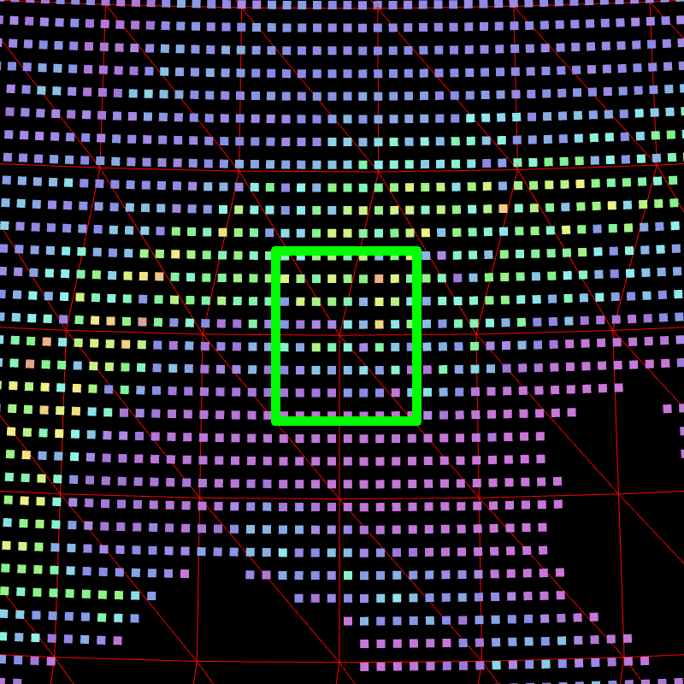

At the end of the setup, each MPI task knows :
- which points of the source grid are required, for each point of the target grid
- which MPI task it has to send the value of each point of the source grid it holds
Keeping this information in an object allows for re-use. The setup of this interpolation is long and quite complex, but is it entirely distributed. No global array is used at all. It is also worth noting that this setup heavily relies on fast sort functions.
The interpolation itself is a two step process :
- redistribution of the points of the source grid onto the distributed target grid (method interpolationA::shuffle)
- use of a reduction operator (currently addition, minimum, maximum); (method interpolationA::interpolation)
The class also provides access to the interpolationA::shuffle method and the indices required to interpret its results.
All high-resolution fields from geophysical databases are interpolated using interpolationA. This class handles missing values.

Four points interpolation
The class interpolation4 implements a traditional 4-points linear interpolation. Missing values are taken into account.
The setup of this interpolation is similar to that of interpolationA. , except that for each target point we look for the four points surrounding it.

Both interpolations have been tested on simple fields, such as :
X = cos (lon) x cos (lat)
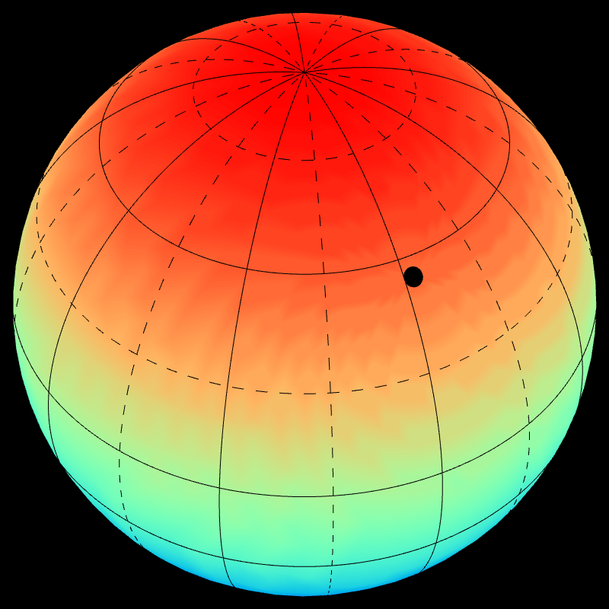Figure 1: Interpolation from a high resolution lat/lon to a stretched/rotated Gaussian t31c2.2
Y = sin (lon) x cos (lat)
Z = sin (lat)

The results look correct.

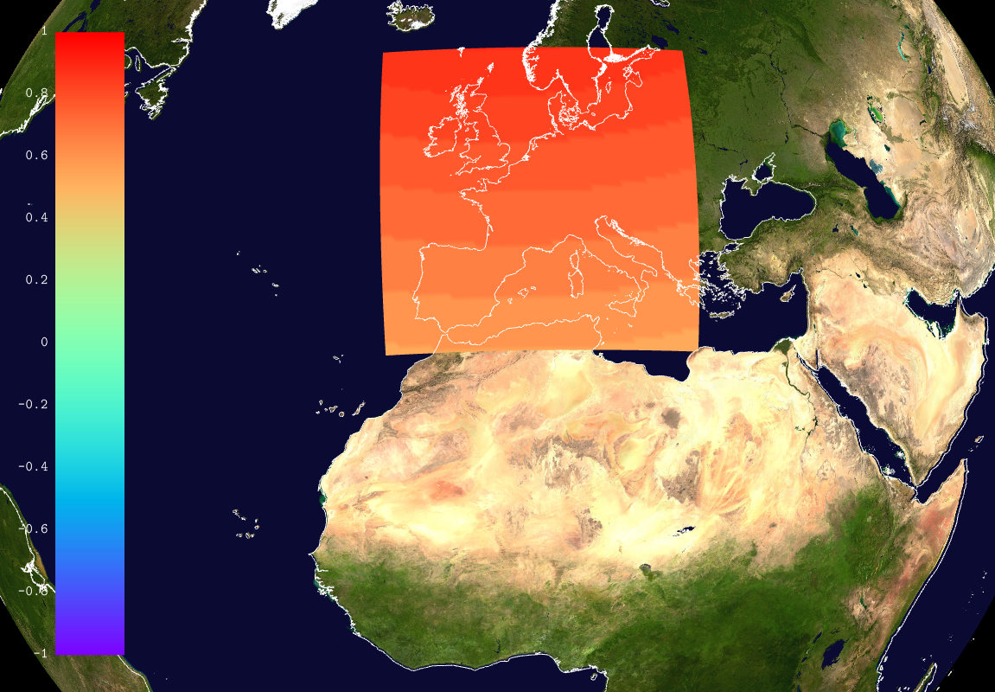Figure 2: Interpolation from a Gaussian t31c2.2 to a 64x64 AROME domain

It is important to note that these interpolations can handle all structured grids, both for target and source.

First order finite differences gradient
There is not much to say about this operator except that is handles missing values, and uses the halos provided by Atlas. It is used for the computation of the SSO (sub-scale orography) parameters.
This operator has been tested on X, Y, Z fields with success.
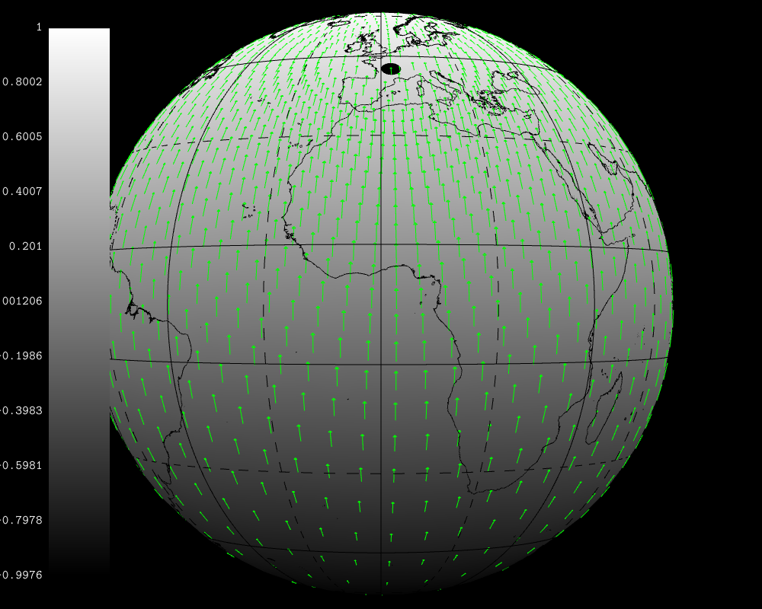Figure 3: Gradient of Z on a t31c2.2 Gaussian grid

First order finite differences half-gradient
This operator is very similar to the gradient operator. It computes finite differences in the X and Y directions, both positive and negative.
It also returns the differences (in meters) along the X and Y directions both positive and negative.
This operator is used in the calculation of the AOS and HO2 parameters whose purpose is unknown to the author of this document.

Rotation of a gradient field
We consider in this section a gradient of a field, with respect to distance measured in meters on the sphere, expressed in the unit vectors of a particular projection.
Interpolation a gradient field computed from a source grid to a target grid gives a sensible result on the target grid only if both grids share the same projection.
If this is not the case, then the interpolated gradient has to be “rotated”. Its norms remains unaffected, but its coordinates in the unit vectors of the target projection have to be rotated.
This is better explained using an example :

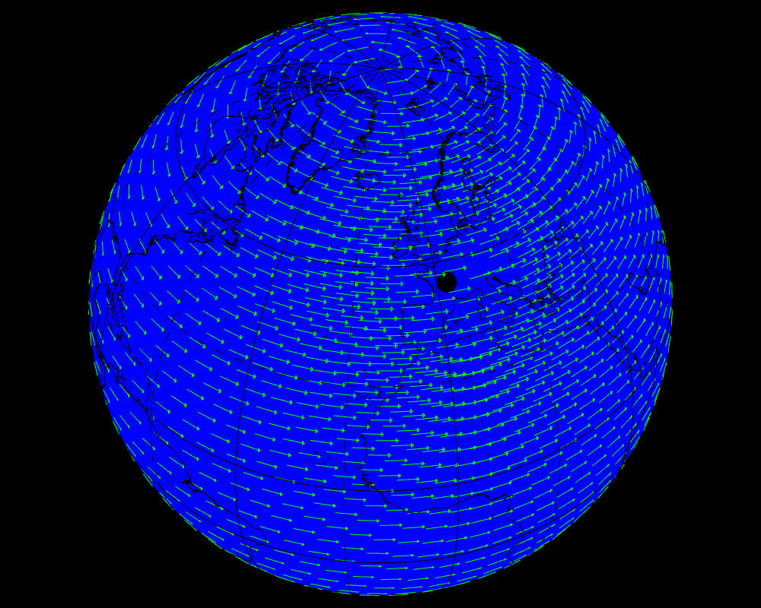Figure 4: Gradient of longitude, computed on a lat/lon grid, and interpolated and rotated on a t31c2.2 Gaussian grid

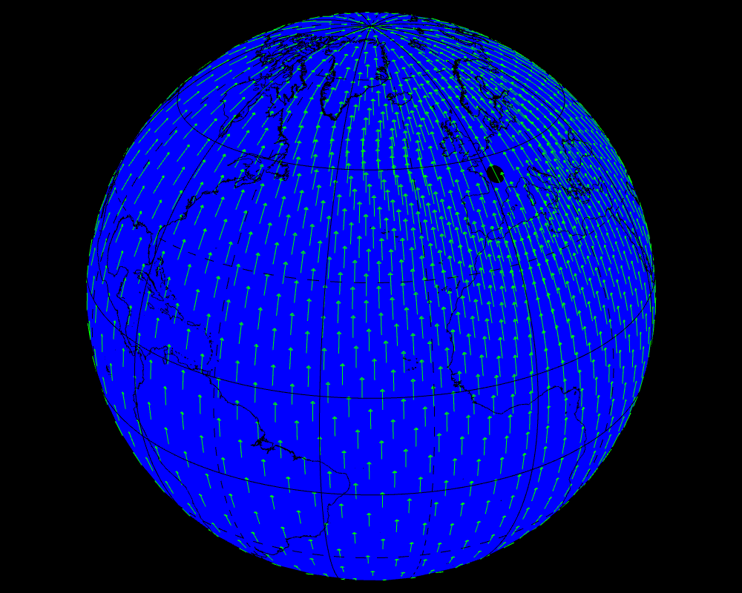Figure 5: Gradient of the latitude, computed on a lat/lon grid and interpolated on a t31c2.2 Gaussian grid

Conclusion and acknowledgments
This study shows that the required operators for SURFEX can be implemented in Atlas, and therefore, Atlas could actually be used to support the distribution and the geometry of the SURFEX library and tools.
The corrections and direct contributions are currently integrated into Atlas source code. We look forward having a full development branch with our contributions. Some work (not discussed here) necessary to improve Atlas gather/scatter code (required for efficient IO), is in progress.
The author thanks W. Deconinck (ECMWF) for its patience at looking at our modifications and integrating them into Atlas main branch.
The author also thanks F. Suzat (CNRM/GMAP) for keeping in touch with the on-going work on Atlas applied to SURFEX, and his efforts and encouragements.

