Toggle em them cho anh 1 cai class DownArrow

Xem chi tiet o day

<http://stackoverflow.com/questions/5371397/jquery-toggle-with-arrows-problem>

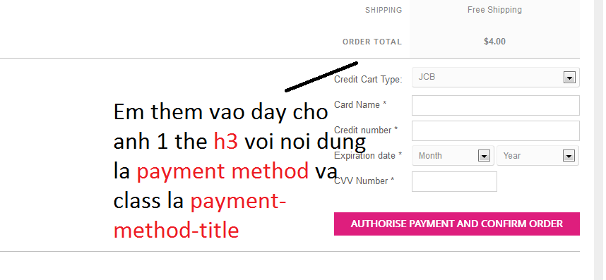

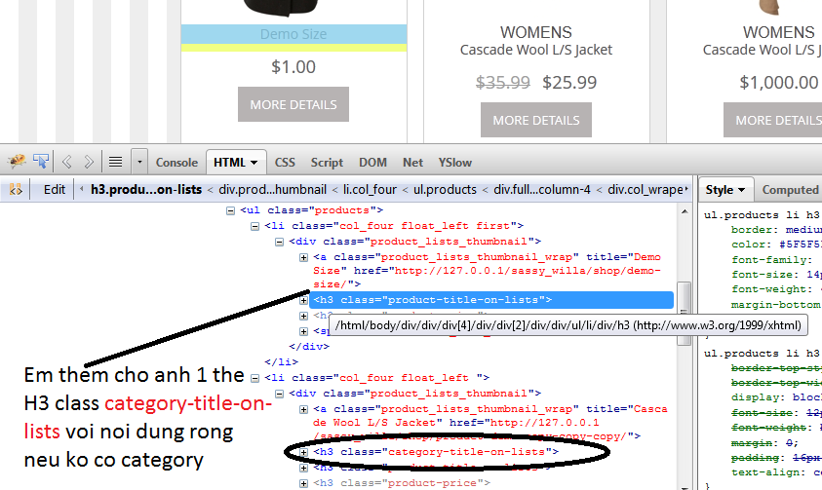



+ Cai page Thank You anh ko the nao` vao dc, no cu bao loi~ o giai doan cuoi cung, em check giup anh cai nhe