HW 2_3 Feedback linearized controller.

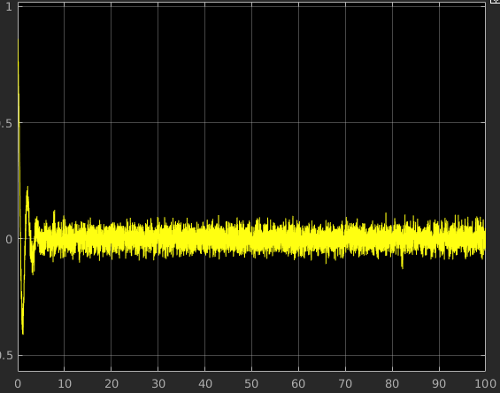

Aircraft with thrust = step(5, t=0.1s) and elevator = (1, t=1s). Not sure why it oscilates
