Distinguishing Drift from Signal in Microwave-Imaging Machine Learning: A Three-Experiment Control Framework
Peter Martin, and Cynthia M. Furse, Fellow, IEEE
Department of Electrical and Computer Engineering, University of Utah, Salt Lake City, UT 84112 USA
Take-Home Messages
- A machine-learning model trained on empty-phantom microwave measurements achieved 82% within-session 96-way position accuracy, driven entirely by measurement drift. Multi-session leave-one-session-out (LOSO) cross-validation dropped the same model to 2.3% (chance = 1.04%), showing that drift is session-specific and does not transfer across recording sessions.
- On the same antennas with a metal target present, LOSO reached 99.35%. The 42x gap between drift and real signal on identical hardware is the empirical basis for treating multi-session LOSO as a required control experiment in microwave-imaging ML.
- Reducing the measurement to a single reflection channel (S11) widened the gap to 77x. This means the drift-control framework can be reproduced with the cheapest possible microwave measurement setup: a 1-port VNA and one antenna.
- Standard detectable-difference thresholds (10% relative CI-band gap) correctly reject post-warmup thermal drift, but do not reject mechanical drift caused by loose antenna mounting. The framework can also be used to diagnose mechanical instability.
- Any microwave-imaging ML paper reporting high per-position accuracy without a matched empty-phantom control is reporting drift-memorization capacity, not detection capacity. We recommend the three controls as a minimum standard for future work in this area.
- Reducing measurement drift remains important even when multi-session LOSO is used. LOSO removes drift as a fake position fingerprint, but drift also adds noise to every measurement, which reduces the signal-to-noise ratio of the real object. High-contrast targets such as the metal fishing weight used here are well above the drift noise floor and give 99% LOSO even with mechanical setup issues; low-contrast targets such as a real biological tumor produce a smaller scattering signal and would be drowned out by drift even if LOSO worked perfectly. Warmup characterization, mechanical stabilization, and per-port synthetic-positions DD checks therefore matter on their own, independent of the statistical controls.
- Drift has two distinct components that limit different aspects of ML performance. Trial-to-trial noise (jitter between consecutive sweeps at the same position) limits within-session accuracy; slow drift (mean shift over the timescale of a session) limits LOSO accuracy. Mechanical improvements such as replacing tape with a rubber band mount reduced trial-noise on the affected port by 10% and slow drift on the same port by 88% (S33 from 0.0176 to 0.0021), showing that the two components respond to different interventions. For a target to be reliably localized across sessions, its scattering signal must exceed both components: signal > trial-noise for within-session detection, signal > slow-drift for cross-session detection.
Distinguishing Drift from Signal in Microwave-Imaging Machine Learning: A Three-Experiment Control Framework
Peter Martin, and Cynthia M. Furse, Fellow, IEEE
Abstract: Recent work applies deep learning to microwave imaging for breast cancer detection, with reported per-position accuracies above 95% on single-session data. This paper shows that single-session accuracy on this class of measurement can be produced by measurement drift alone, without any object present. On empty-phantom data with a 4-port vector network analyzer (VNA), a physics-features multi-layer-perceptron (MLP) ensemble reaches 82% within-session 96-way position accuracy. When the same model is evaluated using multi-session leave-one-session-out (LOSO) cross-validation on the same empty-phantom data, accuracy drops to 2.3%, close to the chance baseline of 1.04%. This shows that the per-position pattern learned within a session is a fingerprint of measurement drift, and that this fingerprint does not survive to the next recording session. When the same protocol is applied to identical antennas with a metal scattering object, LOSO reaches 99.35%; reducing the measurement to a single reflection channel (S11) keeps LOSO at 100% for the real object while dropping empty-phantom LOSO to 1.30%. We distinguish two components of measurement drift, trial-to-trial noise and slow drift, that limit within-session accuracy and LOSO accuracy respectively. A three-way mount comparison (tape, rubber band, cables-only) shows that a mechanical mount improvement reduced slow drift on the affected reflection channel by 88% while reducing trial noise by only 10%, and localizes a residual drift contribution to the port-4 cable. We recommend three linked control experiments (empty-phantom within-session accuracy, empty-phantom LOSO, and synthetic-positions detectable-difference on continuous data) as a minimum standard for future microwave-imaging ML publications, and note that drift reduction remains important on its own even when LOSO controls are in place because the drift components set a noise floor that a real target's scattering signal must exceed. The framework is reproducible with a 1-port VNA and one antenna.
Index Terms: Breast phantom, control experiment, cross-session validation, detectable difference, drift, leave-one-session-out (LOSO), machine learning, microwave imaging, multi-layer perceptron (MLP), S-parameters, vector network analyzer (VNA).

I. Introduction
MICROWAVE imaging for breast cancer detection has been studied for over two decades [1], [2]. Recent work has applied convolutional neural networks (CNNs) and other machine-learning models to vector-network-analyzer (VNA) measurements, with several groups reporting single-session per-position classification accuracy above 95%. Our own prior work in this area reported 100% accuracy on adipose-only phantoms and 92.2% on phantoms with dense fibroglandular inserts, using a two-antenna system and a hierarchical CNN [3].
While working on that system, we noticed that high single-session accuracy did not always transfer to measurements taken on a later day, even with the same phantom, antennas, and operator. In the discussion of our prior paper, we speculated that this could be due to "session-specific cues, such as cable position, temperature drift, or noise that drifts within a test session." This paper investigates that possibility directly.
The specific concern is that a flexible nonlinear classifier such as a CNN or MLP, given enough parameters, can memorize any per-position pattern that appears in its training data, whether or not that pattern is caused by a physical object at that position. If the underlying VNA drift or mechanical setup produces a per-position pattern that is stable within a recording session, the model will learn it and appear to work, even when no object is present. We refer to this failure mode as drift memorization.
Testing whether a reported result is a real detection or drift memorization requires an empty-phantom control experiment: run the same measurement protocol with no object in the phantom, train the same model, and observe the accuracy. If the model reaches high accuracy on the empty-phantom data, the training procedure is memorizing something that has nothing to do with the object, and any result on real-object data must be interpreted with caution.
There is also a second reason to care about drift, which the empty-phantom control does not capture. Drift adds noise to every measurement, and that noise competes with the real scattering signal from the object. If the drift noise floor is comparable to or larger than the object signal, the object cannot be reliably localized no matter how flexible the classifier is or how carefully the training and testing sessions are separated. This is a signal-to-noise-ratio problem, not a memorization problem, and multi-session cross-validation does not address it. The high real-object accuracy we report later in this paper was obtained with a high-contrast metal target, whose scattering signal is well above the drift noise floor of our system. A lower-contrast target, such as an actual biological tumor, produces a smaller scattering signal, and drift reduction becomes more important for that class of measurement. Warmup characterization, mechanical stabilization, and per-port drift diagnostics therefore matter on their own, independent of the classifier or the cross-validation protocol.
For clarity, we distinguish two components of measurement drift throughout this paper. Trial-to-trial noise is the jitter between consecutive sweeps at the same position within a single recording session; it is the noise floor of a single measurement. Slow drift is the shift of the mean magnitude over the timescale of the session; it is what accumulates over minutes to hours and what differs from one session to the next. The two components have different physical origins (short-term thermal and electronic noise vs. long-term thermal drift and mechanical settling), respond to different interventions (VNA warmup and averaging vs. antenna mounting and cable stabilization), and limit different aspects of the ML pipeline. Trial-to-trial noise limits within-session accuracy because each trial at a given position becomes more variable. Slow drift limits LOSO accuracy because the per-position pattern learned in one session no longer applies in the next. A useful summary of the detection condition is that for a real target to be reliably classified, its scattering signal must exceed both the trial-noise floor and the slow-drift floor at each measurement point. Reducing either component lowers the minimum detectable signal, which is why drift reduction matters even when the statistical controls are in place.
In this paper we describe three linked control experiments: (i) empty-phantom within-session accuracy, which quantifies how strong the drift memorization signal is inside a single recording session; (ii) empty-phantom leave-one-session-out (LOSO) accuracy, which quantifies how much of that drift memorization transfers to a session recorded on a different day; and (iii) synthetic-positions detectable-difference (DD) analysis on a continuous single-position sweep, which quantifies whether pure drift can produce false positive detections above the standard 10% relative-gap threshold used in microwave imaging DD analysis.
We apply the three controls to a 4-port Keysight MN7021A VNA measurement with the Sam Medium Separated antenna configuration on a 3D-printed acrylic breast phantom. On empty-phantom data, we obtain 82% within-session position accuracy, which is orders of magnitude above the chance baseline of 1.04%. The same model reaches only 2.3% under LOSO. On identical antennas with a metal object present, LOSO reaches 99.35%. The 42x gap between real-object LOSO and empty-phantom LOSO on the same hardware is the central empirical result. We also show that reducing the measurement to a single reflection channel (S11) widens this gap to 77x, suggesting that the framework can be reproduced with a 1-port VNA and a single antenna.
The paper is organized as follows. Section II describes the measurement setup, data-collection protocols, and the three control experiments. Section III presents the results. Section IV discusses interpretation and practical guidance. Section V lists limitations. Section VI describes future work. Section VII concludes.

II. Methods and Procedures

A. Measurement System
All 4-port measurements were taken with a Keysight MN7021A vector network analyzer (referred to internally as the "Hunter VNA") at 791 linearly spaced frequency points from 0.1 GHz to 8 GHz. Two antenna sets are used in this paper: Sam Medium Separated (four elements mounted in two pairs on opposite sides of the phantom) and, for a cross-system replication, McGill Separated (four elements with wider spacing, previously used with a 2-port VNA at 201 frequency points up to 6.5 GHz).
The breast phantom is a 3D-printed acrylic shell, referred to as the A3 shell (larger than the A2 shell used in our prior work). During real-object trials, the phantom is filled with canola oil as an adipose-tissue surrogate. During drift-control trials, the phantom is left empty.
The scattering object used for real-object comparison is a lead fishing weight, matching the target used in our prior work. Positions are defined on a rectangular grid: 6 rows by 8 columns by 4 sub-positions per grid cell, giving 192 nominal positions, of which 96 fall inside the phantom footprint and are actively measured. At each measured position, 16 back-to-back sweeps are recorded, separated by 200 ms.

B. Data Collection Protocols
Three data-collection protocols were used in this study:
Batch drift test: four back-to-back empty-phantom recording sessions using the same automated batch program used for real-object sessions. Each session takes approximately 30 minutes and includes the same inter-position timing (a simulated operator-move delay between positions) as a real session. No object is placed in the phantom at any point.
Overnight live sweep: a single-position continuous sweep at approximately 1 Hz, running for 15.17 hours (55,298 individual CSV files). No operator interaction after the first sweep. This protocol was used to characterize the VNA settling behavior at both short (minutes) and long (hours) timescales.
Real-object comparison: three sessions with the metal object on the same 51-position grid, same VNA settings, same antennas. These sessions were recorded before the drift-control work and are drawn from a separate study.

C. The Three Control Experiments
Each control experiment uses the same physics-motivated feature extraction and MLP classifier described in Section II-D. The controls differ only in how training and testing data are split.
Control 1: Empty-phantom within-session accuracy. For each batch-drift session individually, features are computed for every position and trial. A 75/25 stratified train/test split is performed by position (four random trials from each of the 96 positions held out for testing, the remainder used for training). Position vote-aggregation across trials yields a single accuracy value per session. The chance baseline is 1/96 = 1.04%. This measures how well the classifier can memorize the drift fingerprint within a single recording session.
Control 2: Empty-phantom multi-session LOSO. All four batch-drift sessions are pooled. A 4-fold leave-one-session-out cross-validation is run: three sessions are used for training and one is held out for testing. Training features are standardized using per-session z-scores; test features are standardized using the test session's own z-score. Position vote-aggregation across trials produces a per-fold accuracy. This measures how much of the within-session drift fingerprint transfers to a session recorded on a different day.
Control 3: Synthetic-positions detectable difference. The 15-hour continuous overnight run is partitioned into 1-hour blocks. Within each block, the first 30 seconds (about 30 sweeps) is treated as a "baseline," and each subsequent 30-second window is treated as a fake "position." This produces 119 fake positions per hour. The standard CI-band-gap DD calculation used in our prior work [4], [5] is then applied: for each fake position, the 95% confidence-interval bands of the position and baseline magnitudes are compared. When the position band is entirely above the baseline band, the gap between them is the detectable difference; when they overlap, the detectable difference is zero. A fake position is flagged as "detected" when the relative CI-band gap exceeds 10% at any frequency in the 2-8 GHz analysis band. This measures whether pure drift within an hour can exceed the standard microwave-imaging detection threshold.

D. Feature Extraction and Model
For each measured trial we build a physics-motivated feature vector by concatenating, per S-parameter channel: magnitude in dB, phase in radians, real part, imaginary part, per-trace statistics (mean, standard deviation, median, minimum, maximum), and the first 64 taps of the inverse fast Fourier transform (IFFT) of the complex trace. The IFFT taps approximate a time-domain representation of the frequency response, so the feature vector captures both frequency-domain and time-domain information. At 791 frequency points and 16 S-parameter channels this yields 18,792 features per trial. For the S11-only ablation, the same feature extraction is applied to the single S11 channel, yielding 873 features per trial.
The classifier is an ensemble of three multi-layer perceptrons (MLPs) with hidden layers of size (256, 128), ReLU activation, 200 maximum training iterations, and early stopping on a 10% validation fraction (patience = 15 iterations without improvement). At inference time, the three networks' output probabilities are averaged and the maximum-probability class is returned.
We use an MLP rather than a CNN for these controls because preliminary comparisons showed that MLPs on physics features generalize better across recording sessions than CNNs on raw S-parameter matrices, despite CNNs achieving higher single-session accuracy. This is consistent with the pattern that higher-capacity nonlinear models memorize drift more effectively. A full architecture comparison is deferred to future work.

E. Drift Metrics
Two scalar metrics are used throughout the paper to characterize measurement drift, corresponding to the two components introduced in Section I.
Trial-CV (trial-to-trial noise floor). For each S-parameter channel and each measured position, we compute the standard deviation of the trace magnitude across the 16 trials, normalized by the mean magnitude, at each frequency point, and then average across frequency. The median across positions is reported as the per-S-parameter trial-CV. This is a measurement noise floor: it quantifies how much the magnitude at a fixed physical configuration jitters between consecutive sweeps.
Slow drift (session-scale mean shift). For each S-parameter channel, we compute the mean magnitude across the first 10% of trials in the session and the mean across the last 10% of trials, then take the absolute difference and normalize by the overall session mean, per frequency point, and finally average across frequency. This quantifies how much the mean magnitude shifted over the timescale of the session, which is what accumulates over minutes to hours.
The two metrics quantify independent physical phenomena and, as shown in Section IV-E, respond to different interventions. Trial-CV limits within-session accuracy because it degrades the signal-to-noise ratio of a single measurement. Slow drift limits multi-session LOSO accuracy because it determines how much the per-position pattern changes between sessions. Together they set the detection threshold: for a target to be reliably localized, its scattering signal must exceed both floors.

III. Results

A. Empty-Phantom Within-Session Accuracy
Table I reports the within-session 75/25 split accuracy for each of the four batch-drift sessions.
TABLE I
Empty-Phantom Within-Session Position Accuracy (96 Positions, Chance = 1.04%)
Session | Positions | Accuracy | Std. Dev.
S001 | 96 | 73.75% | 1.38%
S002 | 96 | 82.08% | 1.21%
S003 | 96 | 82.08% | 3.51%
S004 | 96 | 90.83% | 2.12%
Mean | 96 | 82.19% | -

Every session's within-session accuracy is more than 70 percentage points above chance, even though no object was present in the phantom at any point during data collection. The absolute range across the four sessions (73.75% to 90.83%) suggests that the drift fingerprint became somewhat more structured as the sessions went on, which is consistent with an initial thermal transient settling out over the first sessions.

B. Empty-Phantom LOSO
Table II reports the LOSO per-fold and mean accuracies on the same four sessions.
TABLE II
Empty-Phantom Multi-Session LOSO Position Accuracy
Test session | Trial-level | Position-vote
S001 held out | 2.28% | 2.08%
S002 held out | 3.12% | 2.08%
S003 held out | 3.32% | 2.08%
S004 held out | 4.23% | 3.12%
Mean | 3.24% | 2.34%

The within-session accuracy of 82.19% drops to 2.34% under LOSO, which is within a factor of 2.5 of the chance baseline of 1.04%. This means the per-position patterns the classifier learned in one session do not appear at all in a session recorded on a different day. The drift memorization is therefore session-specific, and multi-session LOSO effectively removes it. This is the central control result.

C. Real-Object Comparison
Table III compares the empty-phantom control accuracy to prior real-object measurements on the same antennas.
TABLE III
Real Object vs. Empty Phantom on Identical Antenna Configuration (Sam Medium Separated, A3 Phantom)
Setting | S-parameter channels | Within-session | LOSO
Real object, full 4-port | 16 channels | 100% | 99.35%
Real object, S11 only | 1 channel | 100% | 100.00%
Empty phantom, full 4-port | 16 channels | 82.19% | 2.34%
Empty phantom, S11 only | 1 channel | 88.28% | 1.30%

Two drift-vs-signal ratios are visible in this comparison. For the full 4-port measurement, real-object LOSO exceeds empty-phantom LOSO by a factor of 42 (99.35% / 2.34%). For the single-reflection-channel measurement, the ratio widens to 77 (100.00% / 1.30%). The S11-only case is particularly informative, because it uses the smallest possible measurement configuration (one port, one antenna, one reflection channel), and it shows that a real object's per-position signal survives multi-session validation while pure drift does not.
We also replicated the empty-phantom LOSO control on an independent 2-port VNA measurement using the McGill antenna set at 0 to 6.5 GHz on 201 frequency points and a 64-position grid. Empty-phantom LOSO accuracies of 3.25% (N=2 sessions, averaged over 5 test subsets) and 5.0% (N=3 sessions) were obtained, against a chance baseline of 1.56%. The near-chance LOSO reproduces on this completely different measurement system, indicating that the control experiment is robust to the specific VNA architecture or antenna type.

D. Synthetic-Positions DD on Overnight Data
Table IV summarizes the synthetic-positions DD analysis on selected hours of the 15-hour overnight run. Each row reports the fraction of the 119 fake positions in that hour whose relative CI-band gap exceeds 10% at any frequency in the 2 to 8 GHz analysis band. Columns are the four VNA ports; rows are hours from the start of the sweep.
TABLE IV
Synthetic-Positions Detection Rate (%) Per Port, Selected Hours of the 15-Hour Overnight Run
Hour | Port 1 | Port 2 | Port 3 | Port 4
0 (fresh VNA) | 22.7 | 22.7 | 42.4 | 23.9
1 | 0.0 | 0.0 | 20.8 | 1.1
2 | 0.0 | 0.0 | 20.8 | 0.0
4 | 0.0 | 0.0 | 18.1 | 0.0
8 | 0.0 | 0.0 | 14.5 | 0.0
12 | 0.0 | 0.0 | 5.9 | 0.0
14 | 0.0 | 0.0 | 0.0 | 0.0

Three observations are worth noting. First, during the first hour after VNA power-on, all four ports show more than 20% detection rate on empty-phantom data. This means the standard 10% detection threshold is defeated by warm-up drift alone if measurements are taken immediately after turning on the VNA. Second, once past the first hour, ports 1, 2, and 4 collapse to 0% detection rate. The standard DD threshold correctly rejects post-warmup thermal drift on those ports. Third, port 3 remained at 15 to 20% detection rate for the first nine hours before decaying to 0. After the experiment we inspected the setup and found that the port 3 antenna adhesive tape had lost contact with the phantom surface, allowing small mechanical movement. This provides a useful secondary finding: the standard DD threshold rejects electronic drift but not mechanical drift. The three-experiment framework can therefore also be used to diagnose mechanical instability by looking for per-port asymmetry in the synthetic-positions detection rate.

E. Mount Comparison and Cable-Level Diagnostic
To separate the trial-noise and slow-drift components of measurement drift and to isolate their physical origins, we ran the same batch-drift protocol under three mount conditions: (i) the original loose tape mount used in the first batch drift test; (ii) a rubber-band mount that mechanically clamps each antenna to the phantom surface; and (iii) an antennas-removed configuration in which only the SMA cables are present. Table V summarizes per-port trial-CV (mean over S-parameters involving that port) and reflection-channel slow drift (S11, S22, S33, S44 individually) under each mount.
TABLE V
Trial-CV and Reflection Slow-Drift Per Port Under Three Mount Conditions
Port / Channel | Metric | Tape (n=4) | Rubber (n=6) | Cables (n=2)
P1 (any S1x) | Trial-CV | 0.0301 | 0.0296 | 0.301
P2 (any S2x) | Trial-CV | 0.0316 | 0.0299 | 0.283
P3 (any S3x) | Trial-CV | 0.0517 | 0.0464 | 0.284
P4 (any S4x) | Trial-CV | 0.0304 | 0.0287 | 0.315
S11 reflection | Slow drift | 0.00285 | 0.00048 | 0.00007
S22 reflection | Slow drift | 0.00089 | 0.00095 | 0.00010
S33 reflection | Slow drift | 0.01760 | 0.00208 | 0.00008
S44 reflection | Slow drift | 0.00135 | 0.00218 | 0.00040

Three observations follow. First, replacing the tape mount with a rubber band reduced trial-CV on the port with the mechanically-compromised antenna (port 3) from 0.052 to 0.046, a 10% reduction, and left the other three ports essentially unchanged. Second, the same mount change reduced the reflection-channel slow drift on port 3 (S33) from 0.0176 to 0.0021, an 88% reduction, and reduced S11 slow drift from 0.0029 to 0.0005, an 83% reduction. The mount improvement therefore has a much larger effect on slow drift than on trial noise, which is consistent with the two components having different physical origins. Third, in the antennas-removed configuration, all three ports 1, 2, 3 show reflection-channel slow drift below 0.0001, but port 4 shows 0.0004, which is 4.7 times the mean of the other three. This localizes a residual port-4 drift contribution to the cable, connector, or VNA channel, independent of the antenna. Since port-4 slow drift with antennas attached (rubber band condition) is 0.00218, the cable contribution accounts for approximately 18% of the total and the antenna contribution accounts for the remaining 82%.
The rubber-band configuration was also evaluated for LOSO accuracy on the same 6-session set. Empty-phantom within-session accuracy averaged 86.7%, higher than the 82.2% seen with tape, and 6-fold LOSO averaged 3.65%, comparable to the 2.34% seen with tape. The counterintuitive rise in within-session accuracy is a consequence of the trial-noise reduction: cleaner measurements produce a more sharply-defined per-position drift fingerprint within a session, which the classifier memorizes more effectively. The absence of a corresponding improvement in LOSO reflects an intrinsic property of drift on this measurement system: the drift trajectory is random from session to session, so reducing the magnitude of the trajectory does not make it more consistent across sessions. LOSO on empty-phantom data therefore stays near the chance baseline regardless of drift magnitude. This does not diminish the value of drift reduction, however, because the effect on the detectability of a real target is different: reducing drift lowers the noise floor of the training data, so target signals that would previously be indistinguishable from drift within a session become learnable. In the language of Section III-C, drift reduction lowers the threshold that a real target's scattering signal must exceed.

IV. Conclusions and Discussion
This paper introduces three linked control experiments for distinguishing measurement drift from real signal in microwave-imaging machine-learning workflows. The empty-phantom within-session control quantifies how much drift can be memorized by a flexible classifier. The empty-phantom LOSO control verifies that this memorization is session-specific rather than a stable property of the hardware. The synthetic-positions DD control quantifies whether pure drift can defeat the standard microwave-imaging detection threshold.
The 82% within-session position accuracy achieved on empty-phantom data is a large number by any standard. If the empty-phantom origin were not disclosed, that number would be indistinguishable from a serious detection result in a typical microwave-imaging ML publication. This is the key observation of the paper. Reports of high per-position accuracy on single-session data, without a matched empty-phantom control, are not evidence of detection capability; they are evidence of drift-memorization capacity.
Multi-session LOSO on the same data collapsed accuracy to 2.34%, close to chance. On identical antennas with a real object present, LOSO reached 99.35%. The 42x gap between real-object LOSO and empty-phantom LOSO on the same hardware is what we recommend as the numerical evidence for a real detection claim. When the measurement is reduced to a single reflection channel (S11), the gap widens to 77x, showing that even the simplest possible microwave measurement retains enough signal-to-drift separation to support meaningful cross-session detection.
The synthetic-positions DD result adds a complementary diagnostic. Because this experiment uses only continuous single-position measurements, without any object placement or position stepping, it isolates the temporal drift component of the noise budget from any operator or mechanical variability. When the detection rate on this control significantly exceeds the empty-phantom noise floor, either the VNA has not warmed up sufficiently or the physical setup has a mechanical stability problem, and both diagnoses can be made without touching a real object.
It is worth emphasizing that the value of the drift-control framework is not only that it exposes drift memorization. The above results might suggest that once multi-session LOSO is applied, drift can be ignored. That is not the right conclusion. Drift plays two roles in a microwave-imaging ML pipeline. The first role is as a session-specific per-position pattern that a flexible classifier will memorize; this is the failure mode that LOSO controls for. The second role is as noise that adds to every measurement, which reduces the signal-to-noise ratio of the real scattering signal from the object. Multi-session LOSO removes the first role but not the second. A high-contrast target like the metal fishing weight used here is comfortably above the drift noise floor even in the presence of substantial mechanical instability, and so we recover 99% LOSO accuracy despite the port-3 tape issue. A lower-contrast target, such as an actual biological tumor, produces a much smaller scattering signal and would sit much closer to (or below) the drift noise floor. For that class of measurement, reducing drift is essential, and the practical guidance from the framework (settling characterization, mechanical stabilization, and per-port synthetic-positions DD monitoring) provides the tools to do so. In short, LOSO makes drift statistically irrelevant to the training/testing procedure, but does not make it physically irrelevant to the measurement.
The choice of MLP over CNN in this study also deserves comment. Our prior work used a hierarchical CNN, and in that setting we already noticed that high in-session accuracy did not always survive cross-session validation
[3]. Preliminary comparisons on the current data confirm that CNNs achieve higher within-session accuracy but lower LOSO accuracy than the physics-features MLP used here. The higher-capacity model memorizes drift more effectively. For the purpose of the control experiments themselves, this makes the MLP a slightly more conservative choice; the drift-vs-signal ratios reported here would only widen if a CNN were used, so the conclusions of the paper are not sensitive to this choice.

V. Limitations
The batch-drift sessions were collected over a single afternoon on a single VNA instrument. VNAs from other manufacturers may have different thermal-drift timescales, and our estimate of 17 minutes for the short-term settling of the Keysight MN7021A may not generalize to other hardware. We recommend that any laboratory reproducing this framework record its own overnight settling curve to characterize its own VNA.
The port 3 mechanical drift observed in the overnight synthetic-positions DD test was caused by adhesive tape losing contact with the phantom surface. In follow-up experiments (not reported here) we found that a rubber band fixture eliminated this drift entirely. This is a mechanical issue and is largely outside the scope of the control framework, which quantifies rather than eliminates such variability. However, the framework does provide a way to detect the issue after the fact.
Our claim that the MLP outperforms the CNN for cross-session generalization is based on informal comparison rather than a full grid-search architectural study. The qualitative conclusion (that drift is session-specific and that multi-session LOSO removes it) should be model-independent, but the specific accuracy numbers reported here will change for different classifier architectures.
The empty-phantom LOSO test uses four sessions, and the McGill 2-port replication uses only two and three sessions in its two configurations. Additional sessions would strengthen the LOSO conclusion but were not necessary to demonstrate that drift-driven LOSO accuracy stays near chance.

VI. Future Work
We plan to run the three controls on additional antenna configurations and on tissue-mimicking phantoms with fibroglandular inserts, to check whether the drift-vs-signal ratios reported here hold across a range of measurement conditions. This is especially important for detection claims on dense phantoms, where the real-object signal is smaller and the drift signal may be a larger fraction of the total measured variability.
A second direction is domain adaptation. Even though drift does not survive LOSO in our experiments, some fraction of session-to-session variability likely does survive: mechanical setup shifts, cable positioning, and long-term thermal drift all leave residuals across sessions. Techniques such as domain-adversarial neural networks (DANN) may be able to reduce these residuals and improve real-object LOSO accuracy further.
A third direction is establishing per-VNA warmup and cooldown recommendations. The 17-minute short-term settling we observed on the Keysight MN7021A is specific to that instrument, and the standard 10% DD threshold is only defeated by warmup drift within the first hour. A short characterization protocol (e.g., 30 minutes of continuous sweeping at power-on, with automatic settling detection) could be included in the drift-control framework as a fourth optional control.
Finally, we recommend that the three controls be adopted as a minimum standard for future microwave-imaging ML publications, or that authors state clearly when they were not performed. The reproducibility of the controls on a 1-port VNA with one antenna makes the barrier to adoption very low.

VII. Conclusion
A three-experiment control framework is introduced for distinguishing measurement drift from real signal in microwave-imaging machine learning. On empty-phantom data with a 4-port VNA, within-session position classification accuracy reaches 82%, driven entirely by drift memorization. Multi-session LOSO on the same data drops accuracy to 2.34%, within 2.5x of the chance baseline. On identical antennas with a real object, LOSO reaches 99.35%; reducing to a single reflection channel keeps real-object LOSO at 100% while dropping empty-phantom LOSO to 1.30%. The 42x to 77x gap between real-object and drift LOSO on the same hardware is the empirical basis for the claim that multi-session LOSO is a valid control for drift memorization. A synthetic-positions detectable-difference test on continuous single-position data provides a complementary diagnostic for warmup and mechanical stability. Multi-session LOSO does not, however, remove drift as a noise contribution to the measurement itself. For high-contrast targets such as the metal fishing weight used here, drift is well below the object signal and does not limit detection performance. For lower-contrast targets such as an actual biological tumor, drift reduction remains essential because drift competes directly with the object signal in the measurement. We recommend the three controls as a minimum standard for future microwave-imaging ML publications, and we recommend that drift reduction efforts (warmup, mechanical stabilization, per-port monitoring) continue to be pursued even when strong statistical controls are in place.

Disclosures
Dr. C. M. Furse is a co-founder of LiveWire/Viper Innovation, Inc., which is commercializing SSTDR technology, and therefore she is disclosing a financial conflict of interest.
All software for data acquisition, feature extraction, model training, and figure generation was written with assistance from Claude (Anthropic, claude.ai). Claude was also used to assist in drafting and revising this manuscript. Experimental design, data collection, domain expertise, and analysis were performed by the first author. This disclosure follows IEEE guidelines on generative AI usage in research.

References
[1] E. C. Fear, S. C. Hagness, P. M. Meaney, M. Okoniewski, and M. A. Stuchly, "Enhancing breast tumor detection with near-field imaging," IEEE Microwave Magazine, vol. 3, no. 1, pp. 48-56, Mar. 2002.
[2] N. K. Nikolova, "Microwave imaging for breast cancer," IEEE Microwave Magazine, vol. 12, no. 7, pp. 78-94, Dec. 2011.
[3] P. Martin, M. Addad, S. Makin, and C. M. Furse, "Two-Antenna Microwave Breast Tumor Localization Using a Convolutional Neural Network," [prior submission].
[4] S. Makin, M. Addad, B. Redhead, and C. M. Furse, "Variability in Spread Spectrum Time-Domain Reflection and Transmission Measurements," IEEE Transactions on Instrumentation and Measurement, vol. 74, pp. 1-9, 2025.
[5] M. Addad, B. McMaster, H. Hermans, B. Redhead, C. Veernapu, R. Doman, S. Makin, and C. M. Furse, "Detectability of Tumor Locations in Breast Phantoms using Microwave Imaging with SSTDR," presented at the 2026 IEEE International Symposium on Antennas and Propagation and USNC-URSI Radio Science Meeting (IEEE AP-S/URSI 2026), Detroit, Michigan, USA, Jul. 2026.
[6] M. Lu, X. Xiao, Y. Pang, G. Liu, and H. Lu, "Detection and Localization of Breast Cancer Using UWB Microwave Technology and CNN-LSTM Framework," IEEE Transactions on Microwave Theory and Techniques, vol. 70, no. 11, pp. 5085-5094, Nov. 2022.
[7] M. Ambrosanio, S. Franceschini, V. Pascazio, and F. Baselice, "An End-to-End Deep Learning Approach for Quantitative Microwave Breast Imaging in Real-Time Applications," Bioengineering, vol. 9, no. 11, p. 651, Nov. 2022.
[8] M. Borghouts, M. Ambrosanio, S. Franceschini, M. M. Autorino, V. Pascazio, and F. Baselice, "Microwave Breast Sensing via Deep Learning for Tumor Spatial Localization by Probability Maps," Bioengineering, vol. 10, no. 10, p. 1153, Oct. 2023.
[9] Keysight Technologies, "MN7021A user manual," 2024.
[10] Supplementary code and data: [GitHub URL TBD].

Figures
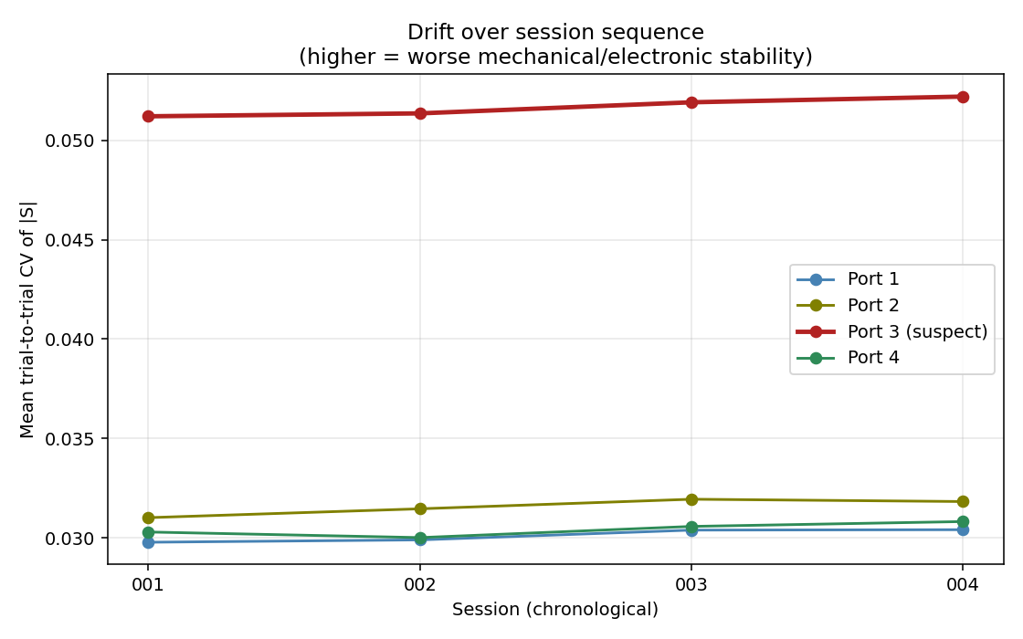
Fig. 1. Per-port trial-to-trial coefficient of variation across the four back-to-back empty-phantom batch sessions. Port 3 shows a consistent 1.68 times elevation over ports 1, 2, and 4 in every session, later diagnosed as mechanical antenna instability caused by adhesive tape losing contact.
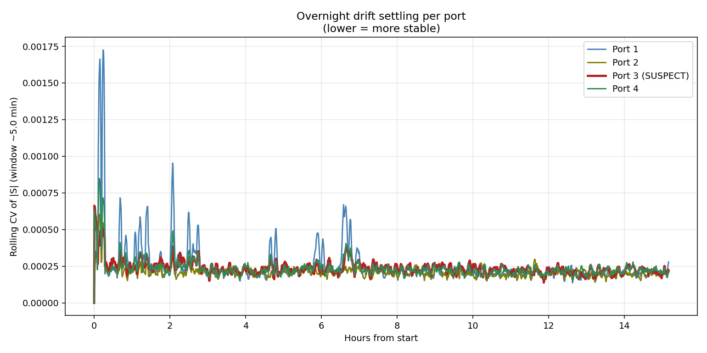
Fig. 2. Rolling coefficient of variation of band-averaged |S| per port across 15 hours of continuous overnight sweeping. All ports show short-term settling within approximately 17 minutes. Port 3 shows a long tail of mechanical drift persisting nine hours before finally decaying to the same asymptote as the other ports.
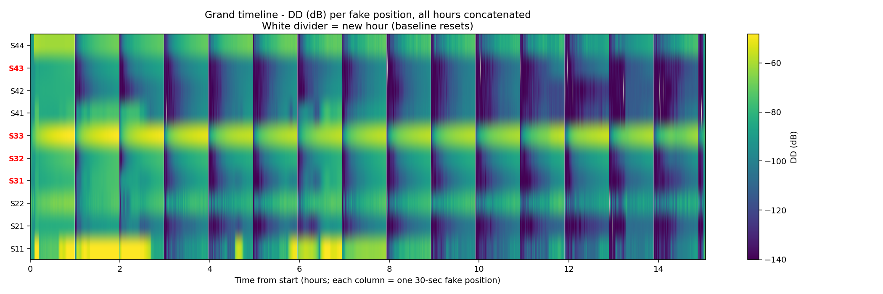
Fig. 3. Synthetic-positions detectable difference in dB across the full 15-hour overnight run. Each column represents one 30-second window treated as a fake "position" and compared against a 30-second baseline at the start of each hour. Vertical white lines mark hour boundaries. S-parameters involving port 3 (S13, S23, S33, S34, S43, shown in red on the left axis) show elevated DD for the first nine hours; other S-parameters settle to background within one hour.
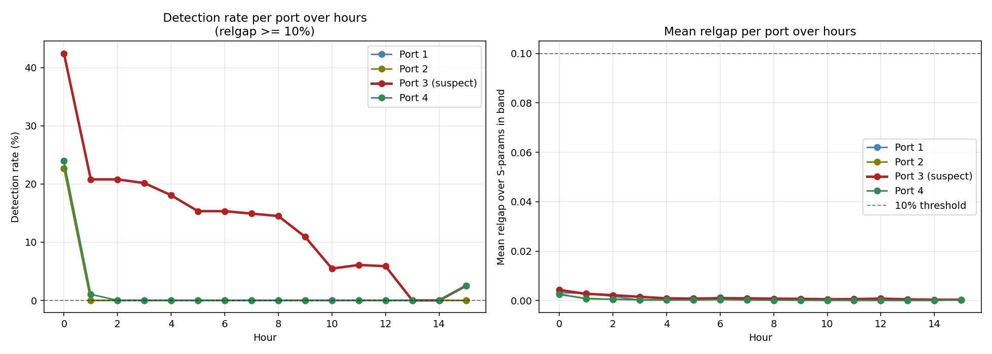
Fig. 4. Left: detection rate per port over the overnight run (fake positions where relative CI-band gap exceeds 10%). Right: mean relative CI-band gap per port over hours, with the 10% detection threshold shown as a dashed reference line. Post-warmup, ports 1, 2, and 4 remain below the threshold; port 3 persistently violates it due to mechanical drift.
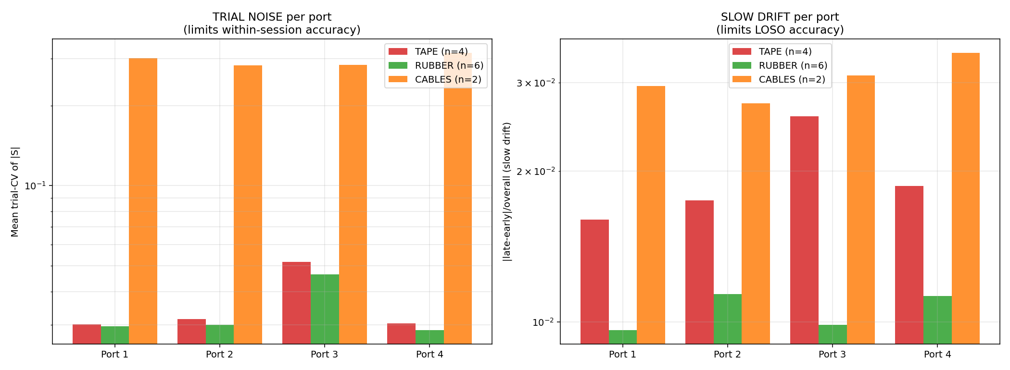
Fig. 5. Trial-CV (left) and slow drift (right) per port under three mount conditions: tape (n=4 sessions), rubber band (n=6 sessions), and cables-only with no antennas (n=2 sessions). Log y-axis. Rubber-band mount reduces trial-CV on the compromised port 3 by 10% and slow drift on the same port by 88% relative to tape, showing that mechanical stability primarily affects slow drift rather than trial noise. Cables-only trial-CV values include open-ended transmission channels and are not directly comparable across the antenna conditions.
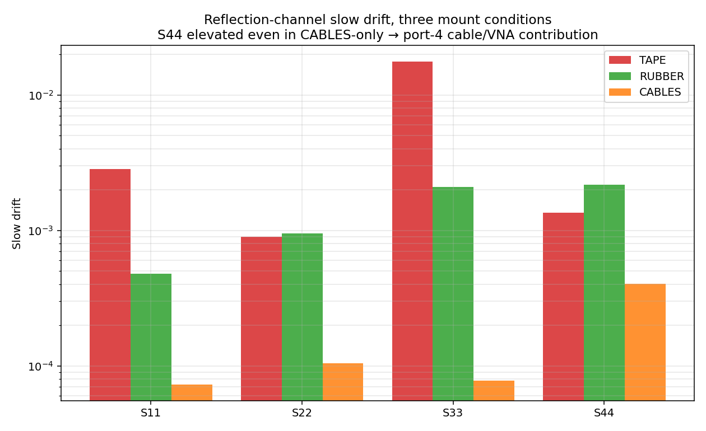
Fig. 6. Reflection-channel slow drift (S11, S22, S33, S44) under the three mount conditions. Log y-axis. S33 is dramatically improved by the rubber-band mount, confirming the tape-mount hypothesis for port 3. S44 shows a small but consistent elevation (4.7 times the mean of the other three reflection channels) in the cables-only case, localizing a residual drift contribution to the port-4 cable, connector, or VNA channel independent of the antenna.
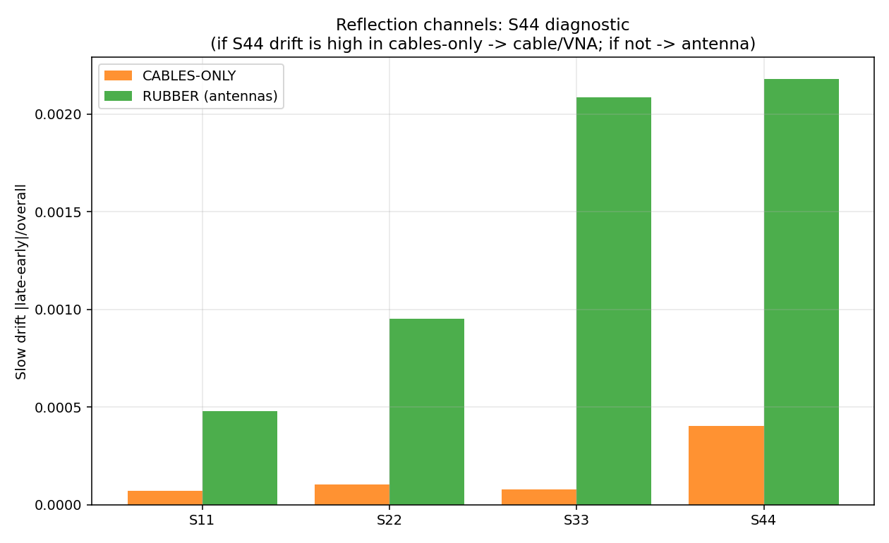
Fig. 7. Focused S44 diagnostic: slow drift of the four reflection channels under two mount conditions (cables-only vs rubber-band with antennas attached). Approximately 18% of the S44 slow drift under normal operating conditions is contributed by the cable and VNA channel; the remaining approximately 82% is contributed by the antenna itself.

Peter Martin received the A.S. degrees in business and general studies from Salt Lake Community College, Salt Lake City, in 2022, and is currently pursuing the B.S. degree in electrical engineering at the University of Utah, where he is an undergraduate research assistant in the Department of Electrical and Computer Engineering. His research focuses on microwave breast tumor imaging, specifically the use of machine learning for tumor localization and the characterization of drift in microwave measurement chains.
Cynthia M. Furse (M'85, SM'99, F'08) is a Distinguished Professor of Electrical and Computer Engineering at the University of Utah. She applies EM to sensing and communication in complex lossy media. She is a Fellow of the IEEE, the National Academy of Inventors, and the Applied Computational Electromagnetics Society, and has received numerous teaching and research awards including the 2020 IEEE Chen To Tai Distinguished Educator Award and the 2025 Harrington-Mittra Award in Computational EM.

