Weak prompts:
a) Regression
A method used to predict a number by finding patterns between variables.
b) SQL
A language used to get and manage data in a database.
c) Dataset
A table of organized data with rows and columns.
Improved Prompt:
a) Explain regression
Regression is a way to find the relationship between variables. It helps you see how one thing changes when another thing changes. In data analysis, people often use regression to predict a number, like sales, income, or test scores. For example, regression could help predict how much a house might cost based on its size. It looks at patterns in past data and uses them to estimate future values.
b) Help me understand SQL
SQL stands for Structured Query Language. People use SQL to work with data stored in databases. It helps you view, filter, sort, and update information. For example, you could use SQL to find all customers from Chicago or list products under a certain price. Think of SQL as a way to ask a database questions and get answers.
c) Create a dataset
A dataset is a collection of organized data, usually in rows and columns. Each row is one record, and each column is one type of information. For example, a student dataset might include Name, Age, Grade, and Attendance. Creating a dataset means choosing what information you want to track and putting it into a table format.
Here is a simple example:
Name | Age | Grade | Attendance
Ana | 18 | A | 95%
Luis | 19 | B | 88%
Maya | 18 | A | 92%
If you need, I can also turn these into stronger prompts for your assignment.
way shorter for each
a) Regression
A method used to predict a number by finding patterns between variables.
b) SQL
A language used to get and manage data in a database.
c) Dataset
A table of organized data with rows and columns.
Explain these concepts to me in-depth
Here’s a deeper explanation of each one.
a) Regression
Regression is a method in data analysis and statistics used to study the relationship between variables. Most often, you use regression when you want to predict a number. That number is called the dependent variable, or outcome. The factors used to explain or predict it are called independent variables, or features.
Example:
You want to predict a house price.
The price is the outcome.
Things like square footage, number of bedrooms, and location are the features.
Regression helps answer questions like:
How much does the outcome change when one feature changes?
Which features matter most?
What value should I predict for a new case?
A simple type is linear regression. Linear regression tries to fit a straight line through data points. The idea is to find the line that best represents the pattern in the data.
Example:
If study hours go up, test scores might also go up.
Regression tries to model that pattern with an equation.
A basic equation looks like this:
y = mx + b
y = predicted result
x = input variable
m = slope, or how much y changes when x changes
b = starting point
In real data work, regression often uses more than one variable:
Price = size + bedrooms + age of house + location
Why regression matters:
It helps with prediction
It helps you measure impact
It helps you understand relationships in data
Common business uses:
Predicting sales
Forecasting costs
Estimating employee performance metrics
Predicting customer spending
Estimating delivery time
Important point:
Regression works best when you are predicting a continuous number, such as revenue, temperature, or salary. If you are predicting categories like yes or no, approved or denied, you usually use classification instead.
b) SQL
SQL stands for Structured Query Language. SQL is the standard language people use to interact with relational databases. A database stores organized information in tables.
Think of a table like a spreadsheet:
Rows = records
Columns = fields
Example customer table:
CustomerID | Name | City
1 | Ana | Chicago
2 | Luis | Dallas
3 | Maya | Chicago
SQL lets you ask the database questions and work with the data inside it.
The main things SQL helps you do:
Retrieve data
Filter data
Sort data
Combine data from multiple tables
Add new data
Update existing data
Delete data
Common SQL commands:
SELECT
Used to choose which data you want to see.
Example:
SELECT Name, City FROM Customers
This returns the Name and City columns from the Customers table.
WHERE
Used to filter rows.
Example:
SELECT Name FROM Customers WHERE City = 'Chicago'
This shows only customers in Chicago.
ORDER BY
Used to sort results.
Example:
SELECT Name, Age FROM Customers ORDER BY Age DESC
This sorts from oldest to youngest.
GROUP BY
Used to summarize data.
Example:
SELECT City, COUNT(*) FROM Customers GROUP BY City
This counts how many customers are in each city.
JOIN
Used to combine tables based on a shared field.
Example:
You have one table for customers and another for orders.
A JOIN lets you connect them to see which customer placed which order.
Why SQL matters:
Most companies store data in databases
Analysts use SQL to pull data for reports and dashboards
SQL helps clean, filter, and organize data before analysis
Simple real-world example:
A manager asks,
“How many orders did we get last month from customers in Chicago?”
SQL helps you answer that by pulling the right records, filtering by date and city, and counting the results.
Why SQL is important for data analysts:
You often do not get perfect data handed to you
You need to pull your own data
You need to combine tables
You need to check accuracy before building charts or reports
c) Dataset
A dataset is a collection of related data organized for analysis. Most datasets are arranged in rows and columns.
Rows usually represent individual records.
Columns usually represent variables or attributes.
Example student dataset:
Name | Age | Grade | Attendance
Ana | 18 | A | 95
Luis | 19 | B | 88
Maya | 18 | A | 92
In this dataset:
Each row is one student
Each column tells you one thing about the student
Datasets can be small or huge.
A small dataset might have 10 rows.
A company dataset might have millions of rows.
Types of data in a dataset:
Numerical data
Examples: age, salary, sales
Categorical data
Examples: city, department, product type
Date or time data
Examples: order date, hire date
Text data
Examples: comments, product descriptions
A good dataset should be:
Organized
Consistent
Accurate
Relevant to the question you want to answer
Why datasets matter:
A dataset is the foundation of analysis
If the dataset is messy, incomplete, or wrong, your results will be weak
Common dataset problems:
Missing values
Duplicate rows
Inconsistent formatting
Wrong data types
Spelling differences like “Chicago” and “chicago”
Outliers or unusual values
Creating a dataset means deciding:
What information you need
What each column should represent
How each row should be recorded
How to keep the data clean and consistent
Example:
If you are tracking course performance, your dataset might include:
Course Name
Enrollment Count
Average Rating
Instructor Name
Completion Rate
Then each row would represent one course.
How all three connect
These three ideas often work together in data analysis.
First, you have a dataset.
Then, you use SQL to pull or organize the dataset from a database.
After that, you might use regression to analyze the data and predict outcomes.
Example workflow:
A company has sales data stored in a database.
You use SQL to pull sales, region, and ad spend data.
That becomes your dataset.
Then you use regression to see whether ad spend helps predict sales.
Simple way to remember them:
Dataset = the data
SQL = the tool to get and manage the data
Regression = the method to analyze and predict with the data
Here’s one quick example using all three:
You work for an online course company.
Your dataset includes:
Course Name
Enrollment Count
Average Rating
Price
You use SQL to pull the table from the database.
Then you use regression to see whether rating and price help predict enrollment.
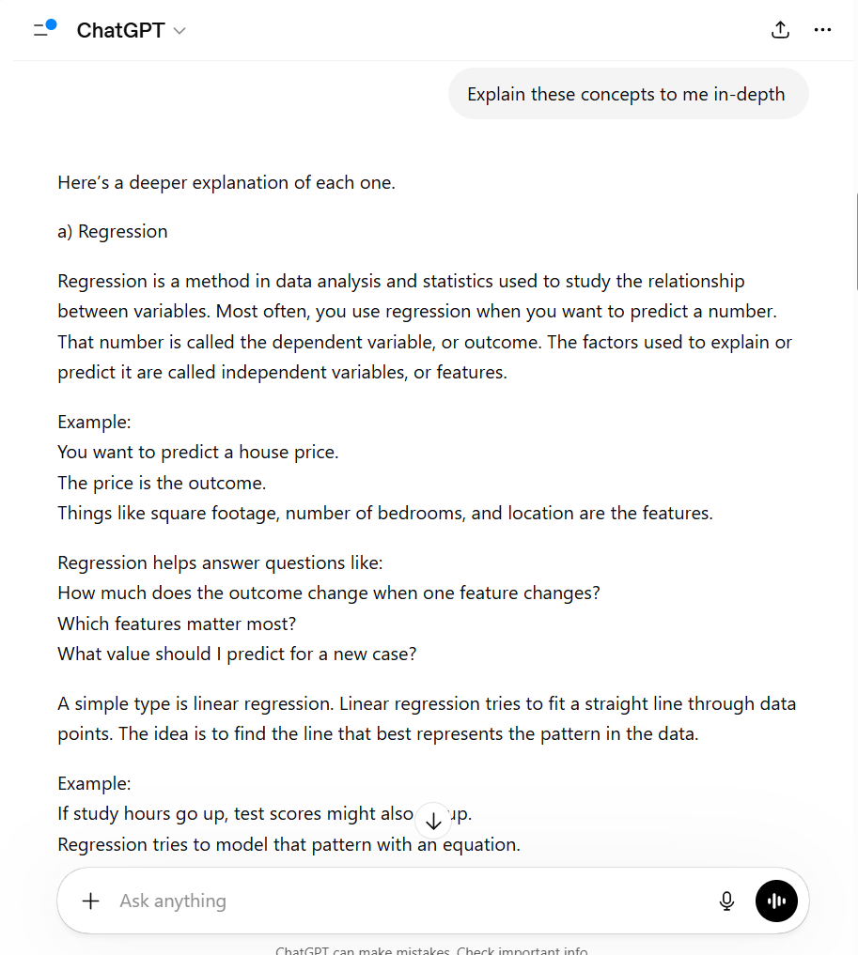
Why this revision is better:
These notes are more detailed and offer examples for each concept for easy understanding.

