**SOME TYPES OF EXERCISES COMBINED ER MODEL AND SQL**

**Lesson 1:**

A system to be managed:

• Information about the Teacher includes: TID (teacher code), TName (teacher's full name, a string of no more than 30 characters), YoB (year of birth, an integer), Address (address where the teacher is living, which is a string of no more than 50 characters).

• Information about the Project includes: PID (project code), PName (project name, is a string of no more than 50 characters), Category (category of the project, is a string of no more than 20 characters) .

• Student information includes: SID# (student code), SName (student name, which is a string of no more than 30 characters), YoB (student's date of birth), Hometown (hometown, a string of no more than 20 characters), Class (the class the student takes, is a string of no more than 20 characters).

• Information on the Guide includes: TID, PID, SID, Year (the year when the student does the project with the teacher, is an integer), Mark (given on a 10-point scale, perhaps up to 0.5). In a year, each student only works on one project under the guidance of one or more teachers.

Requirements:

1. Draw an entity-relationchip diagram with the information given above, then transfer to the relational model.

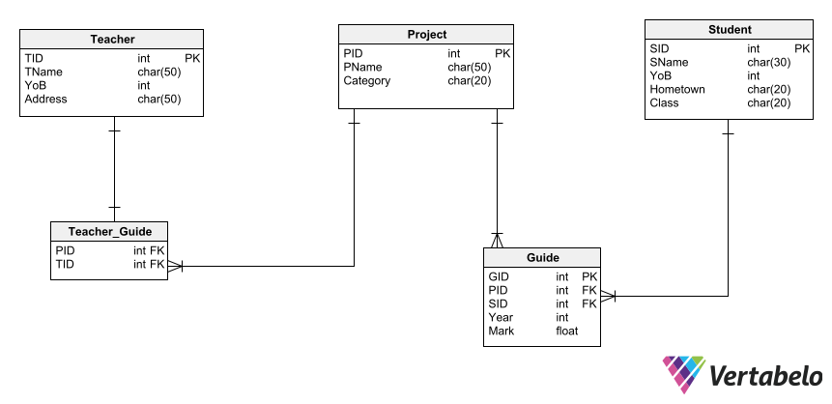

Teacher(TID, TName, YoB, Address)

Project(PID, PName, Category)

Student(SID, Sname, YoB, Hometown, Class)

Guide(TID, PID, SID, Year, Mark)

2) Use SQL data definition language to create the tables obtained in step 1. Notice to identify all primary key and foreign key constraints.

3) Use the SQL data manipulation language to express the following queries:

a. Gives information about the teacher whose code is "IT001".

b. Indicate how many projects are in the "Apps" category.

c. Tell me how many students whose hometown is "Hai Phong" working with the teacher with the code "IT012".

d. Indicate the name of the project that no student joins in.

e. Due to negligence, the information on the date of birth of the student named "Nguyen Xuan Dung", hometown "Ha Nam" was entered incorrectly. The exact date of birth is "November 12, 1991". Please update this information.

f. For objective reasons, student "Le Van Luyen" whose hometown "Bac Giang" has withdrawn from school. Please delete all information related to this student.

**Lesson 2:**

Suppose you need to build an information management application for a football club with the following description:

• Information about the club's players includes: Player's name, date of birth, player's shirt number, awards. Each player/ footballer can participate in different matches. Information about the position of the footballer, number of yellow cards, number of red cards of each footballer in each match is specified. Information in each match includes: Match number, date and time, opponent, pitch, number of goals, number of goals conceded. Each match belongs to a certain league. Tournament information includes: Code, tournament name, year, other detailed description.

• Each match has a captain (assume that the captain does not change during the match).

• The club also has regular sponsors. Sponsor information needs to be managed: Sponsor's name, address. Sponsors can support the club in each league. Information on the amount of each sponsor's tournament sponsorship is specified.

Requirements:

1) Draw entity - relationship diagram to model data for the above problem.

2) Design a relational database for the above problem.