Final Report
Vu Tuan Minh – 20194805
Dao Duc manh - 20194794
- Abstraction
Currently, the demand for medical examination and treatment and health examination of people is increasing. Moreover, the development of medicine provides more and more different medical services. This increases the need for information storage in the medical field. That's why we chose this database design.
Each patient when going to the hospital needs to provide personal information (name, age,gender, address, email, insurance, phone number, ). Then, they need to choose one or more available medical packages. Each medical examination package including necessary services, each service is responsible by a doctor. After signing up for the package, the patient will receive an appointment card that includes information about the examination location for each service in the package, and wait for their turn. When each service is completed, the doctor is responsible for the results of the examination, diagnosis and prescription for each service. Finally, all examination results, diagnoses, prescriptions of each service will be summed up by a doctor assigned with that visit and given advice, results, diagnosis, and final prescription. On that basis, the system calculates the remaining hospital fees and debts of each patient in each visit. Patients after receiving medical examination information from the hospital can send feedback related to examination time, doctor's attitude, drug prices, quality of services provided,... Then, the patient pays the hospital fee. The medical examination is over.
- Describe the real problem
- Any patient go to the hospital will take these step:
  - Patient go to the hospital, providing personal info (including name, gender, dob, address, insurance, email,symptoms).
  - Patient will select the package (including many services) according to their symptom, and then he/she made a visit to take all test in the service.
  - After taking the test, patient receive a final form consist of all-test’s diagnostic, advice and drug.
  - Moreover, patient will receive the bill contain all their fee( including service fee and drug fee, insurance may lower the cost).
  - After receive all thing they need, patient have to fill in the feedback form about the service’s quality. After that, the service process end.
  - Final form is created by summing all the test record, drug (inserted by doctor) of the visit, and the advice (inserted by doctor).
  - One service is placed in only one room, one doctor only do the test for only one service, but one service can be done by many doctor (for many patients).
  - To prevent the overdose, the doctor responsible for final form must consider the duplicate drugs.
  - Patient have insurance will have 50% discount in drug fee.
- User of this database:
  - Doctor. (agent)
  - Patient. (agent)
    - We only consider all the info and relation occur at the hospital.
- Aim:
  - Help the doctor managing patient info, service providing, drugs using.
  - Help the patient manage their test history and service fee.
- Design a database
2.1. Design model: Top-down
* Reason:
+ Since we want create a physical database design from objects modeled at a logical level, so we apply the top-down approaching.
2.2.Analyze entities and attributes
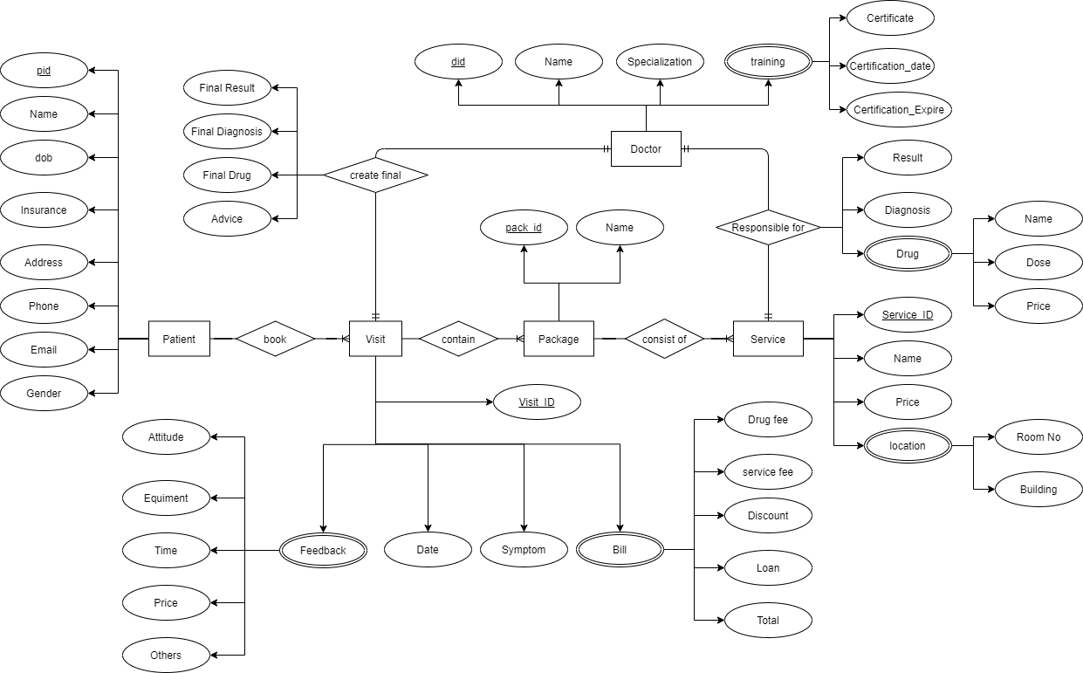

+ Patient (pid, visit_id, patient_name, dob, gender, phone, insurance, email, address)
+ Visit (pid, visit_id, visit_date, symptom)
+ Feedback (visit_id, attitude, equipment, test_time, price, other)
+ Bill (visit_id, total_cost, discount, loan, drug_fee, service_fee)
+ Package (visit_id, pack_id, package_name)
+ Service (visit_id, pack_id, service_id, service_name, price)
+ Location (service_id, room_id, building)
+ Test (did, visit_id, pack_id, service_id, test_result, diagnosis)
+ Drug (did, visit_id, pack_id, service_id, drug_name, dose, price)
+ Doctor (did, service_id, doctor_name, specialization)
+ Training (did, certificate, certification_date, certification_expire)
+ Final_form (visit_id, did, final_result, final_diagnosis, final_drug, advice)
* Meaning of the attributes:
+ pid: patient ID
+ dob: date of birth
+ did: doctor ID
+ equipment: rate of patient about the amenities
+ attitude: rate of patient about how the staff work
+ price: rate of patient about cost of all services
+test_time: what patient think about waiting time or time spent for all test.
+other: any complain about the aspect out of those above.
2.3 The value
+ gender only receive two values “M” for male and “F” for female.
+ health_insurance only receive two values “Y” for yes and “N” for no.
+ package and service:

Pack_id: pack1  Pack_name: Kham ngoai 1 | Pack_id: pack2  Pack_name: Kham mat | Pack_id: pack3  Pack_name: Kham ngoai 1 | Pack_id: pack4  Pack_name: Tim mach
Service_id: TMH1  Service_name: Kham tai | Service_id: M1  Service_name: Do thi luc | Service_id: CXK  Service_name:Co xuong khop | Service_id: TM1  Service_name: Dien tim
Service_id: TMH2  Service_name: Kham mui | Service_id: M2  Service_name: Sieu am nhan cau | Service_id: DL  Service_name: Da lieu | Service_id: TM2  Service_name: X-quang
Service_id: TMH3  Service_name: Kham hong |  |  | Service_id: TM3  Service_name: Xet nghiem mau
Service_id: RHM
Service_name: Kham rang ham mat

+ Total price = (service fee) + (drug fee)
+ Service fee = sum of service price
+ drug fee = sum of drug price
+ Discount = 50% drug fee
+ Loan = total price - discount
2.4 Relation model
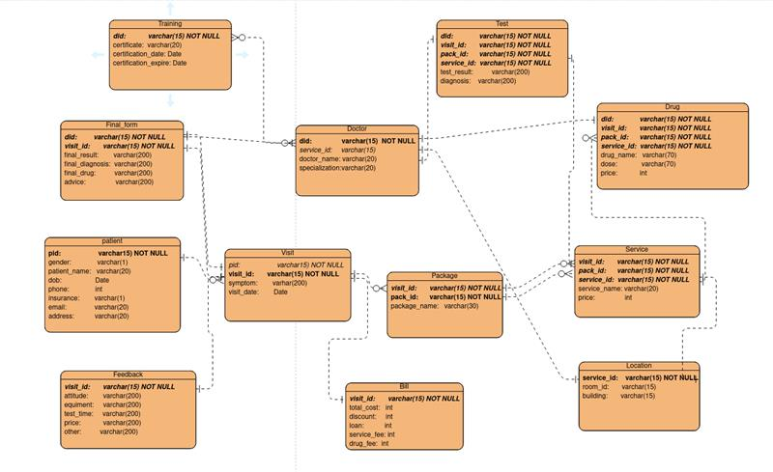
2.5 Function
We find out the relation between the input and the output of the system that can brings the convenient for both patients and doctors, who directly use this database.
+ In the view of patient
- Find the information of user follow his/her full name
- Find the information of user follow a part of his/her name
- Find the final result for each time he/she visits hospital → Profile of a patient
- Find the bill(total_cost, discount, loan) for each time he/she visits
+ In the view of doctor
- Find all patient who he/she has tested
- Find all the patient tested in the same day
+ In the view of system
- Compute drug fee for each patient all the time he/she visits
- Compute service fee for each patient all the time he/she visits
- Update total_cost for each patient all the time he/she visits
- Update discount for each patient all the time he/she visits
- Update loan for each patient all the time he/she visits

2.6 Contribution
All these database design and function created is our group’s team work, so we won’t separate the contribution, we divide every work equally.

