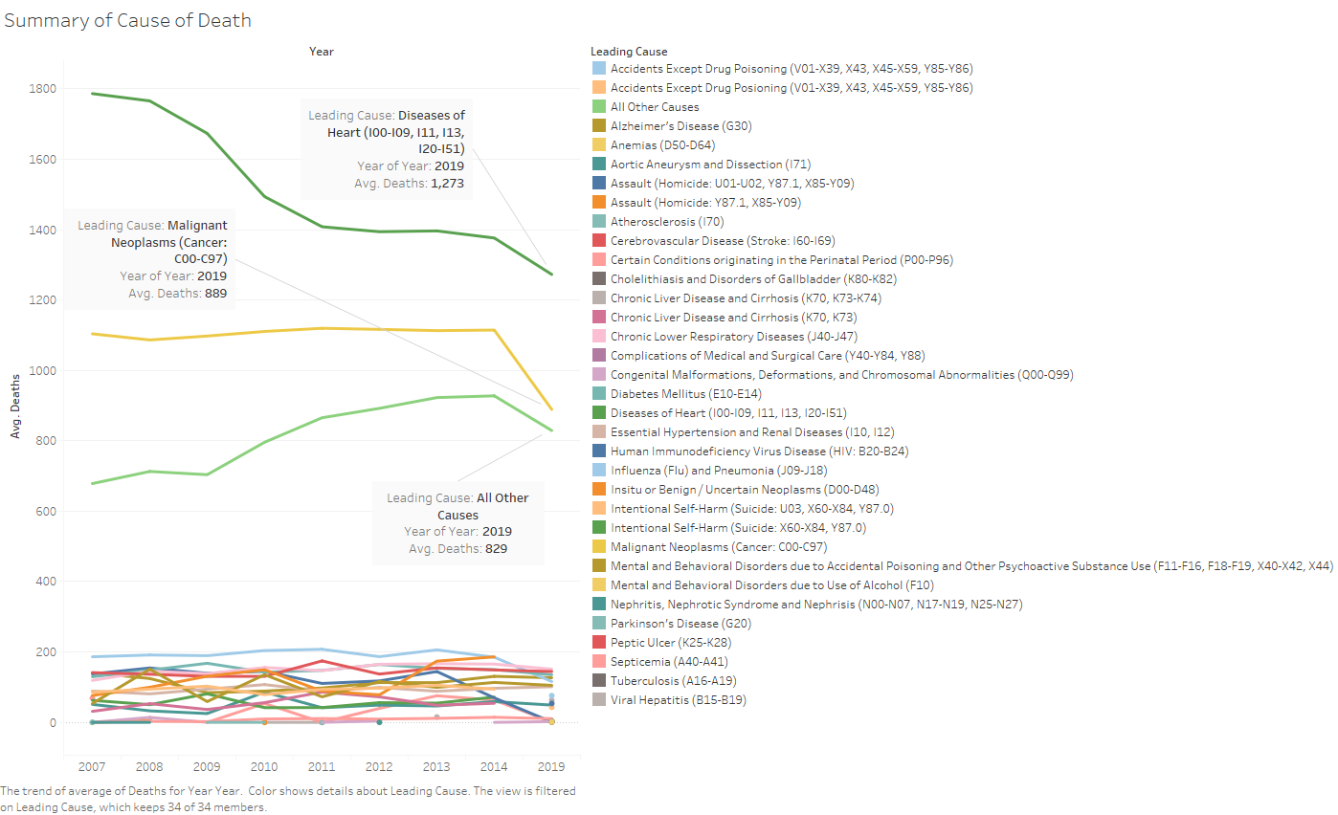

For this chart, I kept all leading causes of death to show that even over time heart disease was the number one cause. This is combined female and male descendance. Most of the other causes do not come close.

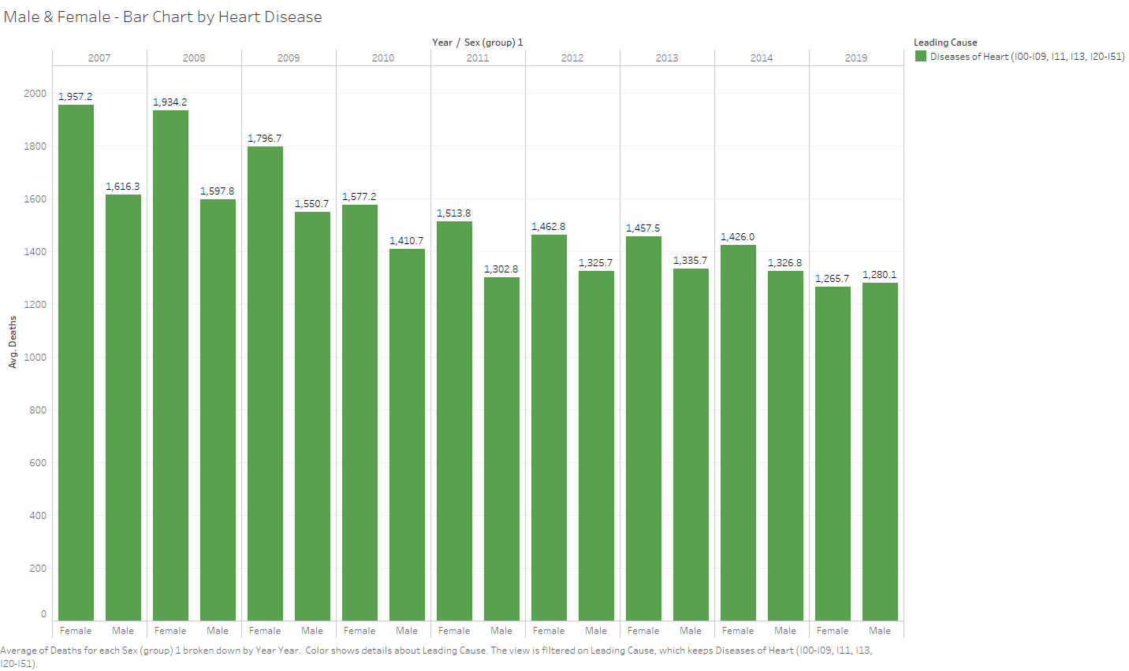

Comparison Male vs Female Deaths from Heart Disease. We can see a decline of almost 700 from this disease.