Outputs for the given 7 inputs
Input 1:
b1;
r1 (Y);
w1 (Y);
r1 (Z);
b2;
r2 (X);
w2 (X);
w1 (Z);
e1;
r2 (Y);
b3;
r3 (Z);
w3 (Z);
w2 (Y);
e2;
b4;
w4 (Y);
r3 (X);
w3 (X);
e3;
w4 (X);
e4;

Output1:

Executing b1;

Changes in Tables: New transaction is added to the transaction table with Transaction ID: 1

Executing r1 (Y);

Changes in Tables: Added item_id entry into lock table, Lock Status is updated to 'Read Lock', The item Y for transaction 1 is newly added into lock table and also added the item to transaction table in corresponding transaction

Executing w1 (Y);

Changes in Tables: The item Y's lock status for transaction 1 is upgraded from 'Read Lock' to 'Write Lock'

Executing r1 (Z);

Changes in Tables: Added item_id entry into lock table, Lock Status is updated to 'Read Lock', The item Z for transaction 1 is newly added into lock table and also added the item to transaction table in corresponding transaction

Executing b2;

Changes in Tables: New transaction is added to the transaction table with Transaction ID: 2

Executing r2 (X);

Changes in Tables: Added item_id entry into lock table, Lock Status is updated to 'Read Lock', The item X for transaction 2 is newly added into lock table and also added the item to transaction table in corresponding transaction

Executing w2 (X);

Changes in Tables: The item X's lock status for transaction 2 is upgraded from 'Read Lock' to 'Write Lock'

Executing w1 (Z);

Changes in Tables: The item Z's lock status for transaction 1 is upgraded from 'Read Lock' to 'Write Lock'

Executing e1;

Changes in Tables: Transaction 1 is committed, and the status is updated to committed. The items to be unlocked: ['Y', 'Z']

Executing r2 (Y);

Changes in Tables: The item Y's lock status for the transaction 2 is downgraded from 'Write lock' to 'Read lock' in the lock table

Executing b3;

Changes in Tables: New transaction is added to the transaction table with Transaction ID: 3

Executing r3 (Z);

Changes in Tables: The item Z's lock status for the transaction 3 is downgraded from 'Write lock' to 'Read lock' in the lock table
Executing w2 (Y);

Changes in Tables: The item Y's lock status for transaction 2 is upgraded from 'Read Lock' to 'Write Lock'

Executing e2;

Changes in Tables: Transaction 2 is committed, and the status is updated to committed. The items to be unlocked: ['X', 'Y']

Executing b4;

Changes in Tables: New transaction is added to the transaction table with Transaction ID: 4

Executing w4 (Y);

Changes in Tables: Blind write happens and the item Y's lock status for transaction 4 is directly set to 'Write Lock'

Executing r3 (X);

Changes in Tables: The item X's lock status for the transaction 3 is downgraded from 'Write lock' to 'Read lock' in the lock table

Executing w3 (X);

Changes in Tables: The item X's lock status for transaction 3 is upgraded from 'Read Lock' to 'Write Lock'

Executing e3;

Changes in Tables: Transaction 3 is committed, and the status is updated to committed. The items to be unlocked: ['Z', 'X']

Executing w4 (X);

Changes in Tables: Blind write happens and the item X's lock status for transaction 4 is directly set to 'Write Lock'

Executing e4;

Changes in Tables: Transaction 4 is committed, and the status is updated to committed. The items to be unlocked: []

Transaction Table:

{'1': {'trans_state': 'committed', 'Timestamp': 1, 'list_of_waitingoperations': [], 'trans_item': [], 'phase': False}, '2': {'trans_state': 'committed', 'Timestamp': 2, 'list_of_waitingoperations': [], 'trans_item': [], 'phase': False}, '3': {'trans_state': 'committed', 'Timestamp': 3, 'list_of_waitingoperations': [], 'trans_item': [], 'phase': False}, '4': {'trans_state': 'committed', 'Timestamp': 4, 'list_of_waitingoperations': [], 'trans_item': [], 'phase': False}}

Lock Table:

{'Y': {'lock_status': 'write_lock', 'locking_transactions': [], 'list_of_transactions_waiting': []}, 'Z': {'lock_status': 'write_lock', 'locking_transactions': [], 'list_of_transactions_waiting': []}, 'X': {'lock_status': 'write_lock', 'locking_transactions': [], 'list_of_transactions_waiting': []}}

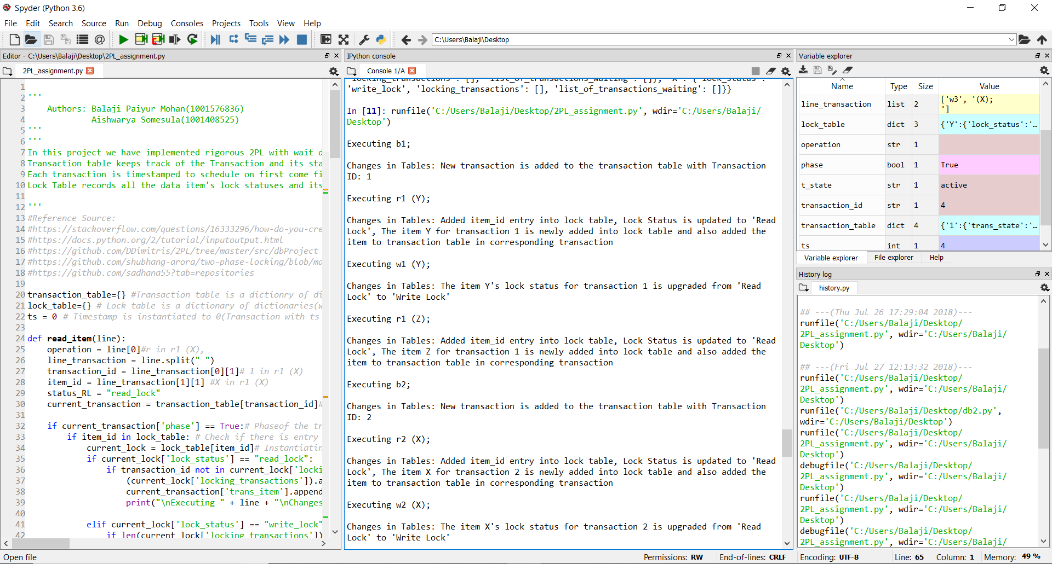
Input 2:
b1;
r1 (Y);
w1 (Y);
r1 (Z);
b2;
r2 (X);
w2 (X);
w1 (Z);
r2 (Y);
e1;
b3;
r3 (Z);
w3 (Z);
w2 (Y);
e2;
r3 (X);
w3 (X);
b4;
w4 (X);
e3;
e4;

Output2:

Executing b1;

Changes in Tables: New transaction is added to the transaction table with Transaction ID: 1

Executing r1 (Y);

Changes in Tables: Added item_id entry into lock table, Lock Status is updated to 'Read Lock', The item Y for transaction 1 is newly added into lock table and also added the item to transaction table in corresponding transaction

Executing w1 (Y);

Changes in Tables: The item Y's lock status for transaction 1 is upgraded from 'Read Lock' to 'Write Lock'

Executing r1 (Z);

Changes in Tables: Added item_id entry into lock table, Lock Status is updated to 'Read Lock', The item Z for transaction 1 is newly added into lock table and also added the item to transaction table in corresponding transaction

Executing b2;

Changes in Tables: New transaction is added to the transaction table with Transaction ID: 2

Executing r2 (X);

Changes in Tables: Added item_id entry into lock table, Lock Status is updated to 'Read Lock', The item X for transaction 2 is newly added into lock table and also added the item to transaction table in corresponding transaction

Executing w2 (X);

Changes in Tables: The item X's lock status for transaction 2 is upgraded from 'Read Lock' to 'Write Lock'

Executing w1 (Z);

Changes in Tables: The item Z's lock status for transaction 1 is upgraded from 'Read Lock' to 'Write Lock'

Executing r2 (Y);

Changes in Tables: Transaction 2 is aborted, and the subsequent operations are disregarded

Executing e1;

Changes in Tables: Transaction 1 is committed, and the status is updated to committed. The items to be unlocked: ['Y', 'Z']

Executing b3;

Changes in Tables: New transaction is added to the transaction table with Transaction ID: 3

Executing r3 (Z);

Changes in Tables: The item Z's lock status for the transaction 3 is downgraded from 'Write lock' to 'Read lock' in the lock table

Executing w3 (Z);

Changes in Tables: The item Z's lock status for transaction 3 is upgraded from 'Read Lock' to 'Write Lock'

Executing w2 (Y);

Changes in Tables: transaction 2 is already aborted, and the status is updated to aborted

Executing e2;

Changes in Tables: Transaction 2 is already aborted, its current Transaction state is: aborted

Executing r3 (X);

Changes in Tables: The item X's lock status for the transaction 3 is downgraded from 'Write lock' to 'Read lock' in the lock table

Executing w3 (X);

Changes in Tables: The item X's lock status for transaction 3 is upgraded from 'Read Lock' to 'Write Lock'

Executing b4;

Changes in Tables: New transaction is added to the transaction table with Transaction ID: 4

Executing w4 (X);

Changes in Tables: Transaction 4 is aborted, and the subsequent operations are disregarded

Executing e3;

Changes in Tables: Transaction 3 is committed, and the status is updated to committed. The items to be unlocked: ['Z', 'X']

Executing e4;

Changes in Tables: Transaction 4 is already aborted, its current Transaction state is: aborted
Transaction Table:

{'1': {'trans_state': 'committed', 'Timestamp': 1, 'list_of_waitingoperations': [], 'trans_item': [], 'phase': False}, '2': {'trans_state': 'aborted', 'Timestamp': 2, 'list_of_waitingoperations': [], 'trans_item': [], 'phase': False}, '3': {'trans_state': 'committed', 'Timestamp': 3, 'list_of_waitingoperations': [], 'trans_item': [], 'phase': False}, '4': {'trans_state': 'aborted', 'Timestamp': 4, 'list_of_waitingoperations': [], 'trans_item': [], 'phase': False}}

Lock Table:

{'Y': {'lock_status': 'write_lock', 'locking_transactions': [], 'list_of_transactions_waiting': []}, 'Z': {'lock_status': 'write_lock', 'locking_transactions': [], 'list_of_transactions_waiting': []}, 'X': {'lock_status': 'write_lock', 'locking_transactions': [], 'list_of_transactions_waiting': []}}

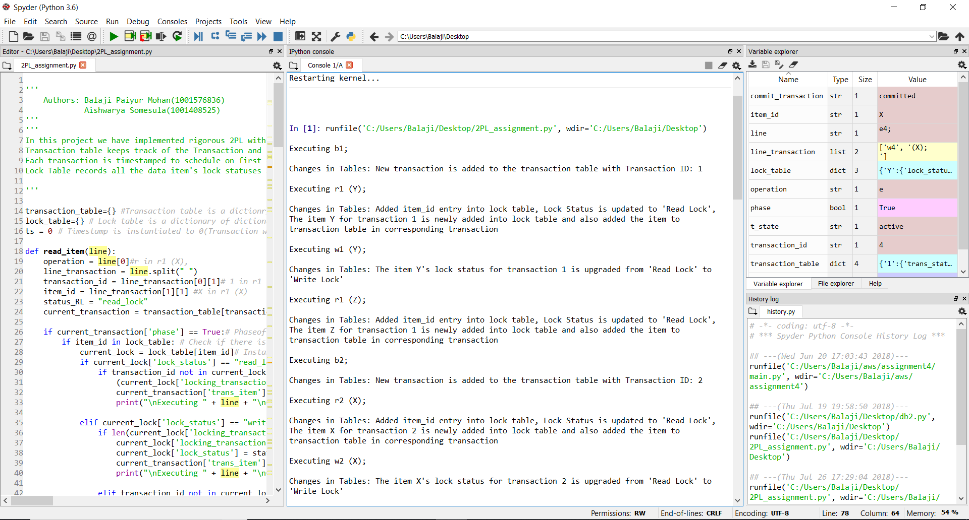
Input 3:
b1;
r1 (Y);
w1 (Y);
r1 (Z);
b2;
r2 (X);
w2 (X);
w1 (Z);
r2 (Y);
e1;
b3;
r3 (Z);
w3 (Z);
w2 (Y);
e2;
b4;
w4(X);
r3 (X);
e4;
w3 (X);
e3;

Output3:

Executing b1;

Changes in Tables: New transaction is added to the transaction table with Transaction ID: 1

Executing r1 (Y);

Changes in Tables: Added item_id entry into lock table, Lock Status is updated to 'Read Lock', The item Y for transaction 1 is newly added into lock table and also added the item to transaction table in corresponding transaction

Executing w1 (Y);

Changes in Tables: The item Y's lock status for transaction 1 is upgraded from 'Read Lock' to 'Write Lock'

Executing r1 (Z);

Changes in Tables: Added item_id entry into lock table, Lock Status is updated to 'Read Lock', The item Z for transaction 1 is newly added into lock table and also added the item to transaction table in corresponding transaction

Executing b2;

Changes in Tables: New transaction is added to the transaction table with Transaction ID: 2

Executing r2 (X);

Changes in Tables: Added item_id entry into lock table, Lock Status is updated to 'Read Lock', The item X for transaction 2 is newly added into lock table and also added the item to transaction table in corresponding transaction

Executing w2 (X);

Changes in Tables: The item X's lock status for transaction 2 is upgraded from 'Read Lock' to 'Write Lock'

Executing w1 (Z);

Changes in Tables: The item Z's lock status for transaction 1 is upgraded from 'Read Lock' to 'Write Lock'

Executing r2 (Y);

Changes in Tables: Transaction 2 is aborted, and the subsequent operations are disregarded

Executing e1;

Changes in Tables: Transaction 1 is committed, and the status is updated to committed. The items to be unlocked: ['Y', 'Z']

Executing b3;

Changes in Tables: New transaction is added to the transaction table with Transaction ID: 3

Executing r3 (Z);

Changes in Tables: The item Z's lock status for the transaction 3 is downgraded from 'Write lock' to 'Read lock' in the lock table

Executing w3 (Z);

Changes in Tables: The item Z's lock status for transaction 3 is upgraded from 'Read Lock' to 'Write Lock'

Executing w2 (Y);

Changes in Tables: transaction 2 is already aborted, and the status is updated to aborted

Executing e2;

Changes in Tables: Transaction 2 is already aborted, its current Transaction state is: aborted

Executing b4;

Changes in Tables: New transaction is added to the transaction table with Transaction ID: 4

Executing w4 (X);

Changes in Tables: Blind write happens and the item X's lock status for transaction 4 is directly set to 'Write Lock'

Executing r3 (X);

Changes in Tables: The item X's lock status for the transaction 3 is downgraded from 'Write lock' to 'Read lock' in the lock table

Executing e4;

Changes in Tables: Transaction 4 is committed, and the status is updated to committed. The items to be unlocked: []

Executing w3 (X);

Changes in Tables: The item X's lock status for transaction 3 is upgraded from 'Read Lock' to 'Write Lock'

Executing e3;

Changes in Tables: Transaction 3 is committed, and the status is updated to committed. The items to be unlocked: ['Z', 'X']

Transaction Table:

{'1': {'trans_state': 'committed', 'Timestamp': 1, 'list_of_waitingoperations': [], 'trans_item': [], 'phase': False}, '2': {'trans_state': 'aborted', 'Timestamp': 2, 'list_of_waitingoperations': [], 'trans_item': [], 'phase': False}, '3': {'trans_state': 'committed', 'Timestamp': 3, 'list_of_waitingoperations': [], 'trans_item': [], 'phase': False}, '4': {'trans_state': 'committed', 'Timestamp': 4, 'list_of_waitingoperations': [], 'trans_item': [], 'phase': False}}

Lock Table:

{'Y': {'lock_status': 'write_lock', 'locking_transactions': [], 'list_of_transactions_waiting': []}, 'Z': {'lock_status': 'write_lock', 'locking_transactions': [], 'list_of_transactions_waiting': []}, 'X': {'lock_status': 'write_lock', 'locking_transactions': [], 'list_of_transactions_waiting': []}}

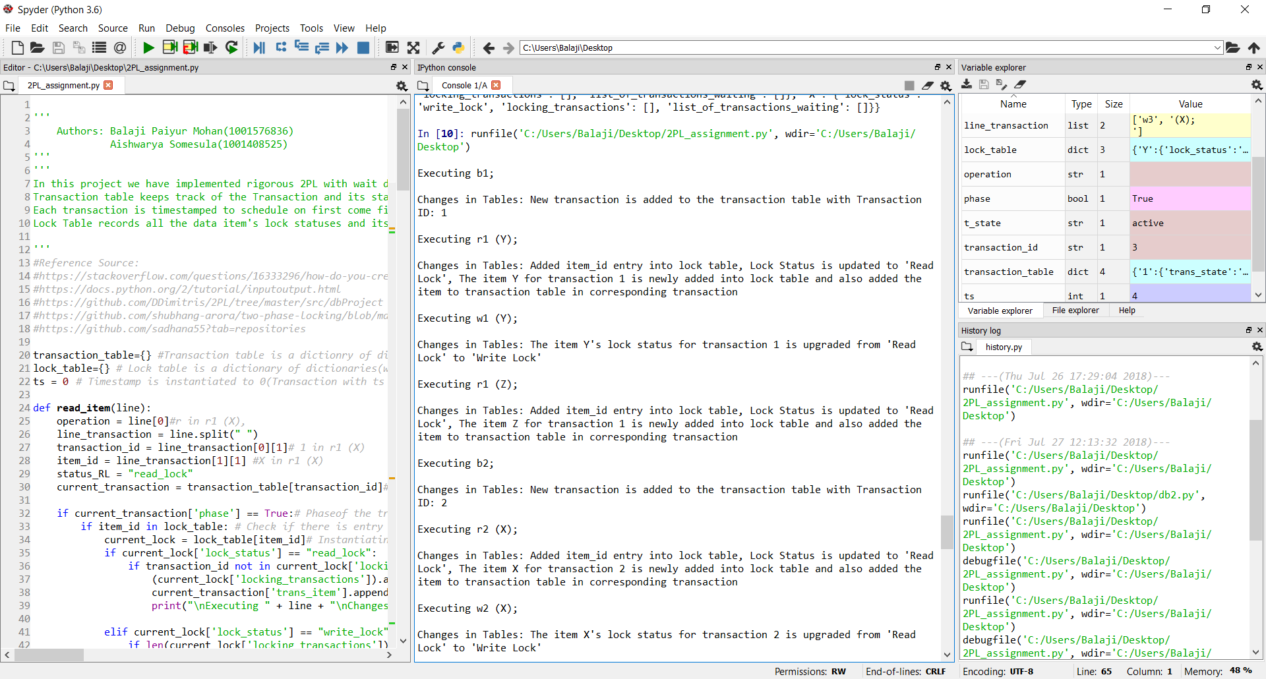
Input 4:
b1;
r1 (Z);
b2;
r2 (X);
w2 (X);
w1 (Z);
r2 (Y);
r1 (Y);
w1 (Y);
b3;
r3 (Z);
e1;
w3 (Z);
w2 (Y);
e2;
r3 (X);
w3 (X);
e3;

Output4:
Executing b1;

Changes in Tables: New transaction is added to the transaction table with Transaction ID: 1

Executing r1 (Z);

Changes in Tables: Added item_id entry into lock table, Lock Status is updated to 'Read Lock', The item Z for transaction 1 is newly added into lock table and also added the item to transaction table in corresponding transaction

Executing b2;

Changes in Tables: New transaction is added to the transaction table with Transaction ID: 2

Executing r2 (X);

Changes in Tables: Added item_id entry into lock table, Lock Status is updated to 'Read Lock', The item X for transaction 2 is newly added into lock table and also added the item to transaction table in corresponding transaction

Executing w2 (X);

Changes in Tables: The item X's lock status for transaction 2 is upgraded from 'Read Lock' to 'Write Lock'

Executing w1 (Z);

Changes in Tables: The item Z's lock status for transaction 1 is upgraded from 'Read Lock' to 'Write Lock'

Executing r2 (Y);

Changes in Tables: Added item_id entry into lock table, Lock Status is updated to 'Read Lock', The item Y for transaction 2 is newly added into lock table and also added the item to transaction table in corresponding transaction

Executing r1 (Y);

Changes in Tables: The item Y's lock status for the transaction 1 is updated to Read lock again in the lock table

Executing w1 (Y);

Changes in Tables: Found multiple read locks on the item Yfor this transaction 1. The operations on the transactions are performed based on the result of wait-die protocol.

Executing w1 (Y);

Changes in Tables: Transaction 1 is blocked, and it's being added to list of waiting operations : [{'operation': 'w', 'item_id': 'Y'}]

Executing b3;

Changes in Tables: New transaction is added to the transaction table with Transaction ID: 3

Executing r3 (Z);

Changes in Tables: Transaction 3 is aborted, and the subsequent operations are disregarded

Executing e1;

Changes in Tables: Since Transaction 1 is already blocked, e1 is added to list of waiting operations

Executing w3 (Z);

Changes in Tables: transaction 3 is already aborted, and the status is updated to aborted

Executing w2 (Y);

Changes in Tables: Found multiple read locks on the item Yfor this transaction 2. The operations on the transactions are performed based on the result of wait-die protocol.

Executing w2 (Y);

Changes in Tables: Transaction 2 is aborted, and the subsequent operations are disregarded
e1
Changes in Tables: The Transaction is committed and the next waiting item to be unlocked: ['Z', 'Y']

Executing e2;

Changes in Tables: Transaction 2 is already aborted, its current Transaction state is: aborted

Executing r3 (X);

Changes in Tables: transaction 3 is already aborted, and the status is updated to aborted

Executing w3 (X);

Changes in Tables: transaction 3 is already aborted, and the status is updated to aborted

Executing e3;

Changes in Tables: Transaction 3 is already aborted, its current Transaction state is: aborted

Transaction Table:

{'1': {'trans_state': 'committed', 'Timestamp': 1, 'list_of_waitingoperations': [], 'trans_item': [], 'phase': False}, '2': {'trans_state': 'aborted', 'Timestamp': 2, 'list_of_waitingoperations': [], 'trans_item': [], 'phase': False}, '3': {'trans_state': 'aborted', 'Timestamp': 3, 'list_of_waitingoperations': [], 'trans_item': [], 'phase': False}}

Lock Table:

{'Z': {'lock_status': 'write_lock', 'locking_transactions': [], 'list_of_transactions_waiting': []}, 'X': {'lock_status': 'write_lock', 'locking_transactions': [], 'list_of_transactions_waiting': []}, 'Y': {'lock_status': 'write_lock', 'locking_transactions': [], 'list_of_transactions_waiting': []}}

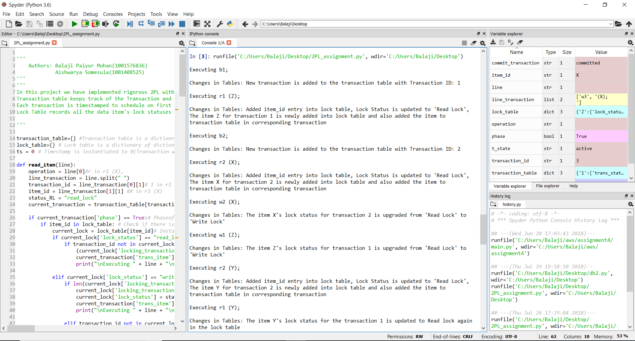

Input 5:
b1;
r1 (Y);
r1 (Z);
b2;
r2 (Y);
b3;
r3 (Y);
w1 (Z);
w3 (Y);
e1;
e3;
w2 (Y);
r2 (X);
w2 (X);
e2;

Output 5:
Executing b1;

Changes in Tables: New transaction is added to the transaction table with Transaction ID: 1

Executing r1 (Y);

Changes in Tables: Added item_id entry into lock table, Lock Status is updated to 'Read Lock', The item Y for transaction 1 is newly added into lock table and also added the item to transaction table in corresponding transaction

Executing r1 (Z);

Changes in Tables: Added item_id entry into lock table, Lock Status is updated to 'Read Lock', The item Z for transaction 1 is newly added into lock table and also added the item to transaction table in corresponding transaction

Executing b2;

Changes in Tables: New transaction is added to the transaction table with Transaction ID: 2

Executing r2 (Y);

Changes in Tables: The item Y's lock status for the transaction 2 is updated to Read lock again in the lock table

Executing b3;

Changes in Tables: New transaction is added to the transaction table with Transaction ID: 3

Executing r3 (Y);

Changes in Tables: The item Y's lock status for the transaction 3 is updated to Read lock again in the lock table

Executing w1 (Z);

Changes in Tables: The item Z's lock status for transaction 1 is upgraded from 'Read Lock' to 'Write Lock'

Executing w3 (Y);

Changes in Tables: Found multiple read locks on the item Yfor this transaction 3. The operations on the transactions are performed based on the result of wait-die protocol.

Executing w3 (Y);

Changes in Tables: Transaction 3 is aborted, and the subsequent operations are disregarded

Executing w3 (Y);

Changes in Tables: Transaction 3 is aborted, and the subsequent operations are disregarded

Executing e1;

Changes in Tables: Transaction 1 is committed, and the status is updated to committed. The items to be unlocked: ['Y', 'Z']

Executing e3;

Changes in Tables: Transaction 3 is already aborted, its current Transaction state is: aborted

Executing w2 (Y);

Changes in Tables: The item Y's lock status for transaction 2 is upgraded from 'Read Lock' to 'Write Lock'

Executing r2 (X);

Changes in Tables: Added item_id entry into lock table, Lock Status is updated to 'Read Lock', The item X for transaction 2 is newly added into lock table and also added the item to transaction table in corresponding transaction

Executing w2 (X);

Changes in Tables: The item X's lock status for transaction 2 is upgraded from 'Read Lock' to 'Write Lock'

Executing e2;

Changes in Tables: Transaction 2 is committed, and the status is updated to committed. The items to be unlocked: ['Y', 'X']

Transaction Table:

{'1': {'trans_state': 'committed', 'Timestamp': 1, 'list_of_waitingoperations': [], 'trans_item': [], 'phase': False}, '2': {'trans_state': 'committed', 'Timestamp': 2, 'list_of_waitingoperations': [], 'trans_item': [], 'phase': False}, '3': {'trans_state': 'aborted', 'Timestamp': 3, 'list_of_waitingoperations': [], 'trans_item': [], 'phase': False}}

Lock Table:

{'Y': {'lock_status': 'write_lock', 'locking_transactions': [], 'list_of_transactions_waiting': []}, 'Z': {'lock_status': 'write_lock', 'locking_transactions': [], 'list_of_transactions_waiting': []}, 'X': {'lock_status': 'write_lock', 'locking_transactions': [], 'list_of_transactions_waiting': []}}

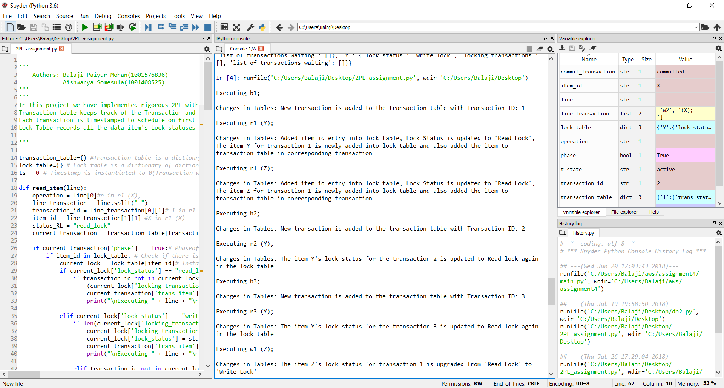

Input 6:
b1;
r1 (Y);
r1 (Z);
b2;
r2 (Y);
b3;
r3 (Y);
w1 (Z);
w3 (Y);
w2 (Y);
r2 (X);
e1;
e3;
w2 (X);
e2;

Output 6:
Executing b1;

Changes in Tables: New transaction is added to the transaction table with Transaction ID: 1

Executing r1 (Y);

Changes in Tables: Added item_id entry into lock table, Lock Status is updated to 'Read Lock', The item Y for transaction 1 is newly added into lock table and also added the item to transaction table in corresponding transaction

Executing r1 (Z);

Changes in Tables: Added item_id entry into lock table, Lock Status is updated to 'Read Lock', The item Z for transaction 1 is newly added into lock table and also added the item to transaction table in corresponding transaction

Executing b2;

Changes in Tables: New transaction is added to the transaction table with Transaction ID: 2

Executing r2 (Y);

Changes in Tables: The item Y's lock status for the transaction 2 is updated to Read lock again in the lock table

Executing b3;

Changes in Tables: New transaction is added to the transaction table with Transaction ID: 3

Executing r3 (Y);

Changes in Tables: The item Y's lock status for the transaction 3 is updated to Read lock again in the lock table

Executing w1 (Z);

Changes in Tables: The item Z's lock status for transaction 1 is upgraded from 'Read Lock' to 'Write Lock'

Executing w3 (Y);

Changes in Tables: Found multiple read locks on the item Yfor this transaction 3. The operations on the transactions are performed based on the result of wait-die protocol.

Executing w3 (Y);

Changes in Tables: Transaction 3 is aborted, and the subsequent operations are disregarded

Executing w3 (Y);

Changes in Tables: Transaction 3 is aborted, and the subsequent operations are disregarded

Executing w2 (Y);

Changes in Tables: Found multiple read locks on the item Yfor this transaction 2. The operations on the transactions are performed based on the result of wait-die protocol.

Executing w2 (Y);

Changes in Tables: Transaction 2 is aborted, and the subsequent operations are disregarded

Executing r2 (X);

Changes in Tables: transaction 2 is already aborted, and the status is updated to aborted

Executing e1;

Changes in Tables: Transaction 1 is committed, and the status is updated to committed. The items to be unlocked: ['Y', 'Z']

Executing e3;

Changes in Tables: Transaction 3 is already aborted, its current Transaction state is: aborted

Executing w2 (X);

Changes in Tables: transaction 2 is already aborted, and the status is updated to aborted

Executing e2;

Changes in Tables: Transaction 2 is already aborted, its current Transaction state is: aborted

Transaction Table:

{'1': {'trans_state': 'committed', 'Timestamp': 1, 'list_of_waitingoperations': [], 'trans_item': [], 'phase': False}, '2': {'trans_state': 'aborted', 'Timestamp': 2, 'list_of_waitingoperations': [], 'trans_item': [], 'phase': False}, '3': {'trans_state': 'aborted', 'Timestamp': 3, 'list_of_waitingoperations': [], 'trans_item': [], 'phase': False}}

Lock Table:

{'Y': {'lock_status': 'read_lock', 'locking_transactions': [], 'list_of_transactions_waiting': []}, 'Z': {'lock_status': 'write_lock', 'locking_transactions': [], 'list_of_transactions_waiting': []}}

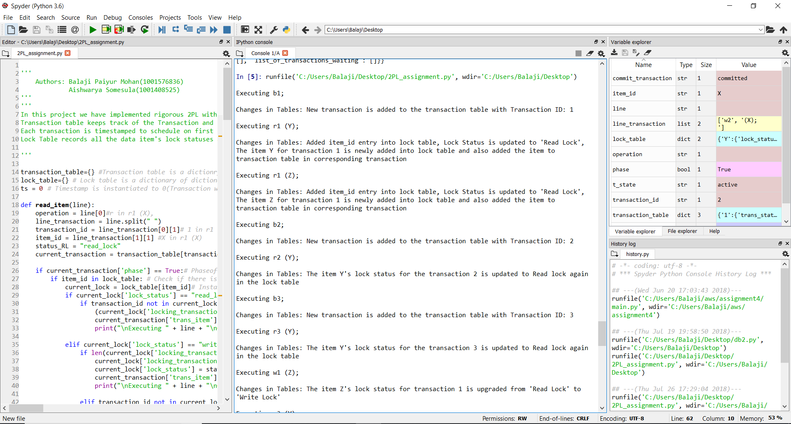

Input 7:
b1;
r1 (Y);
w1 (Y);
r1 (Z);
b2;
r2 (Y);
b3;
r3 (Z);
w1 (Z);
w2 (Y);
r2 (X);
e1;
w3 (Z);
e3;
w2 (X);
e2;

Output 7:

Executing b1;

Changes in Tables: New transaction is added to the transaction table with Transaction ID: 1

Executing r1 (Y);

Changes in Tables: Added item_id entry into lock table, Lock Status is updated to 'Read Lock', The item Y for transaction 1 is newly added into lock table and also added the item to transaction table in corresponding transaction

Executing w1 (Y);

Changes in Tables: The item Y's lock status for transaction 1 is upgraded from 'Read Lock' to 'Write Lock'

Executing r1 (Z);

Changes in Tables: Added item_id entry into lock table, Lock Status is updated to 'Read Lock', The item Z for transaction 1 is newly added into lock table and also added the item to transaction table in corresponding transaction

Executing b2;

Changes in Tables: New transaction is added to the transaction table with Transaction ID: 2

Executing r2 (Y);

Changes in Tables: Transaction 2 is aborted, and the subsequent operations are disregarded

Executing b3;

Changes in Tables: New transaction is added to the transaction table with Transaction ID: 3

Executing r3 (Z);

Changes in Tables: The item Z's lock status for the transaction 3 is updated to Read lock again in the lock table

Executing w1 (Z);

Changes in Tables: Found multiple read locks on the item Zfor this transaction 1. The operations on the transactions are performed based on the result of wait-die protocol.

Executing w1 (Z);

Changes in Tables: Transaction 1 is blocked, and it's being added to list of waiting operations : [{'operation': 'w', 'item_id': 'Z'}]

Executing w2 (Y);

Changes in Tables: transaction 2 is already aborted, and the status is updated to aborted

Executing r2 (X);

Changes in Tables: transaction 2 is already aborted, and the status is updated to aborted

Executing e1;

Changes in Tables: Since Transaction 1 is already blocked, e1 is added to list of waiting operations

Executing w3 (Z);

Changes in Tables: Found multiple read locks on the item Zfor this transaction 3. The operations on the transactions are performed based on the result of wait-die protocol.

Executing w3 (Z);

Changes in Tables: Transaction 3 is aborted, and the subsequent operations are disregarded
e1
Changes in Tables: The Transaction is committed and the next waiting item to be unlocked: ['Y', 'Z']

Executing e3;

Changes in Tables: Transaction 3 is already aborted, its current Transaction state is: aborted

Executing w2 (X);

Changes in Tables: transaction 2 is already aborted, and the status is updated to aborted

Executing e2;

Changes in Tables: Transaction 2 is already aborted, its current Transaction state is: aborted

Transaction Table:

{'1': {'trans_state': 'committed', 'Timestamp': 1, 'list_of_waitingoperations': [], 'trans_item': [], 'phase': False}, '2': {'trans_state': 'aborted', 'Timestamp': 2, 'list_of_waitingoperations': [], 'trans_item': [], 'phase': False}, '3': {'trans_state': 'aborted', 'Timestamp': 3, 'list_of_waitingoperations': [], 'trans_item': [], 'phase': False}}

Lock Table:

{'Y': {'lock_status': 'write_lock', 'locking_transactions': [], 'list_of_transactions_waiting': []}, 'Z': {'lock_status': 'write_lock', 'locking_transactions': [], 'list_of_transactions_waiting': []}}
