**5. SYTEM DESIGNING**

**5.1 Database Design**

During the designing our system we opt following method throughout the application. We follow the modular fashion to develop a system. Before starting any module we has a discussion with project head, which involves basic needs of particular module, its usages etc.

Once we understand needs of system we start to take help from the Arc View, which involves how various operations takes place, their conditions, parameters to be considered etc. Then we start with algorithmic design of the module. Once we completed algorithmic design of the module we have to take approval from the project head. Project head given us various suggestion, views and also point out mistakes. After approval from the project head we begin with design of the module. At start followed by testing of particular module.

**5.2 Data Structure Design:-**

Our application is live web-based application which is going to be used by any user in organization. So our application has been started from scratch. Moreover we have to show task on the browser of user. We have to also provide the tips, mailing server.

We have to build the graphics user interface of our application more attractive as possible as of the requirement of the proposed application. The design of the application must be in such a way that the user may find it friendly. And hence we were successful in satisfying the needs of the user.

**5.3 Data Dictionary:-**

Admin **:**

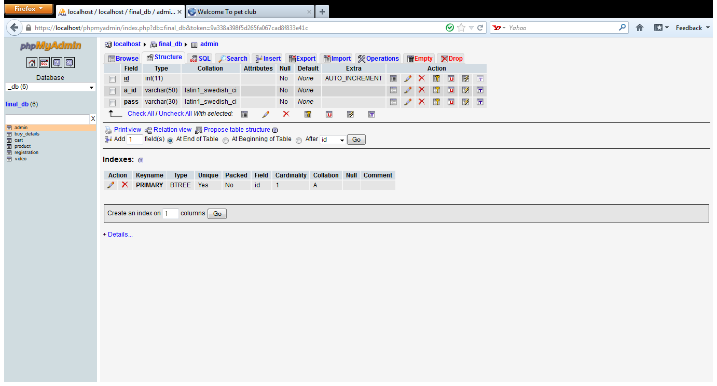

Buy Details:

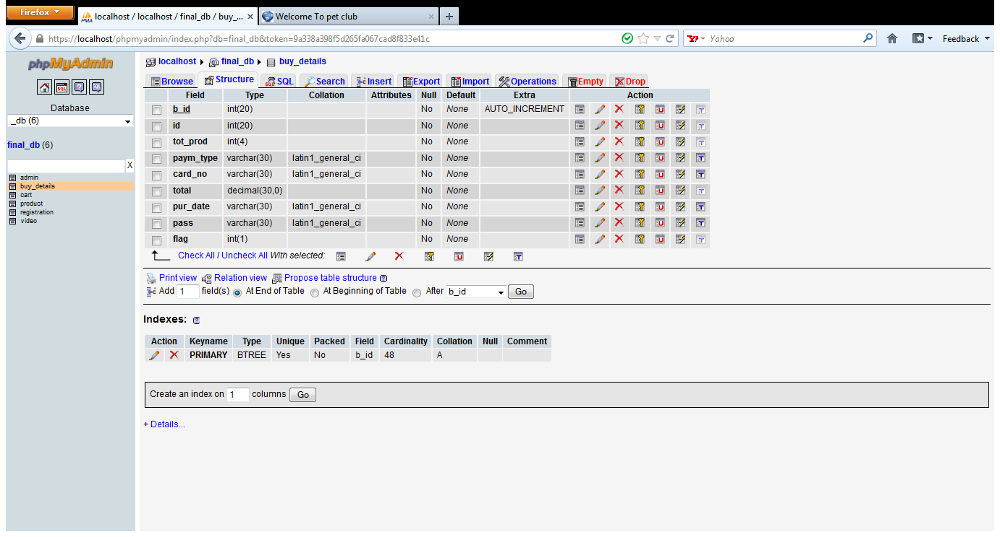

Cart :

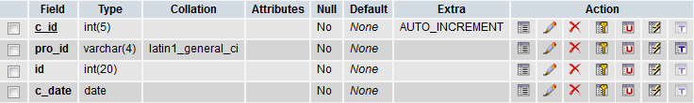

**Pet Product:**

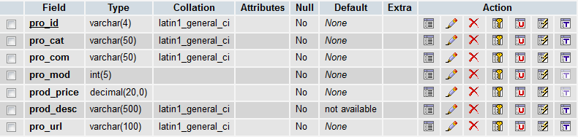

**Registration :**

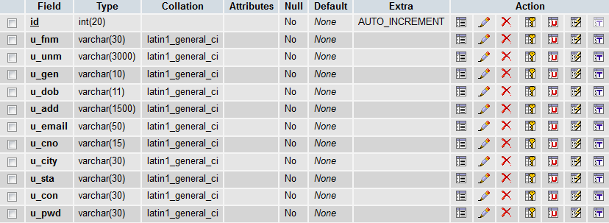

**Video :**

