Playwright Tools Template
by Patrick M Brennan (pbrennan@gmail.com)

This package allows a playwright to quickly write and annotate plain text with a few easy to type tags, which are subsequently transformed into proper stage play format.

The Problem:

Formatting a stage play is a nontrivial task. Time which is spent fussing with character slugs (the character names over each line) and stage directions is time which is more profitably spent thinking about the characters and writing good dialogue.

From talking to playwrights about their work process, I have come to believe that many playwrights needlessly spend time formatting their writing: writing each character's entire name, every time the character has a line, and then manually centering and capitalizing it, before actually typing the line. This is not only an enormous waste of time, it also breaks the flow of the dialogue in the playwright's head, and may therefore actually impact the quality of the work.

The Benefits of Using this Package:
- You can write faster, since you are typing fewer letters.
- You can write with better "flow", since you are not interrupting your writing to fiddle with formatting.
- You can easily import text from multiple sources and quickly format it into your script.
- You can easily export text from stageplay format to plain text.

PROS:
- These styles and macros are free.
- LibreOffice/OpenOffice is high-quality free software. You can install it and use it without paying any money, and it's fully compatible with MS Word and WordPerfect. It costs a lot less than Final Draft, too.
- LibreOffice/OpenOffice runs on Windows, MacOS, and Linux, so you won't be tied down to any one platform when you write.
- You can use the styles without using the macros, if you wish. There is nothing to tie them together.
- You can easily modify the styles to suit your own taste.
- If you do want to use the macros, then you will find that writing a play using marked-up text is significantly faster and easier, and it doesn't require you to be sitting at one particular computer when you do it. You can write anywhere you can edit plain text, and when you get the time you can just copy and paste the text into this template, press the “ApplyFormatting” button and have a fully-formatted play.
- The macros are fully bidirectional; they can take marked-up text and convert it to fully-formatted text or they can take fully-formatted text and convert it to marked-up text.
- The macros don't require the text to be totally formatted or totally marked-up; they will convert whatever is available to be converted when you press the buttons and leave the rest alone. This means you can type a little marked-up text, press the “ApplyFormatting” button, type a little more marked-up text and press it again, and everything will work as you expect it to.
- Comparing two versions of a play (using, e.g. Beyond Compare) is much easier with marked-up plain text than with formatted text.

CONS:
- Setting up the character tags is a little clunky at the moment and could use some revision. It's not optimal to have to have a text file in the same directory called tags.txt.
- Markup is defined in a very arbitrary way which reflects my own personal choices (e.g., the way all character tags are defined inside slashes). In the future I may give the user more leeway on how the markup is defined.
- Although you can edit the macros, OpenOffice's implementation of Visual Basic for Applications is not the easiest environment in the world to master and I would not recommend it lightly.

Alternatives to this Package:
- Write your own styles and macros in Word or your favorite alternative word processor. I have many playwright friends who have opted for this approach, and it works just fine for them.
- Use a dedicated play writing program such as Final Draft.
- Use a program like LaTeX with customized macros. This is an advanced topic, for serious nerds only. If this is the way you choose, you have my undying admiration.
Getting Started:

- Download and install your free copy of LibreOffice or OpenOffice, if you haven't already. (See http://www.libreoffice.org/download/ or download.openoffice.org)
- Configure OpenOffice Writer to allow you to open these macros:
  - On the main toolbar, select Tools > Options... (on Mac, select OpenOffice > Preferences... or press Cmd-,)
  - A dialog will appear. On the left side of the dialog, open the first selection, marked "OpenOffice.org", and select "Security".
  - On the right side of the dialog, press "Macro Security..." You will get this dialog:
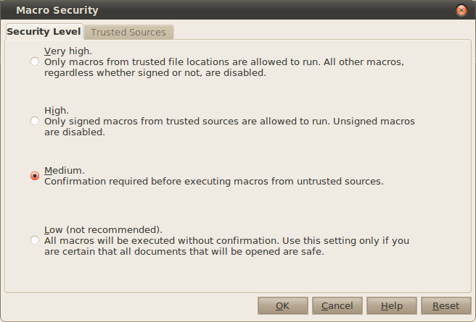
  - Select "Medium". This will allow you to open and run the PlaywrightToolsTemplate.odt file, with a prompt asking you if you want to enable the macros.

- Make a new folder (directory) on your disk. Name it whatever you like, e.g. "My new Play". Copy the file “PlaywrightToolsTemplate.odt” from this package into your new folder. You may also rename it if you wish. This is what I usually do to start a new play.
- Open the file “PlaywrightToolsTemplate.odt” (or whatever you named it) in OpenOffice. When you see a dialog like this:
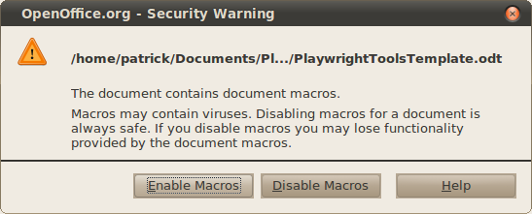
Press "Enable Macros".
- Now that you've loaded the file, you probably want to try it out! Go to the last page of the document and begin typing lines in tagged format, like so (important: don't copy from here and paste into your document. The extra formatting from this document will confuse the macro code):
## ENTER HAMLET, HORATIO, and MARCELLUS.
/ham/ The air bites shrewdly; it is very cold.
/hor/ It is a nipping and an eager air.
/ham/ What hour now?
- Of course you don't have to type Hamlet! Feel free to write your own lines. This package is for your plays, after all.
- Now press “ApplyFormatting”. You will get this prompt:
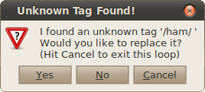
This means that you haven't told the system what name to supply when it encounters the tag /ham/. Press "Yes" and you will be presented with this dialog:
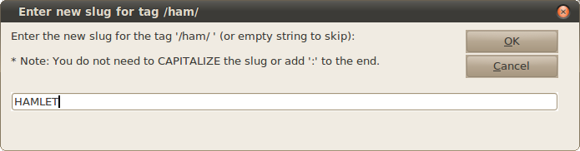
type "HAMLET" in the box and press OK. You will repeat this process for Horatio. (Note that you will only need to do this the first time you ever use the "/ham/ " tag in your document. Even after closing the document, your assignment of HAMLET to "/ham/ " will be remembered.)
Now, viola! Your play is properly formatted! The text above will now look a lot like this:

ENTER HAMLET, HORATIO, and MARCELLUS.

HAMLET:
The air bites shrewdly; it is very cold.

HORATIO:
It is a nipping and an eager air.

HAMLET:
What hour now?

Isn't that MUCH BETTER? It's in standard playwriting format! And you didn't have to set it yourself! Imagine the amount of time this can save!
- You may press "ApplyFormatting" as often as you like, to pick up additional tagged text you have entered since the last time you pressed the button. The package will detect newly-entered tagged text and format it all for you!
- If you want to see how this is all being remembered for you, look in the directory (folder) where you put your new document. You will see a new file called "tags.txt". If you open up that file in a text editor, this is what you will see:

HAMLET,ham
HORATIO,hor

This is just the computer's way of remembering that "/ham/ " means HAMLET, and "/hor/ " means HORATIO. Advanced users: This file is editable (use a TEXT EDITOR – not a word processor!) and you may add as many tags to it as you wish, but be sure to save the file and press the "Reload" button in your document in order for the new tags to show up. However, it is not necessary to edit this file in order to use this macro package.

A Detailed Look At What's Inside:
- A template containing styles for easily formatting stage plays and easy-to-follow directions for using them. (PlaywrightToolsTemplate.odt)
- A set of macros which will take marked-up plain text and apply these styles to the text, in order to easily and rapidly create properly-formatted stage plays. They are also useful for importing previously-formatted play text and massaging it to conform to the newly-defined styles.
- A macro which will detect long speeches and automatically format them to straddle pages, supplying the important " (CONT'D)" slug line at the top of the next page.
- A macro which will highlight any character's lines, or the stage directions, as an aid to preparing a script for a reading. Highlight each character's lines in turn, print each version out, then print out one version with your stage directions highlighted. MUCH easier than going through your printed script with a highlighter yourself.
- The original source code for the macros, saved as a .BAS file. (PlaywrightToolsCode.bas) This file also contains much more complete documentation on how to use this package.
- This README file. (Readme.odt, Readme.pdf)

The styles are:
- CHARACTERNAME: for the character slug over a line.
- LINE: for the spoken line itself.
- STAGE_DIRECTION_OVERLINE: for stage directions which are placed over lines (a.k.a. “wrylies”)
- STAGE_DIRECTION_BLOCK: for stage directions which are meant to be formatted as a block.

The markup elements are:
- Begin a line with / followed by a short code to signify a character, followed by another / and a space, followed by the line that character speaks, e.g.:
/joe/ Hey there! My name is Joe.
The character sequence "/joe/ " is called the "character tag"
- Use [[ immediately after the character tag to start a "wryly". End it with ]], e.g.:
/joe/ [[Smiling]] Hey there! My name is Joe.

Which gets formatted into:

JOE:
(Smiling)
Hey there! My name is Joe.

- Begin a line with ## followed by a space to begin block stage directions. For example:

## ENTER HAMLET.

Will get formatted into:

ENTER HAMLET.

- Anywhere inside a character's line, type ( to begin inline stage directions. End them with ), e.g.:
/joe/ Hey there! (He picks up the phone) My name is Joe.
- Apply some simple character decoration with *, _, and \, e.g.
/joe/ This is *bold*. This is _underline_. This is \italic\.

Which gets formatted into:

JOE:
This is bold. This is underline. This is italic.

