Project 1: Temporal Analysis of Tweets

- Objective:
The objective of this lab is to conduct a temporal analysis on a large set of Twitter data using the R programming language.
- Introduction:
The R language is one of the most predominant programming languages used in data analysis. R was used in this project to identify and display (plot) temporal patterns on a Twitter data set from 2014. The dataset was for the entire year and had over 68,000 rows of data in the provided .csv file.
- Method
The provided pu2014.csv file was imported into the working directory using the “readme” command. Once the file was imported the necessary data columns were placed in a data frame using the “select” function. Before beginning any analysis, the epoch (Unix) time was converted to day-month-year, day of the week, and local time as specified in the project instructions. To do this the “anytime” library was used along with the “format” function.

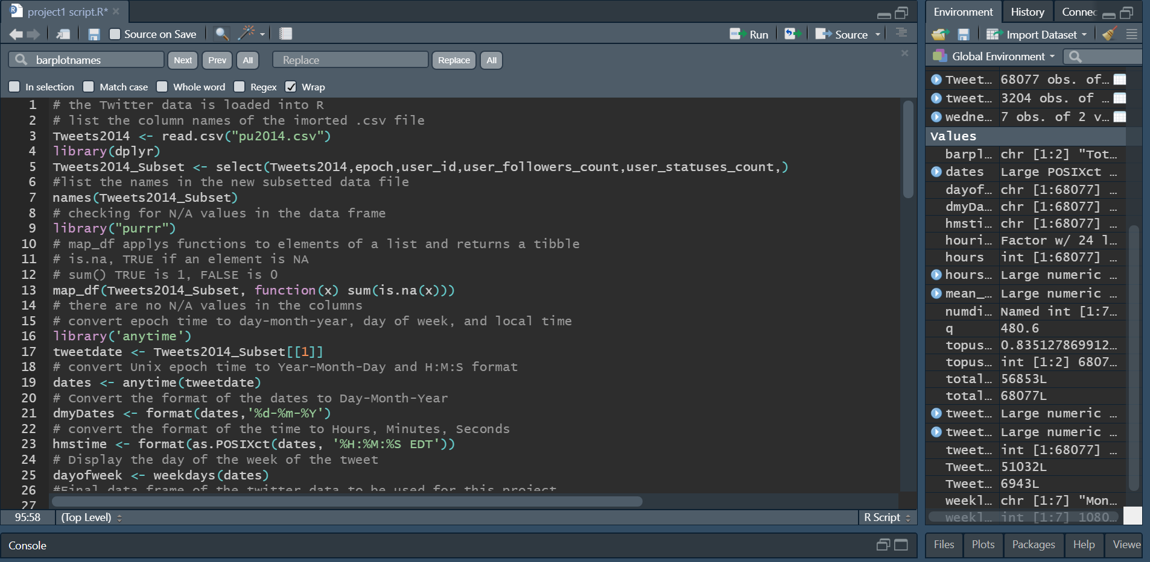
Figure 1: Import data and change epoch time

The number of distinct users was determined by using the “sapply” and “unique” commands. They were applied to the length of the data frame to capture the number of unique values per column. Extracting the number of tweets by each individual user was done by using the “count” function to numerically count the number of occurrences of each “user_id” in the data frame. This information was placed in a data frame and sorted in decreasing order using the “order” function with decreasing = true. Once this was accomplished the data was plotted to show the number of tweets by each user.

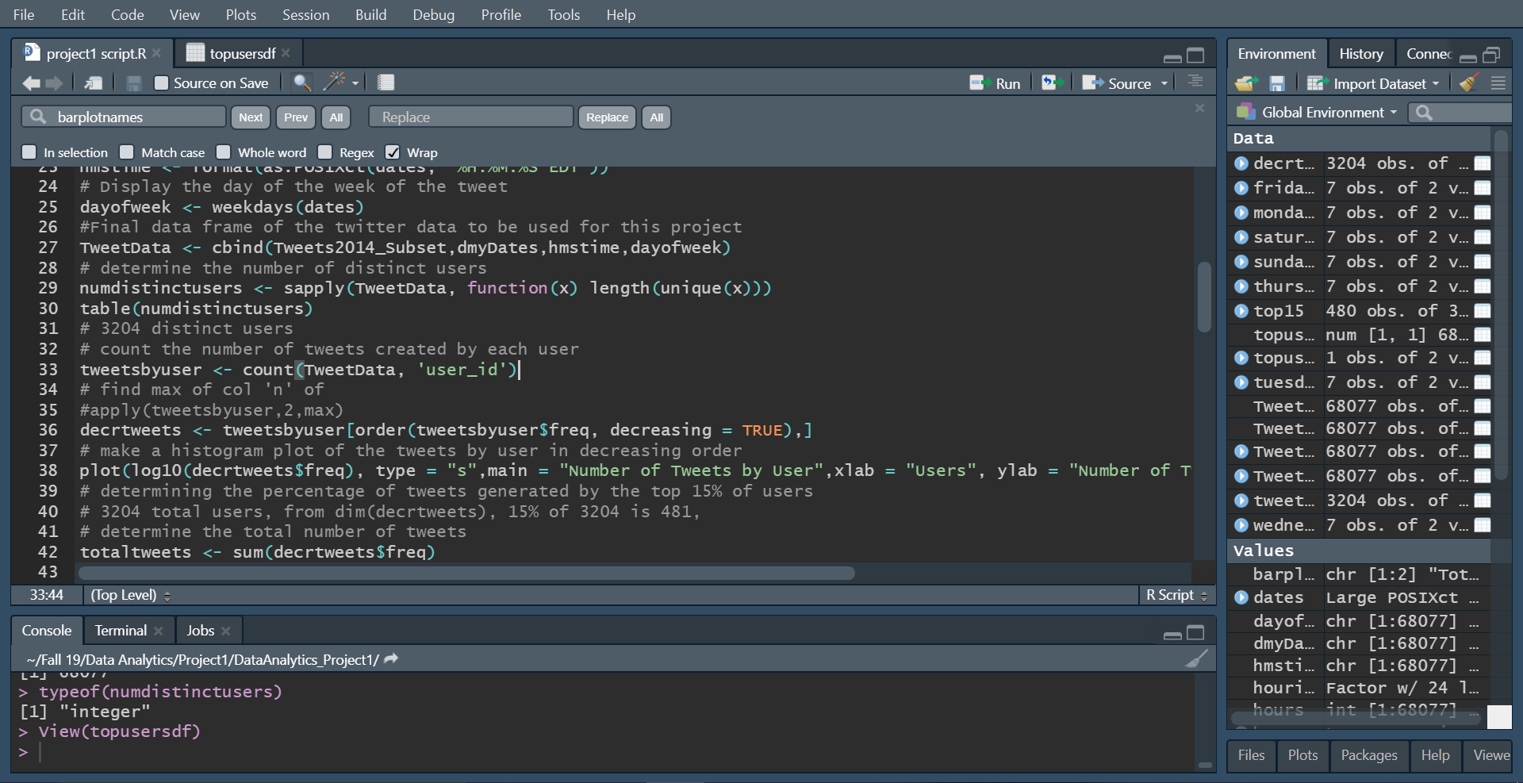
Figure 2: Code to plot the number of tweets by user.

To display that a small number of users generate a disproportionately large number of tweets the frequency (number) of tweets that corresponded to each user_id was summed using the “sum” function. From here it was decided to analyze what percentage of tweets were generated by the top 15 percent of users. The number of users in the top 15 percent of those who tweet is 480. The first 480 users by “user_id” in the decreasing data frame were subset into a separate data frame where the sum of their tweets was found to be 56,853 out of a total of 68,077 tweets. This means the top 15 percent of users generate 0.835 or 84 percent of all tweets.
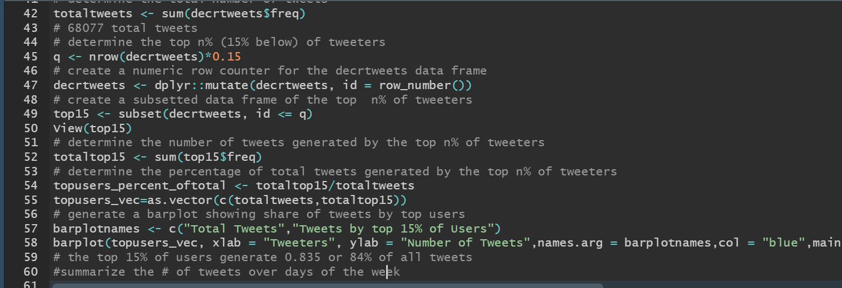
Figure 3: Determining share of tweets by top users.

To determine the number of tweets over the workweek and weekend the sum of each occurrence of the word “Monday”, “Tuesday” etc. was determined using the “ldply” function. This function combines the results for each element of a list into a data frame. After the creation of a data frame for each day of the week the corresponding elements in each were added together to find that there were 51,032 weekday tweets over the year and 6,953 weekend tweets in 2014. This is somewhat surprising and may be something to explore in the future.

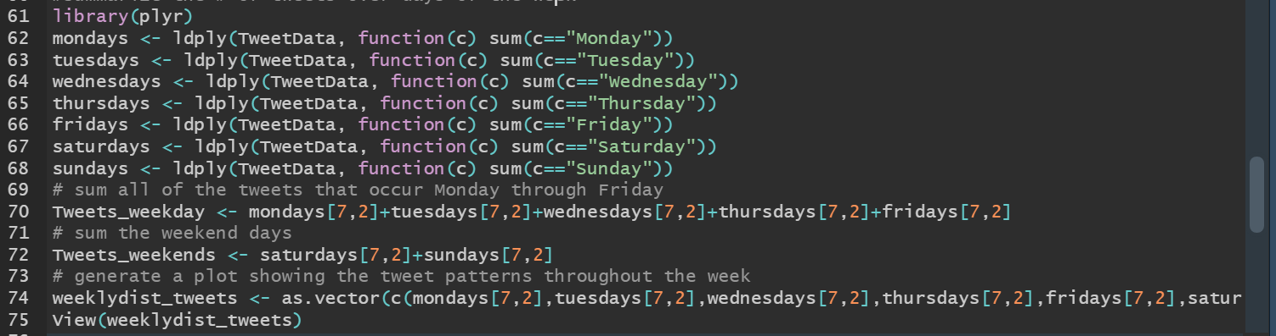
Figure 4: Determining tweet counts for the days of the week.

- Conclusion
R is a powerful tool to conduct data analytics. There were difficulties due to a general lack of experience with the R language, however, it has demonstrated its capabilities in not only organizing and plotting data but also in performing powerful commands. The robust libraries associated with R allow for straightforward programming with minimal to no looping required. This allows more time for analyzing data and executing the commands within the program, especially when large data sets are involved.
Appendix:

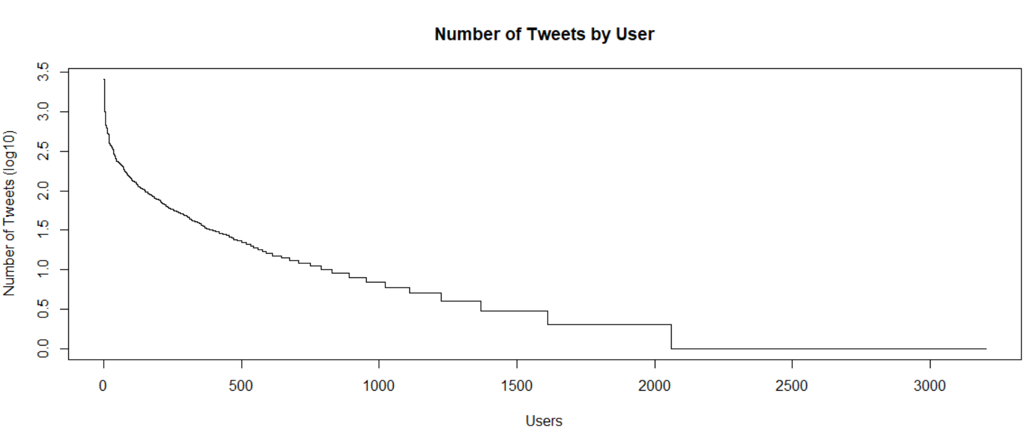
Figure 5: Number of tweets by user.

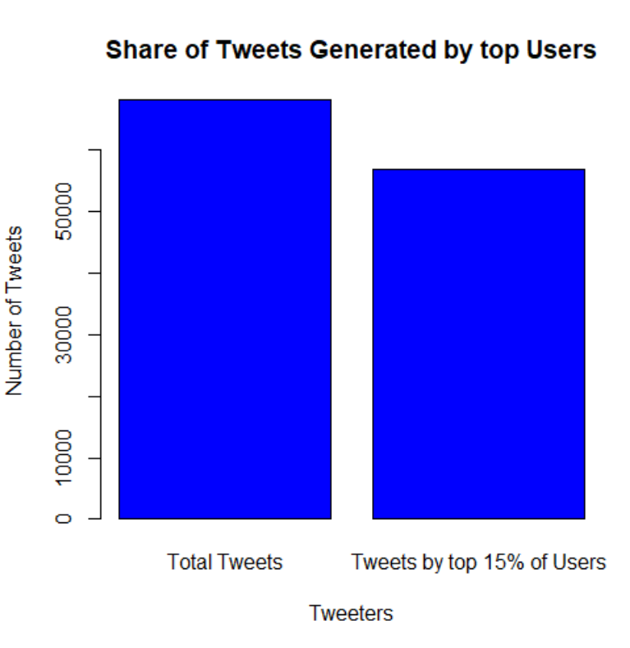
Figure 6: Total tweets vs those generated by the top users.

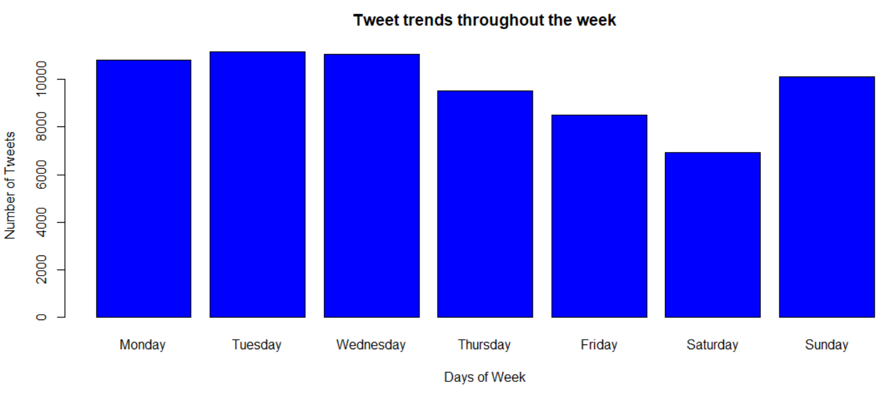
Figure 7:Avg Tweets over the course of a week in 2014.

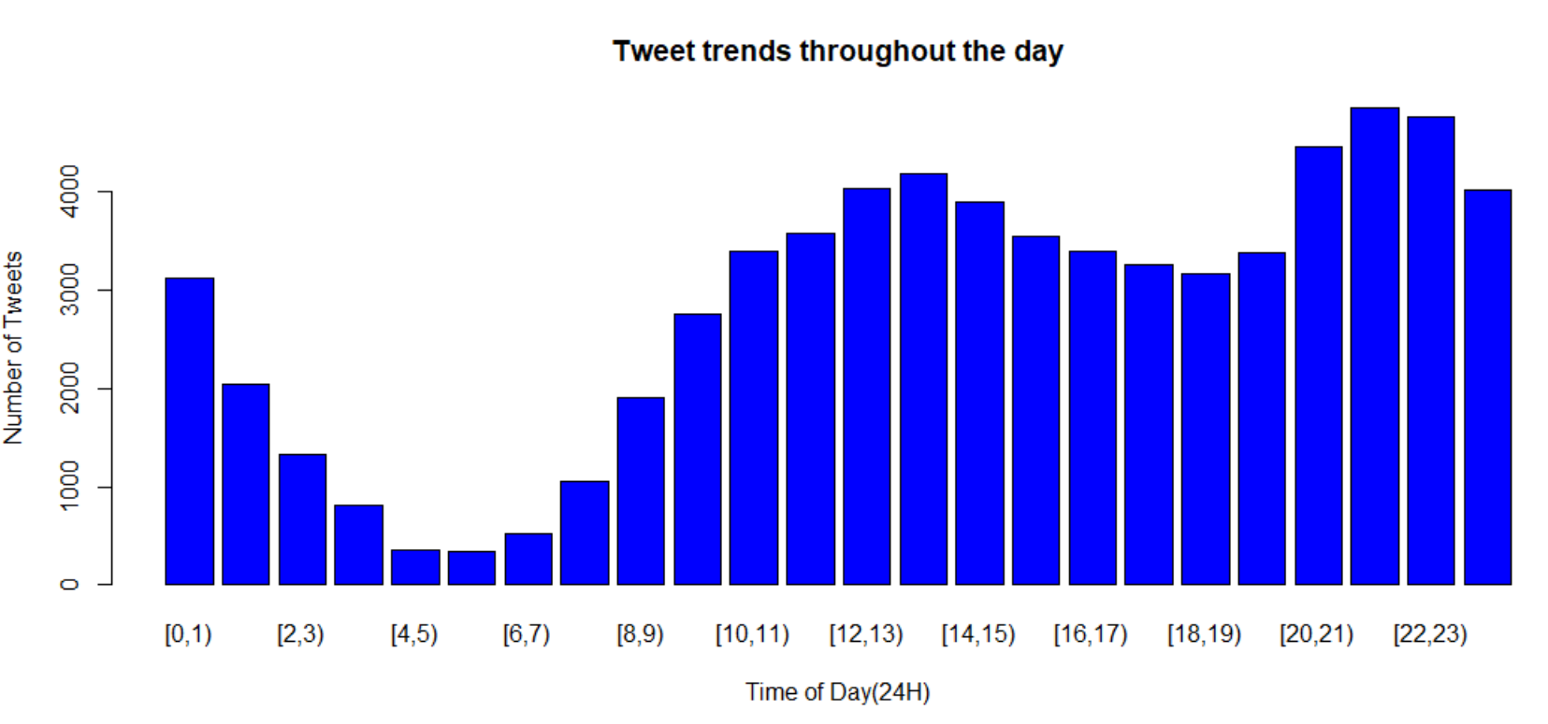
Figure 8: Average tweets over the course of a day in 2014.

