Project 3: Data Classification and Thematic Mapping

- Objective:
The objective of this lab is to create thematic maps using the provided U.S. Census data of Indiana from 2010 and the tmap function in R.
- Introduction:
Thematic maps are a visual way to display data that has a geographic element. The data is separated into classes using different methods of data classification. The data classification methods used were “Jenks”, “k-means”, “hierarchical clustering” (hclust), “Bayesian hierarchical clustering” (bclust), “Pretty clustering”, and “Quantile”. Six thematic maps were produced using these methods. A histogram of the break points was also produced to facilitate the comparison of the classification methods. A student version of the k-means clustering method was also attempted to be compared with the built r function, however, I was unable to make this work. The difficulties were mostly due to my lack of programming experience and will be discussed later.
- Method
To produce the professional quality maps tmap was used in with the imported shapefiles which were imported as sf objects into r. The maps were to display the population density of the census tracts within Indiana. To do this the total area in square kilometers of the census tracts were calculated along with the density of the tract. The area was calculated using the st_area function in r which calculates the area of the polygons in r. The population of the tract was then divided by the area to get the density.
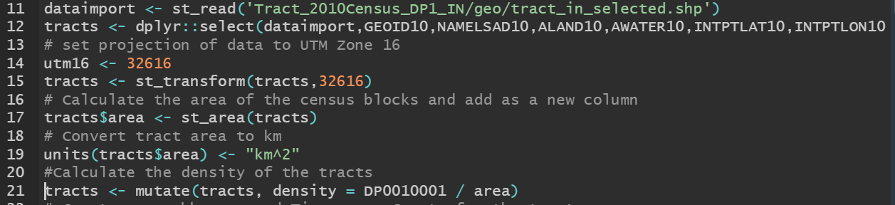
Figure 1: Calculating the tract areas and the population density of the tracts.
The creation of the maps in a professional manner was not particularly difficult but very time consuming. The exact placement of the elements on the map takes time and practice to get just right. The maps were created in the “plot” mode of “tmap”. This allows for the addition of a north arrow and scale bar. The “view” mode of “tmap” makes it easy to select a nice background map when mapping vector data but blocks the addition of north arrows.
The Jenks thematic map was created first. The jenks method attempts to minimize the deviation from the class mean while maximizing the deviation from the means of the other classes. K-means was the next method used to separate the tract density data. K-means is similar to the Jenks method but separates the observations into groups such that minimizes the sum of squares of the observations to a set cluster center. Through an iterative process k-means assigns the data points to a cluster and measures the distance from that center to the data point. It then assigns the data to the closest cluster centroid. This is repeated until a set number of iterations or a threshold is met. The “hclust” function was also used. This implements the hierarchical clustering method which uses a hierarchy system to classify the data. The “bclust” or bagged clustering algorithm uses a combination of the k-means and hierarchical methods to classify the data. It first runs the k-means to partition the data then applies the hierarchical method to combine the cluster centers. The pretty breaks method just rounds the numbers to be whole numbers instead of floating numbers. The quantile classification method divides the classes so that each class has approximately the same number of features.
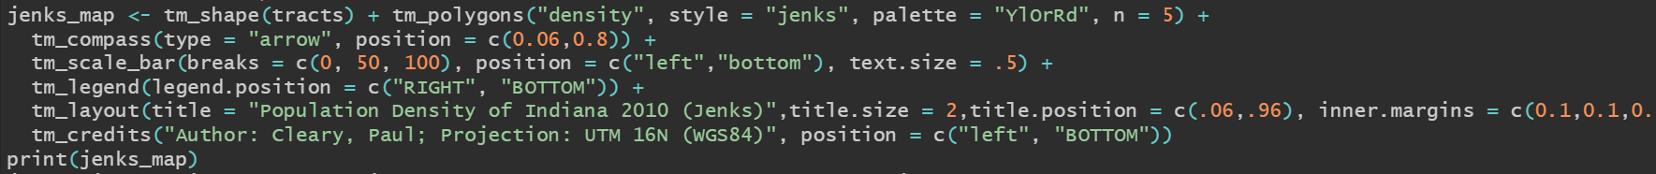
Figure 2: Creating the Jenks thematic map.

To compare the breakpoints of the different clustering algorithms the histograms were printed of each classification method. The Jenks and k-means methods were most comparable to each other while the other methods looked similar to each other.

The implementation of the student generated k-means function proved to be the most difficult part of the assignment. After reading extensively about the k-means function it proved to be very difficult to write a code. To implement k-means you first select the number of clusters to have then randomly select the same number of objects to be the cluster centers. Then each observation is assigned to the closest centroid. For each cluster a new center is created by calculating the mean of the observations in the cluster. The process is then repeated until the threshold is met.

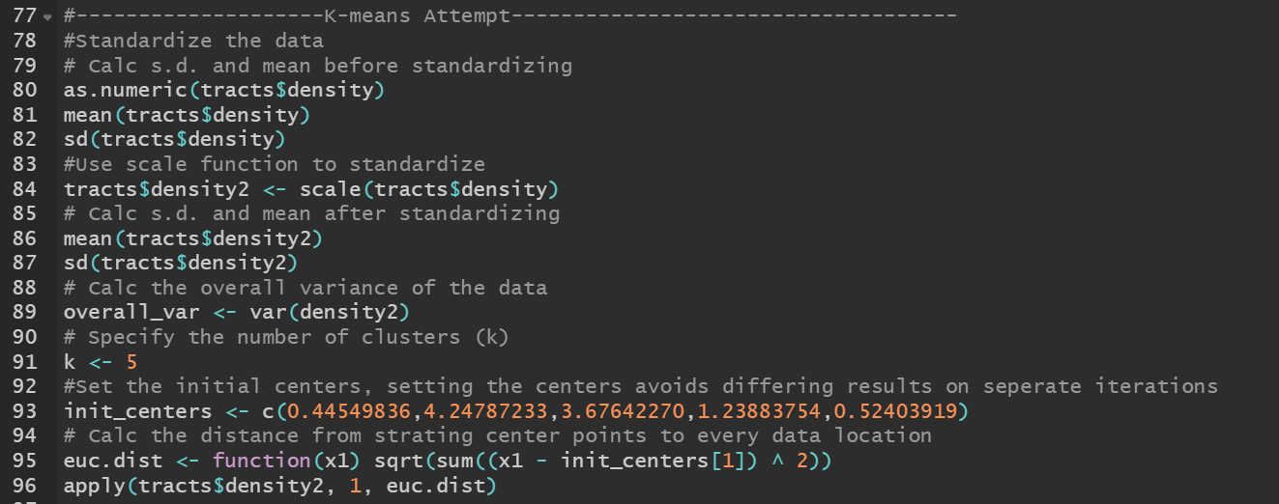
Figure 3: Attempt at creating a k-means function.

- Conclusion
Creating thematic maps using r and displaying data driven geospatial information without the need for ArcMap or another software package. It can be difficult and more time consuming than ArcMap but as experience is gained much more data analysis can be performed on the information. The built-in functions are very useful to save time and easily implement as was demonstrated by my inability to create a k-means function.

Appendix:

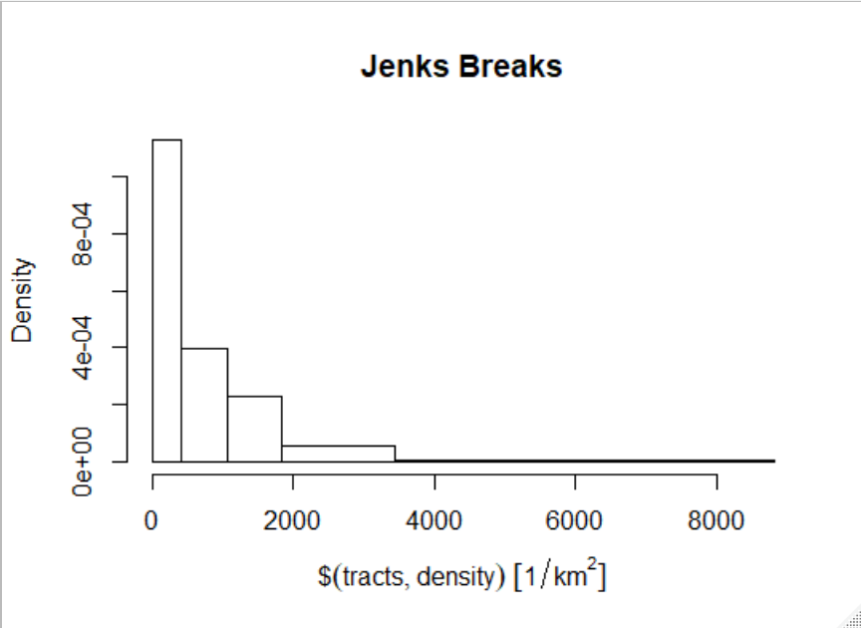
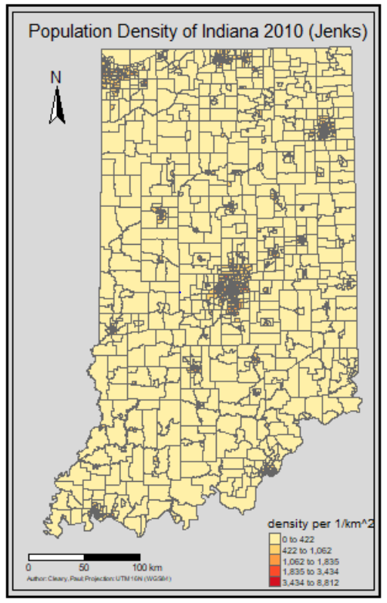
Figure 4: Thematic Map using Jenks Method

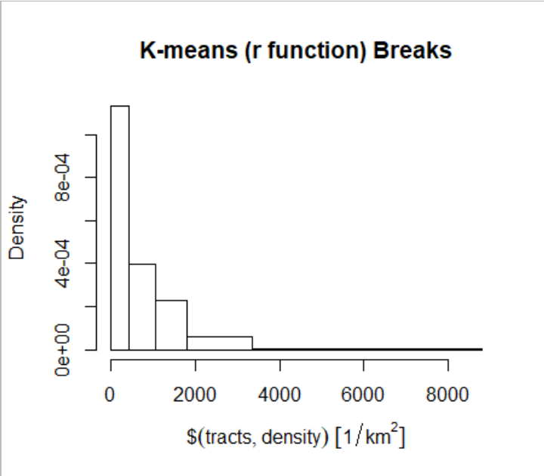
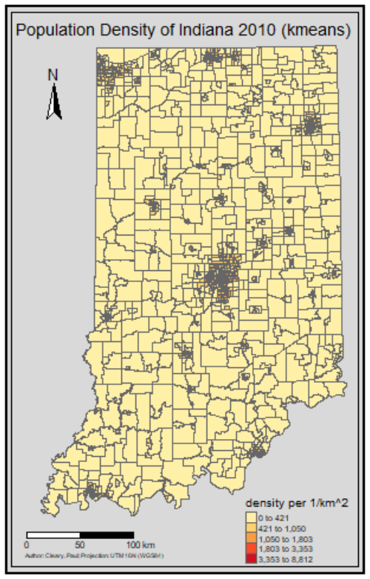
Figure 5: Thematic Map using built in K-means function.

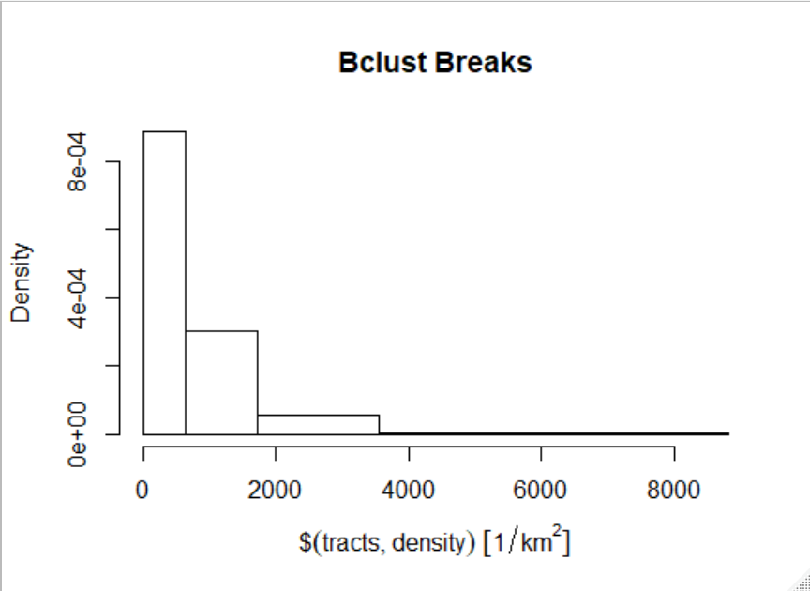
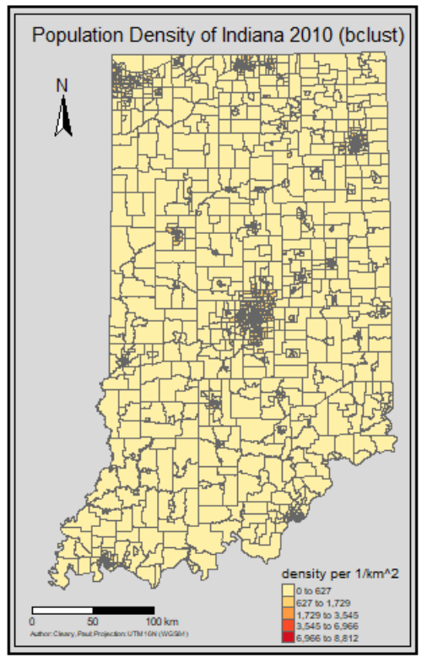
Figure 6: Thematic map using the bclust function.

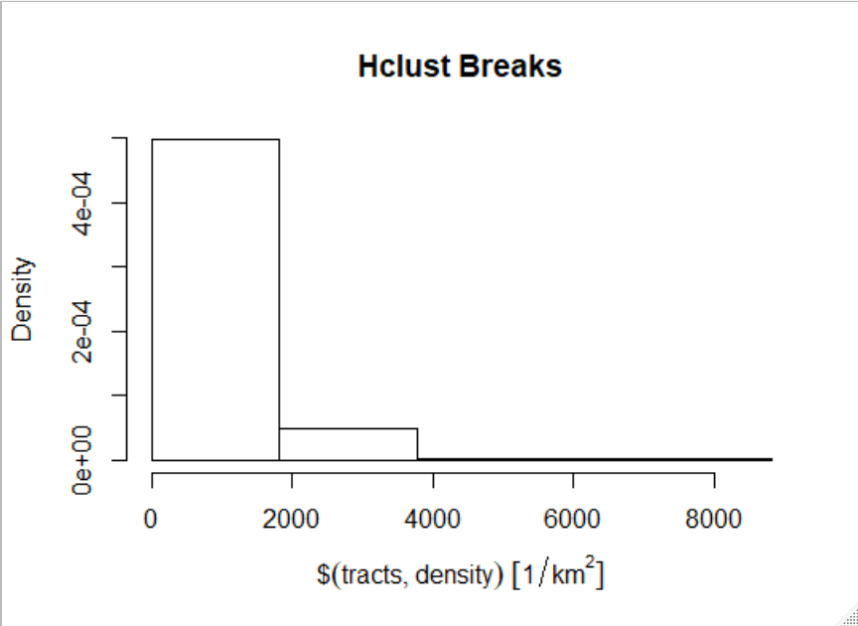
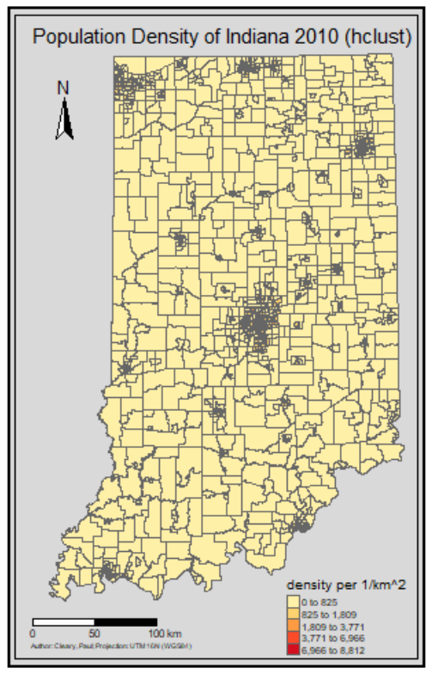
Figure 7: Thematic map using the hclust function.

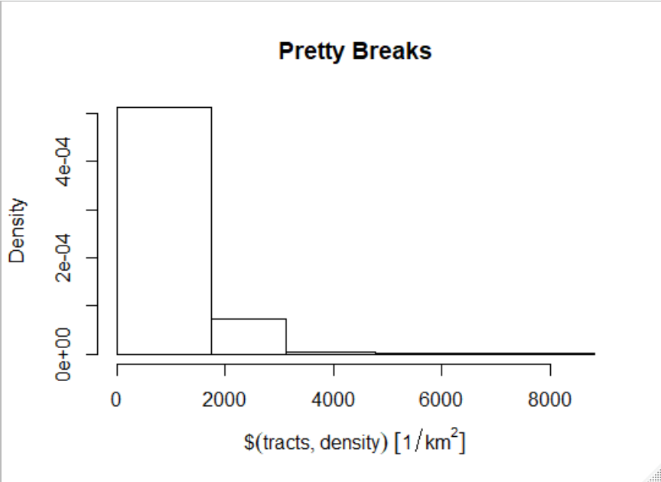
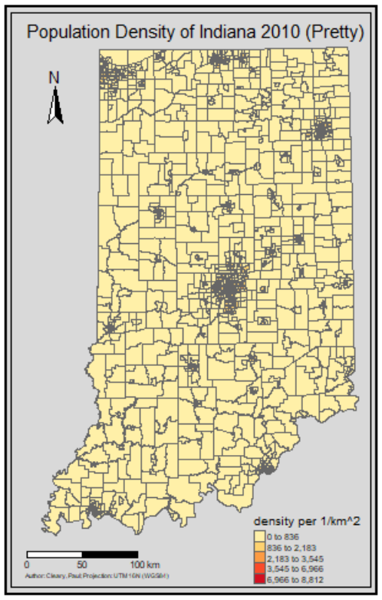
Figure 8: Thematic map using Pretty breaks function.

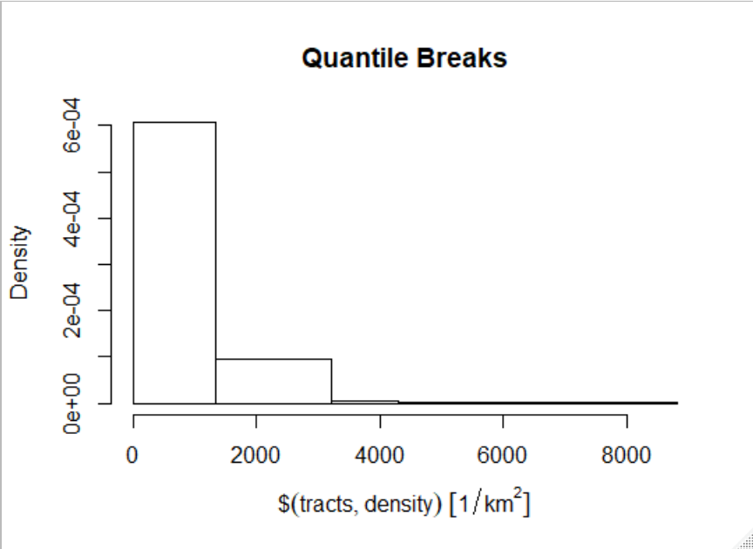
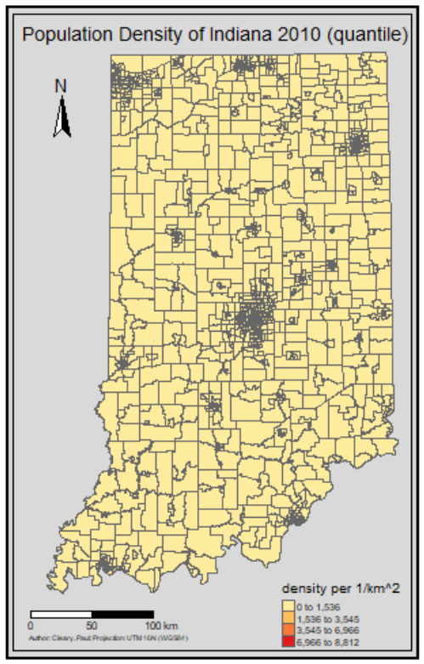
Figure 9: Thematic map using the Quantile breaks function.

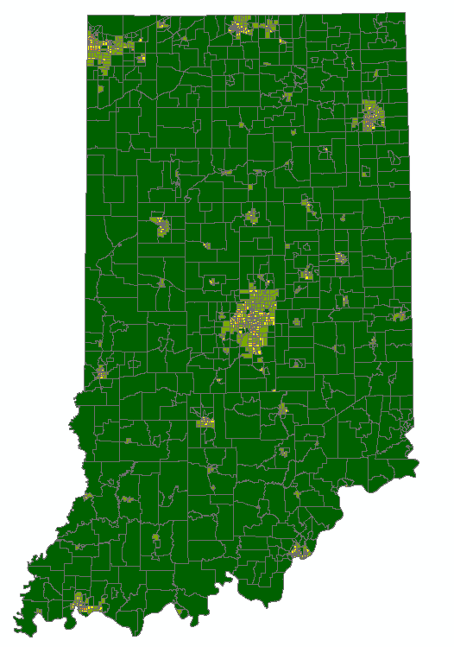
Figure 10: Jenks classification produced in ArcMap.

