Project 4: Spatial Analytics

- Objective:
The objective of spatial analytics is to use information or data with a geographic aspect to tell a story or provide detailed information to assist in a decision-making process.
- Introduction:
This lab uses geo-tagged twitter data collected in 2014 in and around the Purdue campus to analyze the movements and behaviors of students and other personnel on the Purdue campus. The “busiest” buildings in terms of the number of tweets were identified then these buildings were analyzed temporally over an average week to see if there were any interesting patterns. Prior to conducting this analysis, the perimeter, area, and centroid of each building polygon on the Purdue campus was calculated. The geometries were first cleaned to allow for consistent and easy data processing.
- Method
The data geometries were checked and cleaned using several commands. These functions looked for empty, corrupt and, invalid geometries. After running these functions it was determined that all three of these discrepancies existed in the dataset. To correct for these, several additional commands were used including ‘st_make_valid’ and ‘st_cast’. These functions attempt to fix geometries that may have crossed lines in the case of ‘st_make_valid’ or geometries that need to be split in the case of ‘st_cast’.
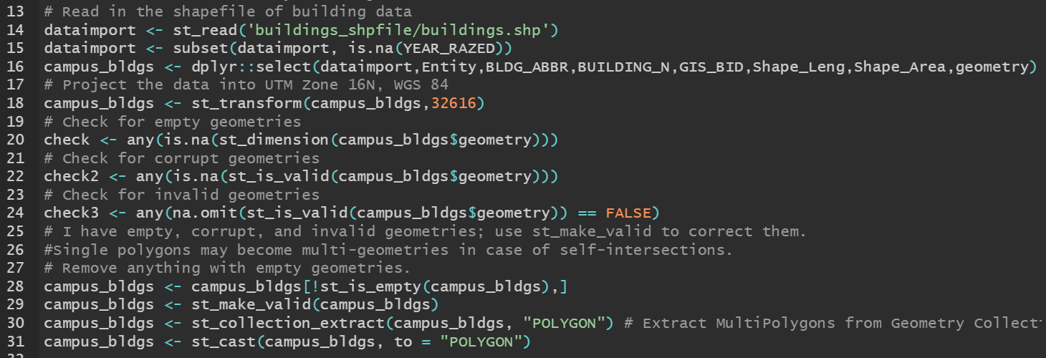
Figure 1: Inspecting and correcting geometries.
Next a function was written to determine the perimeter, area, and centroid of each polygon in the building shapefile. These functions were then compared to the built in R functions that perform the same calculations. The formulas from the ‘Polygon Analytics’ presentation on the course webpage were referenced to write the homemade functions. Writing these functions was challenging but for reasons different than I guessed when beginning the assignment. The biggest challenge faced was dealing with the ‘geometries’ column and the unique data structure of the ‘simple features column’(sfc). Within each element of a sfc column is a ‘simple features geometry’ (sfg). These data elements proved difficult to reference and unlist. The concatenated nature of the x, y coordinates made it difficult to execute the formulas required to calculate the polygon data. Eventually it was discovered that creating a matrix out of each sfg allowed for easier data manipulation while writing the functions.
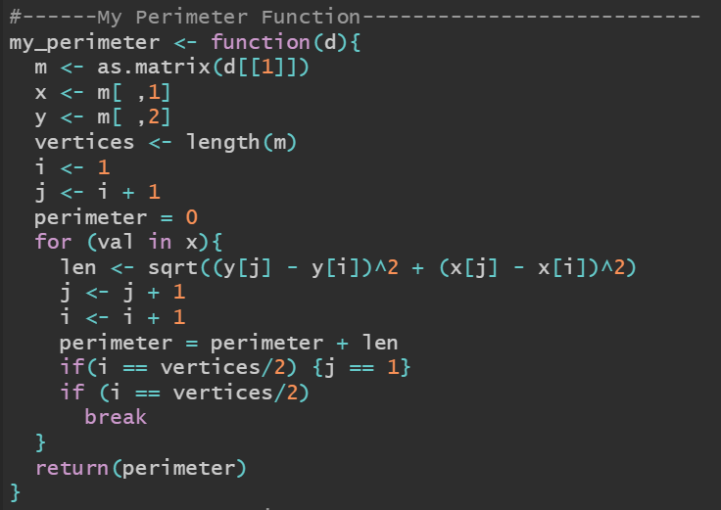
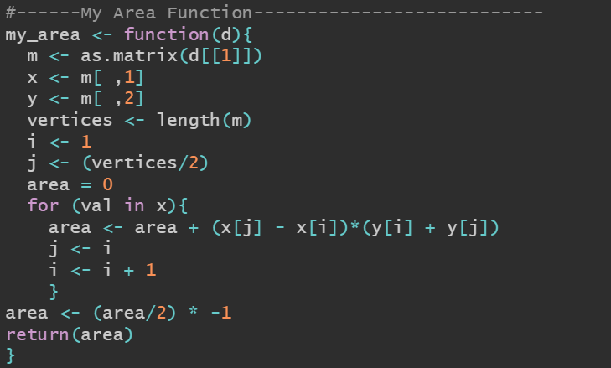
Figure 2: My perimeter and area functions.

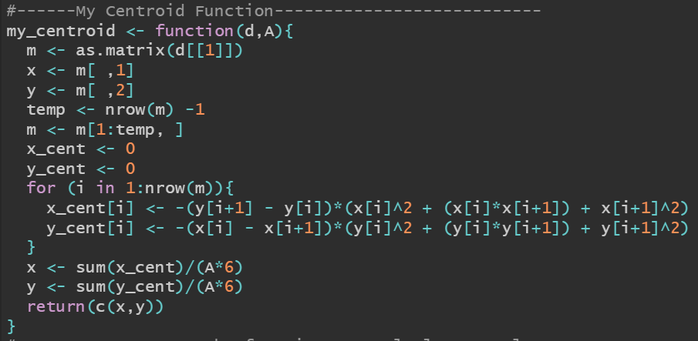
Figure 3: My centroid function

When analyzing my homemade functions against the built in R functions they proved to be identical apart from several centroid calculations. The errors in the centroid appears to be more a result of how the data was cleaned and less a result of the function itself. It looks like either the ‘st_make_valid’ or ‘st_cast’ commands created some sort of abnormally large polygon or separated a polygon that should not have been. My centroid function was unable to deal with these inconsistencies while the R function calculated it correctly. After rounding the perimeter and area measurements to the millimeter to avoid implying an impossible level of accuracy the functions were compared and proved to be the same.
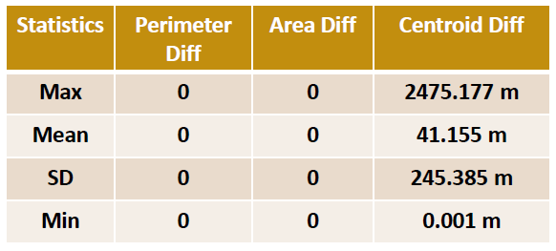
Table 1: Statistics calculated between the homemade and R functions

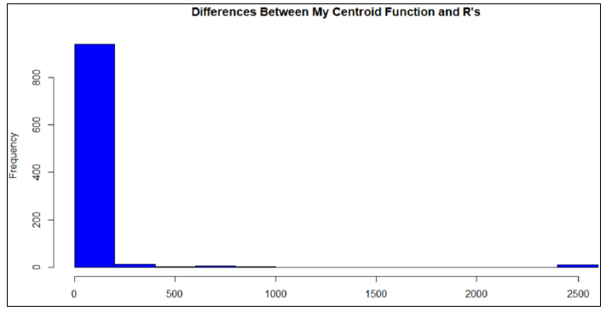
Figure 4: Histogram of differences between my function and the built in R function.

To conduct the spatial analysis in part two of the lab a spatial join was conducted on the building polygons and the twitter data using ‘st_join’ and ‘st_is_within_distance’. The distance was set to 10 meters to try to reduce the likelihood of tweets being assigned to two buildings. Due to the length of time this command took to process both the twitter and the polygon data were cropped to an area surrounding the main part of the Purdue campus. This reduced the number of tweets by 24,119 and the building polygons by 487. This did not change which buildings had the most tweets as that analysis was conducted on both the original and cropped datasets. The building with the most tweets after removing buildings with NA as a name was the Cordova Recreation Center, follwing the CoRec were several dormitories. A thematic map was produced dispalying the “busiest” buildings by twitter data on campus. Next a temporal analysis was conducted on the CoRec, the Richard Owen Dorm, and the Purdue Memorial Union (PMU). This analysis was condcuted by day of the week and is displayed in the bar charts in the appendix.

- Conclusion
Data analysis using the simple features (sf) data object in R continues to prove to be a powerful tool for both spatial and numerical analysis in one package. Despite the difficulties encountered with the SFC and SFG geometries the sf package’s ability to conduct all the analysis in one location without exporting or importing information just to display it on a map or in a plot is very convenient.

Appendix:
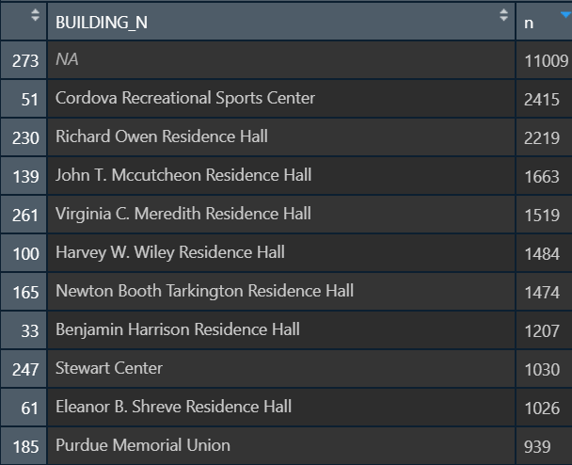
Figure 5: Top ten buildings by Twitter activity

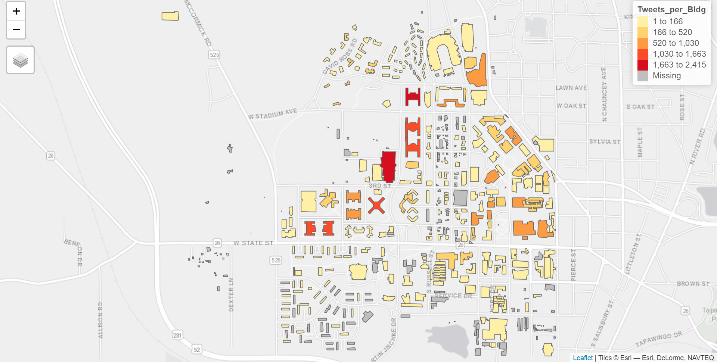
Figure 6: Thematic depiction of Twitter activity by building on the Purdue campus.

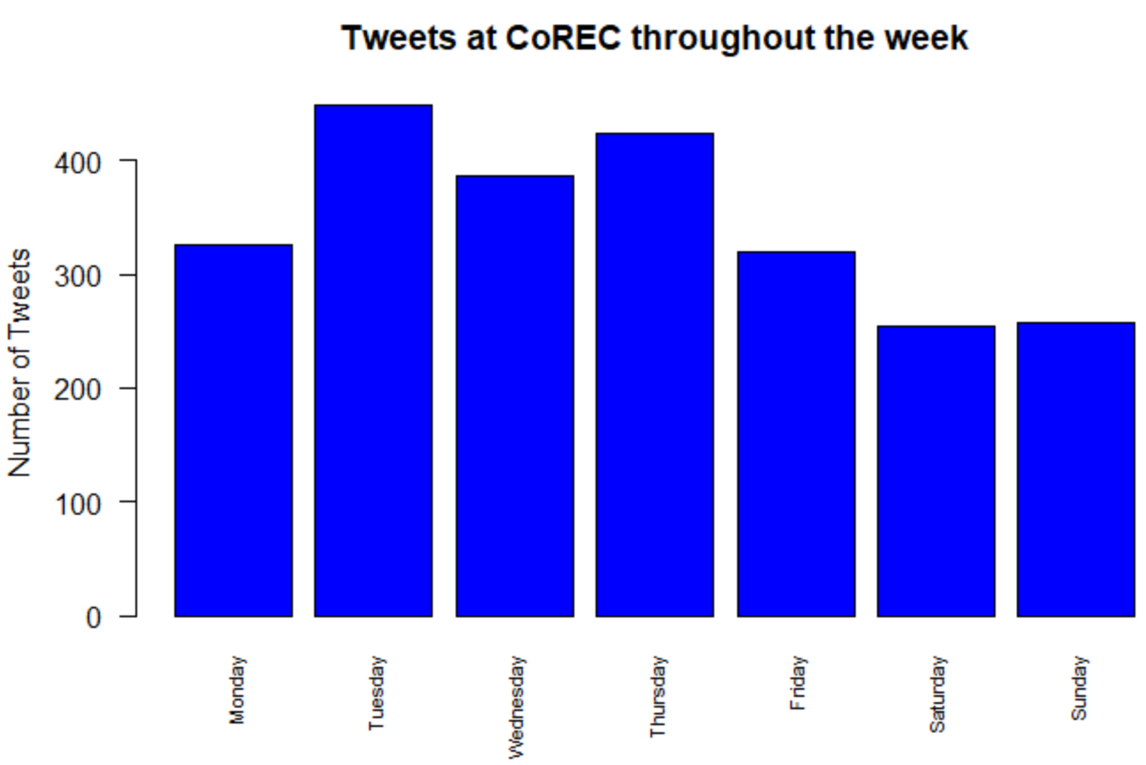Figure 7: Tweets at the Cordova Recreational Sports Center by day of the week.

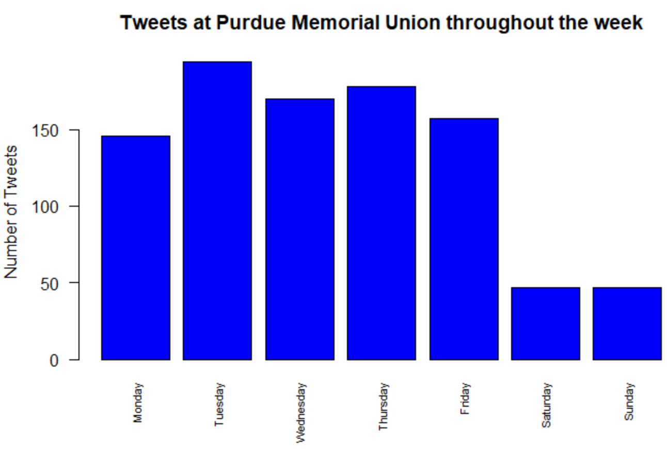
Figure 8: Tweets at the Purdue Memorial Union by day of the week.

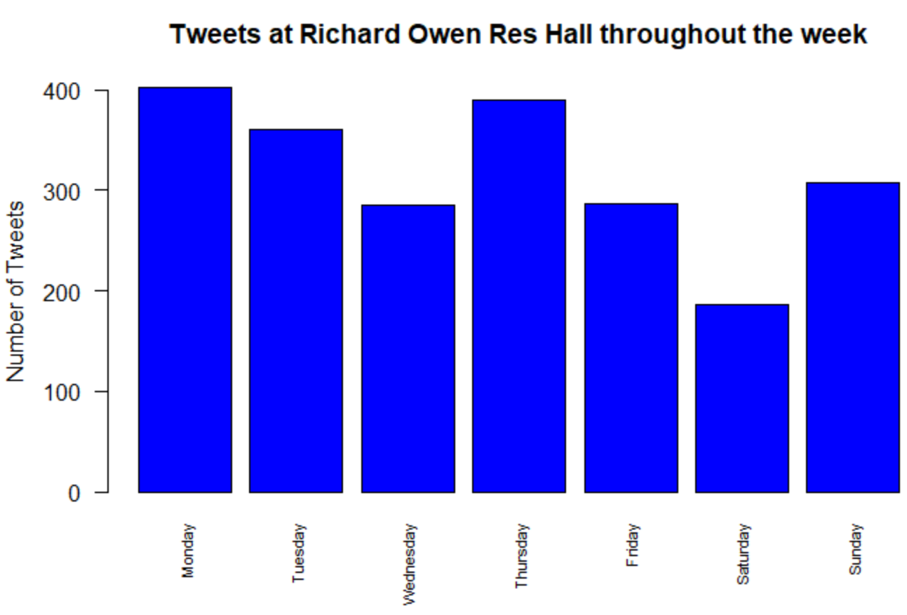
Figure 9: Tweets at the Richard Owen Residence Hall by day of the week.

