Project 5: Raster Analytics

- Objective:
The objective of raster analytics is to conduct analysis on raster data across a geographic area. This is often done with accompanying vector data that provides the geographic boundaries of the analysis area of interest.
- Introduction:
This lab uses a digital elevation model (dem) of the State of Indiana, the counties of the state, and the land cover and floodplain data of the state as well. The land cover data and the DEM are in raster format, this requires raster analysis based off the accompanying state county boundaries. The vector data that raster analysis is based on is very often political boundaries such as counties, states, or census tracts and blocks. The vector boundaries serve as the areas for the zonal analysis. In this assignment the primary zonal analysis conducted was calculating the slope and elevations of the counties, land cover classes, and the floodplain zones.
- Method
The DEM was provided but to begin the raster analysis the land cover data and the Indiana counties had to be downloaded. The land cover data was downloaded from the National Land Cover Database (see references), the vector data of Indiana counties was downloaded from “Indiana Map” which is maintained by Indiana University (see references). The floodplain was also downloaded from the ‘Indiana Map’ (reference 3).
To begin the analysis each dataset had to be projected into the same dataset and cropped to the boundaries of the state of Indiana. The most difficult dataset to deal with was the land cover data. This was originally projected into an Equal Albers projection since it covered the entirety of the continental U.S. It was also rather large and surprisingly difficult to crop and mask to the boundary of Indiana.
To calculate the zonal statistics the ‘exact_extract’ method was primarily used, the exception was when calculating the zonal statistics of the land cover data. I was unable to use ‘exact_extract’ because it can not do zonal statistics between two raster files. Again, using the ‘zonal’ function to calculate the statistics on the land cover data proved to be challenging. The extents and resolution of the DEM and the land cover rasters were not the same so they had to have the extents equaled and resampled.
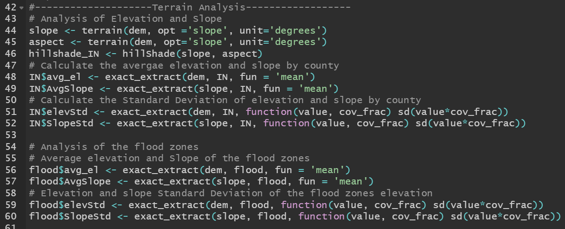
Figure 1: Calculating the elevation and slope zonal statistics.

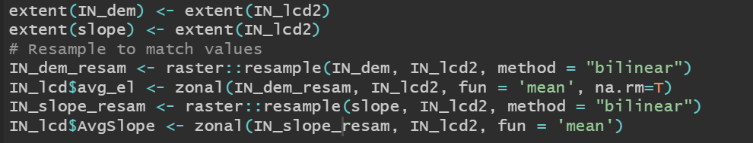
Figure 2: Calculating the statistics of the land cover classes.

Analyzing the data returned some interesting results. Slope is not correlated to elevation; one would think the higher the elevation the steeper the slope. However, in Indiana the highest elevations are basically on a plateau in the central eastern part of the state. The region of Indiana with the largest differences in slope, meaning the hilliest area, is the southern portion of Indiana south of Bloomington. This is evident when looking at the map of the average slope by county in Indiana when compared to the average elevation by county.
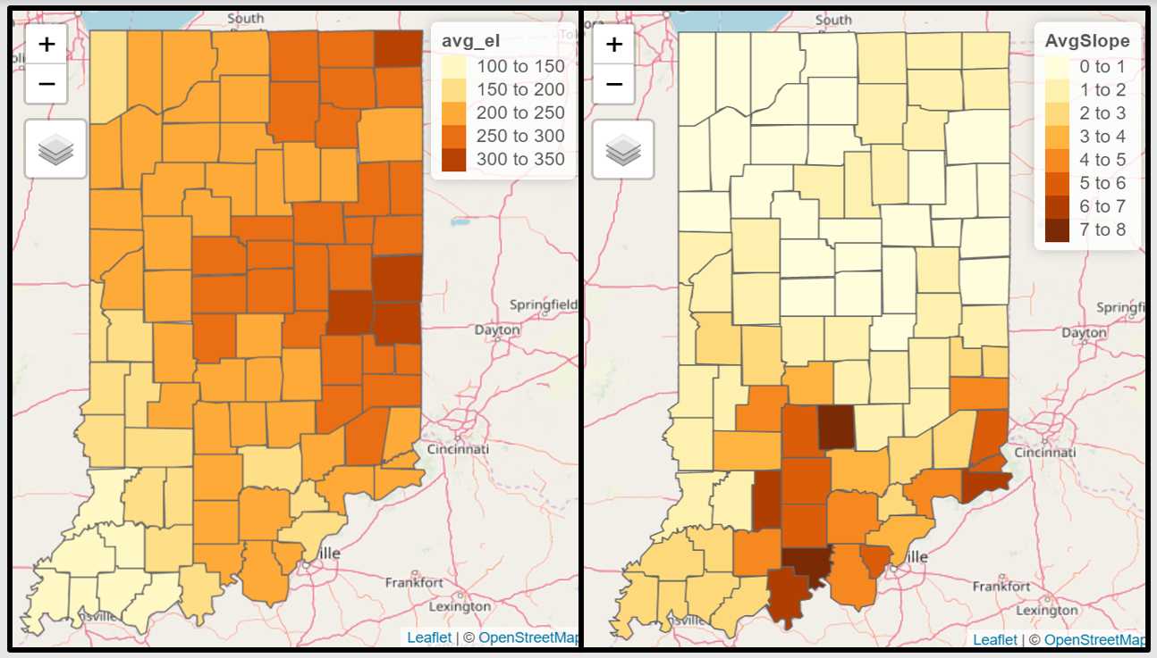
Figure 3: By county Indiana average elevation (meters) on the left and the average slope (degrees) on the right.

- Conclusion
Raster data in R can be very burdensome and time consuming. R does have the ability to deal with rasters, however, I feel this assignment is the first one where I truly felt that ArcGIS or QGIS would have been the preferred method of accomplishing the tasks. The land cover raster was especially burdensome. It’s original file size and the geographic extent proved to be difficult to re-project and crop it to the state boundaries. I also encountered many difficulties in trying to display the calculated data. RStudio has crashed many times and does not display the map even though no error messages are returned. Despite these challenges it was possible to conduct the zonal analysis and draw conclusions from the data.
References:
- National Land Cover Database (https://www.mrlc.gov/national-land-cover-database-nlcd-2016)
- Indiana Counties (https://maps.indiana.edu/layerGallery.html?category=Census)
- Indiana DEM (https://maps.indiana.edu/layerGallery.html?category=Floodplains)

Appendix:

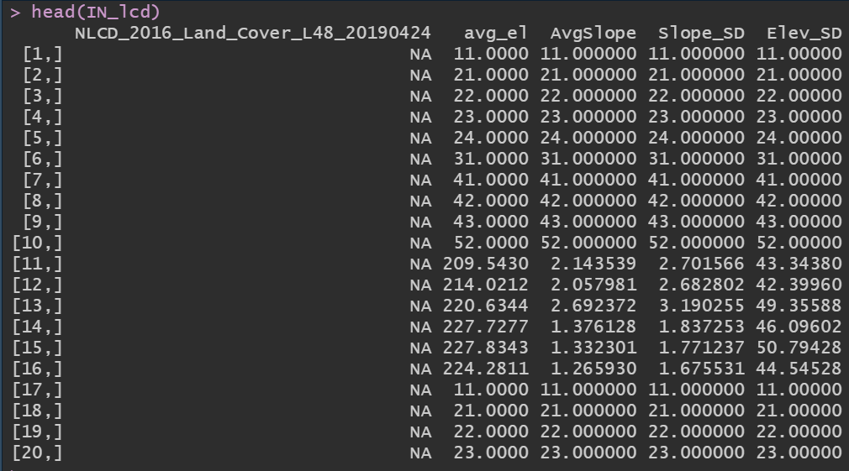
Figure 4: Indiana Land Cover Statistics. Attempting to map this in R routinely crashed the program.

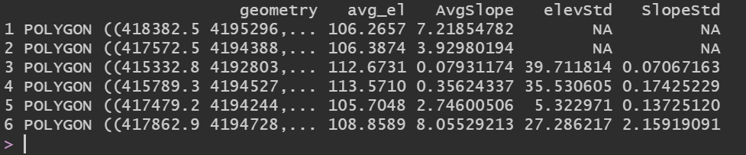
Figure 5: Flood Statistics, using 'head' command.

