Patrick McMillin

Phys 365 9/12/16

**Assignment 3_1**

**21)**

**Script to read and plot:**

% Reads diameter vs time data

% plots data

load partdim.dat

time = partdim(:,1);

diam = partdim(:,2);

% Plots

plot(time,diam)

xlabel('Time (s)')

ylabel('Diameter (mm)')

legend('Diameter')

title('Diameter (mm) V Time (s)')

**Command used:**

>> times_row = 10:10:201

times_row =

Columns 1 through 18

10 20 30 40 50 60 70 80 90 100 110 120 130 140 150 160 170 180

Columns 19 through 20

190 200

>> diameter_vs_time = [times_row',19.995+(20.005-19.995)*rand(20,1)]

diameter_vs_time =

10.0000 20.0014

20.0000 19.9988

30.0000 20.0031

40.0000 20.0003

50.0000 19.9985

60.0000 20.0044

70.0000 20.0038

80.0000 20.0005

90.0000 20.0012

100.0000 20.0009

110.0000 19.9971

120.0000 19.9980

130.0000 19.9997

140.0000 19.9973

150.0000 20.0034

160.0000 19.9969

170.0000 19.9973

180.0000 19.9967

190.0000 19.9973

200.0000 19.9994

>> save partdim.dat diameter_vs_time -ascii

>> partdim

**Plot:** 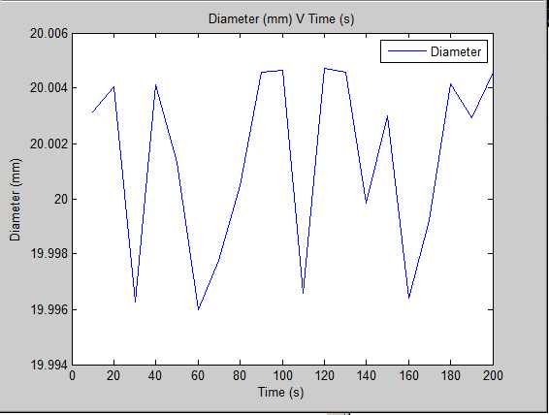

**23)**

**Function:**

function area = calcrectarea(length,width)

% Takes length and width and calculates the area of a rectangle.

area = length*width;

end

**Command:**

>> area = calcrectarea(4,5)

area =

20

**26)**

**Function:**

function ang_wavelength = makeitangular(wavelength)

% Takes a wavelength and calculates its respective angular wavelength.

ang_wavelength = wavelength/(pi*2);

end

**Command:**

>> ang_wavelength = makeitangular(70)

ang_wavelength =

11.1408

**28)**

**Function:**

function logicalval = isdivby4(num)

% Takes an integer and determines if that integer is divisible by 4.

logicalval = logical(0==rem(num,4));

end

**Command:**

>> logicalval = isdivby4(31)

logicalval =

0

**30)**

**Function:**

function logicalval = ispythag(a,b,c)

% Takes three positive integers and determines if the set of the integers

% forms a pythagorean triple (i.e. if a, b, and c satisfy a^2+b^2=c^2).

val = a^2+b^2;

logicalval = logical(c^2==val);

end

**Command:**

>> logicalval = ispythag(3,4,5)

logicalval =

1

**35)**

**Script:**

% Requests two values for the time constant of the exponetial decay

% function, along with the beginning and ending values of a vector 't'

% (this vector will serve as the bounds for the time axis). Then, a plot

% will be generated with two graphs (one for each time constant given),

% within the range of time specified by the user.

tau1 = input('Enter value for the time constant: \n');

tau2 = input('Enter a different value for the time constant: \n');

t1 = input('Enter a start time: \n');

t2 = input('Enter an end time: \n');

x = linspace(t1,t2,100);

y1 = exp((-1)*x./tau1);

y2 = exp((-1)*x./tau2);

plot(x,y1,'r')

hold on

plot(x,y2,'b')

ylabel('Exponential Value')

xlabel('Time')

legend('y1','y2')

title('Two exponential graphs with different tau values')

**Command:**

>> expon_plot

Enter value for the time constant:

1

Enter a different value for the time constant:

4

Enter a start time:

0

Enter an end time:

10

**Plot: (Next Page)**

Answer to the question: The decay rate decreases (meaning decay occurs slower) as the time constant increases.

