Patrick McMillin

PHYS 365 10/19/16

Assignment 8_2

**Chapter 14**

**40)**

**Script:**

% Prompts the user for the initial velocity and the angle at which a

% projectile is fired from the horizontal. Takes these parameters and finds

% the range of the projectile, plots the vertical position as a

% function of x, plots the height of the projectile as a function of

% time, and calculates the amount of time taken for the projectile to reach

% its maximum height.

g = 9.81;

v_0 = input('Enter the initial speed of the projectile: \n');

theta_0 = input('Enter the angle the initial velocity makes with the horizontal: \n');

t_roots = roots([-1/2*g v_0*sind(theta_0) 0]);

x_max = v_0*cosd(theta_0)*t_roots(2);

fprintf('The range of the projectile is %f m.\n',x_max)

t_to_y_max = t_roots(2)/2;

fprintf('The time it takes to reach max height is %f s.\n',t_to_y_max)

t = linspace(0,t_roots(2));

x = v_0*cosd(theta_0).*t;

y = -1/2*g.*t.^2 + v_0*sind(theta_0).*t;

subplot(1,2,1)

plot(x,y)

title('Position')

xlabel('x')

ylabel('y')

subplot(1,2,2)

plot(t,y)

title('Height v Time')

xlabel('t')

ylabel('y')

**Command:**

>> proj_motion

Enter the intial speed of the projectile:

100

Enter the angle the intial velocity makes with the horizontal:

45

The range of the projectile is 1019.367992 m.

The time it takes to reach max height is 7.208020 s.

**Plot:**

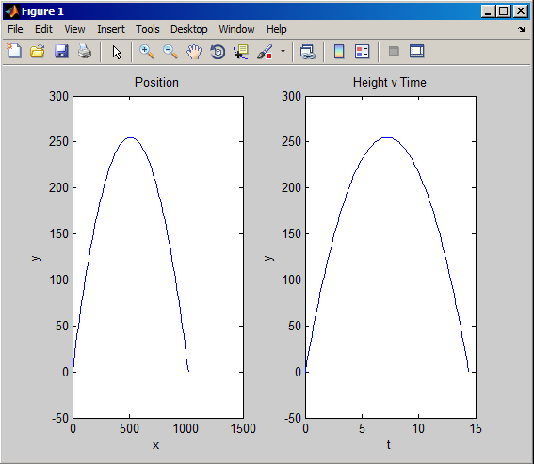

**Handout**

**1)**

**a)**

>> a = [15 35 -37 -19 41 -15];

>> b = [5 0 -4 3];

>> [q,r] = deconv(a,b);

>> poly2sym(q)

ans =

3*x^2 + 7*x - 5

>> poly2sym(r)

ans =

(5*x^2)/1125899906842624 - (5*x)/1125899906842624

**b)**

>> c = [4 6 -2 -5 3];

>> d = [1 4 2];

>> [s,t] = deconv(c,d);

>> poly2sym(c)

ans =

4*x^4 + 6*x^3 - 2*x^2 - 5*x + 3

>> poly2sym(d)

ans =

x^2 + 4*x + 2

**2)**