

Gnuaccounting

Manual

Table of Contents
1 Requirements, installation and start 5
1.1 System requirements 5
1.2 Installation 5
1.3 In Windows 5
1.3.1 With the installer package 5
1.3.2 With the Zip-file 5
1.3.3 In 64bit Windows 5
1.3.4 The portable version for USB-Sticks 6
1.3.5 Gnuaccounting standalone and OpenOfficePortable 7
1.3.6 Gnuaccounting and LibreOffice 7
1.4 In Linux 7
1.4.1 Ubuntu, SuSE 7
1.4.2 OpenSuSE experimental 7
1.5 Command line options 8
2 Set-up and settings 8
2.1 Set-up tasks 8
2.2 Numbers and formats 9
2.2.1 A sample format-string 9
2.2.2 Other formats 9
2.2.3 How to swap prefixes 10
2.2.4 Outgoing receipts 10
2.2.5 Incoming receipts 10
2.3 Simplifications for small enterprises 10
2.3.1 Net income determination 10
2.3.2 VAT-free sales 10
2.3.3 Tax on payment 11
2.3.4 SKR03 11
2.4 Configuration window 11
2.4.1 Options 12
2.4.2 Sales Tax 12
2.5 Settings window 12
2.6 Opening accounts 13
2.7 User management 13
2.8 Todo window 14
3 Accounting 14
3.1 Creating transactions 14
3.2 Templates 15
3.2.1 Template designer 15
3.2.2 Placeholder operations 18
3.2.3 Mandatory invoice elements, „powered by“ line 18
3.3 Private drawings and private deposits 19
3.4 Import from time trackers 19
3.5 Workflows: Cancellations, invoice reminders 19
4 Bookkeeping 20
4.1 Creating entries 20
4.1.1 Import 20
4.1.2 Selection 20
4.1.3 Entry details 21
4.1.4 Manage entries 22
4.1.5 Incoming Transaction Wizard 23
4.2 Accounting frame, create and manage accounts, account totals 23
4.2.1 Accounting frame 23
4.2.2 Create and manage accounts 24
4.2.3 Account reconciliation 24
4.3 Export window 25
4.3.1 Export as CSV 25
4.3.2 Export as ASCII 25
4.3.3 Export as Spreadsheet 25
4.4 Personal accounts 26
4.5 Managing contacts 27
4.6 Document management 27
4.7 Product management 28
4.8 Managing assets 28
4.9 List transactions 28
4.10 Managing VAT rates 29
4.10.1 Set-up 29
4.10.2 Default VAT 29
4.10.3 Tax field 29
5 Optional features 29
5.1 Backup and data versioning 29
5.2 External databases 29
5.3 HBCI-Chipcard banking 30
5.3.1 Set up 30
5.4 Winston 31
5.4.1 Set up 31
5.4.2 Usage 31
5.5 E-Mails 31
5.5.1 Set up 31
5.5.2 Usage 31
5.5.3 Groupware-integration 32
5.5.4 GPG/PGP 32
5.6 Barcoder-Tool 32
5.7 Online shop 33
5.7.1 osCommerce 33
5.7.2 Magento 34
5.7.3 Importing online shop orders 34
5.8 Tesseract OCR 34
6 Uninstalling Gnuaccounting 35
6.1 In Windows 35
6.1.1 After installation via the the installer 35
6.1.2 After installation via the ZIP-file 35
6.2 In linux 35
6.3 When using an external MySQL database 35
7 Troubleshooting 35
7.1 Gnuaccounting does not start 35
7.1.1 Possible reasons 35
7.1.2 Further diagnosis and workarounds 35
8 Appendix 37
8.1 Alternatives 37
8.1.1 Open Source 37
8.1.2 Freeware 37
8.1.3 Commercial 37
8.1.4 POS 38
8.1.5 Opensource or Freeware Windows only 38
8.1.6 Web based 38
8.1.7 Unclear license 39
8.1.8 Unclear if web based or rich client 39
8.2 Frequently used accounts 39

Requirements, installation and start

System requirements
The Java Runtime Environment and OpenOffice are required to run Gnuaccounting.
System requirements::
- Windows 8 or 7 or Vista 32-bit or a 64-bit with a 32 bit JVM or 32- or 64 bit Linux with the KDE window manager.
- 1GB of RAM,
- 1.3 Ghz CPU,
- A screen resoluton of at least 1024x768 pixels

Installation

In Windows

With the installer package
Start the installer. To access the default installation folder in the „programme files“ directory It will ask for Administrator privileges. You can change the installation folder in the first step of the installation,

You can then run Gnuaccounting via Start|All programmes|gnuaccounting|gnuaccounting

With the Zip-file
Right-click the Zip-fiie and select „extract“. Start gnuaccounting.bat in the extracted folder. Default MS Windows File Explorer settings will label .bat files as „MS Windows batch file“.

In 64bit Windows
This is only problematic if a 64-bit Java Virtual Machine is set as default. You will recognize it when nothing happens after starting gnuaccounting.bat by clicking on the gnuaccounting icon.
Please check by
- opening a command prompt (Windows-Icon “cmd<Return>” in the input field)
- invoke „java -version“

Sample output:
java version "1.6.0_24"
Java(TM) SE Runtime Environment (build 1.6.0_24-b07)
Java HotSpot(TM) 64-Bit Server VM (build 19.1-b02, mixed mode)

If the output contains, like in this case, „64-Bit“ , install and use Gnuaccounting portable, Java portable from http://portableapps.com/ or a separate 32-Bit („Windows x86“) virtual machine („JRE“), e.g. Java-SE-7 JRE from http://www.oracle.com/technetwork/java/javase/downloads/index.html

The portable version for USB-Sticks
Portable software does not need to be installed on the target system and if run from a USB stick does not leave any traces like files or registry entries on the system it was executed on.

To install gnuaccounting on a USB stick you will need a portable Java (http://portableapps.com/apps/utilities/java_portable) and a portable OpenOffice.org (http://portableapps.com/apps/office/openoffice_portable).

Gnuaccounting Portable requires the following directory structure:
Common parent directory, e.g. drive letter of the USB stick
  - gnuaccounting
  - Java
  - OpenOfficePortable
  - PortableGit (optional)
Install portable Java and portable OpenOffice.org into the same parent directory. The installation of portable Java will require an online connection. Extract Gnuaccounting from the ZIP-file and move the extracted Gnuaccounting folder below the parent directory as well.

When you start gnuaccountingPortable.bat in the Gnuaccounting folder, Gnuaccounting will use the currect (gnuaccounting) Folder to save files. You can now move the three directories anywhere, gnuaccountingPortable.bat should always start.

If you want you can save the history of your accounting data in a version control system like Git. In this case your accounting data will be checked in whenever you close gnuaccounting, enabling you to later retrieve the version of an arbitrary date.
Download Git portable for MS Windows from http://www.gitscm.org/ , usually in the „7z“ file format. Extract this file e.g. with 7-zip from http://www.7-zip.org or http://www.portableapps.com/7-zip) into the directory PortableGit.
Gnuaccounting will initialize the new Git-repository automatically when you start Gnuaccounting portable for the first time. New versions will be added to the repository whenever gnuaccountingPortable.bat is closed.

Gnuaccounting standalone and OpenOfficePortable
Using OpenOfficePortable from portableapps.com is mandatory for the portable version and optional for the non-portable version of gnuaccounting. Choose the “App\OpenOffice”-subdirectory in the selection of the OpenOffice.org directory (in Administration|Settings).

Gnuaccounting and LibreOffice
Select the LibreOffice-Directory as OpenOffice.org directory (in Administration|Settings) to use Gnuaccounting with LibreOffice.
Since LibreOffice 4 the exchange of some libraries (.jar) might be required: Just overwrite the libraries in libs/noa with those from LibreOffice, typically in it's program\classes directory.
cp /usr/lib/officebean/program/classes/officebean.jar libs/noa/
cp /usr/lib/officebean/program/classes/unoil.jar libs/noa/
Or sometimes
cp /usr/share/libreoffice/program/classes/unoil.jar libs/noa/
This is not required for Apache OpenOffice.org 4 and above.

In Linux

Ubuntu, SuSE
In Ubuntu 13.04, Kubuntu 12.10 or OpenSuSE 12.2:
Open a terminal, extract the Zip file, make gnuaccounting.sh executable and start gnuaccounting.sh
unzip gnuaccounting0.8.7.zip
cd gnuaccounting
In Ubuntu/Kubuntu and other Debian based systems you will have to manually install Java. Please use the next line – but please do not use it in OpenSuSE where Java is already installed.
sudo apt-get install openjdk-7-jre libreoffice-officebean

When using the default-installed LibreOffice 4 you will have to overwrite the LibreOffice/Openoffice and OpenOffice 4-libraries:
cp /usr/lib/officebean/program/classes/officebean.jar libs/noa/
cp /usr/lib/officebean/program/classes/unoil.jar libs/noa/
You can then start Gnuaccounting using
./gnuaccounting.sh

OpenSuSE experimental
Lumnis offers a Open Build Service repository for gnuaccounting. Some functionality may not work there:

sudo zypper ar http://download.opensuse.org/repositories/home:/lumnis/openSUSE_11.4/ 
lumnis
sudo zypper mr -r lumnis
sudo zypper in gnuaccounting
gnuaccounting
This should install and start Gnuaccounting from his repository.

Command line options
Parameter | Description
--configPath=<Directory> | This directory is used to save settings and create subdirectories to store data for all clients.  Use “.” for the current subdirectory or any other directory ending with \ (Windows) or / (Unix).
--officePath=<Directory> | The OpenOffice.org/LibreOffice in this directory will be used when Gnuaccounting is started.  Use “.” for the current subdirectory or any other directory ending with \ (Windows) or / (Unix).

Set-up and settings

Set-up tasks
The installation will provide you with sample customers, products, templates and taxes you are required to replace. The number in brackets of the caption of the „to do“ button on the main window will let you know how many tasks are still open.
Click the „to do“ button and follow the links to the tasks. Alternatively you could
- manage customers with Administration|Manage contacts from the main menu. At least replace the name of „sample customer“ with a real customer (see chapter 4.5)
- manage products with Administration|Manage products from the main menu. Change at least the product name „sample product“ (see chapter 4.7)
- enter company details in Administration|Settings. The bank details are also important. For details, refer to chapter 2.5.
- manage templates. Use the main menu's Administration|Templates and change anything, for example by removing the „this is a sample template“ paragraph and click save. Use the select box to switch to another template and repeat the process.
Created PDF-invoices are augmented by metadata in the ZUGFeRD-standard. For more complete ZUGFeRD-metadata please
- Enter the organization name, tax number and VAT ID in Administration|Settings|Company as well as
- IBAN, BIC and account holder in Administration|Settings|Bank Account

Numbers and formats
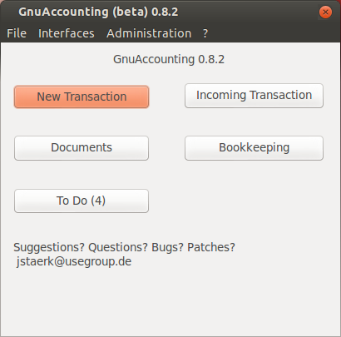Illustration 1: The main window
All incoming and outgoing documents have to be numbered sequentially. To change the format of those numbers access Administration|Numbers and Formats. Index is the next sequential number to assign to a document. You can for example set a different value when migrating from another software where some numbered documents have already been sent.
The index is increased by one per transaction of this type and shows on the document where the placeholder <number:value/> shows in the template.
- The format string determines the file name of the transactions and shows where the template indicates <transaction:number> i
- The prefix determines the filename of the template. If the prefix of a transaction is amended the template file will be renamed as well, so the prefix has to be unique.
- Period is the number of calendar days to calculate the deadline of the payment <transaction:dueDate> (see chapter 3.2)

A sample format-string
IN-<number:year/><number:month/><number:dayofmonth/>/<number:value/>
e.g. results in IN-20100430/15 if the fifteenth invoice is created on 30th of April 2010.

Other formats
The formats for numbers, currencies and languages are imported from the system: In Linux the locale settings, in Windows System|Time and language settings|Formats. Prefixes and sample values are created with the system language when Gnuaccounting is started for the first time.

How to swap prefixes
If you accidentally started Gnuaccounting on a german system for the first time and you want to migrate to an english translation the easiest way would be to delete your ~/.gnuaccounting directory (see deinstallation).
To prevent data loss you would not delete ~/.gnuaccounting but adjust the prefix of the german transaction type Invoice („Rechnung“, RE) before you can change the prefix of reminder (Mahnung, MA) to RE for reminder.
Since transactions are usually subject to a certain workflow you can not create or delete transaction types.

Outgoing receipts
Outgoing receipts are, besides invoice and credit note: shipping ticket, reminder, receipt, offer, cancellation and private drawing. The types “receipt“ and “cancellation“ can also be used for internal receipts.

Incoming receipts
Usually transactions produce outgoing or internally used receipts, e.g. invoices to customers or private drawing receipts for owners.
However, since bank transactions are automatically linked to their document number when a format (as defined in numbers and formats) is recognized it can make sense to „abuse“ an otherwise unused transaction type as an indicator for incoming receipts. If you assign INCOMING-<number:value/> and indicate your incoming transaction number in the purpose field (e.g. “Your invoice <their number> from <date> ournumber INCOMING-<your number>“) the bank transaction will automatically be linked to INCOMING-<your number> when it's imported into your accounts.

Simplifications for small enterprises

Net income determination
If your company does not have to submit a balance sheet a net income determination usually suffices. For this kind of accounting it is possible, although not required, to use double-entry accounting. The net income determination in gnuaccounting is still experimental. It can be accessed via Interfaces|Export as spread sheets in the spreadsheet workbook “Net income determination“.

VAT-free sales
Some businesses do not need to invoice value added taxes: some countries and regions don't have VAT, in many european countries there is a minimum annual turnover below which you can opt-out of VAT.

Since in this case the authorities also won't reimburse on VAT spend on the invoices of other companies select Administration|Taxes, select the 0% VAT and click the “Standard” button to mark it as default VAT for incoming invoices (“Book with standards” stack, see chapter 4.1.1).

For outgoing invoices it is sufficient to select 0% VAT for all products in the product management screen.

Tax on payment
Usually value added taxes need to be payed to the authorities when the goods have been delivered or the service has been provided (tax on issue). If you are eligible to and have selected tax on payment you need to pay these value added taxes only when the customer balanced your invoice, not when you have provided the service.
You can set up tax on payment in the respective select box in Administration|Settings under the tab “Company”.
Effects:
An invoice over a net value of 100 Euro would be booked as follows:
1400 Forderungen to 8400 Erlöse 100
1400 Forderungen to 1776 Ust 19
and when the invoice is balanced
1200 Bank to 1400 Forderungen 119
With tax on payment, however, the invoicing will be booked against to 1766 Ust nicht fällig
1400 Forderungen to 8400 Erlöse 100
1400 Forderungen to 1766 Ust nicht fällig 19
and will be booked on 1776 when balanced as follows:
1200 Bank to 1400 Forderungen 119
1766 USt to 1776 Ust 19

SKR03
“Standardkontenrahmen” SKR is a set of german standard accounting charts issued by the DATEV organisation. It's chart 03 is not per se directed at small businesses but some german tax advisers recommend SKR03 for corporations and sole proprietorships and SKR04 for enterprises.
You can select the accounting chart in Administration|Settings in the tab “Company”.

Configuration window
Those settings which affect the whole application and are not client specific can be accessed in the configuration (Administration|Configuration).
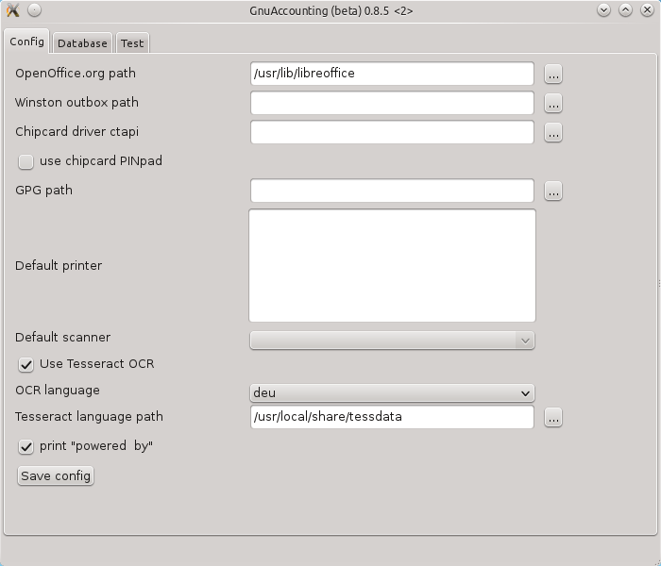Abbildung 2: Configuration window
Gnuaccounting will attempt to auto-detect the OpenOffice.org(or LibreOffice)-directory, which is the only mandatory setting. Click the buttons with the three dots next to a directory setting to open a directory selection dialog.
If you use portable versions of OpenOffice.org please select the directory above the „program“ subdirectory.

Options
To configure Winston, GPG and HBCI (Chipkartendriver respectively PINpad setting) and for text recognition settings (Tesseract and OCR language) as well as the tab „Database“ please refer to chapters 5.4, 5.5.4, 5.3, 5.8 respectively 5.2.
Unselect the „powered by“ checkbox to switch of the „powered by Gnuaccounting“ footer beneath your transaction PDFs and prints.
The tab „Test“ appears shortly after saving and when Gnuaccounting is started and only remains open is the settings are incorrect. There are no configurations to be done in the „Test“ tab.

Sales Tax
Sales tax can be activated in Administration|Settings Sales tax. After activation,
- Product management (chapter 4.7) will provide a second (sales) tax selection besides the usual VAT selection.
- Customer management (chapter 2.7) provides a checkbox for sales tax exempt customers,
- Transaction creation (see chapter 3.1) shows a checkbox for sales tax exempt transactions. When selecting a sales tax exempt customer this checkbox will be preselected.
- Additionally, a salestax-placeholder (see chapter 3.2.1) will be available.
Sales tax rates are managed like VAT rates in Administration|Manage tax rates (see chapter 4.10).
Canada
The usual VAT-functions can be used to emulate the canadian Harmonized Sales Tax (HST) but in some provinces an additional Provincial Sales Tax (PST) might apply to some products or services. In Quebec the according PST is called TVQ. PST and HST are treated like VAT, which means that a new PST rate is defined like a new HST rate and all applicable rates (PST and HST) are listed in the <taxes:list> placeholder.

Settings window
Client-specific data, like the name of the company, can be entered in the settings window (Administration|Settings).

Organization name, tax number, state, IRS office and the frequency of your VAT announcements are important for the Winston-Export, name, street, zip-code, city and (two character) country (code), tax and VAT-ID as well as the tab „Bank details“ for the ZUGFeRD-export. Organization name, as well as the tab „Bank details“ are also required for the BezahlCode-support (placeholder <transaction:bezahlcode>).

Accounting chart (= accounting frame), the selection between „tax on issue“ and „tax on payment“ as well as the „VAT extempt“-selection are used for internal purposes and e.g. affect the spreadsheet, CSV (Datev) or ASCII (Addison) export. Fiscal year is used to filter the entries in some windows.

The DocTag-Standard can be embedded as QR-Code (placeholder <transaction:doctag>) and/or directly into the PDF-metadata if „DocTag in Metadaten“ is activated. The current DocTag version (0.6), however, does not support PDF-standard-compliant RDF-metadata, which is why this option is deprecated and deselected by default. This switch only affects the DocTag export, in the import also the non-compliant metadata will be imported.
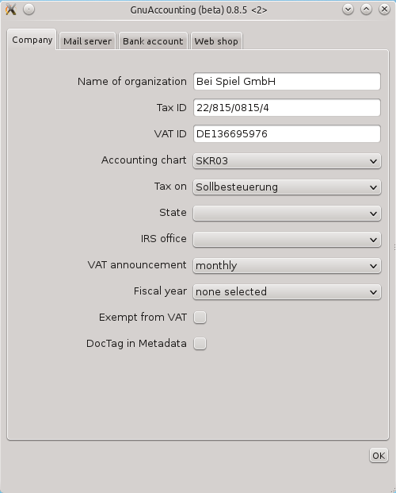Abbildung 3: Settings window

For details on the „Mailserver“ tab please refer to chapter 5.5, for details on the tab „Webshop“ please refer to chapter 5.7.

Opening accounts
You have to create an entry for the initial account balances, e.g. for cash and bank account. Use „New“ in the „Bookkeeping“ window. The contra account is the opening account (e.g. 9000 in SKR03).
Example:
400 Euro cash and -120 Euro on the bank account.
Since assets like bank or cash increase in debit the following entries have to be created:
1000 Kasse (Debit) on 9000 “Saldenvorträge” 400 Euro.
9000 “Saldenvorträge” (Debit) on 1200 Bank 120 Euro.

User management
User management (Administration|User management) allows different users to authenticate when starting Gnuaccounting. If multiple users are supposed to access Gnuaccounting synchronously a database should be set up in the network and Gnuaccounting configured accordingly.
To activate user management you have to assign a password to the administrator user.
The creation of a new user will be delayed until a administrator password has been set.
Gnuaccounting will ask for credentials when it is started and more than one user (Administrator) is configured or a custom administrator password has been set. To switch to another user you will have to quit Gnuaccounting.

Todo window
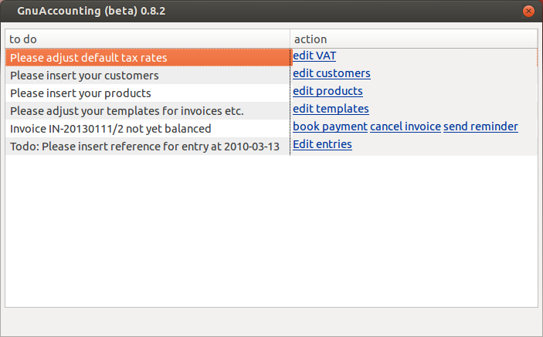Illustration 4: to-do entries
The todo window (button „to do“ on the main screen) lists open tasks, which can be necessary for the initial program set-up (remember to customize the templates), reminders for due payments or for missing document numbers. The number of open tasks is written in brackets behind the button text.

Accounting

Creating transactions
You can create
Illustration 5: Second step: selecting items
- invoices,
- credit notes,
- private drawing reciepts
- shipping tickets
- receipts
by clicking on the „New transaction“ button of the main window.

Then choose the type of transaction, recipient, and date and in a second step the items of the transaction.
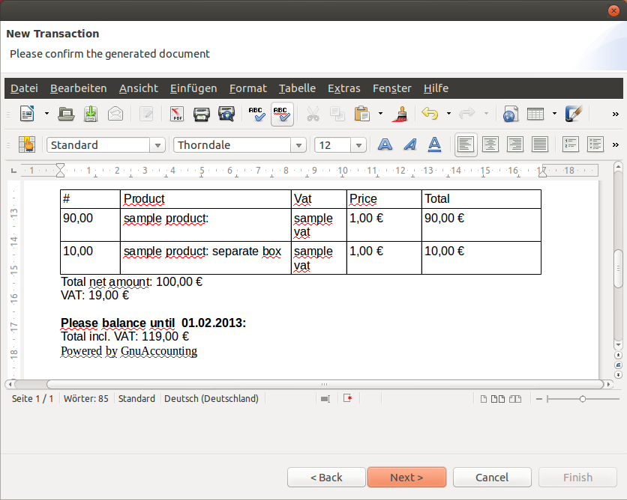Illustration 6: New transaction third step: Preview
Please be aware that you can select articles by clicking the small downward arrow and selecting the article with the mouse, by entering the name of the article with the keyboard or by entering the EAN of the article with keyboard or barcode reader.
You can check the generated document in the third step and choose if you want to print or e-Mail the receipt in the fourth step of the wizard.

In the fourth step you can also select the checkbox „paid in cash“. If you don't, open invoices will be booked in „accounts receivables“ and can be balanced using the overview in the todo window (button „to do“ on the application main screen).

Additionally to the created OpenOffice (.odt)-files each invoice is accompanied by .xml-files in the OpenTrans-format (http://www.opentrans.de/) as welll as a PDF-file. The PDF-file complies to the standad for archivable PDFs PDF/A-3a (ISO 19005-3) and contain additional meta data (like item price, total and tax amount, sender organization inclusive bank details, tax number and VAT-ID) conforming to the „Release Candidate“ of Version 1 of the ZUGFeRD-standard http://www.ferd-net.de/.

Templates
You can design your documents (invoices, credit notes, cancelations, reminders, offers, private drawings, receipts and shipping tickets) manually, or using the embedded template designer. The filenames of the templates are prefixed by the transaction prefix, I.e.: ~/.gnuaccounting/0000/
- IN-template1.odt
- CR-template1.odt
- CA-template1.odt
- RE-template1.odt
- OF-template1.odt
- PD-template1.odt
- RC-template1.odt
- SH-template1.odt
These files may have to be designed manually on unsupported platforms like Gnome.

Template designer
The template designer can be accessed on the main menu Administration/Template designer.
Placeholders are:
Placeholder | Description
<items> | Items start: all items need to be in a block enclosed by <items> and </items>
<item:name> | Name of the product
<item:description> | Description of the product
<item:quantity> | Quantity specified in the transaction
<item:index> | Number of this line
<item:ean> | The European Article Number of the product
<item:unit> | Unit of the product
<item:remarks> | Additional text line specified in the transaction
<item:price> | Net price of a single product
<item:pricegross> | Gross price of a single product
<item:total> | Total net sum (product net*quantity)
<item:totalgross> | Total gross sum (product net*quantity)
<item:vat> | VAT rate of the product
<item:salestax> | Sales tax, see chapter 2.4.2
</items> | Items end: all items need to be in a block enclosed by <items> and </items>
<customer:number> | Customer ID
<customer:name> | Customer name
<customer:co> | C/O line of the customer
<customer:additional> | Additional address line of the customer (e.g. building)
<customer:street> | Street and house number
<customer:zip> | Postal code
<customer:location> | City
<customer:country> | Country
<customer:email> | Customer's E-Mail-Address
<customer:phone> | Phone number
<customer:fax> | Fax number
<customer:vatid> | The (european) VAT ID of the customer
<customer:iban> | IBAN of the customer
<customer:bic> | BIC of the customer
<customer:mandate> | SEPA-mandate for the customer
<sender:name> | Your organisation name (as defined in the settings)
<sender:street> | Street and number of your company
<sender:zip> | Your ZIP code
<sender:location> | Your city
<sender:country> | Your country
<sender:bic> | Your BIC as defined in the bank settings
<sender:iban> | Your IBAN
<sender:creditorid> | Your SEPA creditor ID
<sender:vatid> | Your VAT ID
<sender:bankname> | The name of your bank
<sender:holder> | The name of the holder of your bank account
<customer:mandate> | SEPA mandate for the customer
<transaction:number> | Number of this document
<transaction:duedate> | Date when the amount has to be paid. Please refer to for possible operations on this placeholder.
<transaction:date> | Date when the transaction was created
<transaction:remarks> | Remark specified when creating the transaction
<transaction:total> | Total (net) sum amount of all items
<transaction:totalgross> | Total (gross) sum of all items
<transaction:bezahlcode> | Inserts a BezahlCode-QR-Code (refer to http://www.bezahlcode.de)
<transaction:doctag> | Inserts a DocTag-QR-Code
<transaction:performedfrom> | The start of the performance or delivery date.
<transaction:performedto> | The end of the performance or delivery date.
<transaction:performedperiod> | If there is a difference between performance start and end this will be „performancestart – performanceend“, otherwise it will be the performance start date. As this is a period, not a date, date operations are not applicable.
<vat:total> | Total amount of VAT included
<vat:list> | List of VAT rates used with their respective amounts
<taxes> | If VATs are supposed to be listed in a table, the according <tax:...> elements need to be in a table with one line (to be repeated for each VAT rate) is enclosed by <taxes> and </taxes>
<tax:name> | The descriptive name of the VAT rate
<tax:net> | The total net amount the VAT rate is applied upon
<tax:amount> | The total tax on the respective net amount with the respective VAT
</taxes> | Closing tag for taxes, see <taxes>
<payment-deduction>...</payment-deduction> | Everything within this placeholder, including other placeholders, is only shown if  - the recipient's payment method is deduction  - the recipient has a IBAN  - there is a SEPA mandate entered for the recipient  - you have a SEPA creditor ID  - you have a IBAN.  This placeholder is supposed to be outside of a table.
<payment-invoice>...</payment-invoice> | The opposite of <payment-deduction> (not all of the listed conditions are met) to be used for your „Please pay (amount) until (duedate)“ text.

Placeholder operations
Currently one operation – period-add – can be applied on all date placeholders, i.e. <transaction:date>,<transaction:duedate>, <transaction:performedfrom> and <transaction:performedto>. It adds a specified number of
- calendar days (day or days)
- weekdays (weekdays) or
- Target2-working days (workingdays)

to the element it is applied to and is supposed to cater the need for a indication, when a SEPA deduction will take place. Usage:
period-add="<number> days"
e.g. <transaction:date period-add="5 days">.
Please take note that this adds a period on a date and is therefore not applicable to non-date placeholders like <transaction:performedperiod>.

Mandatory invoice elements, „powered by“ line
Please seek professional advice if you are in doubt what to put on your invoice, In Germany, according to Wikipedia, some attributes are mandatory for invoices with a gross amount exceeding 150 Eur:
- Date
- Issuer company name and tax number
- Recipient
- Invoice number
- Items with quantity and description
- date(s) when the items or services have been supplied or performed
- net amount, tax rate and tax total, in some cases exemption from taxes
The text „powered by Gnuaccounting“ is not mandatory and only will be inserted at the end of each document if not disabled in the settings (Administration|Configuration).

Private drawings and private deposits
The capital of an sole proprietorship or association can be increased or decreased (private drawing) by the owner.
Private drawings are an ordinary transaction type (Main Window, Button „New transaction“, select „Private drawing“ from the select box. For private deposits use a negative value.

Import from time trackers
To create invoices for service providers Gnuaccounting supports importing data from time tracking applications via Interfaces|Import from time tracker. Available import formats are KTimeTracker CSV exports (Ktimetracker is part of the Linux-KDE-package KdePIM), Taskcoach (http://www.taskcoach.org) and the mobile time tracker „Gleeo timer“.

The option „Round to 5 minutes/2 decimals“ will round as follows:

Minutes | Value
0 | 0
5 | 0.08
10 | 0.17
15 | 0.25
20 | 0.33
25 | 0.42
30 | 0.5
35 | 0.58
40 | 0.67
45 | 0.75
50 | 0.83
55 | 0.92

Workflows: Cancellations, invoice reminders
When creating an invoice it will be recorded as open and shown in the „To Do“ window (Main Window, button „To Do“) until it is balanced.

This item can be balanced:
- explicitly with the link „Balance“ in the To-Do list. If you use HBCI the screen activated by the „Balance“ link also allows to directly debit the bank account of the debtor in case of an invoice or directly credit the creditor's bank account in case of a credit note.
Please note that the value added tax is already booked when creating the invoice so the detail booking window will show the gross amount without indicating the VAT amount separately.
- explicitly with the link „Cancel“ in the to-do-list. This link opens a new cancel-transaction with an according comment and all invoice items.
- explicitly with the link „Remind“ in the to-do-list. This link opens a new cancel-transaction with an according comment and all invoice items.
- implicitly via the „Import queue“ window when a bank statement is imported by HBCI or a homebanking software export file: If you select the document number of an open transaction in the column „Document“ the transaction will automatically be balanced.

When a invoice is balanced the only place to see a copy is the link „view“ in the Documents -window. Please note that cancellations and reminders can not be created with the “New transaction” button on the main window as they have to refer to other transactions.

Bookkeeping

Creating entries
Outbound records, e.g. invoices and credit notes are automatically added to the according ledgers. You can manually create entries but the recommended workflow is the creation of entries from the import of bank statements:

Import
Import your bank statement via HBCI or from a export file of your banking software (supported formats: Moneyplex XML export, Starmoney, Hibiscus and CSV export of the german Volksbanken). On the first page please select the file to import and the bank account in your internal accounts (in SKR03 this will most likely be 1200 or a sub-account).
You can import bank statements (Interface|Import from Bank statement) either from previously exported files or directly via HBCI. To import sample data delivered with Gnuaccounting click the browse button next to Moneyplex XML and select the file toimport-moneyplex.xml in the Samples-folder of your Gnuaccounting installation directory.
The import won't overwrite existing entries, no matter if they have already been assigned and booked. The contact for the payments will be matched with the bank details of the entry in the bank statement and will be automatically created if the according bank details do not yet exist.

Selection
In the second step of the wizard choose a VAT rate, the contra account and enter the document number. The document number may be recognized automatically if the purpose field shows a number in a format as defined in „Numbers and Formats“. Select the table row and drag it into the „Book“ stack. If additional details have to be added, e.g. because the incoming invoice entails multiple different VAT rates move the row to the „Details“ stack. If you want to add the document number later please enter <todo/> as document number, this will then open an according reminder in the todo window (Main Window|todo button).

To drag&drop entries into the stack „Book with standards“ please just assign the according document number in the table view. If the amount of the row you then drag into the stack is positive, „standards“ will automatically book (with 19% VAT on) 8400 Erlöse, if it's negative it will assume (19% VAT and) account 3100 Fremdleistungen.
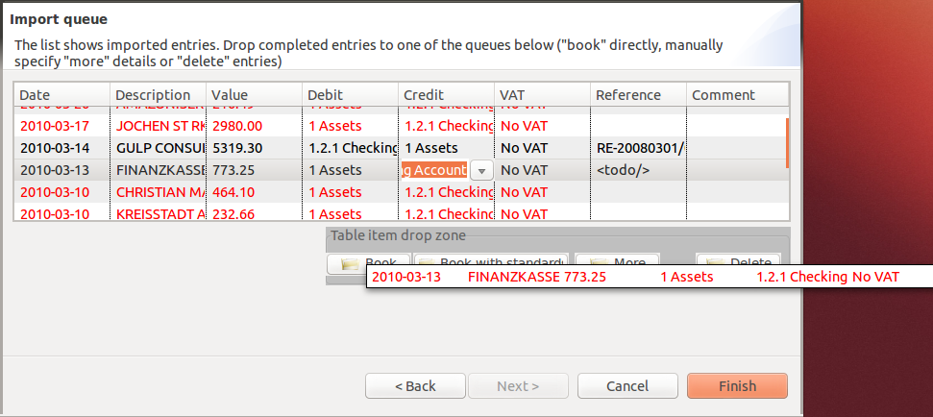Illustration 7: Assignment of entries imported from a bank statement

You can easily delete entries in your import queue by dragging them to the „delete“ stack. You can select multiple table rows at once by holding the CTRL-key while clicking the rows.

Changes in this screen will be lost when you quit Gnuaccounting.

By clicking on a column headers the table can be sorted according to the column values. A second click reverses the sort order.

Entry details
The window for entry details is invoked from
- the import of bank statements if entries are moved to the „details“ stack,
- the accounting edit window (button „New“)
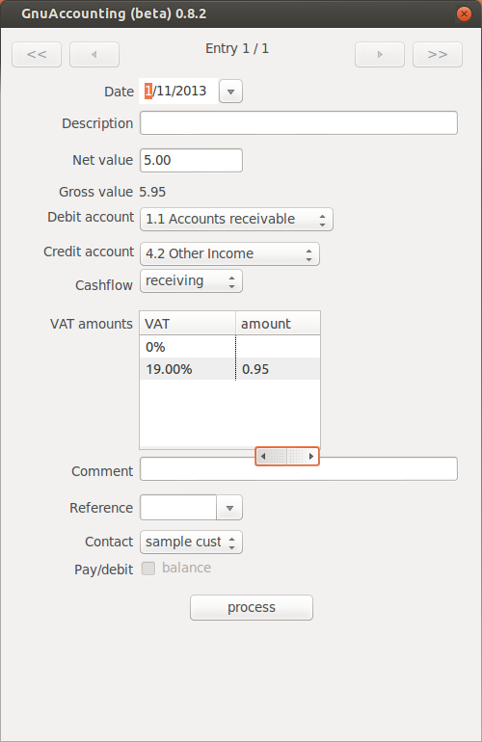llustration 8: Entry details
- when balancing a payment via a link in the „to do“ window.

The table in the middle lists all tax rates that have been entered in Administration|Taxes.

For received invoices the according values can be amended. In outgoing transactions the values of the VAT table will be filled automatically according to the total VAT of the items with the according rate but this step is hardly visible: usually you will see this window only when balancing a setteled invoice and VAT and the net amount are booked against a single liabilities account when the invoice is created: at the time the invoice is balanced you will book the gross amount against liabilities, the VAT table will be empty.

The contact (customer or supplier) is also selected automatically when a transaction has been created by the software itself. When importing from bank statements the contact is matched by his/her bank details and created if those details were not found.

The detail booking window is the only window to allow HBCI debit or credit operations. Just select „Pay/debit“ before you click „process“. This is only possible for sent invoices if bank details are stored for the recipient and „debit“ is selected as payment method for the according customer in the „business contacts“ window.

If you put multiple entries in the details stack in the „Import from bank statement“ wizard the number of entries is written in the top of the window and it is possible to navigate to the next, previous, last respectively first entry with the right, left, right-end respectively left-end arrow buttons at the top.

Manage entries
The button Bookkeeping on the main window will direct you to the screen where you can edit, delete and add ledger entries.
When creating invoices or when importing from bank statements the transactions are splitted to entries, e.g. one entry for the net value and one for the VAT. Since this screen edits entries it can not assist in the selection or change of VAT: This has to be done manually by changing, creating and deleting entries, the usual select box for the VAT rate is not applicable for this screen.
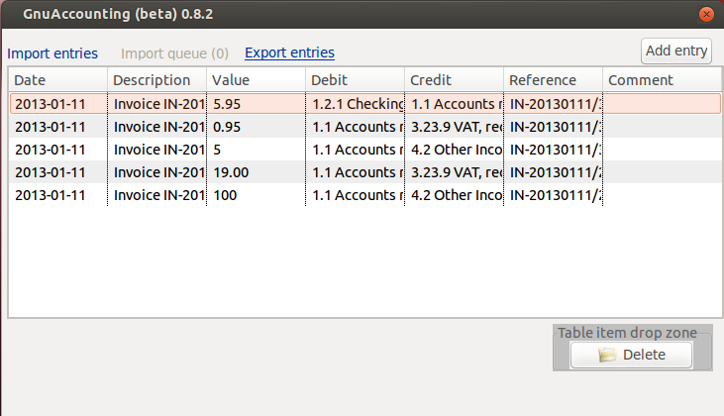Illustration 9: Managing ledger entries
The table can be sorted by clicking on the column headers. A second click reverses the order.

Incoming Transaction Wizard
The Incoming Transaction Wizard will propose the next number for incoming references (Administration|Numbers and Formats). You can specify the incoming invoices' total gross amount, select a VAT rate and the sender of the invoice (=the recipient of the payment). If the requirements for chipcard banking are met (see chapter 5.3) and bank details were stored for the sender in contact management, the „Balance“ checkbox and the purpose field will be enabled. If the „Balance“ checkbox is checked, the gross amount will be electronically transferred when the user clicks Finish. This transfer will mention the purpose the user entered.
Illustration 10: The wizard for incoming transactions
With the browse button you can additionally attach a file, e.g. a electronic copy of the invoice as PDF.
With the scan button you can capture the paper document from your scanner.

Afterwards the following steps will extract metadata
- a scan for barcodes (a barcode can propose a incoming document number) as well as
- QR-Codes (QR-Codes conforming to the BezahlCode-standard (http://www.bezahlcode.de) will fill Amount, Purpose and bank details of the sender = payment recipient).
- When importing a PDF-file: scan for ZUGFeRD-metadata complying the ZUGFeRD-standard version 1 release candidate (http://www.ferd-net.de)
- When import a PDF-file: scan for DocTag-daten confirming the DocTag-standard 0.6 (http://www.doctag.org)
- When importing files: scan for potential incoming document numbers in the file name.

Accounting frame, create and manage accounts, account totals

Accounting frame
Use the main menu (Administration|Accounts) to manage accounts.

Gnuaccounting uses the german „Standard-Kontenrahmen“ 03, SKR03 as accounting frame. The accounts, in particular the codes, should only be amended if urgently needed: The software expects some account codes to exist and some might also be mentioned in the OBDX export attached to the mails to customers and suppliers.

Create and manage accounts
Use the account management window (Administration|Accounts) to create new accounts: select „New account“, enter the description the according text fields and click save.

You can easily create new accounts with new codes but it is recommended to stick to the numbering scheme. You can see in illustration 11 (unten) the account 1201 Tagesgeld which was created by the user as 1201 because it is related and similar to the ordinary bank account (1200 Bank).
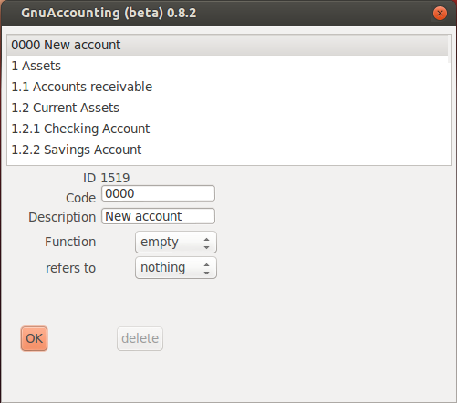Illustration 11: Account management.

Accounts are of a certain type (asset, liability, expense or revenue) and can – or can not – refer to contacts.

Usually one would an account for each customer or supplier for „outstanding debits“ or „liabilities“. This is, however, a lot of administrative overhead and then complicates the accounting because some accounts must show the sum of their sub-accounts to see e.g. the total outstanding debits to any customer. Gnuaccounting behaves more like a customer relationship management and will automatically link the transactions and entries to the selected contacts. In „reference“ you can select whether this account must be linked to none, any contacts (contacts), only to customers, or only to suppliers or only for owners and associates of a company (partners) which e.g. makes sense for private drawings.

Account reconciliation
Select Administration|Account reconciliation to compare periodical account totals with other sources, e.g. you physical bank statement. Enter the start of an account code in the search as you type box and hit enter after selecting the according account. Select the „monthly“ radio box for monthly totals and „Daily“ for daily totals. „Details“ will list all entries and allow a very close inspection which entries might be wrong or missing.
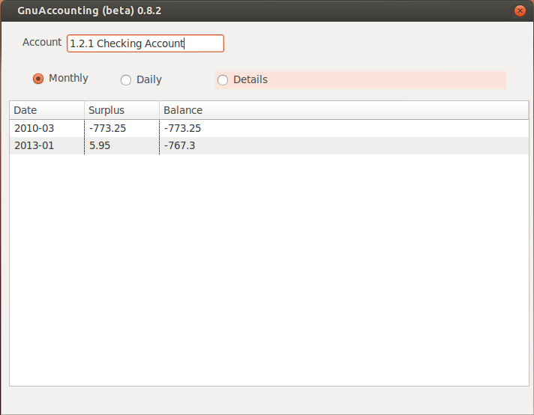Illustration 12: Monthly totals of the checking account

Export window
Interfaces|Export as spread sheet will show your ledgers in an embedded OpenOffice.org Calc window. Please select the period first (first and last day of the selected period will be exported as well). Click “Next” to export as spread sheet.

Export as CSV
Click Interfaces|Export as CSV to create a file suitable for DATEV Kanzleibuchhaltung. Chose the period in the second step and the export file name in the third.

Export as ASCII
Interfaces|Export as ASCII will create a file suitable for the software vendor Addison. Chose a period in the second step as well and the filename of the file to be exported in the third step.
In Addison itself, use the Import (Datenübernahme), select (ASCII-Import-Treiber) „ASCII-Import“ as driver and the exported file as “Importdatei”. You will find a suitable definition file (Konfigurationsdatei) in the Gnuaccounting-directory in the “Samples” subfolder (gnuaccounting-addison.cfg).

Export as Spreadsheet
After pressing “Next” you can save the spreadsheet using File|Save in the embedded OpenOffice Calc window. Apart from OpenOffice ODS you can also save in the Microsoft(r) Excel(tm) format XLS or print (File|Print) the spreadsheet.
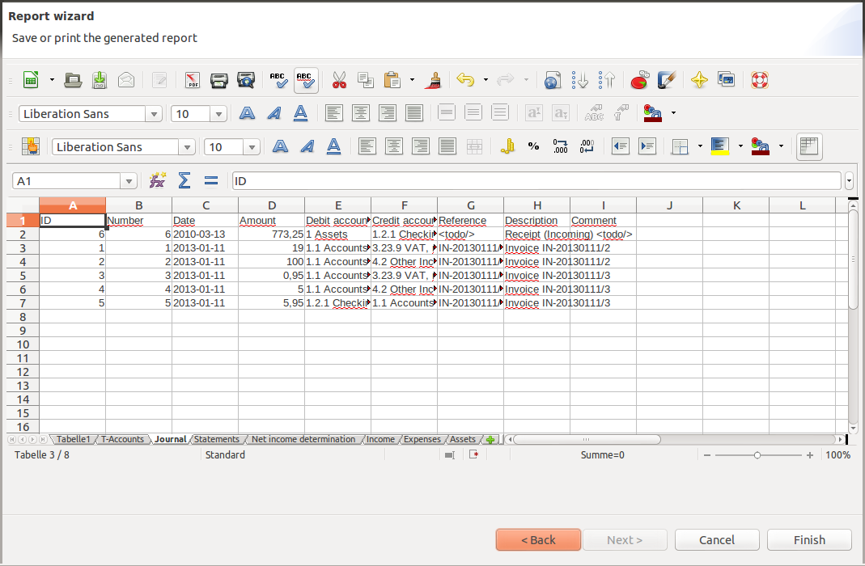Illustration 13: Third worksheet of the spreadsheet export

As you can see from the tabs in the lower part of the Excel document multiple worksheets are created.

- Sheet 1: List of accounts with their totals
- Sheet 2: T-Accounts
- Sheet 3: Journal
- Account statements
- Net income determination
- Income
- Expenses
- List of assets

Personal accounts
Usually one sub-account is created for each debitor and creditor below the Receivables (e.g. 1400 Forderungen) and liabilities accounts (1600 Verbindlichkeiten), e.g. 1401 Receivables from customer XYZ). Gnuaccounting saves the contacts as attributes, not sub-account of the transactions, so this is not necessary. If an export by creditor should ever be required it could be implemented using, for example, the IDs of the contacts.

Managing contacts
Use Administration|Manage contacts in the main menu to create, edit or delete contacts like customers. To create a new contact select the entry „New contact“, enter the details in the according fields and click OK. To edit a contact select it, change it's details and click OK as well. To delete a contact select it and click the „delete“ button.

Attribute Payment: if debit is selected and bank account, account code and account holder is entered and also chipcard banking has been set up in both Administration|Configuration and Administration|Settings (see also chapter 5.3.1) the option to transfer the money from the customers bank account will be enabled (see chapter 4.1.3).

Attribute Email: if an E-Mail-Address has been entered and E-Mail is set up properly (see chapter 5.5.1) you will be able to select the checkbox „E-Mail“ when finishing an invoice. The email will then contain the invoice as a PDF and an openTRANS file.

Attribute Role: Some transactions require certain sender or recipient groups. E.g. an invoice can only be booked as receivable if the recipient is a „customer“ (or „customer and supplier“), private drawings can only be done by a „partner“ (includes owner). „Member“ has been reserved for cooperatives.

All contacts can be exported in the Vcard standard by selecting Interfaces|Import contacts from VCF and selecting the export tab. The destination should be an empty directory which will be filled with 1.vcf for the first contact, 2.vcf for the second contact and so on.
With the import tab on the same window one can import all .vcf-files of the selected directory into one's contact management.

Document management
Gnuaccounting automatically saves all outgoing documents (invoices etc.). Additionally, you can import or scan incoming receipts. Please note that even when scanned, you usually have to keep the original for at least 10 years.
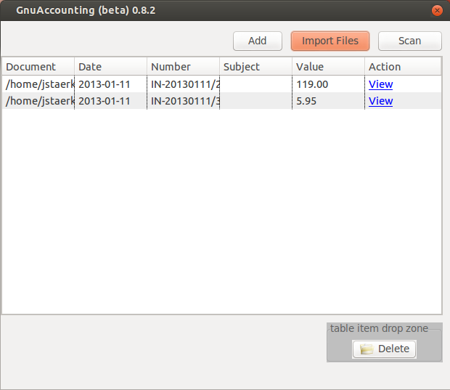Illustration 14: Document management

Start the document management with the button “Documents” on the main window. “New” creates a new entry for a document, “Import files” creates new entries with associated files and “scan” allows you to create a new entry with a scanned document (Windows: TWAIN interface, Linux: SANE scanners).

It is possible to import .JPG, .PNG and .PDF files. The document number will be automatically chosen if the pattern of a document number is recognized. PNG and JPG can be viewed with the „view“ link.

After an invoice has been balanced the “View” link in the according table row in the document management is the only way the software provides to still see this document. (Of course the file is saved in the ~/.gnuaccounting directory).

You can scan documents by clicking on „Scan“. If the according document contains a „Code 39“ barcode the contents of the barcode is automatically proposed as reference number.

Product management
With Administration|Manage products from the main menu you can created, edit and delete products.

To create a new product select the entry „New product“, enter the details in the according fields and click OK. To edit a product select it, change it's details and click OK as well. To delete a product select it and click the „delete“ button.

The attribute Barcode is optional. A valid European Article Number (EAN) in the barcode field will enable the print label button.

Managing assets
Low-value assets (in Germany up to 150, usually 410 Eur) do not need to be managed centrally but more expensive machines, furniture, IT-equipment or vehicles should lead to depreciations in the year-end financial statement and should therefore be entered in Administration|Manage Assets.

List transactions
Administration|List transactions provides a history of past transactions with their entries. Click on the table headings to change the order of the transactions (not of their entries). „Collapse“ hides, „Expand“ shows all entries associated to the depicted transactions.
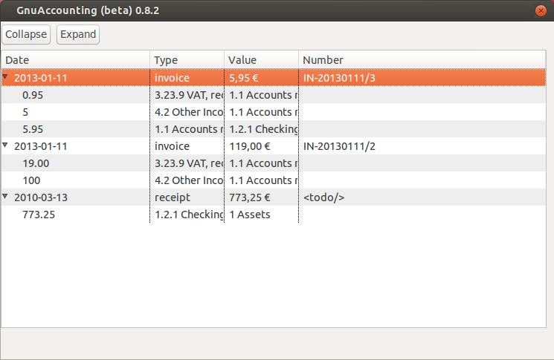Illustration 15: Past incoming and outgoing transactions with their entries

Managing VAT rates

Set-up
Administration|Taxes allows you to create, edit and delete value added tax rates. An empty rate (0%) and a “sample rate” with 19% are predefined. To remove the set-up task “adjust tax rates” from your todo-window you have to rename the sample rate to e.g. „19%“ or „full VAT“.

Default VAT
A little arrow icon marks the default VAT rate in the list view. The default can be set by clicking on the button “standard” after selecting a list item. It is used when processing items from the “book with standards” stack in the bank account import and should therefore be set to 0% for companies who do not use VAT (see chapter 2.3.2).

Tax field
Credit tax field and debit tax field denominate the line in the VAT announcement in which values are put to which the according VAT has been received (debit) respectively spent (credit). German reduced VAT (7%) should also have 66 as credit but 89 as “Debit tax field”.

Optional features

Backup and data versioning
Gnuaccounting will store its files in <user home>/.gnuaccounting/hibernate.log, hibernate.properties and hibernate.script as well as in the *.odt, *.obdx and *.pdf-files in the 0000 subdirectory. Linux usually uses /home/<user name> as user home directory and Windows 7 uses C:\Users\<user name>. Global configuration options are stored in .gnuaccounting/config.xml with client specific settings in .gnuaccounting/0000/settings.xml .

If you want to backup your data, please save the complete <user home>/.gnuaccounting directory and the 0000-subdirectory. The same directories should be put under version control (e.g. Subversion or Git) if you like. When new transactions are created, the <user home>/.gnuaccounting/hibernate.*-files will change and new files (one PDF, one ODT and one ODBX per transaction) will be created in the 0000 subdirectory.

External databases
Gnuaccounting ships with an embedded database but you can use any other (hibernate compatible) database instead. These alternatives include MySQL and PostgreSQL.
You can for example create a MySQL-database “gnuaccounting“ and add a gnuaccounting user with the password 7=S13ben (of course you are supposed to use your own, secure password):
mysql> GRANT ALL PRIVILEGES ON gnuaccounting.* TO 'gnuaccounting'@'localhost' IDENTIFIED BY '7=S13ben';
mysql> FLUSH PRIVILEGES;
mysql> CREATE DATABASE gnuaccounting;
Start Gnuaccounting, select the tab Database in Administration|Configuration. Check „use external database“ and accept the sample values. Enter your password („7=S13ben“ in this example) into the password-field and click “save”. No data will be migrated.

HBCI-Chipcard banking

Set up
Chipcard readers usually provide a so-called „CTAPI“ library, which might be shipped with your chipcard reader software or provided on the web page of the manufacturer. Select this file in Administration|Configuration Chipcard reader CTAPI driver. For ReinerSCT cyberJack in Windows you will usually find the driver in C:\Windows\System32\ctrsct32.dll. In Windows please select “*.dll” instead of “*.so” as file name filter from the select box next to the file name.
Class 2 and class 3 readers provide a separate keypad to enter the HBCI-PIN. Activate „use Chipcard reader PINpad“ if you want to use such a class 2 or class 3 reader.
As a chipcard can contain access to multiple bank accounts you will also have to configure your bank details in the tab „Bank details“ in „Administration|Settings“.
You will be prompted for a new password when using your chipcard for the first time, e.g. via the “import” button on “Interfaces|Bank Account Import”. Create an arbitrary safe password and enter it twice in the according fields. It will be used in the future to access your chipcard.
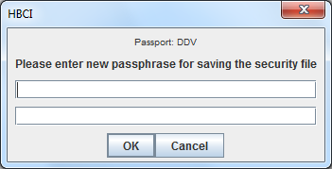Illustration 16: Creating a new password for chipcard access

Winston

Set up
Winston (http://www.felfri.de/winston/) is commercial software for the electronic communication with german tax authorities. The “official” freeware, Elster, does not provide an XML interface and does not run natively on Linux systems. After the installation and entering your data please activate the checkbox „Ausgangskorb benutzen“ in the program configuration.

In the Gnuaccounting configuration please enter the Winston outbox directory in Administration|Configuration and the official name of your organisation, your Tax ID and your responsible IRS office in Administration|Settings. This is also the place where you can chose if you have to announce your VAT in a monthly or quarterly interval.

The defauls Winston outbox directory is C:\Users\<user name>\AppData\Local\Winston\Ausgangskorb on Windows systems.

Usage
When you close your month use Interfaces|VAT announcement and select the according month or quarter.
Start Winston to edit the generated announcement in the outbox or submit it to the authorities.

E-Mails

Set up
Enter your e-mail address, the SMTP-server and it's options (e.g. if SSL or sender authentication should be used), your user name and optionally your password in the Mailserver tab of the settings window (Administration|Settings). If entered, the password will be saved unencrypted. If you leave it empty you will be prompted whenever the mailserver requests authentication. The e-mail address will usually be used as sender address but may also be used as recipient address (e.g. for the below mentioned groupware integration).

Usage
An e-mail is sent when a sender e-mail address and a SMTP server has been configured, a recipient address is assigned to the the recipient in the contact management and the checkbox to send a mail has been checked in the last part of the new transaction wizard. The invoice (credit note or any other transaction type) will be attached as a PDF and a machine-readable OpenTrans (XML) file containing a summary of all relevant payment and booking information.

The message text of the e-mail can not yet be customized. Please keep in mind that even when the message is sent digitally (PGP) signed, in most european countries there is still a legal obligation to send a physical copy or fax to the recipient and to retain that hard copy for at least ten years.

Groupware-integration

The option „send invitations to due dates“ (Administration|Settings, Tab “Mail server”) sends calendar notifications for the respective due dates when a transaction is created.
The calendar entry can then be accepted by the according recipient (always the e-mail address set up in Administration|Settings) if a groupwares like Kolab, Microsoft Exchange/Outlook, Lotus Notes or Google Mail/Google calendar is used. This enables you to easily follow up on multiple due payments on different dates.

GPG/PGP

E-mails can be digitally signed with the Pretty Good Privacy (PGP)-standard. In most european countries this is not legally binding but it might be a good idea to do it voluntarily as email sender addresses can be forged very easily.

Gnu Privacy Guard, GPG, is free and open source software that encrypts and signs according to the PGP standard. E-mail encryption is not yet foreseen in Gnuaccounting since authenticity is usually more important than secrecy when exchanging invoices.

Download GPG, install it, create a private key and enter the GPG-executable in Administration|Configuration. Outgoing emails for transactions will then be digitally signed.

Barcoder-Tool
The Barcoder-tool renames filenames of scanned documents according to the barcodes these scans contain which facilitates e.g. archival of documents with barcode label stickers: the ordinary Gnuaccounting document management will recognize these barcodes but does not touch the original filenames. When using the Barcoder tool the recognized Bar- or QR-code will be added before the original filename, i.e. aaascan.png might change to 001-aaascan.png if a barcode with „001“ is recognized. Applying the tool multiple times on the same file will no longer change the filename, i.e. 001-aaascan.png will not become 001-001-aaascan.png .
JPG and PNG files are supported.
The core functionality seems to be similar to the application „Bardecode Filer“ (http://www.bardecode.com/en1/app/bardecodefiler/) but Gnuaccounting's Barcoder-Tool is based on the free Google Zebra-Crossing-(ZXing)-libraries.
To rename files, click File|Barcoder tool in the main menu of the main window and click „1. Browse“ and select the files you want to process.
The sequence of the files in the now-filled list is important: While the option „Code on every page“ does not change filenames of documents without codes, „Code on first page“ would transfer the last-recognized barcode also to the filenames of subsequent files without barcode. Correspondingly, „Code on last page“ will change the filenames of unlabelled pages before the next recognized code.

Please check Barcode mod 43 if you are using „Code39“ (3of9) Barcodes with checksum and start the capture by clicking the button „2. Process“. For faster results, the Barcoder tool will capture as many scans in parallel as your system has physical CPUs.

The following optical formats are supported (Source: http://code.google.com/p/zxing/ ):
- UPC-A and UPC-E
- EAN-8 and EAN-13
- Code 39
- Code 93
- Code 128
- ITF
- Codabar
- RSS-14 (all variants)
- RSS Expanded (most variants)
- QR Code
- Data Matrix
- Aztec ('beta' quality)
- PDF 417 ('alpha' quality)

Online shop

osCommerce
Download and install osCommerce on your server.
Copy the file opentrans.php from the samples/osCommerce-directory of your Gnuaccounting installation directory to the /catalog/admin-directory of your osCommerce-installation. You might have to allow read access for the web server to this file.
Open http://127.0.0.1/catalog/admin/opentrans.php in your browser. This page should not return an error message. If you chose to install osCommerce in a different directory or on a different server you might have to access an accordingly amended URL.

Start Gnuaccounting and enter your osCommerce administrator user name (usually admin) and password in the tab „webshop“ in „Administration|Settings“. Your administrator password will not be encrypted. Please do not use this functionality if this imposes a security risk.
Please enter the abovementioned address (including opentrans.php) as Webshop URL.

Magento
Download and install Magento. Create a user in the Magento-Administration (System|Web Services|SOAP/XML-RPC Users) with the “Add user“ button. API key and API key confirmation will be ypur password. Select the “admins“-role in the “User Role“ tab and click “Save User“.
Now access System|Web Services|SOAP/XML-RPC Roles to confirm the “admins“-role access: tab “Role Resources“ should show “Resource Access“ “All“ and the created user should be selected in the „Role Users“ tab.
Now copy the file opentrans.php from the samples/magento-Verzeichnis below Gnuaccounting to the Magento-directory and customize the URL to the WSDL of your shop (line 4). This should be in the “/api/“-directory of your magento shop installation and can be accessed with the „?wsdl“-parameter generiert, e.g. http://www.example.com/api/?wsdl . It is a XML-structure, so you can check it with your browser (you might have to switch to the source code view in your browser to see XML-source).
You can now check http://www.example.com/opentrans.php in your browser. The page should show „invalid username or password“.
Now start Gnuaccounting and enter the Magento-API-user name and password („API key“) in the tab webshop in Administration|Settings. The API key will be saved unencrypted. Please do not use this functionality if this imposes a security risk.
Now enter the opentrans.php-URL as Webshop-URL, e.g. http://www.example.com/opentrans.php.

Importing online shop orders
Open the import window (Interfaces|Web shop) and click „Import from WebShop“. Select an entry from the list in the lower part of the window. The details and the items will be listed in the upper part. Drag a list entry to the stack „Create invoice“ to open a window with a new invoice.The items and customer details will be imported automatically, the order changes it's status to „in process“.

Tesseract OCR
Gnuaccounting can perform a automatic text recognition on received documents. As of version 0.8.5 the results will already be saved but are not yet available for further evaluation or display.
Tesseract 3.0.2 has been used for the tests. So far, the Tesseract deployment in the Linux operating system has not yet been successfully tested.
To enable Tesseract support, select Administration|Configuration „Use Tesseract OCR“, select the language to be recognized and the „tessdata“ path to the language files.
Tesseract is available for free at https://code.google.com/p/tesseract-ocr/

Uninstalling Gnuaccounting

In Windows

After installation via the the installer
Select Start|Control center|Uninstall software . Select gnuaccounting from the list and click the “uninstall“ button..
Delete the directory .gnuaccounting in your user home directory, usually C:\Users\<<windows user name>>\.gnuaccounting .

After installation via the ZIP-file
Delete the directory into which you extracted gnuaccounting.
Delete the directory .gnuaccounting in your user home directory, usually C:\Users\<windows user name>\.gnuaccounting .

In linux
rm -rf ~/.gnuaccounting

When using an external MySQL database
Additionally start MySQL and delete the database and the user you created for Gnuaccounting.
Example:
mysql --user=root –password=<your MySQL-root-password>
drop database gnuaccounting;
delete from mysql.user where user='gnuaccounting' and host='localhost';

Troubleshooting

Gnuaccounting does not start

Possible reasons
- Java is not installed or older than Version 1.6
- Java not found by Gnuaccounting
- Java is running in 64-Bit
- Data can not be migrated to this Gnuaccounting version

Further diagnosis and workarounds
- Use Start|All Programs|Gnuaccounting|gnuaccounting-troubleshoot for more detailled output and a console displaying potential exceptions
- Start a terminal or command shell (Windows-key+R, „cmd.exe“) an run „java -version“. If the mentioned version is lower than 1.6, download and install a 32-Bit-Java JRE, e.g. from http://www.oracle.com/technetwork/java/javase/downloads/jre7-downloads-1637588.html
- Should “java -version“ trigger a file not found error please also download and installa 32-Bit-Java JRE from http://www.oracle.com/technetwork/java/javase/downloads/jre7-downloads-1637588.html
- If you are using Microsoft Windows and „java -version“ contains „64-Bit“, a installation of a 32-Bit-JRE from http://www.oracle.com/technetwork/java/javase/downloads/jre7-downloads-1637588.html is recommended as well. It is possible that the 64-bit version remains default. In this case replace „java“ and „javaw“ in gnuaccounting.sh respectively gnuaccounting.bat to include the complete path to your java/javaw executable, e.g. in windows in the gnuaccounting.bat instead of
javaw -Djava...
use
“C:\Program Files (x86)\Java\jre7\bin\javaw“ -Djava...
- Close Gnuaccounting and rename your data directory.
In Windows:
Windows-key+R, „cmd.exe“
cd %HOMEPATH%
ren .gnuaccounting gnuaccounting-old
In Linux
cd ~
mv .gnuaccounting gnuaccounting-old

This will reset all data to „factory default“ when Gnuaccounting is started the next time. You can remove the directory gnuaccounting-old after making sure you no longer need data from the previous installation.

Appendix

Alternatives

Open Source
- Gnucash http://www.gnucash.org/
- Kraft (http://kraft.sourceforge.net/) specialized on craftsmen
- Compiere (www.compiere.com)
- Adempiere (compiere fork)
- idempiere (Adempiere fork)
- JFire (http://www.jfire.org)
- syntax http://willuhn.de/projects/syntax/
- mp, http://code.google.com/p/mp-rechnungs-und-kundenverwaltung/, e.g.Linux-User 11/08
- YaBS http://openyabs.org/ (MP successor?)
- OpenERP
- Lazy8ledger, http://lazy8.nu/
- Gnu Enterprise ([http://www.gnuenterprise.org/ http://www.gnuenterprise.org])
- Postbooks http://sourceforge.net/projects/postbooks
- Tryton, http://tryton.origo.ethz.ch/download
- homebank http://homebank.free.fr/
- osFaktura (www.osFaktura.de, closed beta, discontinued)
- Fakturama (http://fakturama.sebulli.com/)
- Grisbi (http://www.grisbi.org)
- Thera-Pi, http://www.thera-pi.org/, is a ERP software for german physiotherapists, occupational therapist and speech therapists

Freeware
- Java "jes" EÜR http://www.jes-eur.de/ (freeware)

Commercial
- Lin-Habu http://mcrichter.macbay.de/Seiten/Deutsch/Linux/Lin-HaBu/LinHaBu.htm
- Lunux Ledgers http://www.linuxledgers.com
- Quasar http://www.linuxcanada.com/quasar.shtml
- LXFibu, LXAuftrag http://erp.arcad2.de/products_office_lxfibu.php
- Umsatz http://umsatz-programm.de/ for Mac OS Unix only
- Billings time billings http://www.billingsapp.com/ for Mac OS Unix only
- Helium V http://heliumv.com
- Nuclos (previously Nucleus), http://www.nuclos.de/ is considered non-free because it can not be obtained without requesting professional services

POS
- http://www.posper.net/
- TkKasse, http://tkkasse.sourceforge.net
- ERPel http://www.davaosoft.com/
- Lemonpos http://lemonpos.org/
See also http://en.wikipedia.org/wiki/Comparison_of_accounting_software

Opensource or Freeware Windows only
- EasyCash&Tax http://www.easyct.de/
- CAO faktura http://www.cao-faktura.de/
- AvERP http://averp.de/ is freeware for registered users
- Turbocash http://www.turbocashuk.com/
- Freeware faktura http://www.freewarefaktura.de
- osfinancials (open source) http://www.osfinancials.org/en.html
- JTL WaWi http://www.jtl-software.de/produkte/jtl-wawi/
- A1 Faktura http://www.a1-faktura.handwerker-software.info/download.html

Web based
- OpenBravo (allegedly based on early versions of compiere)
- OpenZ http://www.zimmermann-software.de/OpenZ-ERP-Warenwirtschaft.html, german OpenBravo fork
- SQL-Ledger http://www.sql-ledger.com/
- Dolibarr http://www.dolibarr.org/
- Money Manager Ex https://www.moneymanagerex.org/
- Kivitendo, formerly lx-office (http://www.lx-office.org/)
- Nolapro http://www.nolapro.com/
- Frontaccounting http://frontaccounting.com/wb3/
- Bambooinvoice http://www.bambooinvoice.org/
- Project Open http://www.project-open.org/
- weberp http://www.weberp.org/
- intars, http://www.seat-1.com/ERP/Produkte/IntarS.html
- Phreebooks http://sourceforge.net/projects/phreebooks/
- Ledger SMB (includes Perl based http server) http://ledgersmb.org/
- conceptERP www.concepterp.de
- Ustify https://www.ustify.de/
- Common Universally Organized Network http://cuon.org
- Wawision http://www.wawision.de/
- https://invoiceplane.com/ MIT license?
- https://www.invoiceninja.com/ AAL ˜= BSD license
- http://simpleinvoices.org/ GPLv3 license
- http://www.siwapp.org/ MIT license
- http://www.boxbilling.com/ APLlicense
- http://killbill.io/ license
- https://github.com/jethrocarr/amberdms-bs AGPL license

Unclear license
- BS1 accounting http://www.dbsonline.com/accounting/
- unclear license: Nolapro, http://www.nolapro.com/

Unclear if web based or rich client
- http://www.erp5.org/
- ofbiz http://ofbiz.apache.org/
- opentabs http://www.opentaps.org/

Frequently used accounts
The following codes are from the german „SKR03“ accounting frame:
- 0410 Geschäftsausstattung (office equipment): e.g. for furniture more expensive than 410 Eur
- 0480 Geringwertige Wirtschaftsgüter (minor value assets): For more expensive goods please have a look at e.g. 0410, for goods used in manufactoring please e.g. refer to 3000 Roh-Hilfs und Betriebsstoffe (raw materials).
- 1000 Kasse (cash)
- 1200 Bank: Usually a checking account.
- 1400 Forderungen (receivables)
- 1576 Abziehbare Vorsteuer (deducatble VAT)
- 1600 Verbindlichkeiten aus Lieferungen und Leistungen (payables).
- 1776 Umsatzsteuer 19% (VAT). VAT owed to the IRS.
- 1780 Umsatzsteuer-Vorauszahlungen (VAT announcements).
- 1790 Umsatzsteuer-Vorjahr: VAT previous years.
- 1800 Privatentnahmen (private drawings)
- 1810 Privatsteuern (private taxes)
- 1890 Privateinlagen (private investments).
- 2650 sonstige Zinsen und ähnlich Erträge (interests and similar revenues). For fees on bank accounts see also 4970.
- 3000 Roh-, Hilfs und Betriebsstoffe (raw materials)
- 3100 Fremdleistungen (services)
- 4320 Gewerbesteuer (business taxes)
- 4360 Versicherungen (insurances)
- 4380 Beiträge (fees)
- 4650: with 70% of the net amount for entertainment, i.e. business lunches/dinners, will be booked here, the complete VAT will be refundable, 30% of the net amount will be booked to 4654
- 4950 legal advice
- 4970 Nebenkosten des Geldverkehrs (bank charges). For interests please refer to 2650.
- 8400 Erlöse (revenues)
- 9000 Saldenvorträge (balance forward account): At the end of every year the opening balances are booked too this account and booked back at the beginning of the next year.
Example:
400 Euro cash (in „1000“ cash) and 120 Euro dept on 1200 bank.
The following entries need to be created at the beginning of the year:
1000 Kasse (debit) to 9000 Saldenvorträge: 400 €
9000 Saldenvorträge (debit) to 1200 Bank: 120 €

http://de.wikipedia.org/wiki/Rechnung#Tabellarische_Zusammenfassung downloaded at 2012-09-12

