More thoughts on exploratory data reduction

We want to question the assumption that all the indicators can be combined with a simple equally weighted average, as each criterion could suggest a different spatial pattern of democracy. Therefore, we performed an exploratory factor analysis using the incomplete set of variables we have so far.

A three-factor model accounts for 74% of the variance.
MR1 MR3 MR2
SS loadings 2.372 1.437 1.336
Proportion Var 0.339 0.205 0.191
Cumulative Var 0.339 0.544 0.735

With factor correlations of
MR1 MR3 MR2
MR1 1.00 -0.32 -0.24
MR3 -0.32 1.00 0.02
MR2 -0.24 0.02 1.00

Loadings:
MR1 MR3 MR2
Development
Rural-urban -0.248 0.592
Low-high income -0.204 0.884

Proximity to Bogota -0.351 1.003
NSEW
Less free & fair -0.511 0.292 0.252
Stronger civ libs 1.023 -0.342 -0.261
Weaker civ libs 0.912 -0.287 -0.214

Ruling party strength
More free & fair/
Stronger/weaker civ libs 0.377 0.158

Because there are multiple dimensions, it probably creates noisy measurement to combine variables with a simple average. The maps below show the varied spatial patterns captured by each of the factor scores.

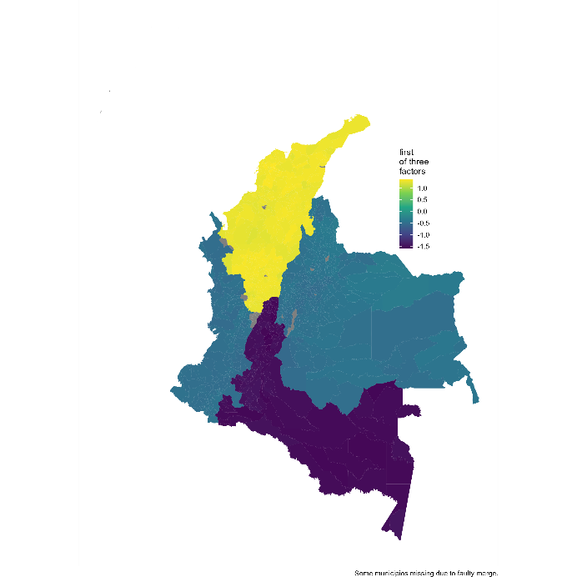

The first factor represents mainly the NSEW regions of the country.

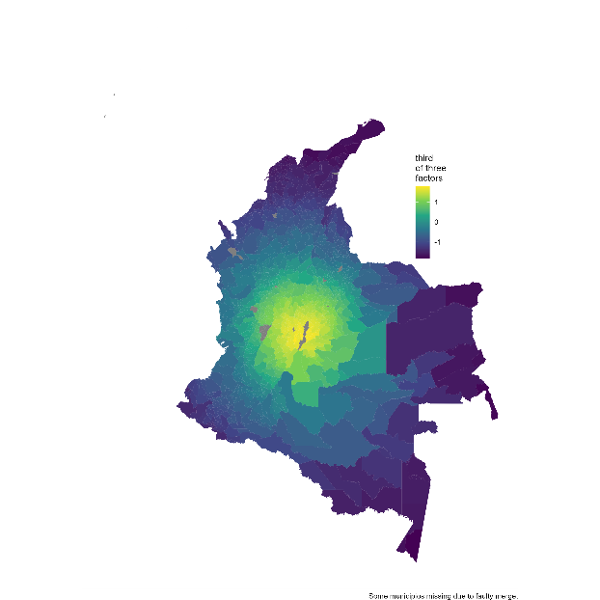

The third factor represents primarily proximity to Bogotá.
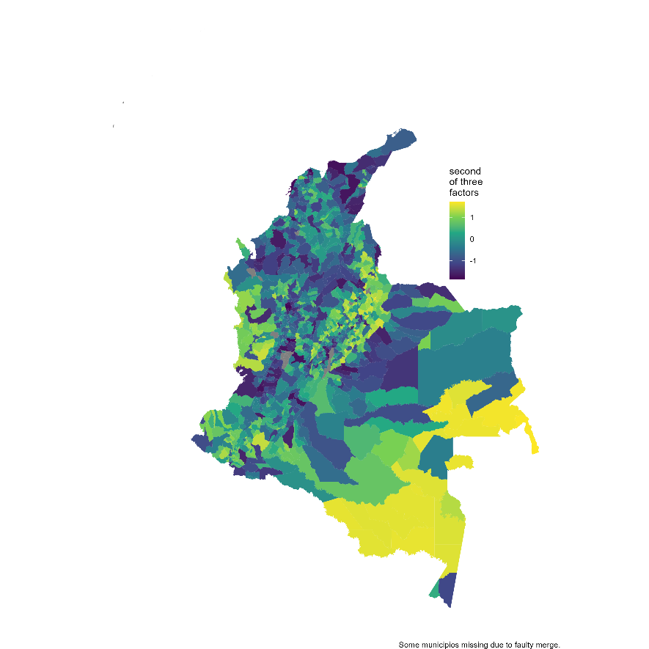

The second factor represents a combination of the rural-urban continuum and the low-high income continuum (color scheme reversed here: yellow is more democratic, dark blue less democratic).

Our next task is to explore ways to combine these factor scores (and future scores based on additional criteria such as civil disturbances, illicit activities, remote areas, and indigenous population) into a summary measure of a concept closer to “democracy.” Just as an example of the kind of end-product we have in mind, here is a how one weighted average of these three factors would look. It is based on 60% rural-urban and income levels (with a correct negative sign), 30% NSEW regions, and 10% proximity to Bogotá. These weights are not based on anything other than sheer intuition; clearly we would need to come up with weights that would have a defensible rationale.

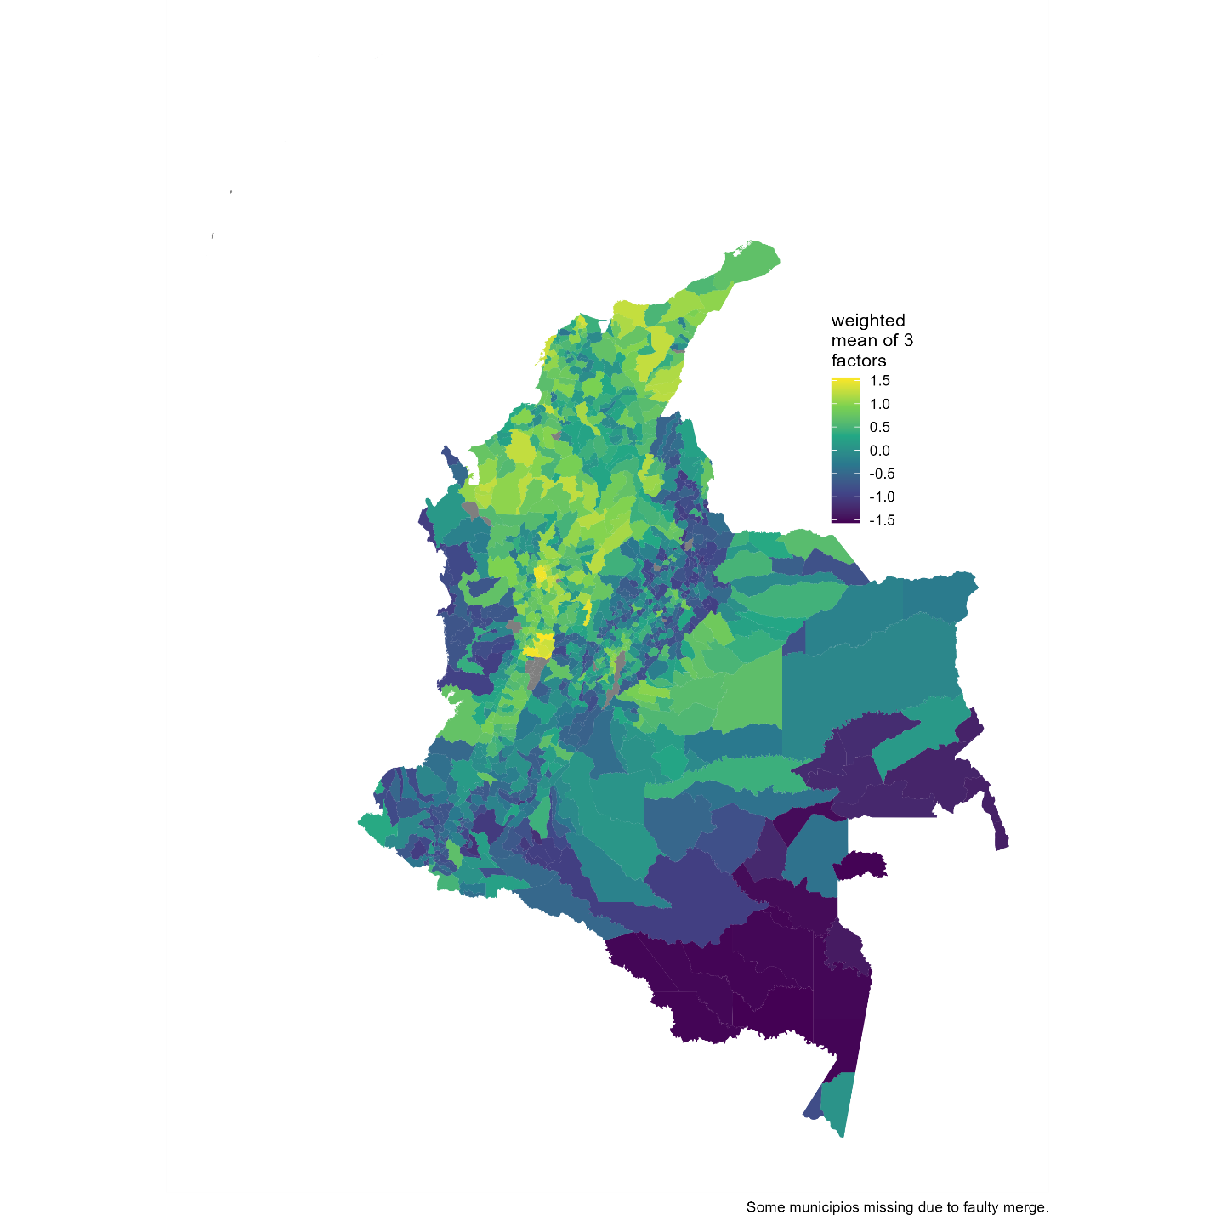
This combination has some face validity, as it suggests more democracy in the capital and the northern Atlantic region, less in the Amazon and the western coast, and a detailed spotted pattern in the Andean highlands.

