1.- Download the zip file from Github.com and decompress it in drive C:
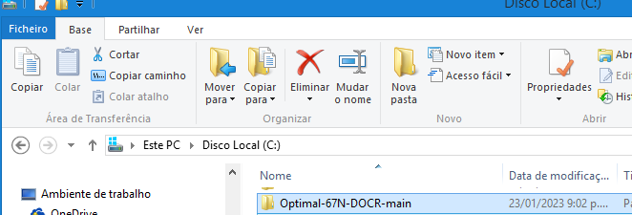
2.- change the compile path in the database file C:\Optimal-67N-DOCR-main\matlab\LoadDatabase.m
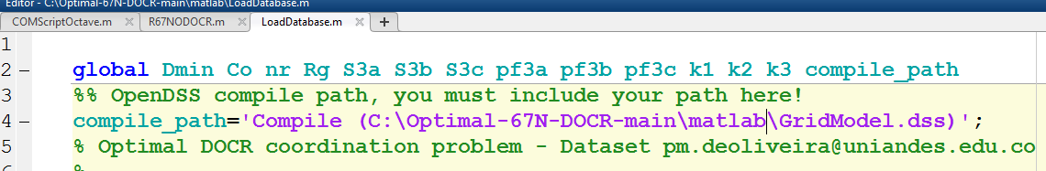
3.- change the compile path in the COM file C:\Optimal-67N-DOCR-main\matlab\COMScriptOctave.m
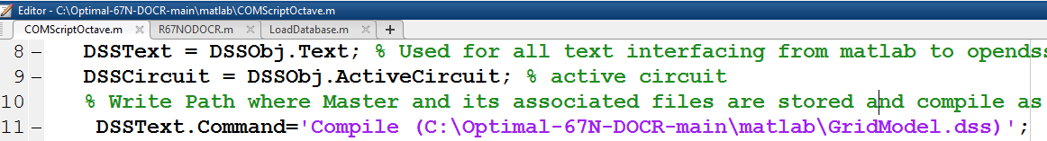
4.- Open the OpenDSS program
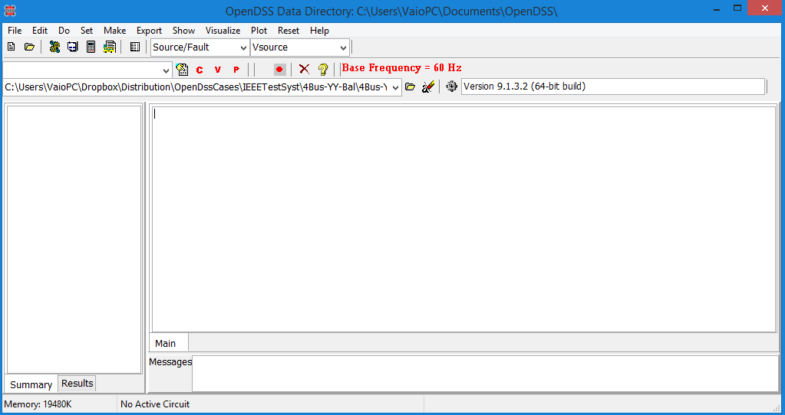
5. Run the program file R67NODOCR.m

The following log must appear in your command window

Optimal 67N Directional Overcurrent Relays Coordination Problem.
Version 1.1 (c) 2020
Power and Energy Group - https://power.uniandes.edu.co/
Universidad de los Andes, Colombia
*************************************************************
Fault resistance: 0.00 ohms
Ground pole resistance: 0.00 ohms
Load Bus3 phase a: 0.00 MVA pf= 0.80 lag
Load Bus3 phase b: 0.00 MVA pf= 0.80 lag
Load Bus3 phase c: 0.00 MVA pf= 0.80 lag
Pick-up current in all relays: 50.00 A
Minimum Time Dial setting: 0.10
Maximum Time Dial setting: unbounded
Coordination interval: 0.20 s
Relay curve parameters 0.14 0.02 -1.00
Modelling with 2 faults per line: near-end far-end faults.
****** Sensitibity and Selectivity Analisis *****************
Number of fault currents to be detected: 12
Number of detected fault currents: 8
Number of nondetected fault currents: 4
Percentage of detected faults currents: 66.67 %
Elapsed modelling time: 0.36 s
*************************************************************

Optimizing. Please wait...!
**** Optimization Results ************************************
Number of unknowns: 6
Number of constraints (selectivity): 8
Number of constraints (time dial limits): 6
Ezzadinne Objective Function (only near faults): 3.0552 s
System Primary Relay Operation Time: 3.6551 s
Optimal TDS Relay 1: 0.2711
Optimal TDS Relay 2: 0.2427
Optimal TDS Relay 3: 0.2579
Optimal TDS Relay 4: 0.2703
Optimal TDS Relay 5: 0.2387
Optimal TDS Relay 6: 0.2553
Elapsed optimization time: 1.25 s
*************************************************************
Verifying the quality of the solution with 1000 random faults
Simulating. Please wait...!
Progress: 25%, 50%, 75%, 100%
**** Simulation Results (Verification)****
Number of fault currents to be detected: 6000
Number of detected fault currents: 5105
Number of nondetected fault currents: 895
Percentage of detected fault currentss: 85.08 %
Mean Operation Times calc with resulting TDSs: 3.3474
StdDev Operation Times calc with resulting TDSs: 0.0771
Verifying if minimum calculated separation time 0.2001 is higher than the coordination time C= 0.2000
Result: 100.0000 % of the faults accomplishes the allowable coordination interval C= 0.2000

5. Run the program file iterR67NODOCR.m

The following figure must appear

