**Професионална гимназия**

**за кюмпютърно програмиране**

**и иновации**

Cars

**Members:**

**The Dream Team:**

Марио Николаев Славов 9А - MNSlavov18@codingburgas.bg

Теодор Боянов Димов 9Б- TBDimov18@codingburgas.bg

Петър Митков Дяков 9В- PMDyakov18@codingburgas.bg

Желязко Александров Иванов 9Г- ZAIvanov18@codingburgas.bg

**Mentor:**

Мариана Енчева

1. **Short description of our project and objectives:**

Our program can find usage in many areas, but its main purpose is to be used by a legitimate car dealership. It consists of a main menu and 5 submenus. You can insert new cars, review the already existing list and then delete them (both of these options have manager access). We wanted to challenge ourselves and try to create something that makes the process of comprising a list of all existing cars in a car dealership and editing it far easier. We have a lot of checks to make sure the parameters entered into our program are feasible. For example – you cannot make the date of manufacturing of a car before the point in time cars were invented.

Here is a short scheme explaining how our program works:

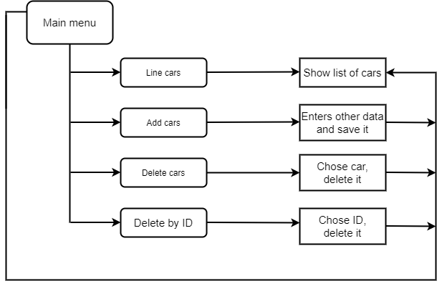

1. **Detailed explanation and description:**

When you first start up the program, you are met with a main menu with 6 options:

1. Insert a new car.
2. Show existing car list.
3. Show existing car list including car IDs (Manager Only).
4. Delete a car from the existing list.
5. Delete a car from the existing list via ID (Manager Only).
6. Exit.

Whenever you insert a new car into the list you are asked to enter various parameters like the car model, its manufacturer, its price and its ID. We have added numerous different checks to make sure the entered parameters stay within certain acceptable ranges. We have many different

Here is one such check:

