Patricia Everett
February 24, 2022
Foundations of Programming, Python
Assignment 7

Intro to Programming - Python

Introduction to Classes, Methods, Properties

In this assignment I will explain the steps I used to add to the starter script in order to create classes, methods and properties. This module has been difficult to fully understand the process in order to create this weeks script.

Classes
In this assignment I broke out the sections and printed the starting script. It gave me the opportunity to better understand how they all go together. Classes have a pattern of fields, constructor, attributes, properties and methods.

Starting the Code
I started with the class of product and determined how to set that up. In watching the videos for a second time, well a few of them, it helped as I walked thru the code. Using the self word also got very confusing and when to do double underscores vs a single. I believe that this will take time, should I decide to continue down this path of developing.

Script
As I stepped thru the code, I also noticed I was getting confused with the getter and setter and found some online assistance with this. The passing of values and verifying that both the class and calling of the function had the same name I noticed a few errors in processing.

Final Code:

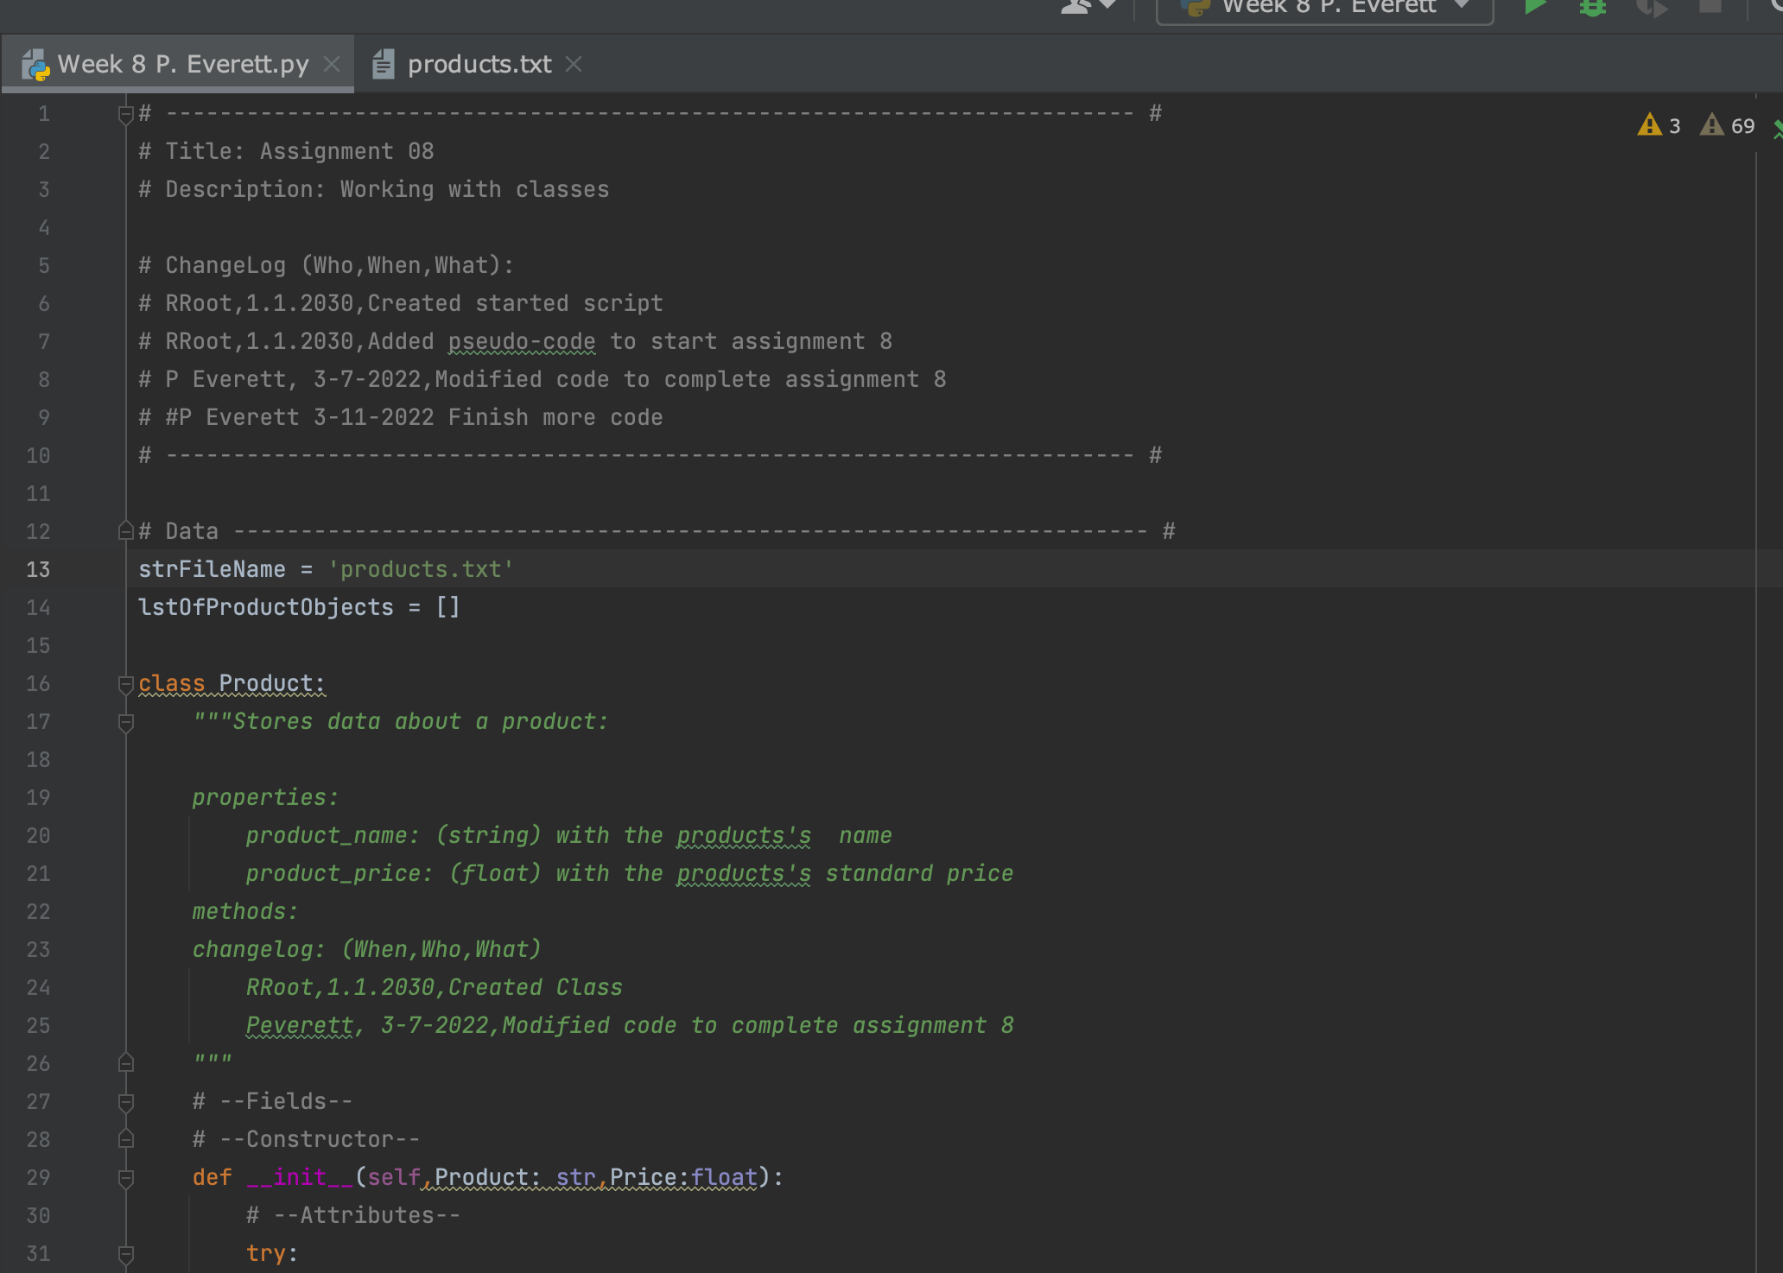

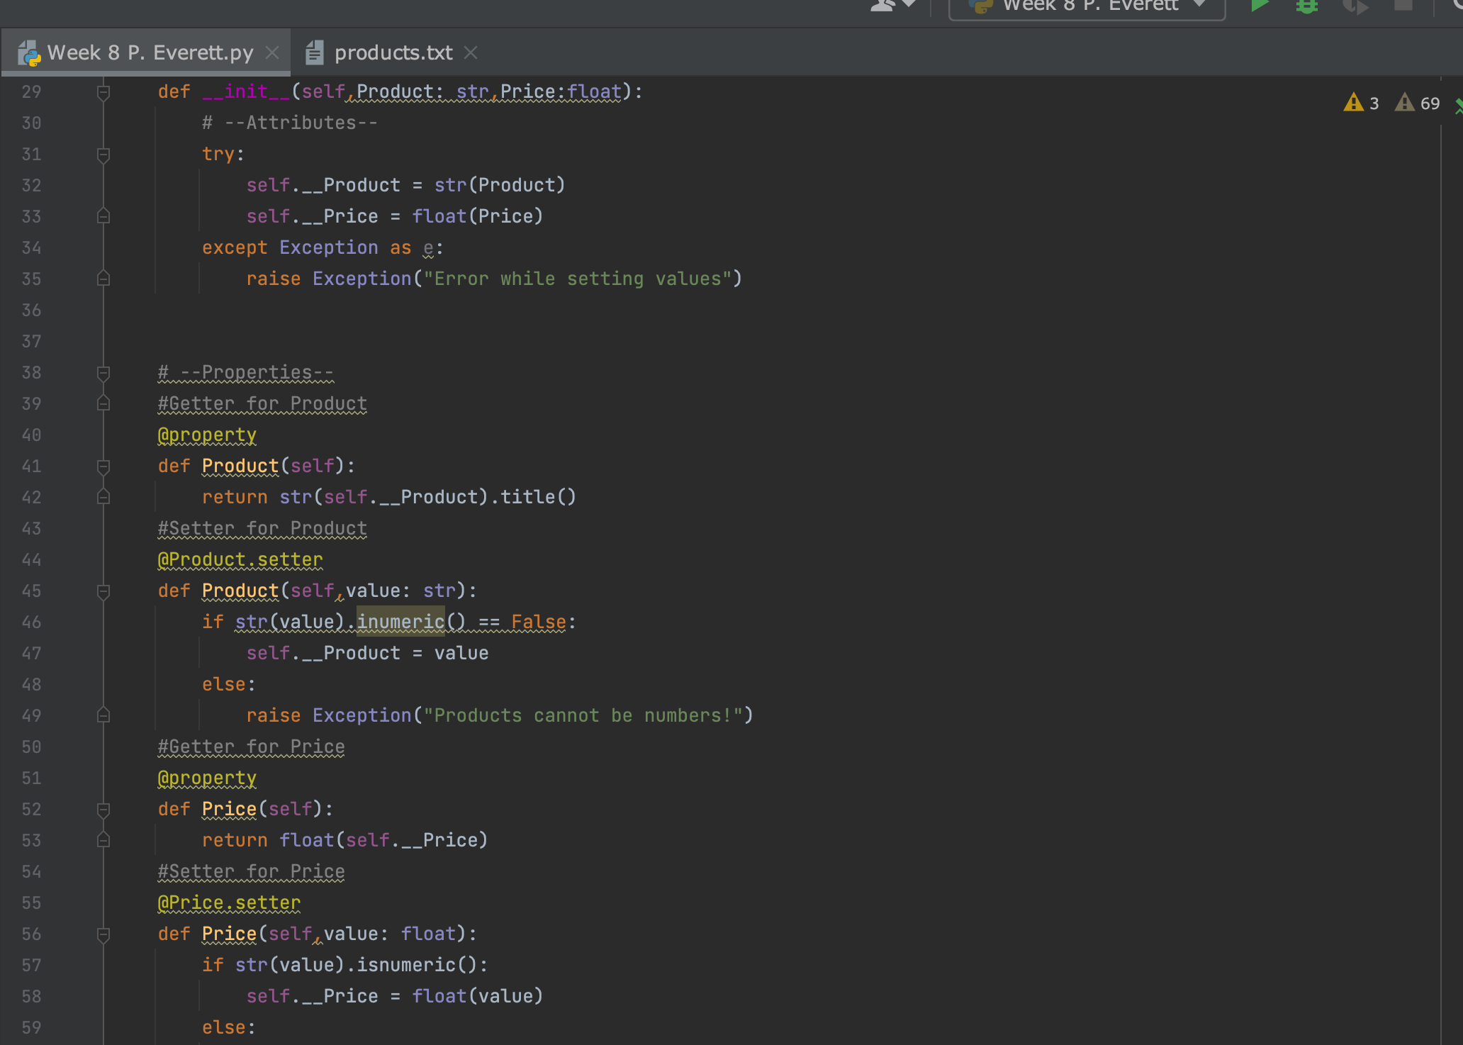

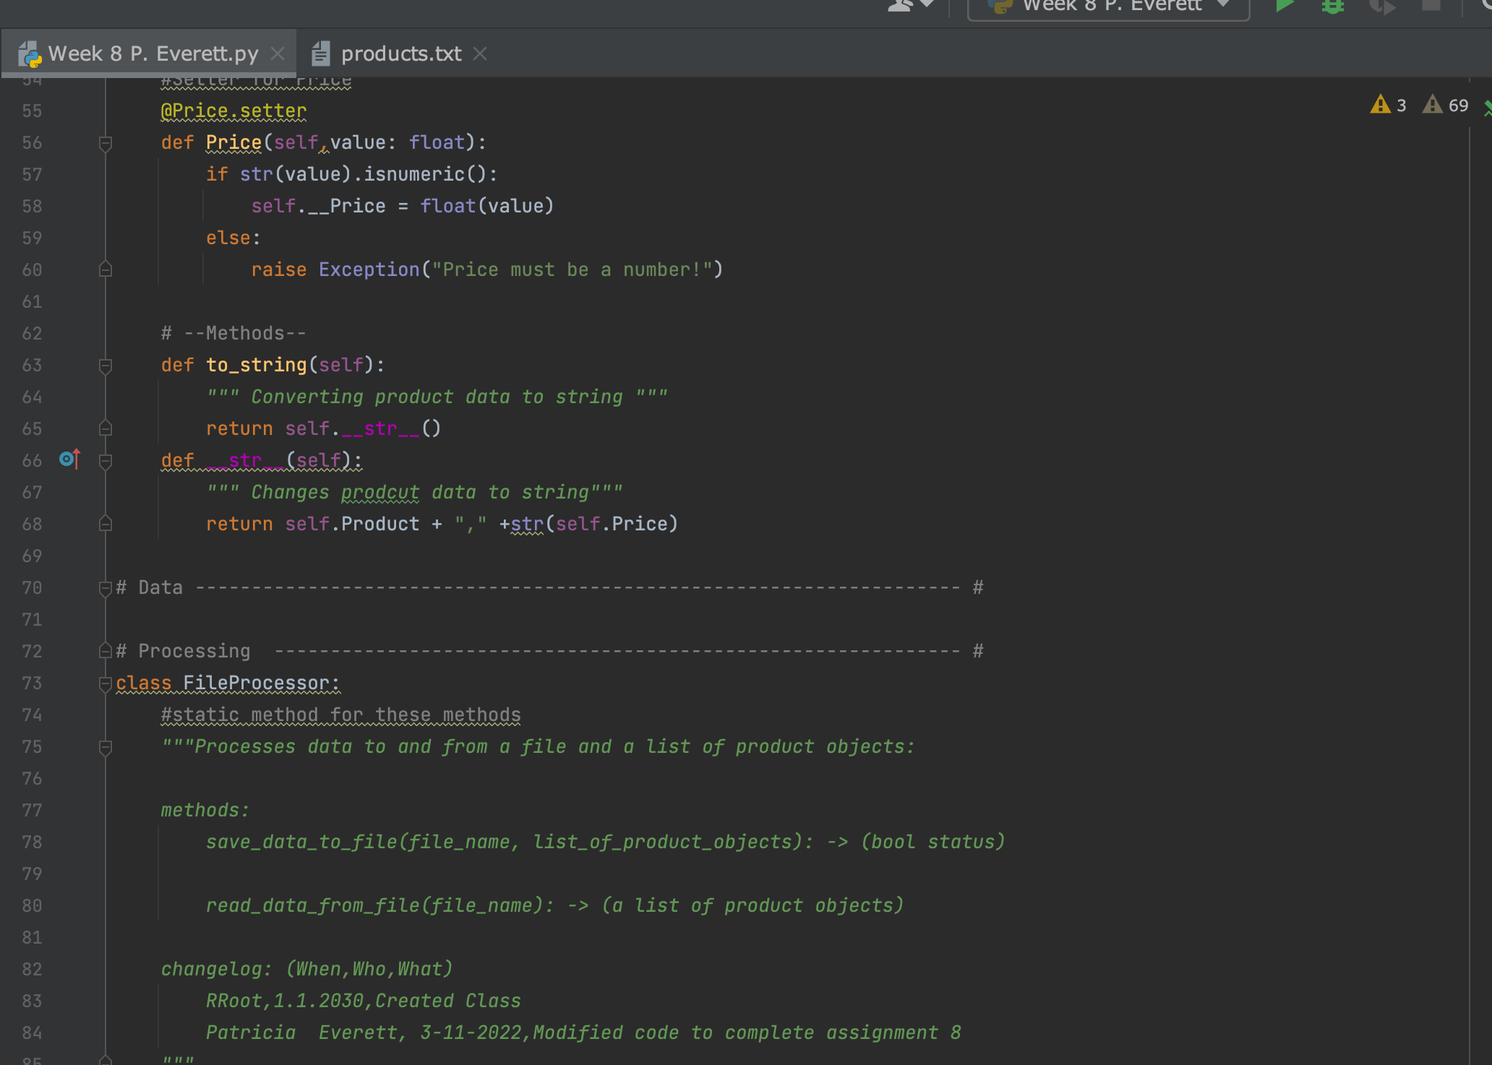
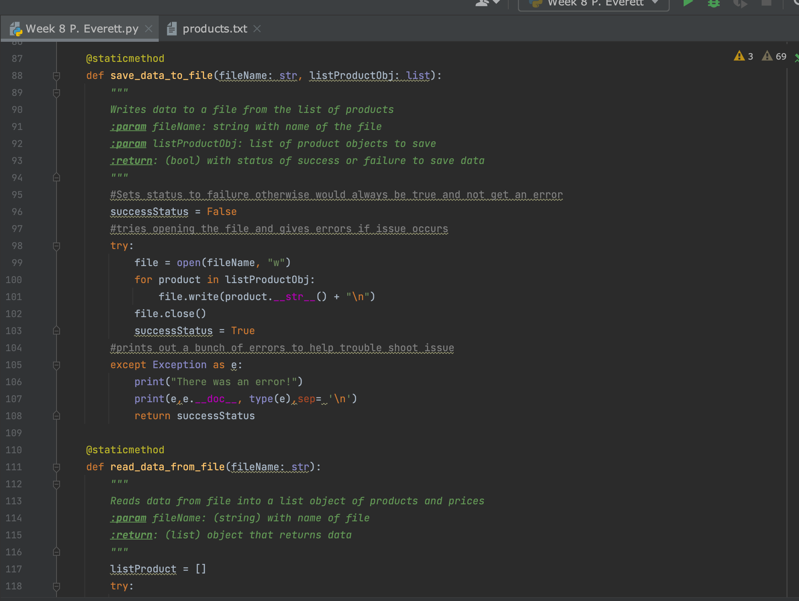
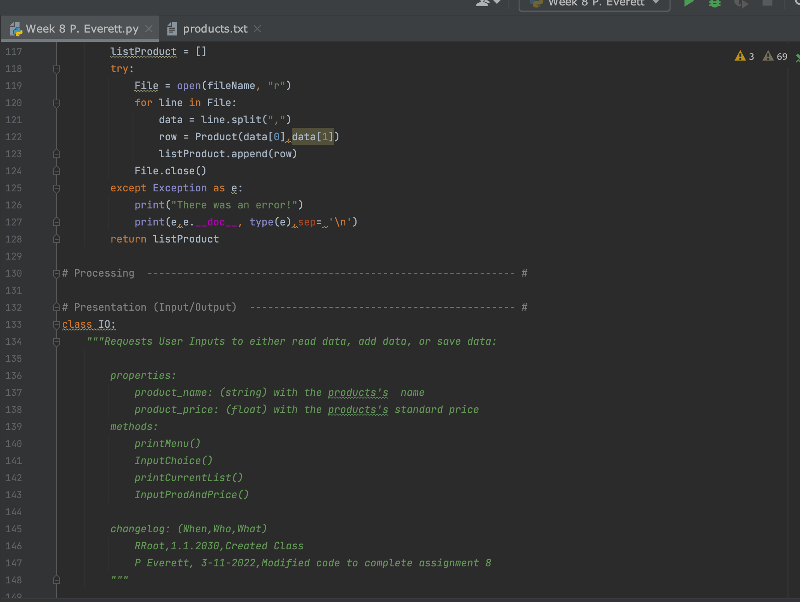

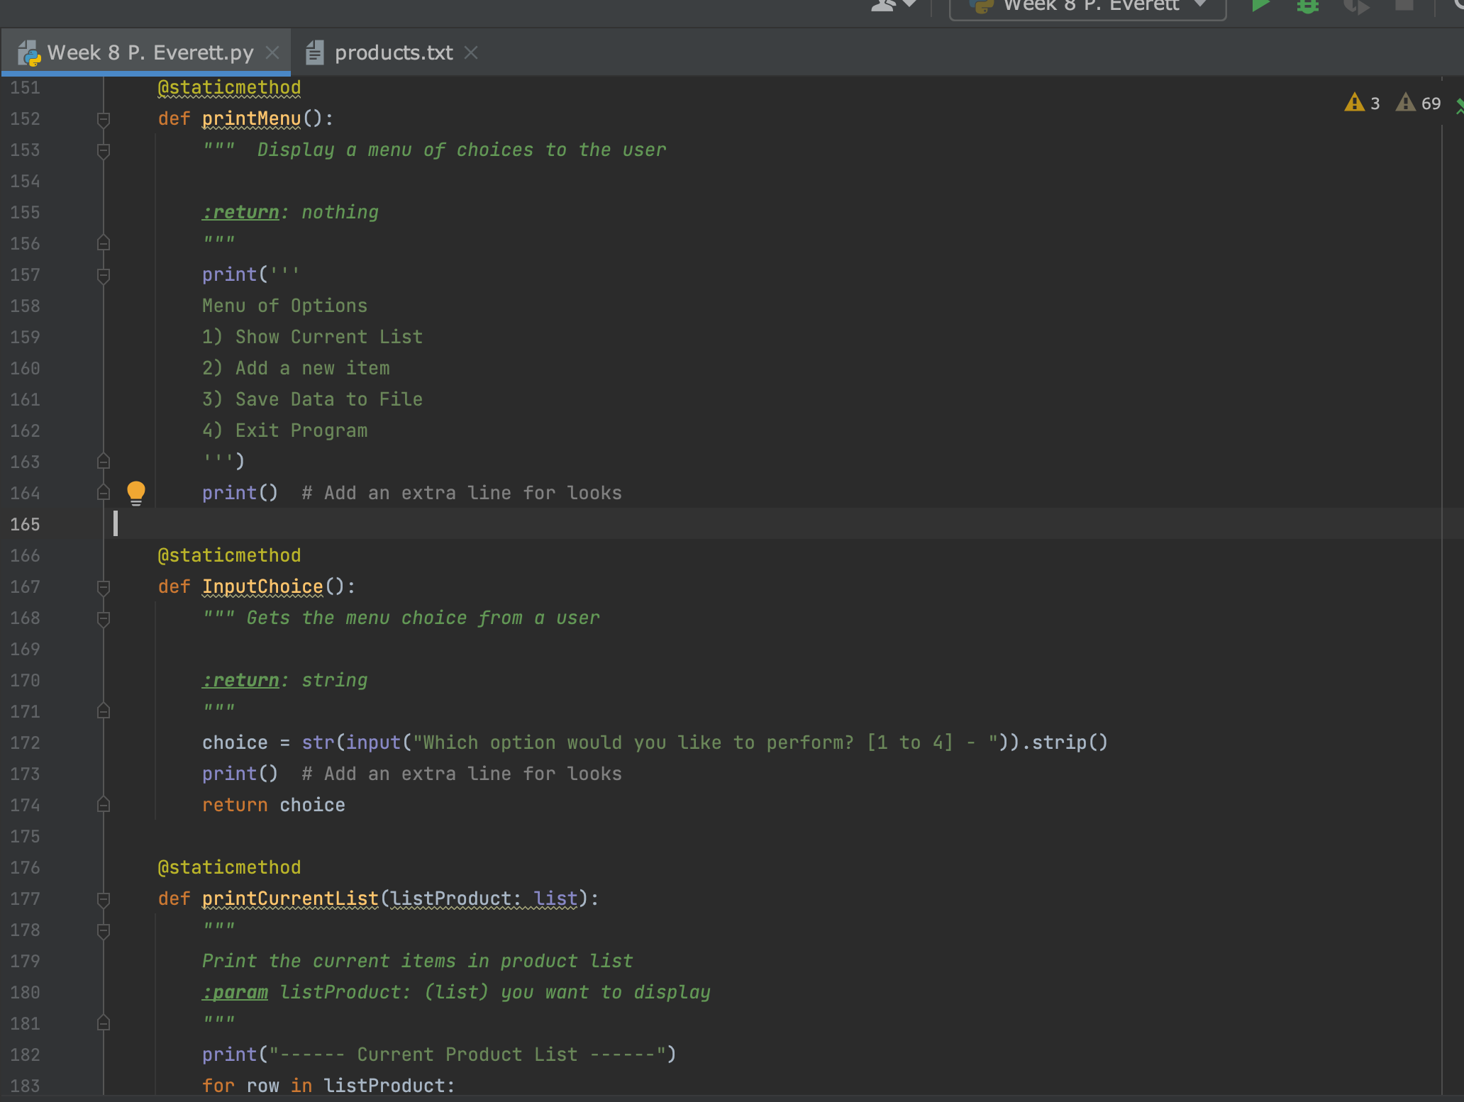

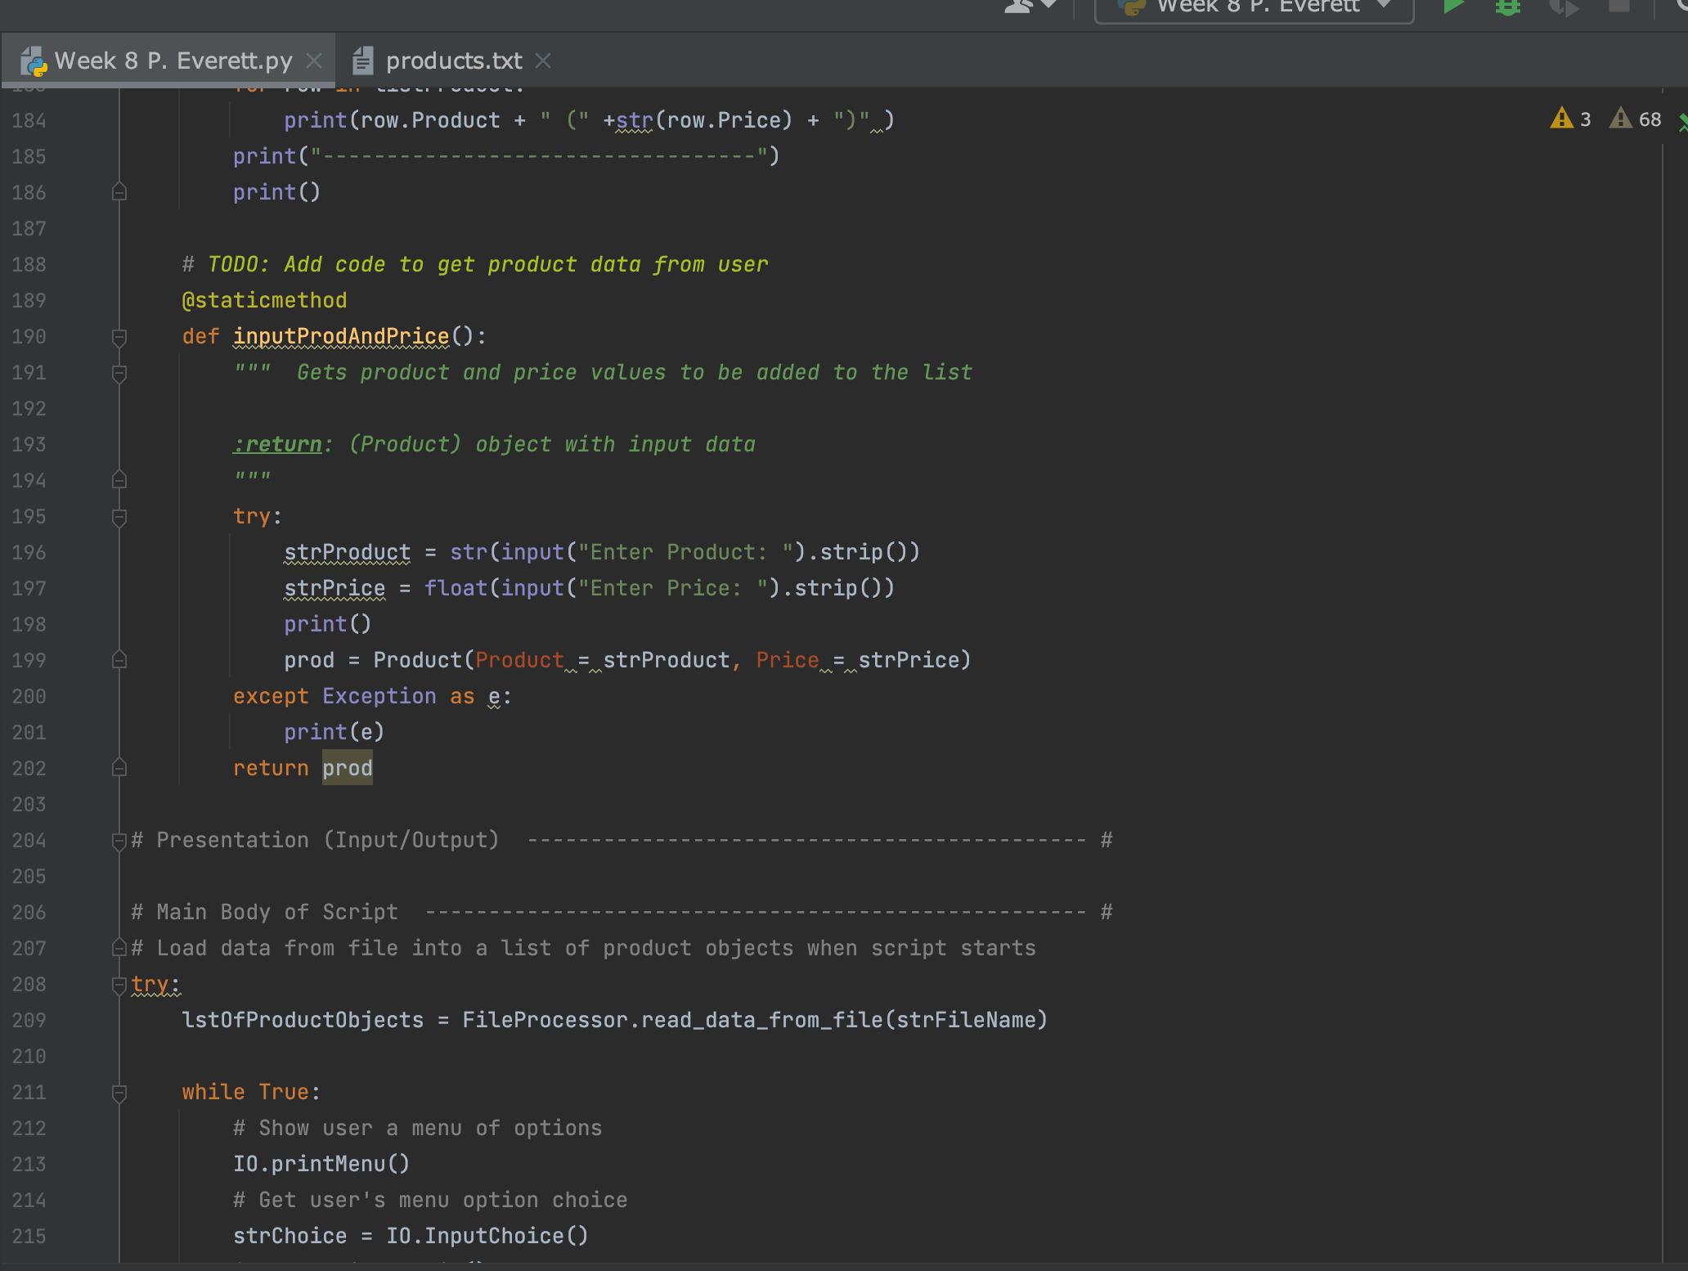

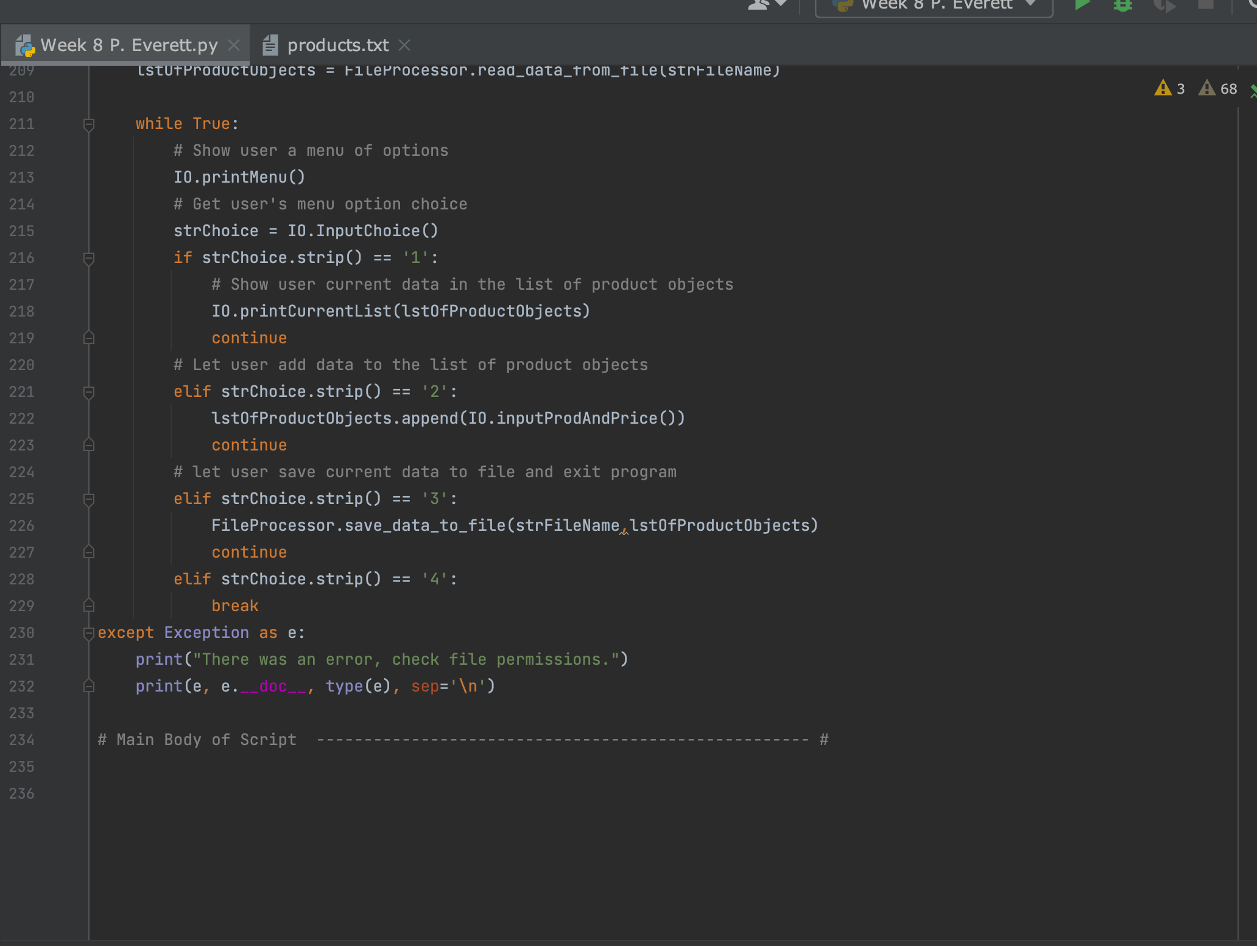

Script Saved
The script was saved in the week 8 folder along with several screen shots. I also took a couple of screen shots of the script working on MY computer:

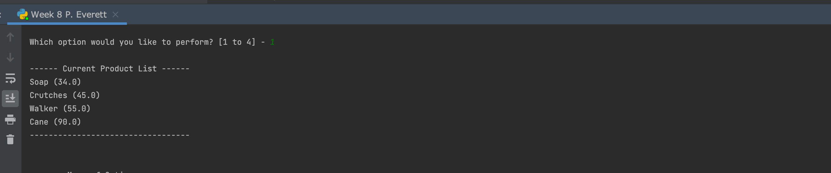

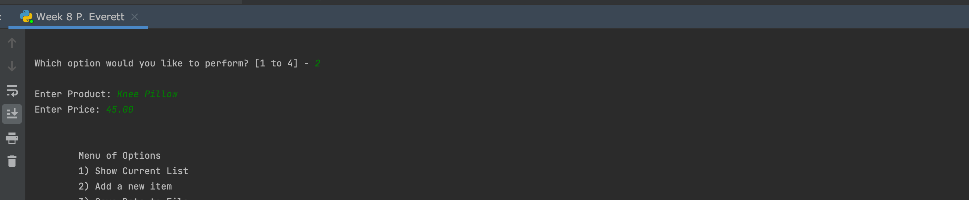

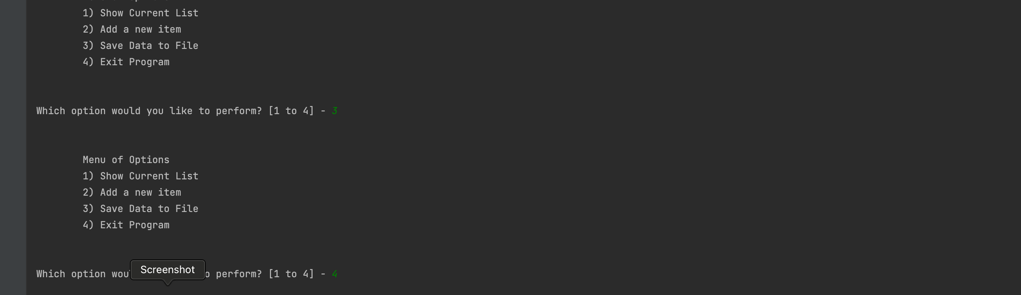

Git Hub Pages
I read thru the provided information for creating the git hub desktop information. I did download the desktop version and was able to publish to my folder on git hub here:

Summary
Using the provided information from this week’s assignment I was able to create one script to show how to use classes, methods, properties etc.

