Patricia Everett

February 17, 2022

Foundations of Programming, Python

Assignment 5

Intro to Programming - Python

# Introduction Writing to a file, removing and saving

In this assignment I will explain the steps I used to create the script. Since PyCharm for Mac is inconsistent, I pulled out my son’s old Windows laptop and fired it up and loaded PyCharm on it. I copied the code from the starter and this time I didn’t get an error message from the code.

# Variables

I wrote the script in the PyCharm environment on a Windows machine. I added a variable to the original list to verify that the end user wanted to quit. All other variables remained the same.

# Starting the Code

I actually took each step as I knew how to code that step. The removal was a little tricky as I realized I had left the parenthesis off the lower which meant that the two strings would never match. The debugging process on the Mac never caught that. It took me hours to realize it, so I am sure I will never use this program ever again once class is done.

# Script

Once I finally got most of the code running, I did complete the exit portion and added a feature that asked the end user if they really wanted to quit.

# Final Code:

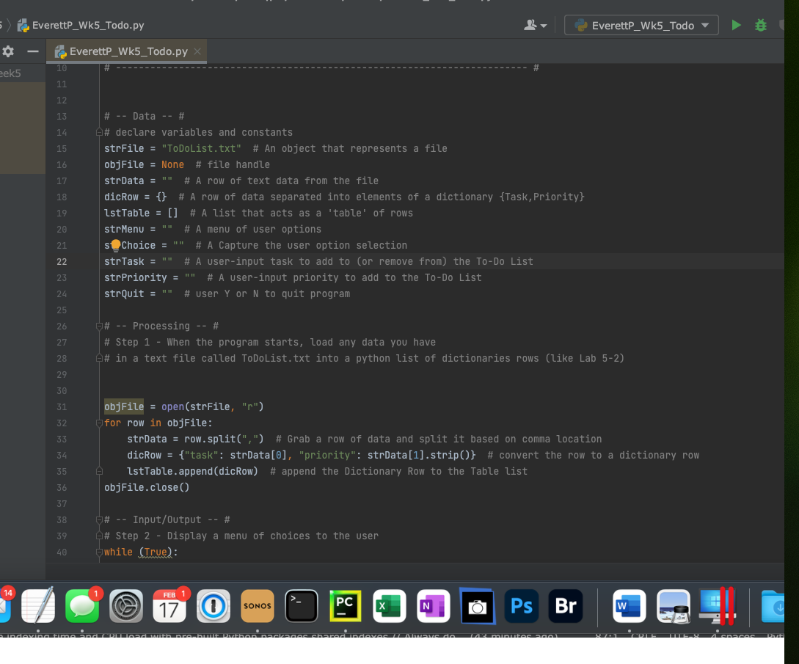

The code finally ran as expected after many changes.

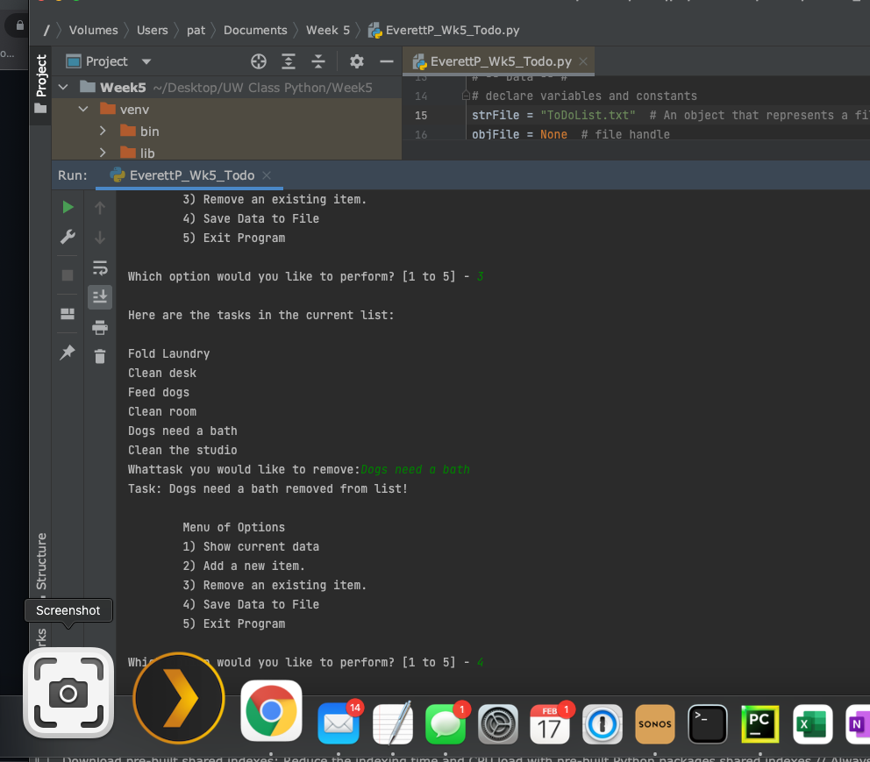

# Script Saved

The Pycharm file was saved in my folder on my Mac along with the ToDoList.txt file.

# Summary

Using the provided information from this week’s assignment I was able to create a script that provides a menu for the end user to choose what steps they want to take. They can add, remove or list out the tasks on the file.