simon-5502-12-solution

## File details

This program was written by Steve Simon on 2025-04-29 and is placed in the public domain. You can use this program any way you please.

library(lme4)  
library(tidyverse)  
  
R.version.string

[1] "R version 4.5.0 (2025-04-11 ucrt)"

Sys.Date()

[1] "2025-04-29"

## Read fasting-turtles

turtles <- read_tsv(  
 file="../data/fasting-turtles.txt",  
 col_names=TRUE,  
 col_types="ncnnn")  
  
glimpse(turtles)

Rows: 8  
Columns: 5  
$ Subject <dbl> 1, 2, 3, 4, 5, 6, 7, 8  
$ Sex <chr> "Male", "Male", "Male", "Male", "Female", "Female", "Female",…  
$ Fed <dbl> 42.8, 43.1, 40.4, 46.6, 42.2, 38.7, 35.3, 40.5  
$ Fasted10 <dbl> 42.4, 42.2, 40.8, 45.9, 42.4, 38.1, 34.3, 40.1  
$ Fasted20 <dbl> 38.9, 40.3, 37.5, 42.9, 39.7, 35.8, 32.3, 37.3

## Check for missing values (optional)

turtles |>  
 mutate(across(everything(), is.na)) |>  
 summarize(across(everything(), sum))

# A tibble: 1 × 5  
 Subject Sex Fed Fasted10 Fasted20  
 <int> <int> <int> <int> <int>  
1 0 0 0 0 0

## Descriptive statistics

None for sex because it is not needed in this analysis. It would also be fine to wait until after restructuring to calculate descriptive statistics.

turtles |>  
 summarize(  
 baseline_mean=mean(Fed),  
 baseline_sd=sd(Fed),  
 baseline_min=min(Fed),  
 baseline_max=max(Fed))

# A tibble: 1 × 4  
 baseline_mean baseline_sd baseline_min baseline_max  
 <dbl> <dbl> <dbl> <dbl>  
1 41.2 3.35 35.3 46.6

turtles |>  
 summarize(  
 time_10_mean=mean(Fasted10),  
 time_10_sd=sd(Fasted10),  
 time_10_min=min(Fasted10),  
 time_10_max=max(Fasted10))

# A tibble: 1 × 4  
 time_10_mean time_10_sd time_10_min time_10_max  
 <dbl> <dbl> <dbl> <dbl>  
1 40.8 3.45 34.3 45.9

turtles |>  
 summarize(  
 time_20_mean=mean(Fasted20),  
 time_20_sd=sd(Fasted20),  
 time_20_min=min(Fasted20),  
 time_20_max=max(Fasted20))

# A tibble: 1 × 4  
 time_20_mean time_20_sd time_20_min time_20_max  
 <dbl> <dbl> <dbl> <dbl>  
1 38.1 3.18 32.3 42.9

## Restructure into long format

turtles |>  
 pivot_longer(  
 cols=Fed:Fasted20,  
 names_to="measure",  
 values_to="plasma_protein") |>  
 mutate(time=case_when(  
 measure=="Fed" ~ 0,  
 measure=="Fasted10" ~ 10,  
 measure=="Fasted20" ~ 20)) -> turtles_1  
  
glimpse(turtles_1)

Rows: 24  
Columns: 5  
$ Subject <dbl> 1, 1, 1, 2, 2, 2, 3, 3, 3, 4, 4, 4, 5, 5, 5, 6, 6, 6, 7…  
$ Sex <chr> "Male", "Male", "Male", "Male", "Male", "Male", "Male",…  
$ measure <chr> "Fed", "Fasted10", "Fasted20", "Fed", "Fasted10", "Fast…  
$ plasma_protein <dbl> 42.8, 42.4, 38.9, 43.1, 42.2, 40.3, 40.4, 40.8, 37.5, 4…  
$ time <dbl> 0, 10, 20, 0, 10, 20, 0, 10, 20, 0, 10, 20, 0, 10, 20, …

## Plot by subject

turtles_1 |>  
 ggplot() +  
 aes(  
 x = time,   
 y = plasma_protein,   
 group = Subject) +  
 geom_line() +  
 labs(  
 x="Time (days)",  
 y="Plasma protein (mg/ml)",  
 title="Line graph of individual turtles over time",  
 caption="Simon, 2025-04-29")

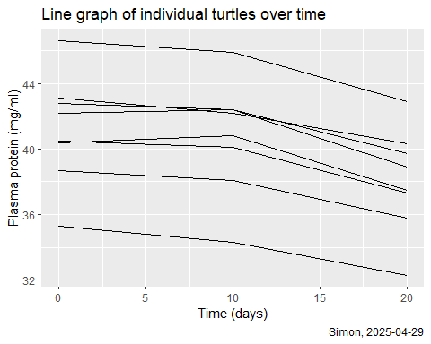

## Mixed model

m1 <- lmer(  
 plasma_protein ~ time + (1 | Subject),  
 data=turtles_1)  
  
summary(m1)

Linear mixed model fit by REML ['lmerMod']  
Formula: plasma_protein ~ time + (1 | Subject)  
 Data: turtles_1  
  
REML criterion at convergence: 89.3  
  
Scaled residuals:   
 Min 1Q Median 3Q Max   
-1.1632 -0.5762 -0.2422 0.5314 1.6075   
  
Random effects:  
 Groups Name Variance Std.Dev.  
 Subject (Intercept) 10.7945 3.2855   
 Residual 0.5811 0.7623   
Number of obs: 24, groups: Subject, 8  
  
Fixed effects:  
 Estimate Std. Error t value  
(Intercept) 41.57708 1.18737 35.016  
time -0.15562 0.01906 -8.166  
  
Correlation of Fixed Effects:  
 (Intr)  
time -0.160

## Calculate ICC

icc <- 10.7945/(10.7945+0.5811)  
icc

[1] 0.948917