Baby steps: a simple illustration of the Metropolis algorithm

Steve Simon

2021-03-19

### Abstract

The Metropolis algorithm is a simple approach to generating random observations from a distribution where the density is known up to a proportionality constant. This algorithm is the easiest to understand and to implement of various methods used in Markov Chain Monte Carlo. In this paper, we show a simple example of the Metropolis algorithm to simulate the geometric distribution with $π$ =1/2, and describe the resulting simulation as analogous to a baby learning to walk.

### Introduction

On March 24, 2017, the FiveThirtyEight website published a couple of mathematical puzzles, one which was contributed by this author.

“Your baby is learning to walk. The baby begins by holding onto a couch. Whenever she is next to the couch, there is a 25 percent chance that she will take a step forward and a 75 percent chance that she will stay clutching the couch. If the baby is one or more steps away from the couch, there’s a 25 percent chance that she will take a step forward, a 25 percent chance she’ll stay in place and a 50 percent chance she’ll take one step back toward the couch. In the long run, what percent of the time does the baby choose to clutch the couch?”

Most statisticians will immediately recognize this

Figures 1 and 2 The transition probabilities are illustrated in Figure 1 and 2.

You can solve this question easily with a computer simulation, but I derived the problem using the Metropolis algorithm to simulate a geometric distribution with p=1/2.

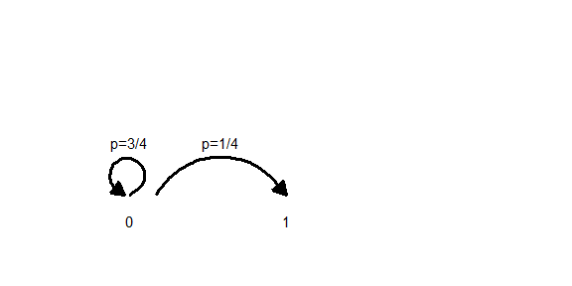

*Figure 1. Baby walk transition probabilities at X = 0.

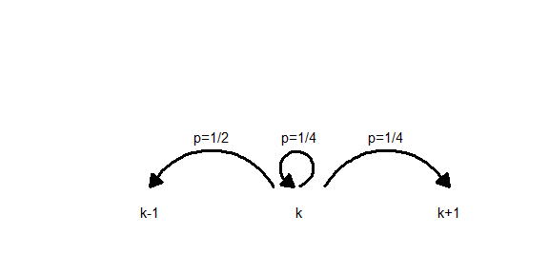

*Figure 2. Baby walk transistion probabilities at X > 0.

The Metropolis algorithm, first defined in Metropolis (1953) was originally developed to study the properties of substances composed of a finite number of interacting molecules. The method has proven useful for many physics problems such as simulated annealing (Kirkpatrick 1983).

### Discussion

John Kruschke motivates the Metropolis algorithm in Chapter 7 of his delightful book on Bayesian data analysis (Kruschke 2014). He describes an island hopping politician who wants to spend time on each island in proportion to its population. He can hop to the east or west, or stay on the current island, and uses the mechanics of the Metropolis algorithm to choose when to hop islands and when to stay put. The baby-walk example is similar in spirit, but provides a concrete distribution to evaluate.

Jim Albert and Jingchen Hu propose an arbitrary discrete distribution with five values and shows how students can simulate from this distribution using coin flips.

### Bibliography

Oliver Roeder. Will The Baby Walk Away? Will The Troll Kill The Dwarves? FiveThirtyEight (2017, Mar 24). <https://fivethirtyeight.com/features/will-the-baby-walk-away-will-the-troll-kill-the-dwarves/>. Accessed 2021-04-02.

S. Kirkpatrick; C. D. Gelatt; M. P. Vecchi Science, New Series, Vol. 220, No. 4598. (May 13, 1983), pp. 671-680.

Kruschke, John (2014). Doing Bayesian Data Analysis. A Tutorial with R, JAGS, and Stan. 2nd edition. Academic Press.

Metropolis, Nicholas; Rosenbluth, Arianna W.; Rosenbluth, Marshall N.; Teller, Augusta H.; Teller, Edward (1953). “Equation of State Calculations by Fast Computing Machines”. J. Chem. Phys. 21 (6): 1087. <doi:10.1063/1.1699114>.