Experimentation without randomized controls

Graphical abstract

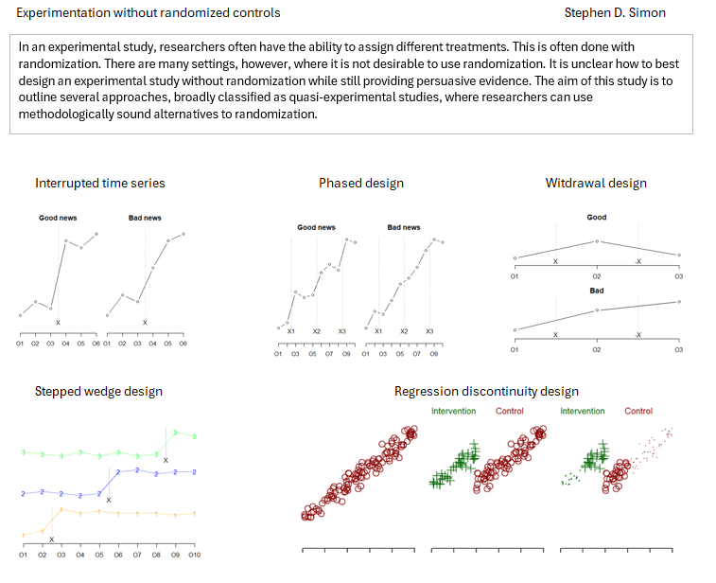

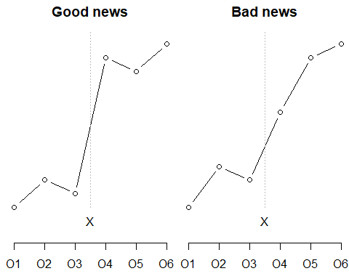

Figure 1. Two hypothetical outcomes from an interrupted time series design.

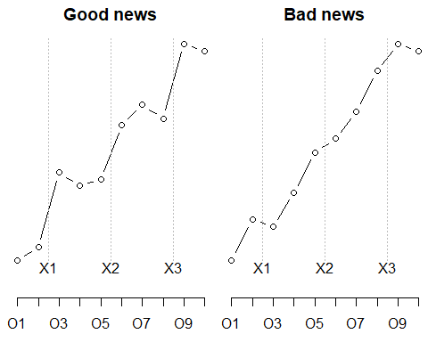

Figure 2. Two hypothetical outcomes for a for an interrupted time series design with phases.

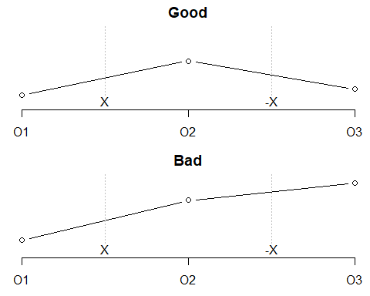

Figure 3. Two hypothetical results from a withdrawal design

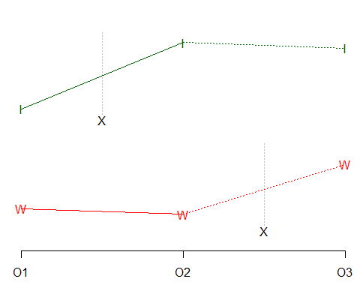

Figure 4. Hypothetical data in a waiting list control design

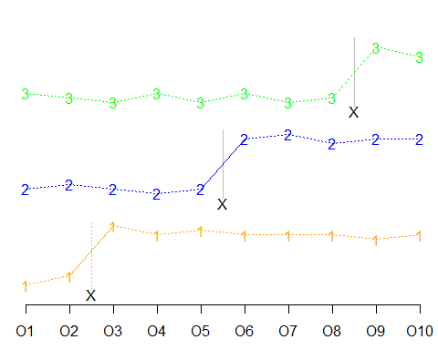

Figure 5. Hypothetical outcome of a stepped wedge design

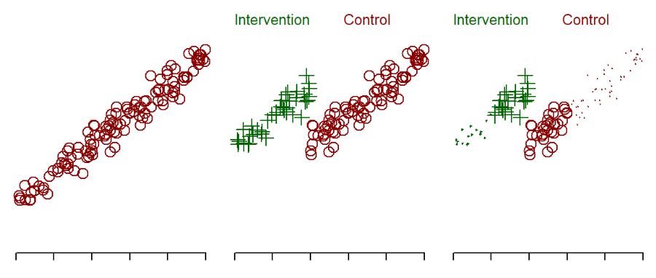

Figure 6. Hypothetical data showing a relationship between a qualifying variable and a health outcome.