Simulating clinical trials--beta extension

Steve Simon

March 22, 2017

## Warning: package 'broom' was built under R version 3.3.3

## Warning: package 'ggplot2' was built under R version 3.3.2

## Warning: package 'magrittr' was built under R version 3.3.3

## Warning: package 'rjags' was built under R version 3.3.2

## Warning: package 'coda' was built under R version 3.3.2

## Warning: package 'rstan' was built under R version 3.4.0

## Warning: package 'StanHeaders' was built under R version 3.4.0

## Warning: package 'tidyr' was built under R version 3.3.2

### Figure 6.1. Discontinuous transition from slow to normal accrual.

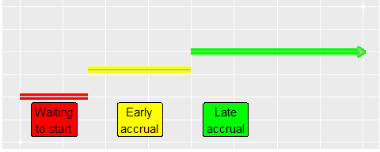

### Figure 6.2. Linear transition from slow to normal accrual.

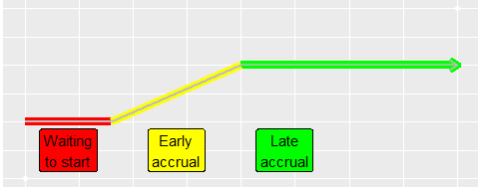

### Figure 6.3. Linear transition from fast to normal accrual.

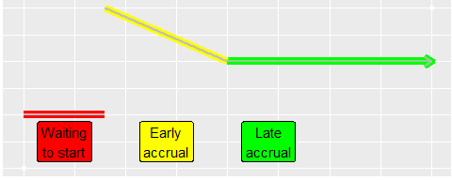

### Figure 6.4. Smooth transition from slow to normal accrual.

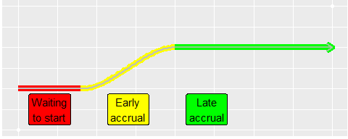

### Figure 6.5. Prior distribution for delta1 (time waiting to start).

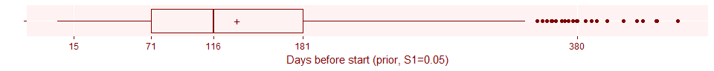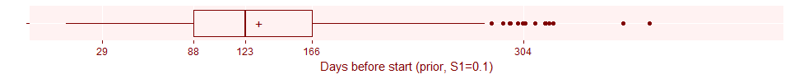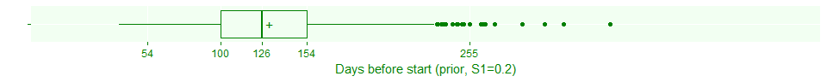

### Figure 6.6. Prior distribution for delta2 (accrual rate early), rescaled to patients per month.

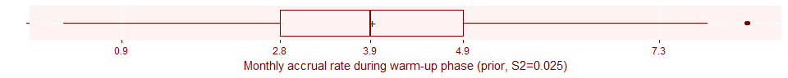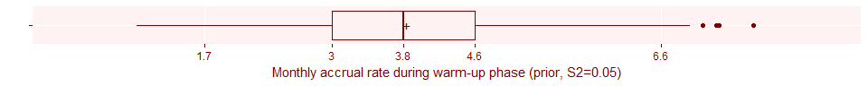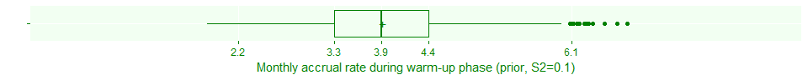

### Figure 6.7. Prior distribution for delta3 (duration of early accrual), rescaled to days.

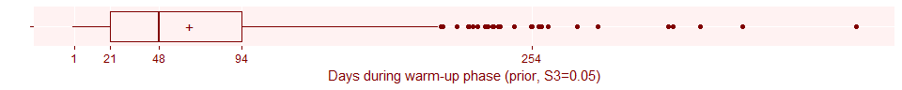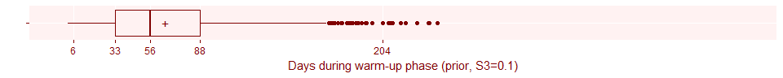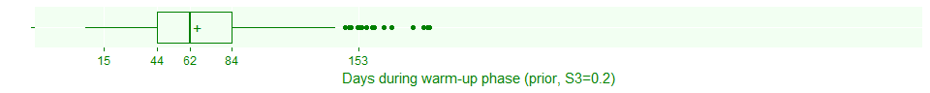

### Here's the code to fit a simulation involving delays.

## model {  
## lambda ~ dgamma(N*S, T*S)  
## delta1 ~ dbeta(N*S1*D1, N*S1*(1-D1))  
## delta2 ~ dbeta(N*S2*D2, N*S2*(1-D2))  
## delta3 ~ dbeta(N*S3*D3, N*S3*(1-D3))  
## for (day in 1:T) {  
## mu[day] <- step(day-delta1*T) * lambda * (delta2 ^ step(delta1*T+delta3*T-day))  
## }  
## for (day in 1:t) {  
## n[day] ~ dpois(mu[day]+0.001)  
## }  
## for (day in 1:(T-t)) {  
## future_n[day] ~ dpois(mu[day+t])  
## }  
## Nstar <- sum(n)+sum(future_n)  
## }

## Compiling model graph  
## Resolving undeclared variables  
## Allocating nodes  
## Graph information:  
## Observed stochastic nodes: 0  
## Unobserved stochastic nodes: 1099  
## Total graph size: 12081  
##   
## Initializing model

##   
## Iterations = 1:1000  
## Thinning interval = 1   
## Number of chains = 1   
## Sample size per chain = 1000   
##   
## 1. Empirical mean and standard deviation for each variable,  
## plus standard error of the mean:  
##   
## Mean SD Naive SE Time-series SE  
## Nstar 296.57400 33.60696 1.0627455 1.1022628  
## delta1 0.12192 0.03844 0.0012155 0.0012467  
## delta2 0.39642 0.08232 0.0026031 0.0026031  
## delta3 0.05905 0.02827 0.0008941 0.0008941  
## lambda 0.32037 0.02710 0.0008569 0.0008533  
##   
## 2. Quantiles for each variable:  
##   
## 2.5% 25% 50% 75% 97.5%  
## Nstar 235.00000 274.00000 296.00000 318.25000 367.0250  
## delta1 0.05680 0.09533 0.11872 0.14759 0.2053  
## delta2 0.23899 0.33835 0.39282 0.45220 0.5583  
## delta3 0.01431 0.03912 0.05549 0.07462 0.1290  
## lambda 0.27105 0.30148 0.31844 0.33900 0.3745

### Figure 6.8. Prior estimate of total sample size, accounting for delays.

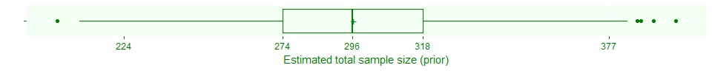

### Figure 6.9. Effect of prior parameters on estimated total sample size.

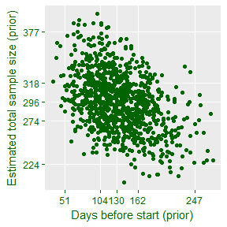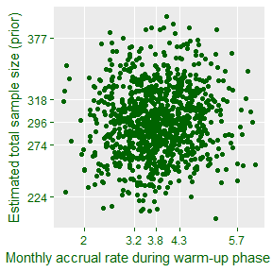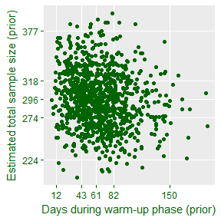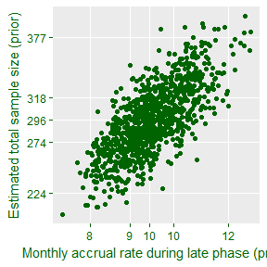

## Compiling model graph  
## Resolving undeclared variables  
## Allocating nodes  
## Graph information:  
## Observed stochastic nodes: 150  
## Unobserved stochastic nodes: 949  
## Total graph size: 12681  
##   
## Initializing model

### Figure 6.10. Updated estimate of total sample size after 150 days of nothing.

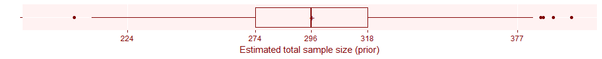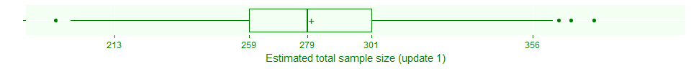

### Figure 6.11. How much longer do you expect to wait after 150 days of nothing.

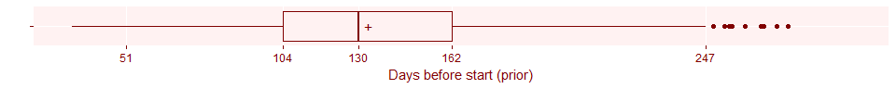

### Figure 6.12. Update of delta2 after 150 days of nothing.

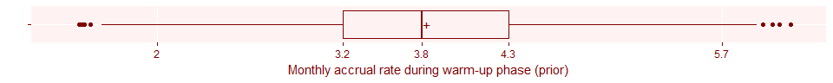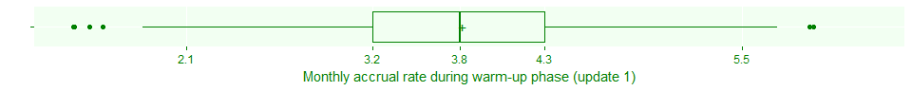

### Figure 6.13. Update of delta3 after 150 days of nothing.

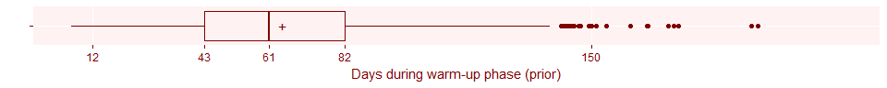

### Figure 6.14. Update of lambda after 150 days of nothing.

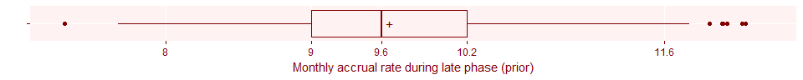

### Update 2. We have 240 days of accrual data after 192 days of waiting.

## Compiling model graph  
## Resolving undeclared variables  
## Allocating nodes  
## Graph information:  
## Observed stochastic nodes: 432  
## Unobserved stochastic nodes: 667  
## Total graph size: 13809  
##   
## Initializing model

##   
## Iterations = 101:1100  
## Thinning interval = 1   
## Number of chains = 1   
## Sample size per chain = 1000   
##   
## 1. Empirical mean and standard deviation for each variable,  
## plus standard error of the mean:  
##   
## Mean SD Naive SE Time-series SE  
## Nstar 235.27600 21.919039 0.6931409 1.0138602  
## delta1 0.16880 0.007002 0.0002214 0.0005701  
## delta2 0.37760 0.075031 0.0023727 0.0038521  
## delta3 0.09585 0.038049 0.0012032 0.0029165  
## lambda 0.29205 0.026154 0.0008271 0.0017057  
##   
## 2. Quantiles for each variable:  
##   
## 2.5% 25% 50% 75% 97.5%  
## Nstar 196.00000 220.00000 235.00000 249.0000 283.0000  
## delta1 0.15133 0.16583 0.17090 0.1739 0.1760  
## delta2 0.23511 0.32938 0.37518 0.4250 0.5266  
## delta3 0.04438 0.06281 0.08553 0.1294 0.1654  
## lambda 0.24470 0.27446 0.29008 0.3088 0.3492

### Figure 6.15. Second update of total sample size.

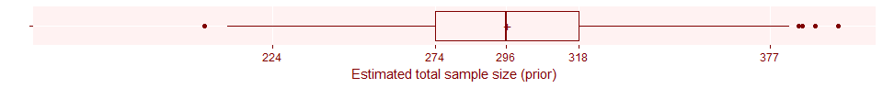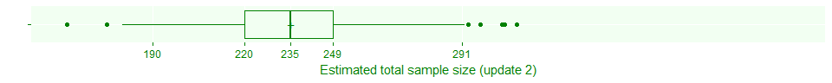

### Figure 6.16. Second update of delta2.

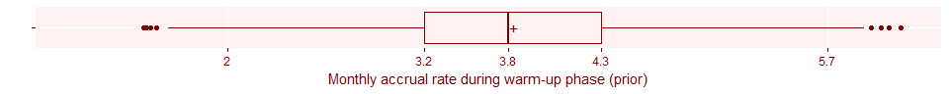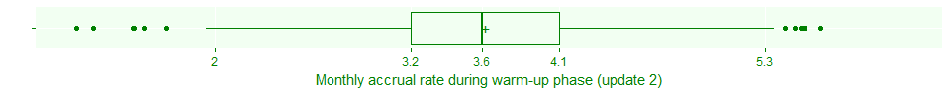

### Figure 6.17. Second update of delta3.



### Figure 6.18. Second update of lambda.

