Simulating clinical trials--binomial extension

Steve Simon

March 22, 2017

## Warning: package 'broom' was built under R version 3.3.3

## Warning: package 'ggplot2' was built under R version 3.3.2

## Warning: package 'magrittr' was built under R version 3.3.3

## Warning: package 'rjags' was built under R version 3.3.2

## Warning: package 'coda' was built under R version 3.3.2

## Warning: package 'rstan' was built under R version 3.4.0

## Warning: package 'StanHeaders' was built under R version 3.4.0

## Warning: package 'tidyr' was built under R version 3.3.2

### Part 7. Modeling exclusions and refusals

### Figure 7.1. Prior distribution for pi1, proportion excluded.

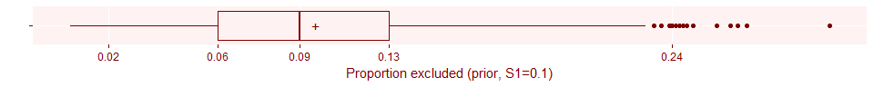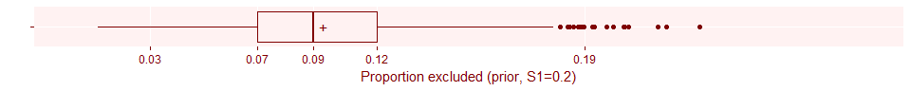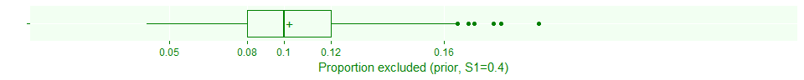

### Figure 7.2. Prior distribution for pi2, proportion refusing.

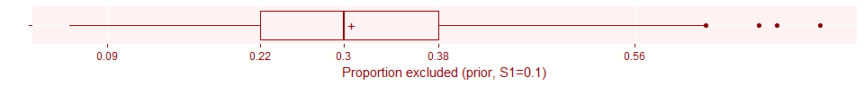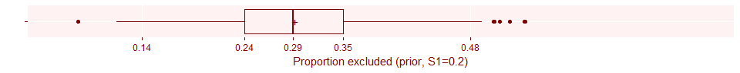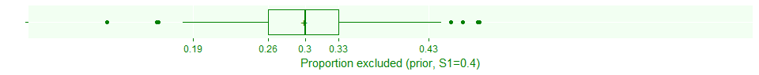

### Here's what the code would look like for this model.

## data {  
## int<lower=1> N; // planned number of patients   
## real<lower=0> T; // planned duration of trial  
## real<lower=0, upper=1> S; // strength of prior  
## int<lower=0> n1; // observed patients  
## int<lower=0> n2; // after exclusions  
## int<lower=0> n3; // after exclusions and refusals  
## real<lower=0> t; // observed time  
## real<lower=0, upper=1> P1; // planned proportion after exclusions  
## real<lower=0, upper=1> S1; // strength of prior for exclusion proportion  
## real<lower=0, upper=1> P2; // planned proportion after refusals  
## real<lower=0, upper=1> S2; // strength of prior for refusal proportion  
##   
## }  
## parameters {  
## real<lower=0> lambda;  
## real<lower=0, upper=1> pi1;  
## real<lower=0, upper=1> pi2;  
## }  
## model {  
## lambda ~ gamma(N*S, T*S);  
## pi1 ~ beta(N*S1*P1, N*S1*(1-P1));  
## pi2 ~ beta(N*S2*P2, N*S2*(1-P2));  
## if (t>0) {  
## n1 ~ poisson(t*lambda);  
## n2 ~ binomial(n1, 1-pi1);  
## n3 ~ binomial(n2, 1-pi2);  
## }  
## }  
## generated quantities {  
## int<lower=0> N1star;  
## int<lower=0> N2star;  
## int<lower=0> N3star;  
## N1star = n1 + poisson_rng((T-t)*lambda);  
## N2star = n2 + binomial_rng(N1star-n1, 1-pi1);  
## N3star = n3 + binomial_rng(N2star-n2, 1-pi2);  
## }

### Figure 7.3. Prior estimate of sample size, accounting for exclusions and refusals.

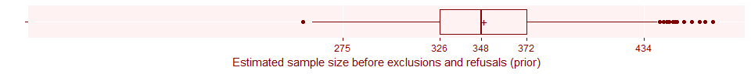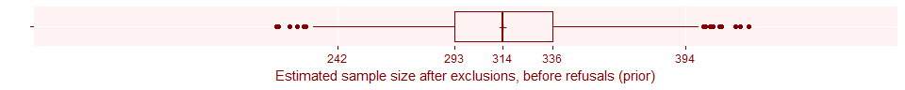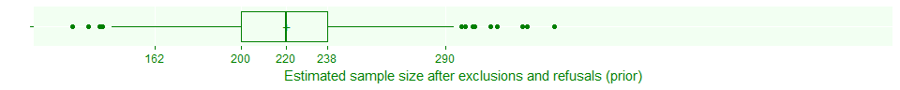

### Figure 7.4. How the prior distributions affect the estimated total sample size.

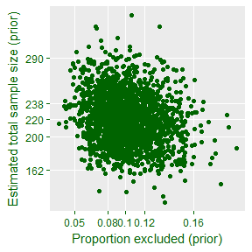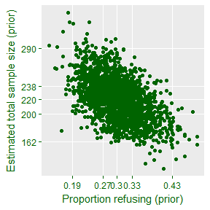

### Figure 7.5. Updated sample size before exclusions and refusals.

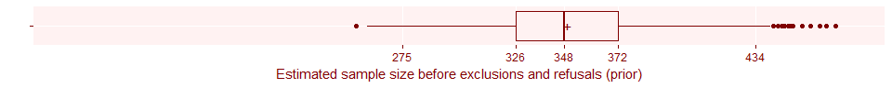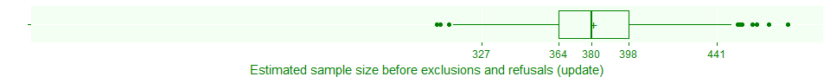

### Figure 7.6. Updated sample size after exclusions, before refusals.

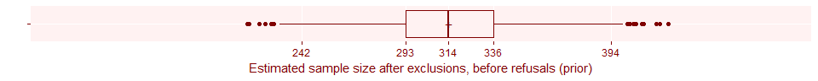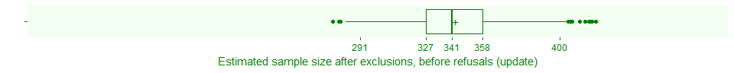

### Figure 7.7. Updated estimates after exclusions and refusals

