| **Introduction to survival analysis. Exercises 04, SAS** |
| --- |
|  |
| **1. Open the WHAS500 data set in the software program** |
| **of your choice** |

| **Obs** | **ID** | **AGE** | **GENDER** | **HR** | **SYSBP** | **DIASBP** | **BMI** | **CVD** | **AFB** | **SHO** | **CHF** | **AV3** | **MIORD** | **MITYPE** | **YEAR** |
| --- | --- | --- | --- | --- | --- | --- | --- | --- | --- | --- | --- | --- | --- | --- | --- |
| **1** | 1 | 83 | 0 | 89 | 152 | 78 | 25.5405 | 1 | 1 | 0 | 0 | 0 | 1 | 0 | 1 |
| **2** | 2 | 49 | 0 | 84 | 120 | 60 | 24.0240 | 1 | 0 | 0 | 0 | 0 | 0 | 1 | 1 |
| **3** | 4 | 70 | 0 | 65 | 123 | 76 | 26.6319 | 1 | 0 | 0 | 1 | 0 | 0 | 1 | 1 |
| **4** | 5 | 70 | 0 | 63 | 135 | 85 | 24.4125 | 1 | 0 | 0 | 0 | 0 | 0 | 1 | 1 |
| **5** | 6 | 70 | 0 | 76 | 83 | 54 | 23.2424 | 1 | 0 | 0 | 0 | 1 | 0 | 0 | 1 |

| **Obs** | **LOS** | **DSTAT** | **LENFOL** | **FSTAT** | **time_yrs** |
| --- | --- | --- | --- | --- | --- |
| **1** | 5 | 0 | 2178 | 0 | 5.96304 |
| **2** | 5 | 0 | 2172 | 0 | 5.94661 |
| **3** | 10 | 0 | 297 | 1 | 0.81314 |
| **4** | 6 | 0 | 2131 | 0 | 5.83436 |
| **5** | 1 | 1 | 1 | 1 | 0.00274 |

| It is always a good idea to peek at the first few rows |
| --- |
| of a dataset to orient yourself at the start. |

| **Introduction to survival analysis. Exercises 04, SAS** |
| --- |
|  |
| **a. Calculate a Cox regression model for systolic blood** |
| **pressure (sysbp) by itself** |

| **The PHREG Procedure** |
| --- |

| **Model Information** | |
| --- | --- |
| **Data Set** | WORK.TIME_RECODE |
| **Dependent Variable** | time_yrs |
| **Censoring Variable** | FSTAT |
| **Censoring Value(s)** | 0 |
| **Ties Handling** | BRESLOW |

| **Number of Observations Read**  **Number of Observations Used** | 500  500 |
| --- | --- |

| **Summary of the Number of Event and Censored Values** | | | |
| --- | --- | --- | --- |
| **Total** | **Event** | **Censored** | **Percent**  **Censored** |
| 500 | 215 | 285 | 57.00 |

| **Convergence Status** |
| --- |
| Convergence criterion (GCONV=1E-8) satisfied. |

| **Model Fit Statistics** | | |
| --- | --- | --- |
| **Criterion** | **Without**  **Covariates** | **With**  **Covariates** |
| **-2 LOG L** | 2455.158 | 2450.998 |
| **AIC** | 2455.158 | 2452.998 |
| **SBC** | 2455.158 | 2456.368 |

| The p-value is less than 0.05 and the hazard ratio |
| --- |
| is less than 1. There is evidence of a statistically |
| significant decline in mortality as sysbp increases. |

| **Introduction to survival analysis. Exercises 04, SAS** |
| --- |
|  |
| **a. Calculate a Cox regression model for systolic blood** |
| **pressure (sysbp) by itself** |

| **The PHREG Procedure** |
| --- |

| **Testing Global Null Hypothesis: BETA=0** | | | |
| --- | --- | --- | --- |
| **Test** | **Chi-Square** | **DF** | **Pr >**  **ChiSq** |
| **Likelihood Ratio** | 4.1606 | 1 | 0.0414 |
| **Score** | 4.0922 | 1 | 0.0431 |
| **Wald** | 4.0902 | 1 | 0.0431 |

| **Analysis of Maximum Likelihood Estimates** | | | | | | |
| --- | --- | --- | --- | --- | --- | --- |
| **Parameter** | **DF** | **Parameter**  **Estimate** | **Standard**  **Error** | **Chi-Square** | **Pr >**  **ChiSq** | **Hazard**  **Ratio** |
| **SYSBP** | 1 | -0.00450 | 0.00223 | 4.0902 | 0.0431 | 0.996 |

| The p-value is less than 0.05 and the hazard ratio |
| --- |
| is less than 1. There is evidence of a statistically |
| significant decline in mortality as sysbp increases. |

| **Introduction to survival analysis. Exercises 04, SAS** |
| --- |
|  |
| **and then adjusted for gender and age.** |

| **The PHREG Procedure** |
| --- |

| **Model Information** | |
| --- | --- |
| **Data Set** | WORK.TIME_RECODE |
| **Dependent Variable** | time_yrs |
| **Censoring Variable** | FSTAT |
| **Censoring Value(s)** | 0 |
| **Ties Handling** | BRESLOW |

| **Number of Observations Read**  **Number of Observations Used** | 500  500 |
| --- | --- |

| **Summary of the Number of Event and Censored Values** | | | |
| --- | --- | --- | --- |
| **Total** | **Event** | **Censored** | **Percent**  **Censored** |
| 500 | 215 | 285 | 57.00 |

| **Convergence Status** |
| --- |
| Convergence criterion (GCONV=1E-8) satisfied. |

| **Model Fit Statistics** | | |
| --- | --- | --- |
| **Criterion** | **Without**  **Covariates** | **With**  **Covariates** |
| **-2 LOG L** | 2455.158 | 2309.238 |
| **AIC** | 2455.158 | 2315.238 |
| **SBC** | 2455.158 | 2325.350 |

| **Testing Global Null Hypothesis: BETA=0** | | | |
| --- | --- | --- | --- |
| **Test** | **Chi-Square** | **DF** | **Pr >**  **ChiSq** |
| **Likelihood Ratio** | 145.9202 | 3 | <.0001 |
| **Score** | 131.4801 | 3 | <.0001 |

| The inclusion of gender and age does not appear to |
| --- |
| have much effect on the hazard ratio for sysbp. |

| **Introduction to survival analysis. Exercises 04, SAS** |
| --- |
|  |
| **and then adjusted for gender and age.** |

| **The PHREG Procedure** |
| --- |

| **Testing Global Null Hypothesis: BETA=0** | | | |
| --- | --- | --- | --- |
| **Test** | **Chi-Square** | **DF** | **Pr >**  **ChiSq** |
| **Wald** | 124.1651 | 3 | <.0001 |

| **Analysis of Maximum Likelihood Estimates** | | | | | | |
| --- | --- | --- | --- | --- | --- | --- |
| **Parameter** | **DF** | **Parameter**  **Estimate** | **Standard**  **Error** | **Chi-Square** | **Pr >**  **ChiSq** | **Hazard**  **Ratio** |
| **SYSBP** | 1 | -0.00426 | 0.00218 | 3.8241 | 0.0505 | 0.996 |
| **GENDER** | 1 | -0.05337 | 0.14080 | 0.1437 | 0.7047 | 0.948 |
| **AGE** | 1 | 0.06646 | 0.00618 | 115.8405 | <.0001 | 1.069 |

| The inclusion of gender and age does not appear to |
| --- |
| have much effect on the hazard ratio for sysbp. |

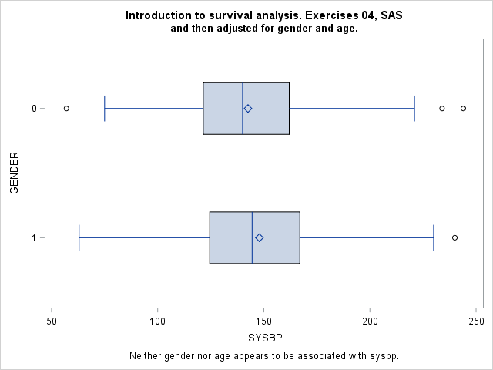

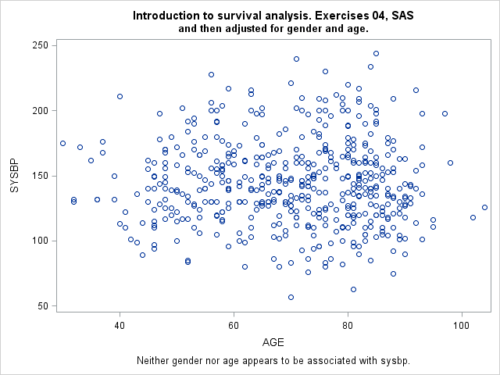

| **Introduction to survival analysis. Exercises 04, SAS** |
| --- |
|  |
| **Calculate the unadjusted survival curves for patients** |
| **with systolic blood pressures of 120, 140, and 160.** |

| **The PHREG Procedure** |
| --- |

| **Model Information** | |
| --- | --- |
| **Data Set** | WORK.TIME_RECODE |
| **Dependent Variable** | time_yrs |
| **Censoring Variable** | FSTAT |
| **Censoring Value(s)** | 0 |
| **Ties Handling** | BRESLOW |

| **Number of Observations Read**  **Number of Observations Used** | 500  500 |
| --- | --- |

| **Summary of the Number of Event and Censored Values** | | | |
| --- | --- | --- | --- |
| **Total** | **Event** | **Censored** | **Percent**  **Censored** |
| 500 | 215 | 285 | 57.00 |

| **Convergence Status** |
| --- |
| Convergence criterion (GCONV=1E-8) satisfied. |

| **Model Fit Statistics** | | |
| --- | --- | --- |
| **Criterion** | **Without**  **Covariates** | **With**  **Covariates** |
| **-2 LOG L** | 2455.158 | 2450.998 |
| **AIC** | 2455.158 | 2452.998 |
| **SBC** | 2455.158 | 2456.368 |

| The unadjusted comparison shows a small decrease |
| --- |
| in risk of death as sysbp increases. |

| **Introduction to survival analysis. Exercises 04, SAS** |
| --- |
|  |
| **Calculate the unadjusted survival curves for patients** |
| **with systolic blood pressures of 120, 140, and 160.** |

| **The PHREG Procedure** |
| --- |

| **Testing Global Null Hypothesis: BETA=0** | | | |
| --- | --- | --- | --- |
| **Test** | **Chi-Square** | **DF** | **Pr >**  **ChiSq** |
| **Likelihood Ratio** | 4.1606 | 1 | 0.0414 |
| **Score** | 4.0922 | 1 | 0.0431 |
| **Wald** | 4.0902 | 1 | 0.0431 |

| **Analysis of Maximum Likelihood Estimates** | | | | | | |
| --- | --- | --- | --- | --- | --- | --- |
| **Parameter** | **DF** | **Parameter**  **Estimate** | **Standard**  **Error** | **Chi-Square** | **Pr >**  **ChiSq** | **Hazard**  **Ratio** |
| **SYSBP** | 1 | -0.00450 | 0.00223 | 4.0902 | 0.0431 | 0.996 |

| The unadjusted comparison shows a small decrease |
| --- |
| in risk of death as sysbp increases. |

| **Introduction to survival analysis. Exercises 04, SAS** |
| --- |
|  |
| **Calculate the unadjusted survival curves for patients** |
| **with systolic blood pressures of 120, 140, and 160.** |

| **The PHREG Procedure** |
| --- |

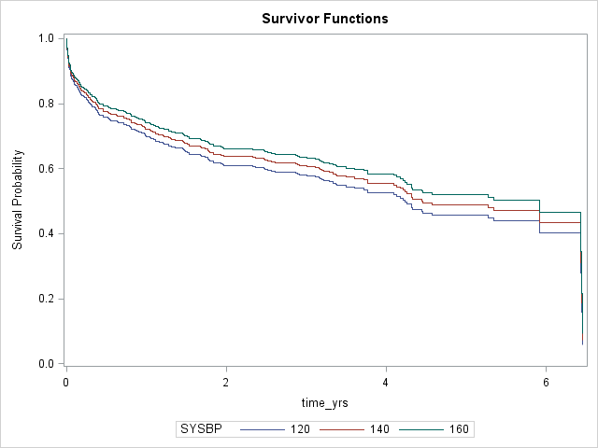

| The unadjusted comparison shows a small decrease |
| --- |
| in risk of death as sysbp increases. |

| **Introduction to survival analysis. Exercises 04, SAS** |
| --- |
|  |
| **Then recalculate these survival curves with age set** |
| **to the overall average age, and to a population** |
| **that is 30% female. Interpret your results.** |

| **The PHREG Procedure** |
| --- |

| **Model Information** | |
| --- | --- |
| **Data Set** | WORK.TIME_RECODE |
| **Dependent Variable** | time_yrs |
| **Censoring Variable** | FSTAT |
| **Censoring Value(s)** | 0 |
| **Ties Handling** | BRESLOW |

| **Number of Observations Read**  **Number of Observations Used** | 500  500 |
| --- | --- |

| **Summary of the Number of Event and Censored Values** | | | |
| --- | --- | --- | --- |
| **Total** | **Event** | **Censored** | **Percent**  **Censored** |
| 500 | 215 | 285 | 57.00 |

| **Convergence Status** |
| --- |
| Convergence criterion (GCONV=1E-8) satisfied. |

| **Model Fit Statistics** | | |
| --- | --- | --- |
| **Criterion** | **Without**  **Covariates** | **With**  **Covariates** |
| **-2 LOG L** | 2455.158 | 2309.238 |
| **AIC** | 2455.158 | 2315.238 |
| **SBC** | 2455.158 | 2325.350 |

| The results are largely unchanged after adjustment. |
| --- |

| **Introduction to survival analysis. Exercises 04, SAS** |
| --- |
|  |
| **Then recalculate these survival curves with age set** |
| **to the overall average age, and to a population** |
| **that is 30% female. Interpret your results.** |

| **The PHREG Procedure** |
| --- |

| **Testing Global Null Hypothesis: BETA=0** | | | |
| --- | --- | --- | --- |
| **Test** | **Chi-Square** | **DF** | **Pr >**  **ChiSq** |
| **Likelihood Ratio** | 145.9202 | 3 | <.0001 |
| **Score** | 131.4801 | 3 | <.0001 |
| **Wald** | 124.1651 | 3 | <.0001 |

| **Analysis of Maximum Likelihood Estimates** | | | | | | |
| --- | --- | --- | --- | --- | --- | --- |
| **Parameter** | **DF** | **Parameter**  **Estimate** | **Standard**  **Error** | **Chi-Square** | **Pr >**  **ChiSq** | **Hazard**  **Ratio** |
| **SYSBP** | 1 | -0.00426 | 0.00218 | 3.8241 | 0.0505 | 0.996 |
| **AGE** | 1 | 0.06646 | 0.00618 | 115.8405 | <.0001 | 1.069 |
| **GENDER** | 1 | -0.05337 | 0.14080 | 0.1437 | 0.7047 | 0.948 |

| The results are largely unchanged after adjustment. |
| --- |

| **Introduction to survival analysis. Exercises 04, SAS** |
| --- |
|  |
| **Then recalculate these survival curves with age set** |
| **to the overall average age, and to a population** |
| **that is 30% female. Interpret your results.** |

| **The PHREG Procedure** |
| --- |

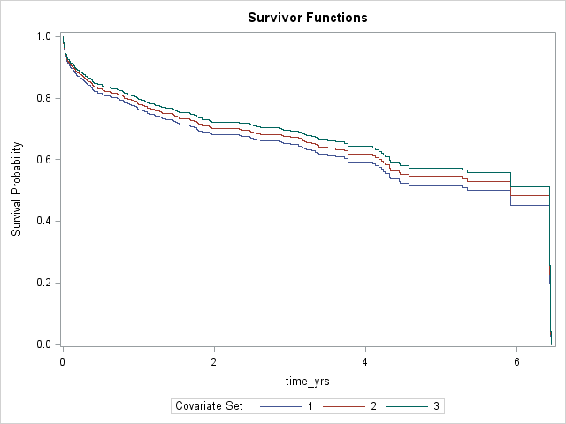

| The results are largely unchanged after adjustment. |
| --- |

| **Introduction to survival analysis. Exercises 04, SAS** |
| --- |
|  |
| **b. Calculate cubic spline model for systolic blood** |
| **pressure with four degrees of freedom.** |

| **The PHREG Procedure** |
| --- |

| **Model Information** | |
| --- | --- |
| **Data Set** | WORK.SYSBP_RECODE |
| **Dependent Variable** | time_yrs |
| **Censoring Variable** | FSTAT |
| **Censoring Value(s)** | 0 |
| **Ties Handling** | BRESLOW |

| **Number of Observations Read**  **Number of Observations Used** | 500  500 |
| --- | --- |

| The spline is statistically significant. |
| --- |

| **Introduction to survival analysis. Exercises 04, SAS** |
| --- |
|  |
| **b. Calculate cubic spline model for systolic blood** |
| **pressure with four degrees of freedom.** |

| **The PHREG Procedure** |
| --- |

| **Knots for Spline Effect sysbp_spline5** | |
| --- | --- |
| **Knot Number** | **sysbp_c** |
| 1 | -56.53333 |
| 2 | -25.36667 |
| 3 | 5.80000 |
| 4 | 36.96667 |
| 5 | 68.13333 |

| The spline is statistically significant. |
| --- |

| **Introduction to survival analysis. Exercises 04, SAS** |
| --- |
|  |
| **b. Calculate cubic spline model for systolic blood** |
| **pressure with four degrees of freedom.** |

| **The PHREG Procedure** |
| --- |

| **Basis Details for Spline Effect sysbp_spline5** | | |
| --- | --- | --- |
| **Column** | **Power** | **Break Knot** |
| 1 | 0 |  |
| 2 | 1 |  |
| 3 | 3 | -56.53333 |
| 4 | 3 | -25.36667 |
| 5 | 3 | 5.80000 |

| **Summary of the Number of Event and Censored Values** | | | |
| --- | --- | --- | --- |
| **Total** | **Event** | **Censored** | **Percent**  **Censored** |
| 500 | 215 | 285 | 57.00 |

| **Convergence Status** |
| --- |
| Convergence criterion (GCONV=1E-8) satisfied. |

| **Model Fit Statistics** | | |
| --- | --- | --- |
| **Criterion** | **Without**  **Covariates** | **With**  **Covariates** |
| **-2 LOG L** | 2455.158 | 2442.424 |
| **AIC** | 2455.158 | 2450.424 |
| **SBC** | 2455.158 | 2463.907 |

| **Testing Global Null Hypothesis: BETA=0** | | | |
| --- | --- | --- | --- |
| **Test** | **Chi-Square** | **DF** | **Pr >**  **ChiSq** |
| **Likelihood Ratio** | 12.7340 | 4 | 0.0127 |
| **Score** | 13.3401 | 4 | 0.0097 |
| **Wald** | 13.0454 | 4 | 0.0111 |

| The spline is statistically significant. |
| --- |

| **Introduction to survival analysis. Exercises 04, SAS** |
| --- |
|  |
| **b. Calculate cubic spline model for systolic blood** |
| **pressure with four degrees of freedom.** |

| **The PHREG Procedure** |
| --- |

| **Analysis of Maximum Likelihood Estimates** | | | | | | | | |
| --- | --- | --- | --- | --- | --- | --- | --- | --- |
| **Parameter** |  | **DF** | **Parameter**  **Estimate** | **Standard**  **Error** | **Chi-Square** | **Pr >**  **ChiSq** | **Hazard**  **Ratio** | **Label** |
| **sysbp_spline5** | **1** | 0 | 0 | . | . | . | . | sysbp_spline5 1 |
| **sysbp_spline5** | **2** | 1 | -0.00351 | 0.01080 | 0.1056 | 0.7452 | . | sysbp_spline5 2 |
| **sysbp_spline5** | **3** | 1 | -0.0005558 | 0.0004879 | 1.2978 | 0.2546 | . | sysbp_spline5 3 |
| **sysbp_spline5** | **4** | 1 | 0.00164 | 0.00114 | 2.0538 | 0.1518 | . | sysbp_spline5 4 |
| **sysbp_spline5** | **5** | 1 | -0.00156 | 0.00107 | 2.1553 | 0.1421 | . | sysbp_spline5 5 |

| The spline is statistically significant. |
| --- |

