Name: Meet Patel

No: N01490221

<https://delightful-lime-chameleon.cyclic.app/login>

https://delightful-lime-chameleon.cyclic.app/logout

https://delightful-lime-chameleon.cyclic.app/api/restaurants/?page=3&perPage=4&borough=

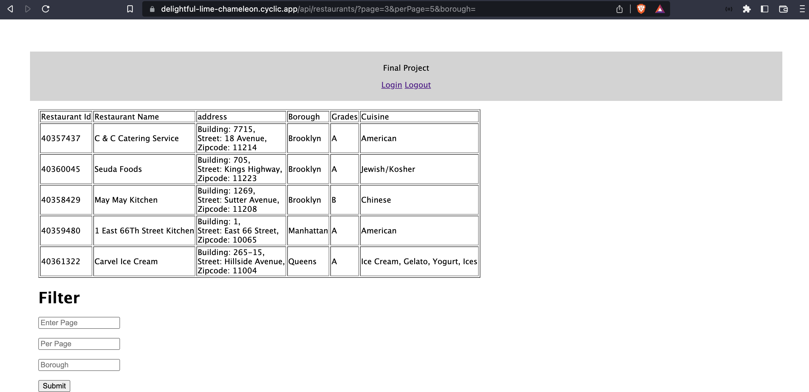

Post Method: localhost:8000/api/restaurants/

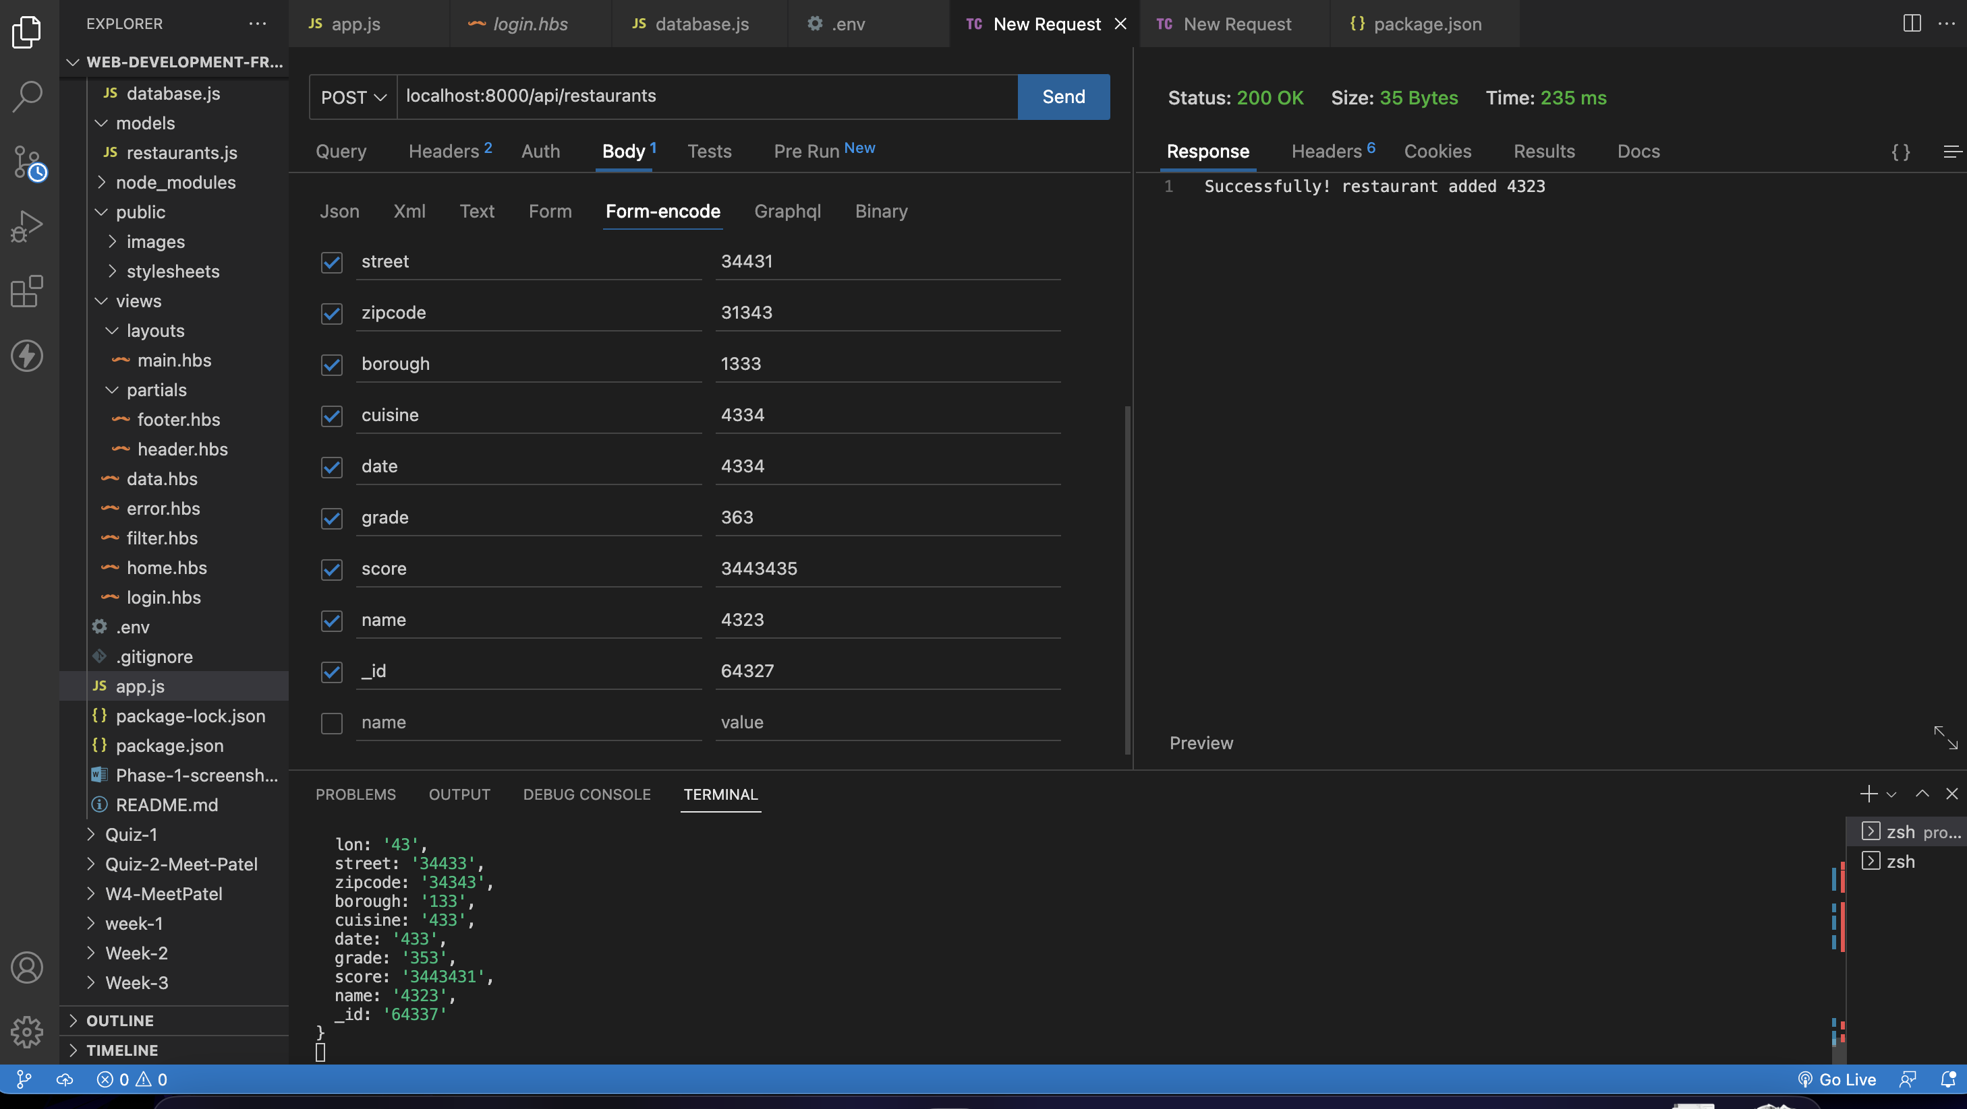

Delete Method: localhost:8000/api/restaurants/40358429

