Phase-1

* Route http://localhost:8000/api/restaurants

* Route http://localhost:8000/api/restaurants?page=2&perPage=1

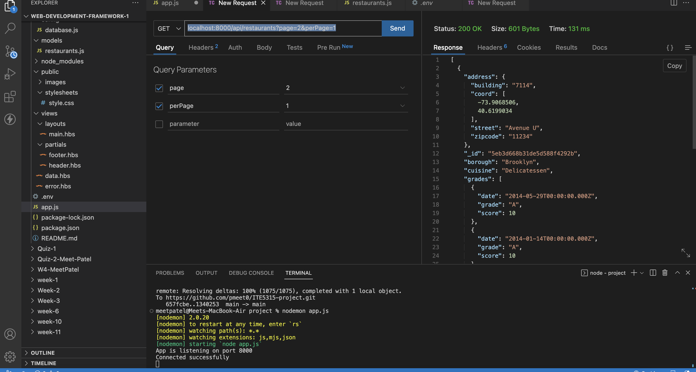

* Post Method for adding data

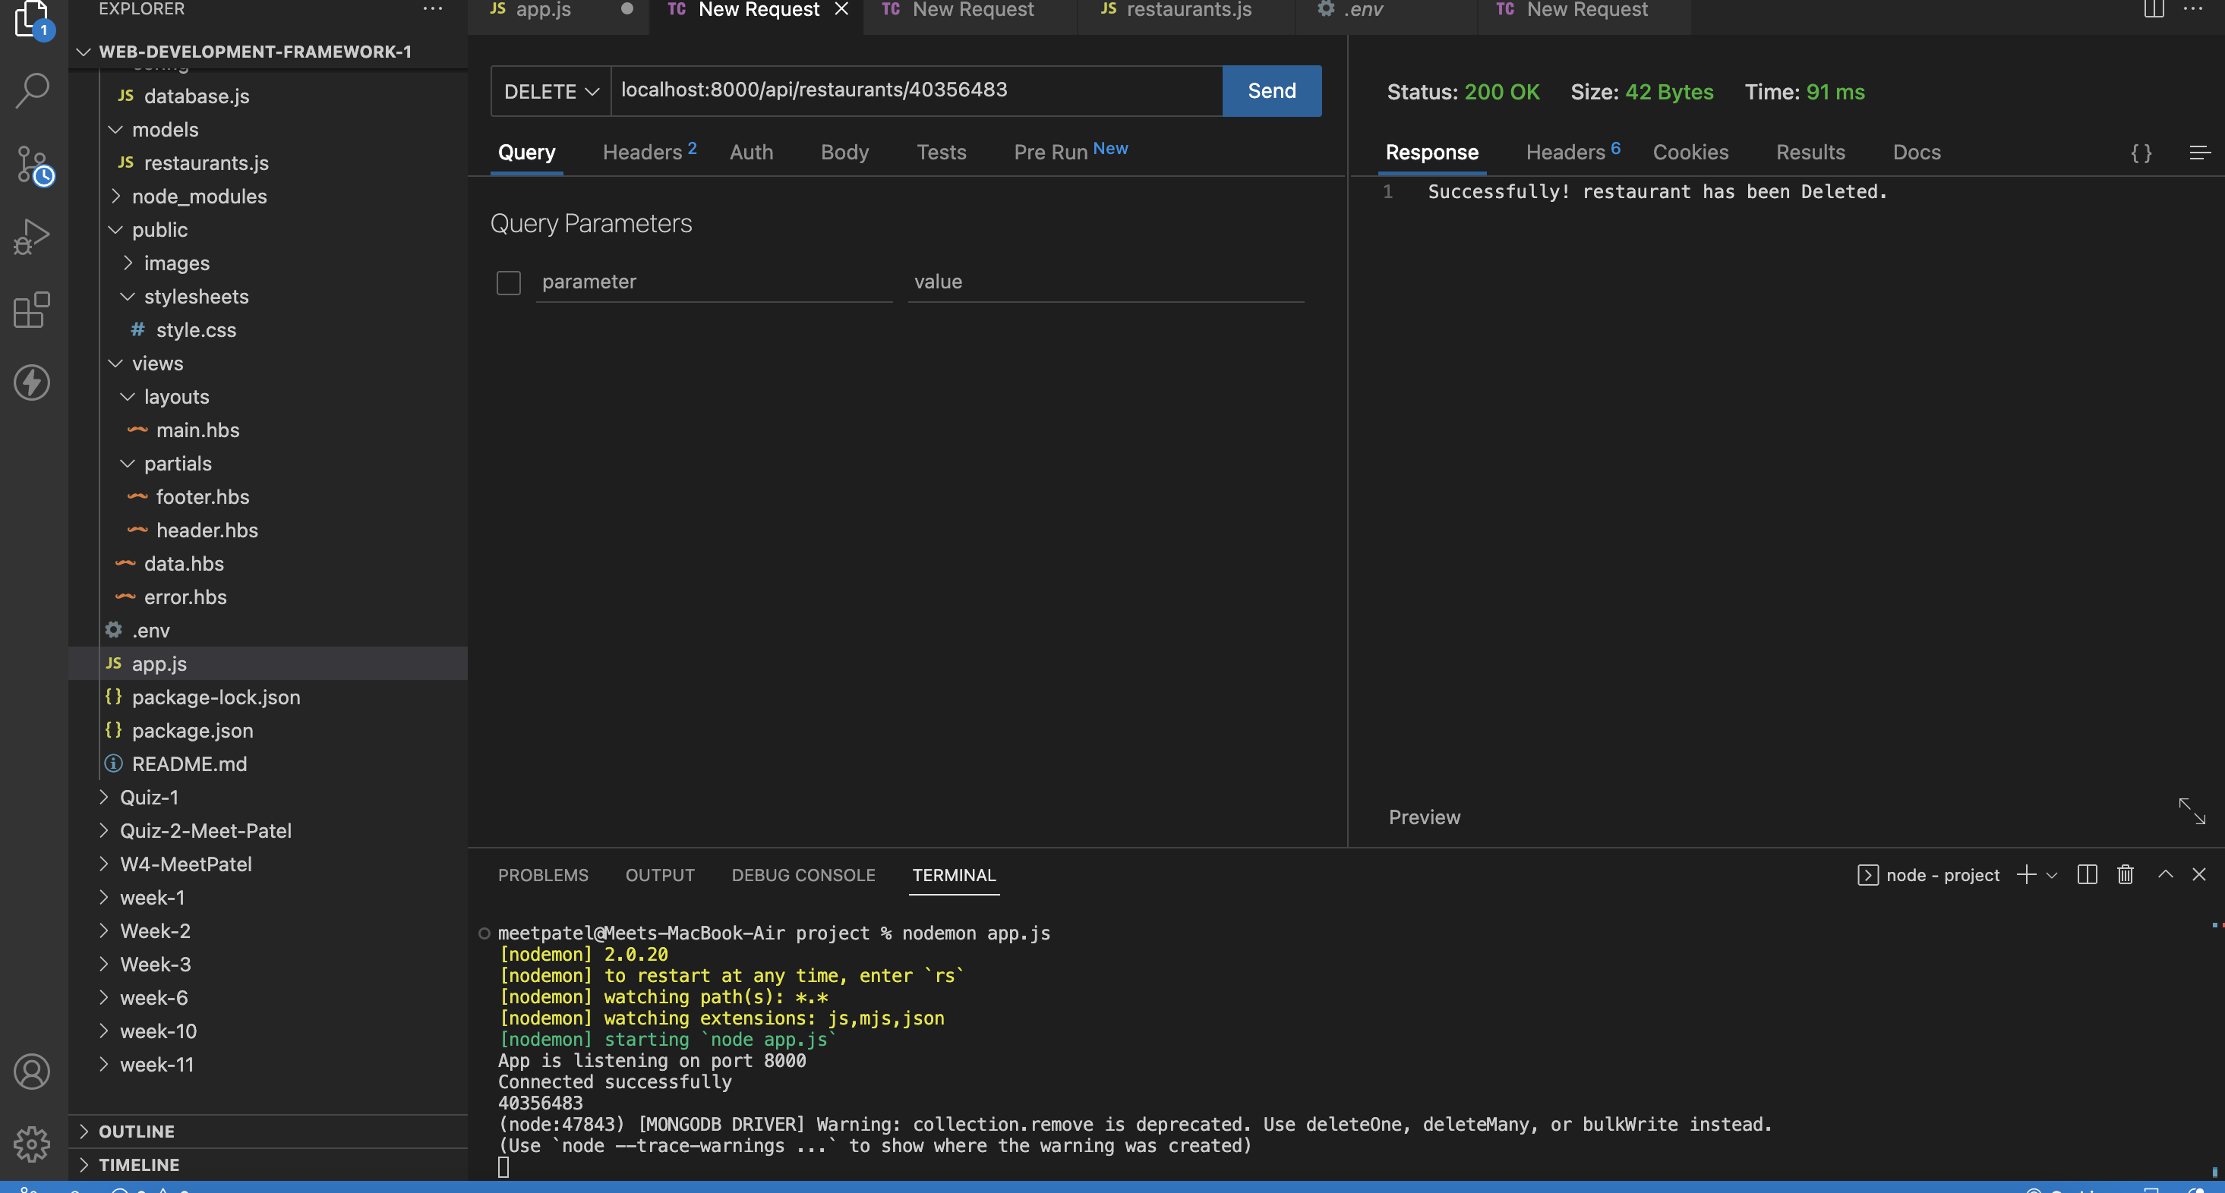

* Data rendering in table using handlebars

