Architecture File of

Logical Architecture

# Table of Contents

1. Table of Contents 2

1. 3

2. Description of Logical Components 4

2.1. Logical Component : Logical System 4

2.1.1. Realizing system components: 4

2.1.2. Realizing physical components: 4

2.2. Logical Component : Groud Subsystem 4

2.2.1. Realizing physical components: 4

2.2.2. Allocated Functions 4

2.2.3. Component Exchanges 5

2.3. Logical Component : Acquisition Subsystem 5

2.3.1. Realizing physical components: 5

2.3.2. Allocated Functions 5

2.3.3. Component Exchanges 6

2.4. Logical Component : Broadcaster 6

2.4.1. Realizing system components: 6

2.4.2. Realizing physical components: 6

2.4.3. Allocated Functions 6

2.4.4. Component Exchanges 6

2.5. Logical Component : Forecaster 7

2.5.1. Realizing system components: 7

2.5.2. Realizing physical components: 7

2.5.3. Allocated Functions 7

2.5.4. Component Exchanges 7

2.6. Logical Component : Weather Operator 7

2.6.1. Realizing system components: 7

2.6.2. Realizing physical components: 7

2.6.3. Allocated Functions 7

2.6.4. Component Exchanges 8

2.7. Logical Component : Scientific User 8

2.7.1. Realizing system components: 8

2.7.2. Realizing physical components: 8

2.7.3. Allocated Functions 8

2.7.4. Component Exchanges 8

2.8. Logical Component : Earth Atmosphere 8

2.8.1. Realizing system components: 9

2.8.2. Realizing physical components: 9

2.8.3. Allocated Functions 9

2.8.4. Component Exchanges 9

# 

# Description of Logical Components

## Logical Component : Logical System

We verify that the ***Logical System*** no longer has any Ports. To do this, we Will also change the color of its countour so that it almost no longer appears.

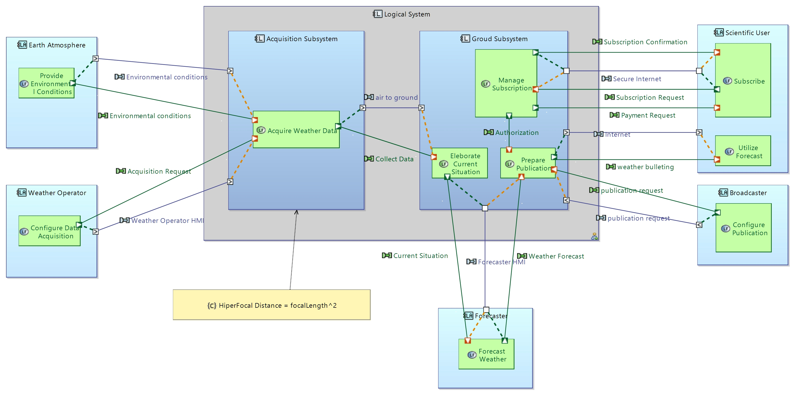

### Realizing system components:

* EOLE

### Realizing physical components:

* Physical System

## Logical Component : Groud Subsystem

*No description*

### Realizing physical components:

* Groud Subsystem

### Allocated Functions

|  |  |
| --- | --- |
| **Function name** | **Description** |
| Eleborate Current Situation | This is a description of Logical Function |
| Manage Subscription | null |
| Prepare Publication | null |

### Component Exchanges

|  |  |
| --- | --- |
| **Name** | air to ground |
| **Direction** | IN |
| **Destination Component** | Acquisition Subsystem |

*No description*

|  |  |
| --- | --- |
| **Name** | Forecaster HMI |
| **Direction** | INOUT |
| **Destination Component** | Forecaster |

*No description*

|  |  |
| --- | --- |
| **Name** | Secure Internet |
| **Direction** | INOUT |
| **Destination Component** | Scientific User |

*No description*

|  |  |
| --- | --- |
| **Name** | Internet |
| **Direction** | OUT |
| **Destination Component** | Scientific User |

*No description*

|  |  |
| --- | --- |
| **Name** | publication request |
| **Direction** | IN |
| **Destination Component** | Broadcaster |

*No description*

## Logical Component : Acquisition Subsystem

*No description*

### Realizing physical components:

* Acquisition Subsystem

### Allocated Functions

|  |  |
| --- | --- |
| **Function name** | **Description** |
| Acquire Weather Data | null |

### Component Exchanges

|  |  |
| --- | --- |
| **Name** | Environmental conditions |
| **Direction** | IN |
| **Destination Component** | Earth Atmosphere |

*No description*

|  |  |
| --- | --- |
| **Name** | Weather Operator HMI |
| **Direction** | IN |
| **Destination Component** | Weather Operator |

*No description*

|  |  |
| --- | --- |
| **Name** | air to ground |
| **Direction** | OUT |
| **Destination Component** | Groud Subsystem |

*No description*

## Logical Component : Broadcaster

*No description*

### Realizing system components:

* Broadcaster

### Realizing physical components:

* Broadcaster

### Allocated Functions

|  |  |
| --- | --- |
| **Function name** | **Description** |
| Configure Publication | null |

### Component Exchanges

|  |  |
| --- | --- |
| **Name** | publication request |
| **Direction** | OUT |
| **Destination Component** | Groud Subsystem |

*No description*

## Logical Component : Forecaster

*No description*

### Realizing system components:

* Forecaster

### Realizing physical components:

* Forecaster

### Allocated Functions

|  |  |
| --- | --- |
| **Function name** | **Description** |
| Forecast Weather | This is a description of Logical Function |

### Component Exchanges

|  |  |
| --- | --- |
| **Name** | Forecaster HMI |
| **Direction** | INOUT |
| **Destination Component** | Groud Subsystem |

*No description*

## Logical Component : Weather Operator

*No description*

### Realizing system components:

* Weather Operator

### Realizing physical components:

* Weather Operator

### Allocated Functions

|  |  |
| --- | --- |
| **Function name** | **Description** |
| Configure Data Acquisition | null |

### Component Exchanges

|  |  |
| --- | --- |
| **Name** | Weather Operator HMI |
| **Direction** | OUT |
| **Destination Component** | Acquisition Subsystem |

*No description*

## Logical Component : Scientific User

*No description*

### Realizing system components:

* Scientific User

### Realizing physical components:

* Scientific User

### Allocated Functions

|  |  |
| --- | --- |
| **Function name** | **Description** |
| Utilize Forecast | This is a description of Logical Function |
| Subscribe | null |

### Component Exchanges

|  |  |
| --- | --- |
| **Name** | Internet |
| **Direction** | IN |
| **Destination Component** | Groud Subsystem |

*No description*

|  |  |
| --- | --- |
| **Name** | Secure Internet |
| **Direction** | INOUT |
| **Destination Component** | Groud Subsystem |

*No description*

## Logical Component : Earth Atmosphere

*No description*

### Realizing system components:

* Earth Atmosphere

### Realizing physical components:

* Earth Atmosphere

### Allocated Functions

|  |  |
| --- | --- |
| **Function name** | **Description** |
| Provide Environmental Conditions | This is a description of Logical Function |

### Component Exchanges

|  |  |
| --- | --- |
| **Name** | Environmental conditions |
| **Direction** | OUT |
| **Destination Component** | Acquisition Subsystem |

*No description*