Lesson 5 Hands On

Part 1
You have just been hired at a startup company. They currently only have ten employees, but they need to be included in the database. So far, they have only been tracked within an excel sheet. Your boss would like you to create a new collection in Atlas named employees. Take a look at the following data and the notes listed below before inserting any data:
Name | Birthday | Address | City | State | Position Name | Remote | Full Time
Alison Davidson | 04/05/75 | 874 W. Oak Place | Gary | Indiana | Customer Support | Yes | Yes
Henry Chapelton | 09/29/80 | 9324 E. Vista Way | Tempe | Arizona | Customer Support | No | Yes
Alex Miller | 11/22/83 | 244 Price Road | Mesa | Arizona | Customer Support | No | No
Carly Nielson | 08/04/87 | 678 W. Westward Road | Phoenix | Arizona | Office Manager | No | Yes
Tom Talbot | 12/30/89 | 12 Oakland Way | Chandler | Arizona | Inventory Manager | No | Yes
Mary Crawley | 07/06/80 | 1010 Granite Way | Charlotte | North Carolina | Human Resources | Yes | Yes
Daisy Baxter | 09/09/87 | 990 E. 84th St. | Tempe | Arizona | CEO | No | Yes
William Coyle | 10/11/91 | 944 W. 16th St. | Phoenix | Arizona | Intern | No | No
Edith Bates | 07/28/90 | 7 E. 20th Pl. | Chandler | Arizona | Customer Support | No | Yes
Gwen Harding | 10/11/86 | 234 W. 48th. St. | Phoenix | Arizona | Office Assistent | No | Yes
Notes:
- The Birthday field should have a data type of Date.
- The Position Name, Remote, and Full Time fields should be within an embedded document called position.
- Remote and Full Time fields should have boolean values.
It's been about a month since you have inserted all employees into the database. There have been a couple of changes to the company. The CEO decided that he no longer wants remote employees, so they have transferred the remote employees and they are now living in Arizona. Alison Davidson now lives at 777 E. 1st St. # 120 Tempe, AZ and Mary Crawley now lives at 8322 W. Vista Pl. Scottsdale, AZ. Since all employees now all live in Arizona, there is no need to have a field named "state" within this collection, so please remove it. Lastly, they would like very efficient searching using the "position" field (remember that field includes a document with three other fields).
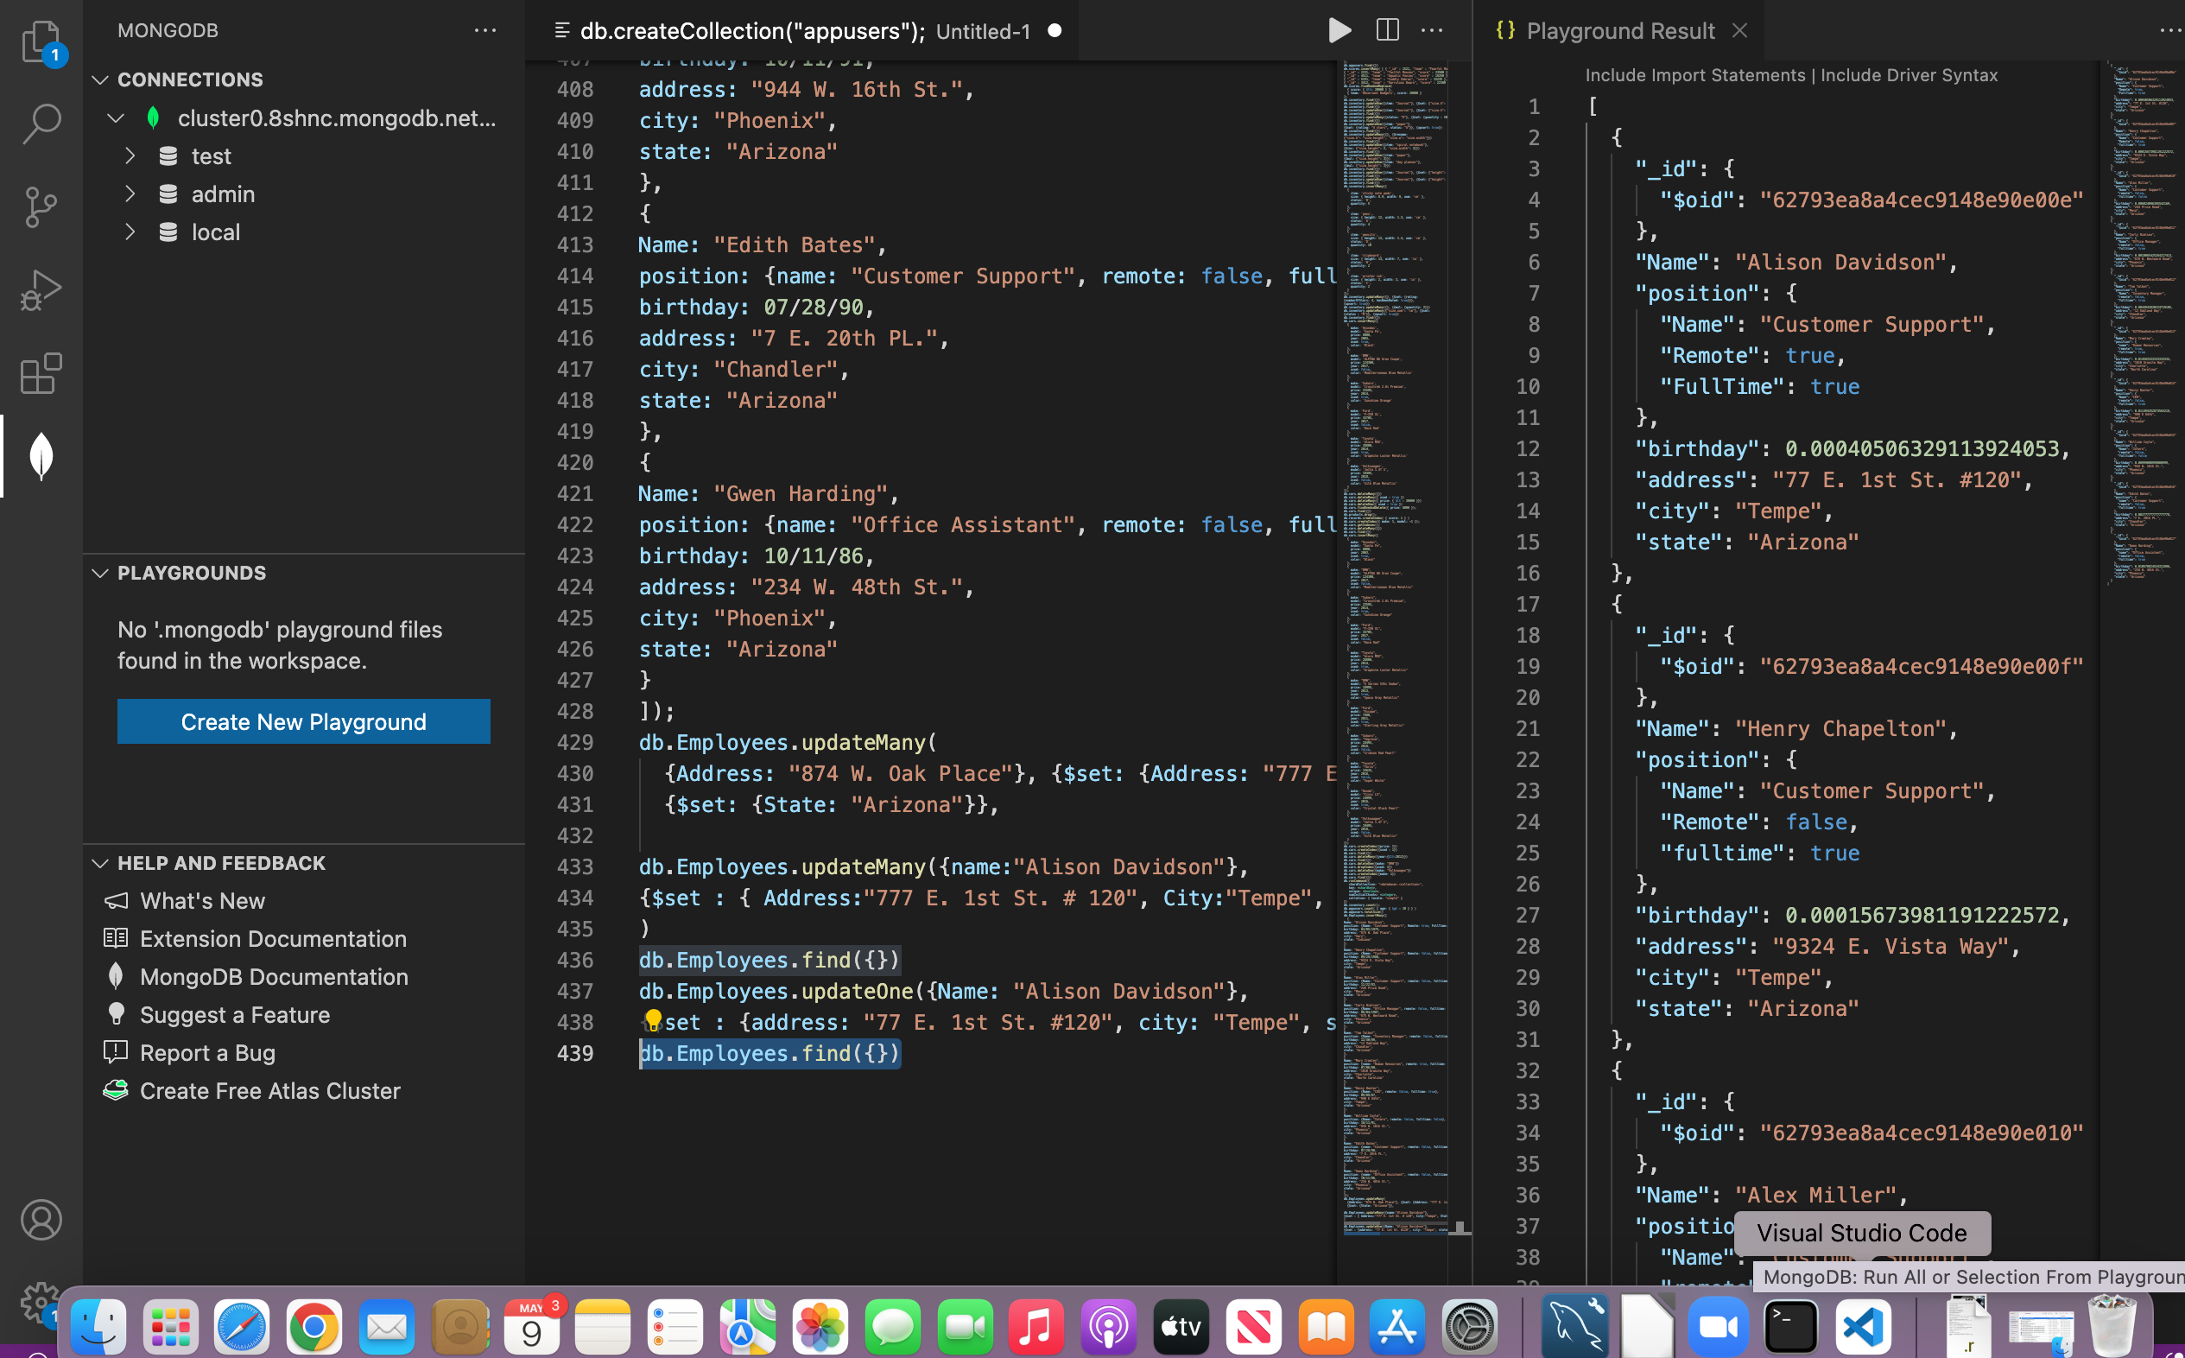
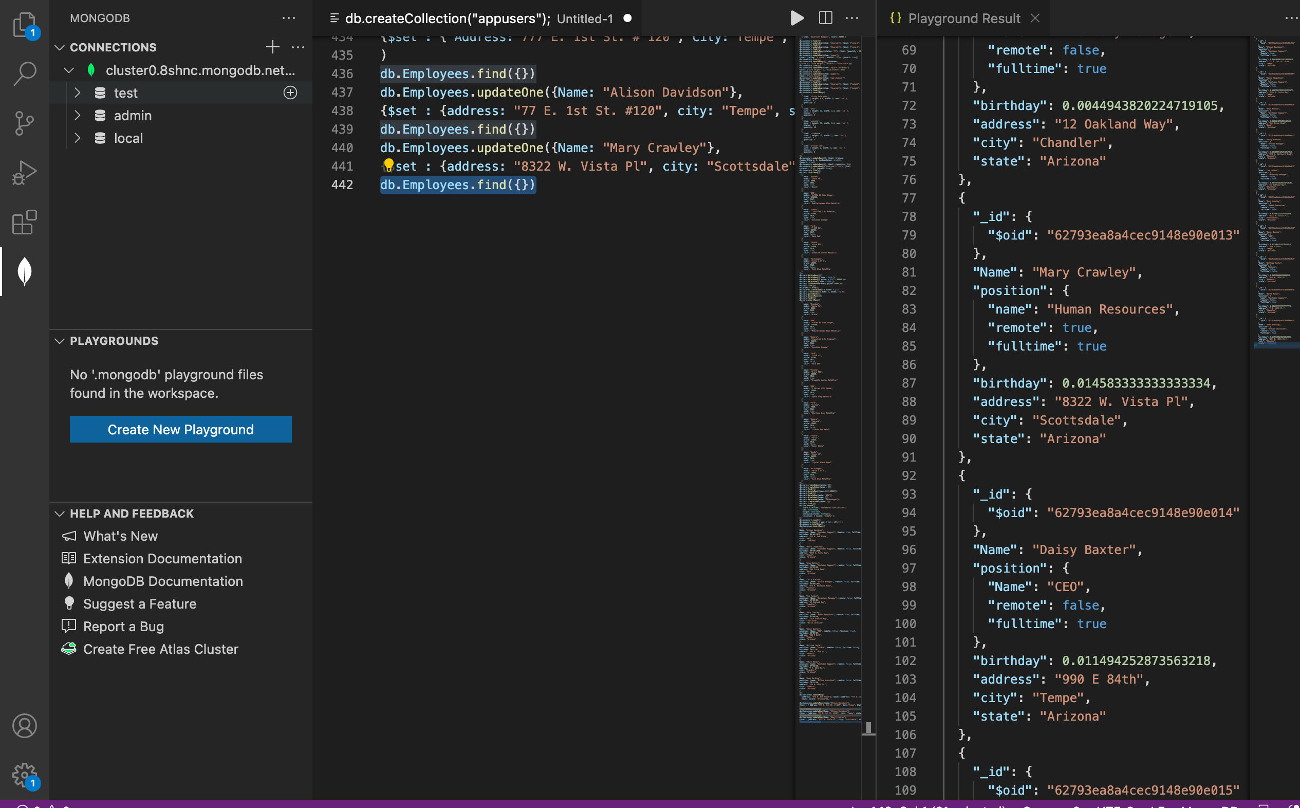
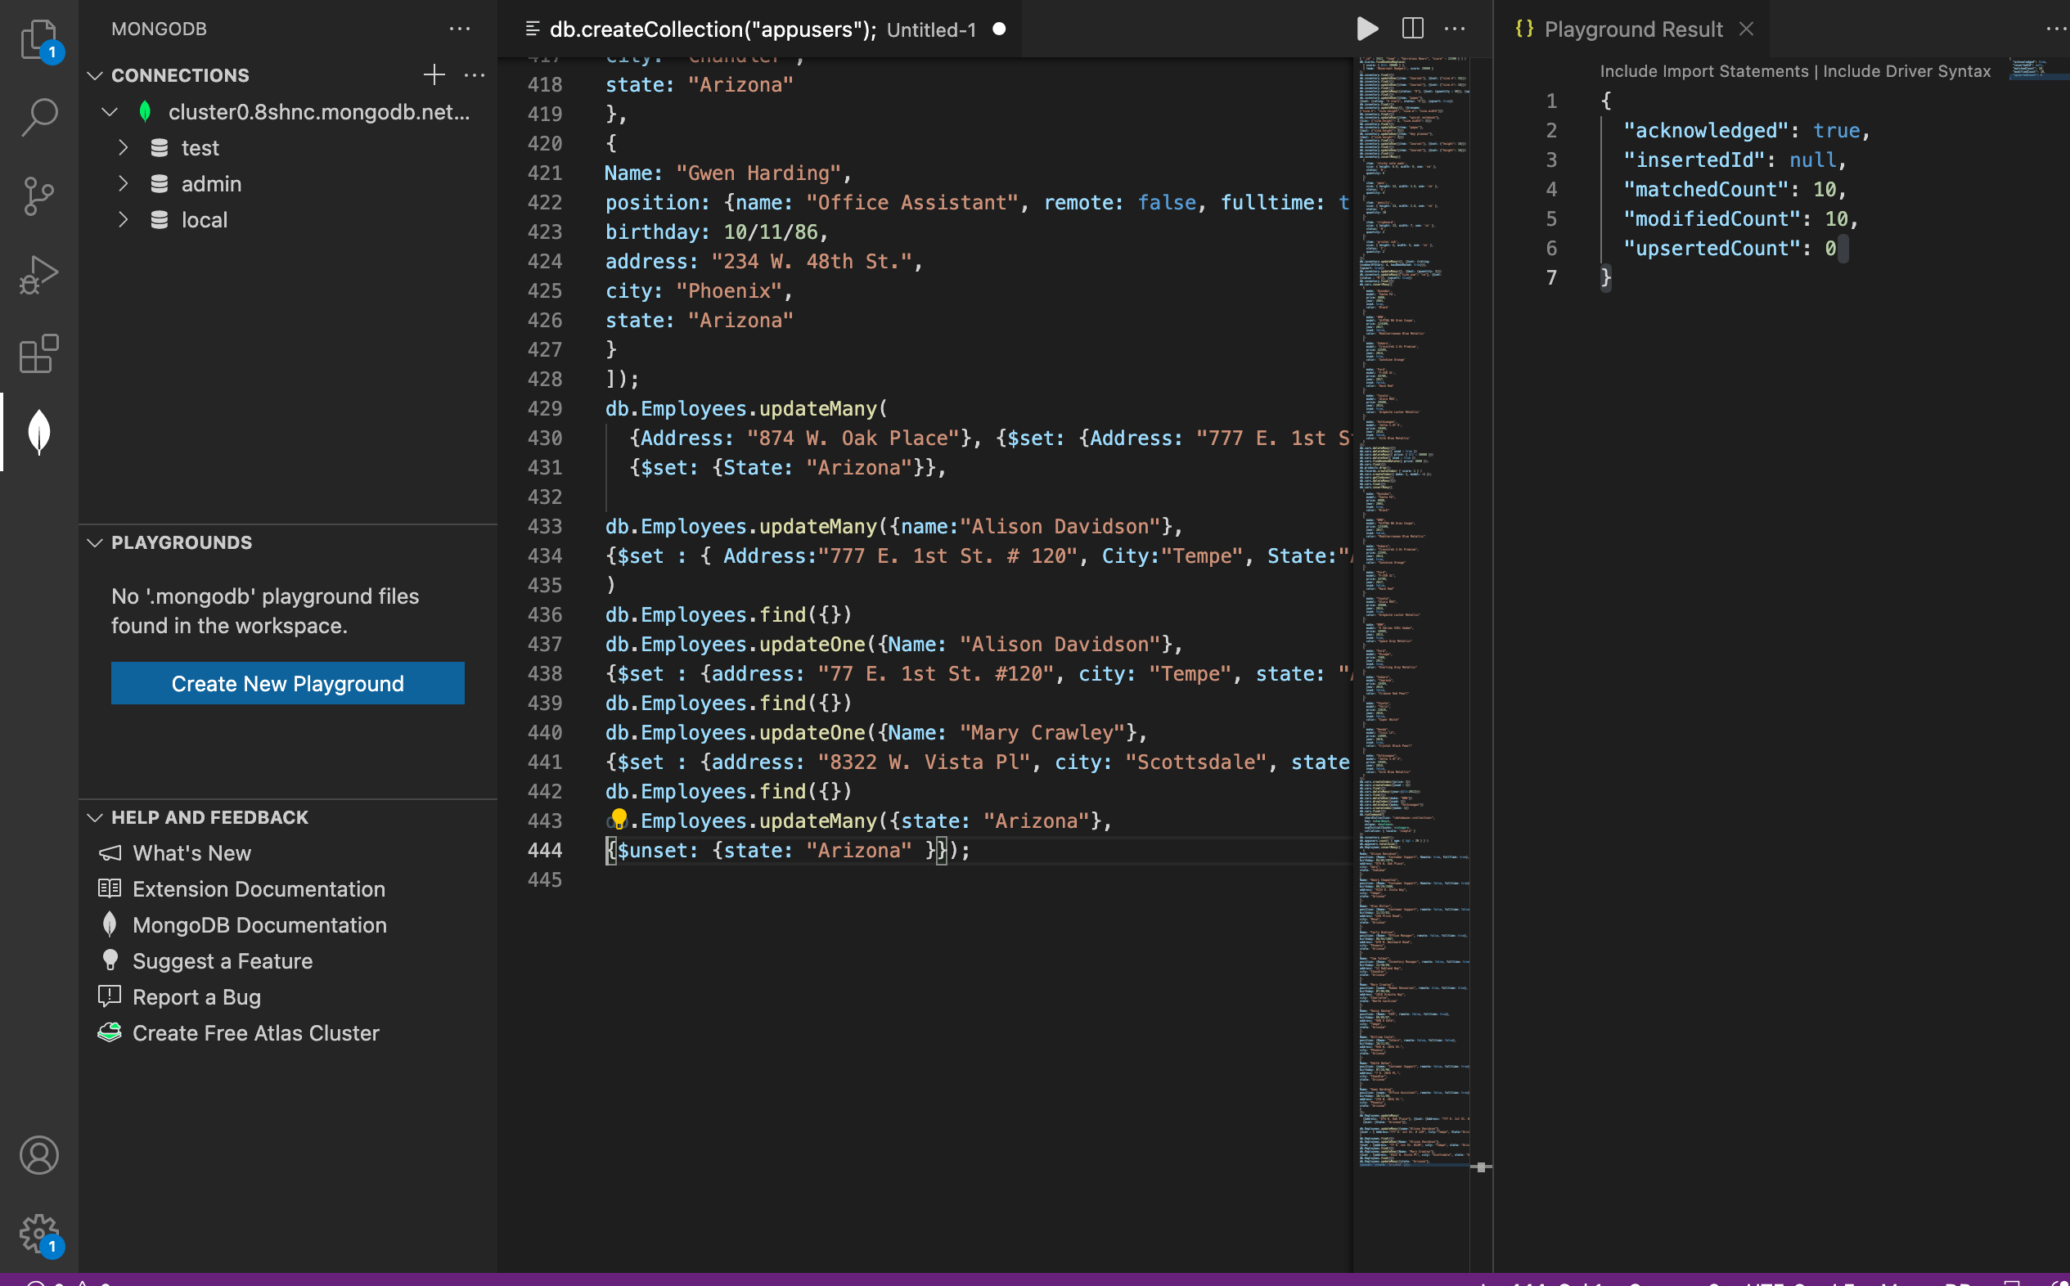
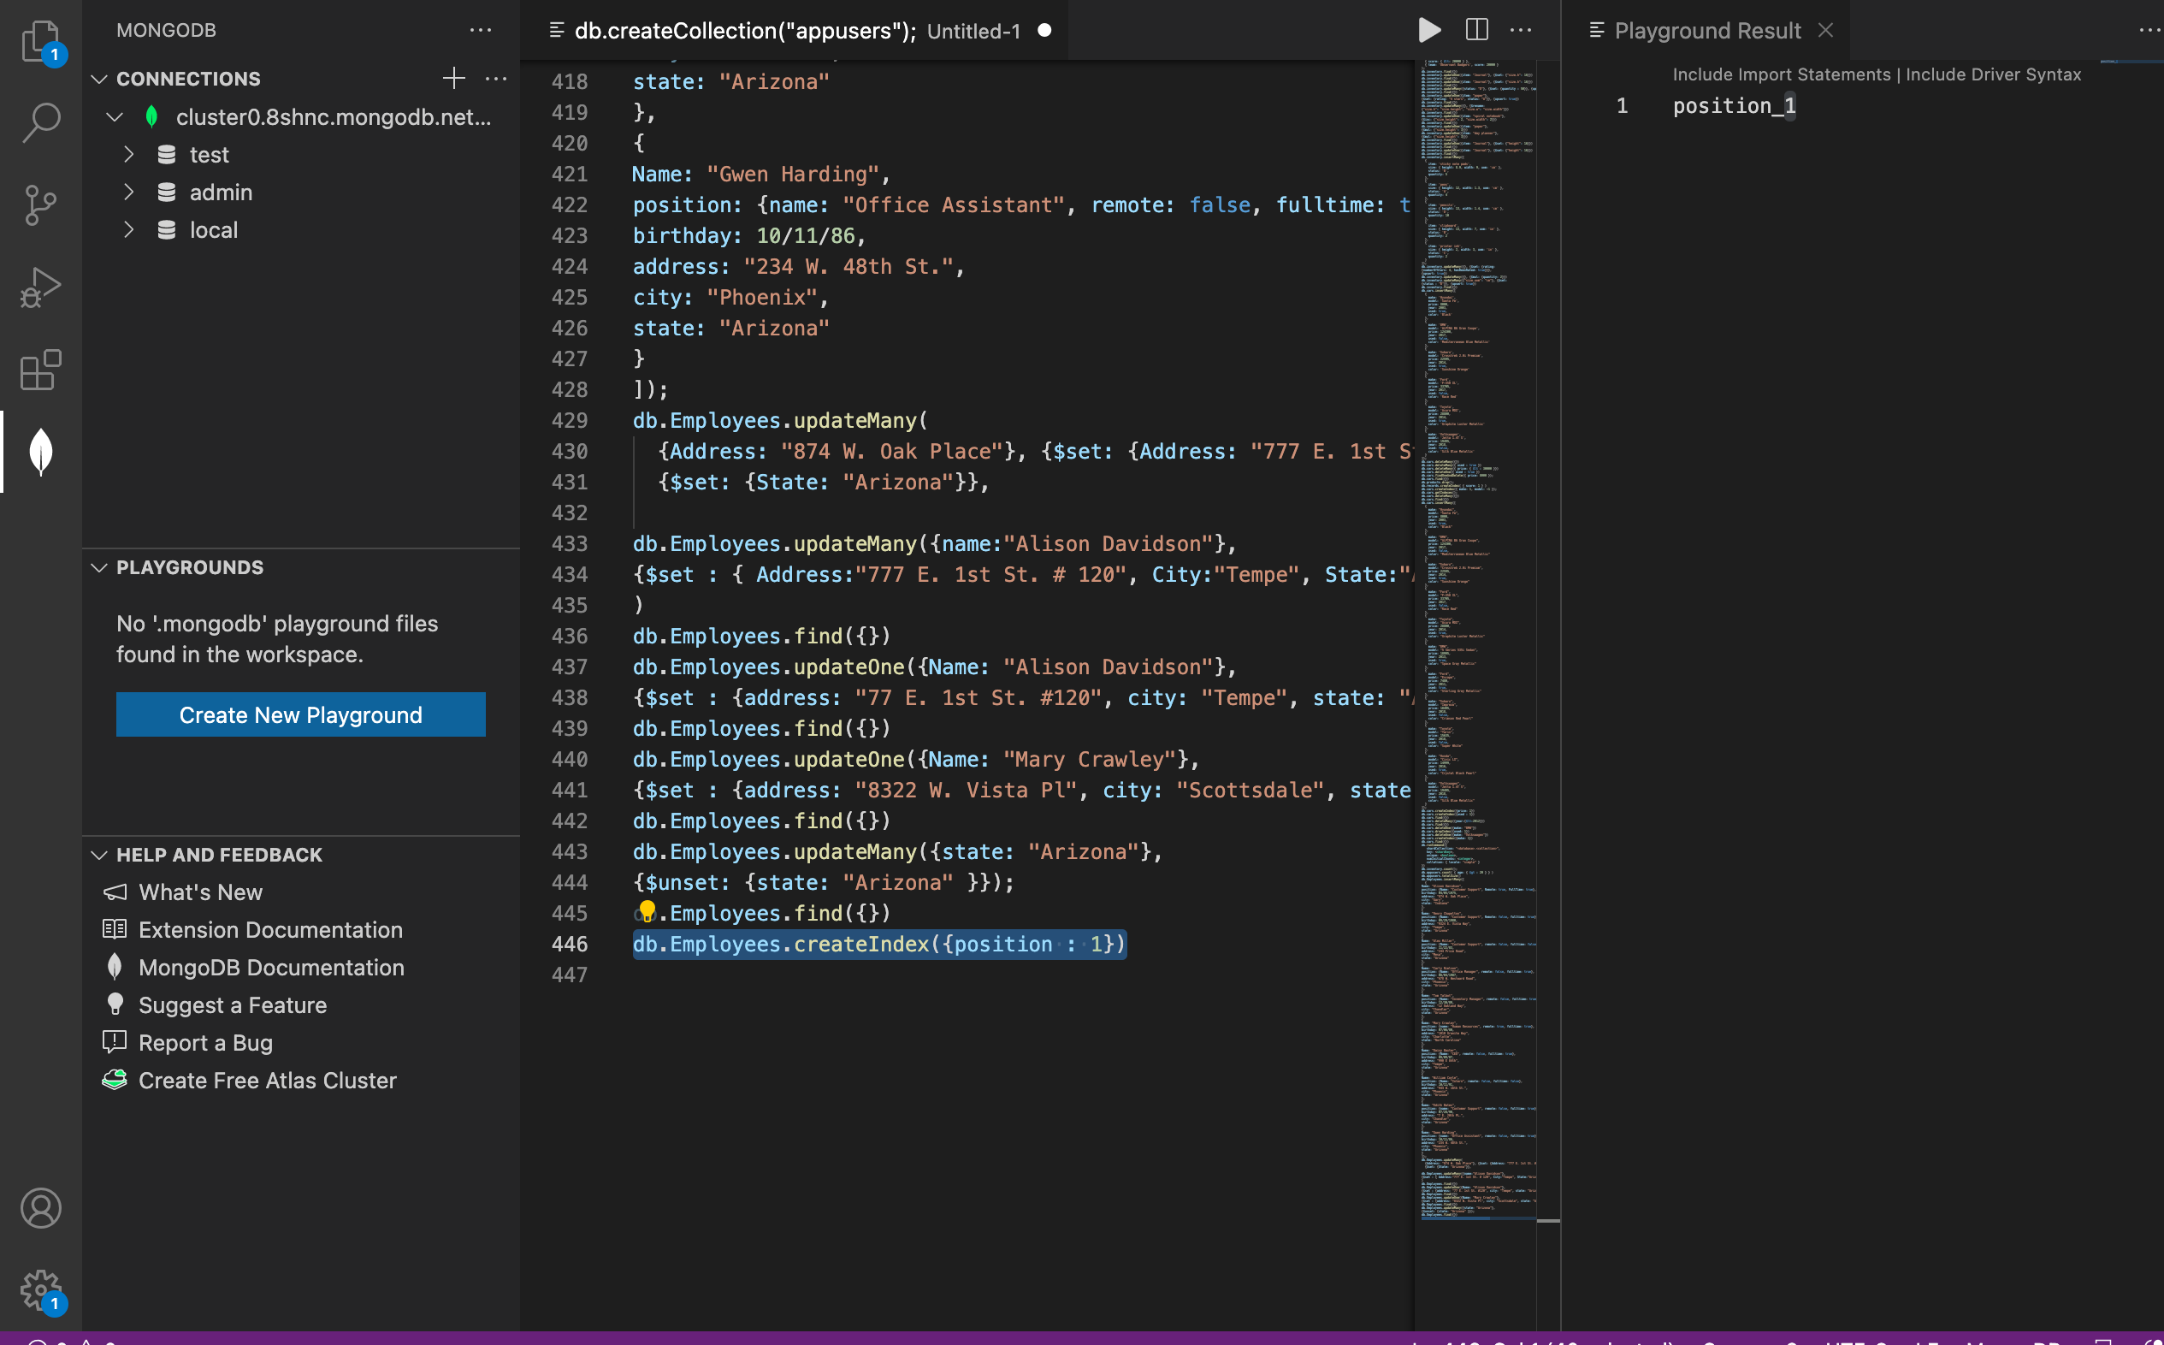

Part 2
You are currently working for a company who wants to build an app similar to Spotify. Below is a list of data for different songs. Please insert this data into a new collection named songs.
SongId | Title | Artist | Album | ReleaseYear
1 | Girls Just Want To Have Fun | Cyndi Lauper | She's So Unusual | 1983
2 | Hips Don't Lie | Shakira feat. Wyclef Jean | Oral Fixation Vol. 2 | 2006
3 | Poker Face | Lady Gaga | The Fame | 2008
4 | Wannabe | Spice Girls | Spice | 1996
5 | California Gurls | Katy Perry feat. Snoop Dogg | Teenage Dream | 2010
6 | Bye, Bye, Bye | NSYNC | No Strings Attached | 2000
7 | I Will Always Love You | Whitney Houston | I Will Always Love You: The Best of Whitney Houston | 2012
8 | Baby One More Time | Britney Spears | Baby One More Time | 1999
9 | Vogue | Madonna | I'm Breathless | 1990
10 | Rolling in the Deep | Adele | 21 | 2011
11 | 1234 | Feist | The Reminder | 2007
12 | Elastic Heart | Sia | The Hunger Games: Catching Fire Soundtrack | 2015
13 | Oops! I Did It Again | Britney Spears | Oops! I Did It Again | 2000
14 | Bad Romance | Lady Gaga | The Fame Monster | 2009
15 | Lose Control | Missy Elliot | The Cookbook | 2005
16 | U Can't Touch This | MC Hammer | Please Hammer, Don't Hurt 'Em | 1990
17 | Thriller | Michael Jackson | Thriller | 1982
18 | Single Ladies | Beyonce | I am... Sasha Fierce | 2008
19 | Rhythm Nation | Janet Jackson | Janet Jackson's Rhythm Nation 1814 | 1989
Notes:
- The artist, album, and releaseYear fields should be an embedded document named details.
- Be sure that the songId and releaseYear fields have a type of number.

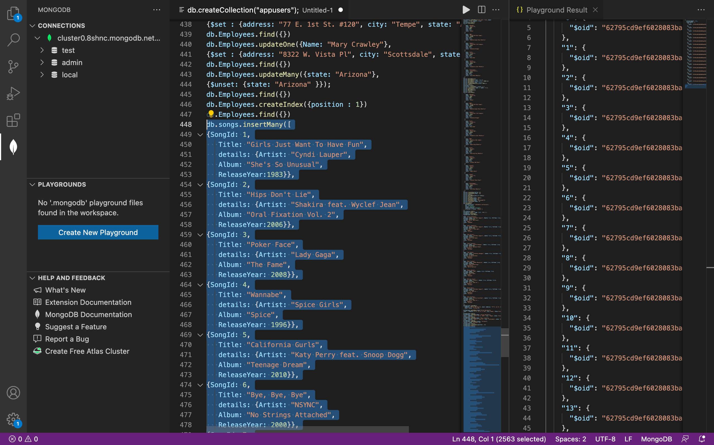
Next, your company has run into some things they would like to be changed within the database:
- The title field needs to be renamed to songTitle, so it is clearer to the developers working with the data.
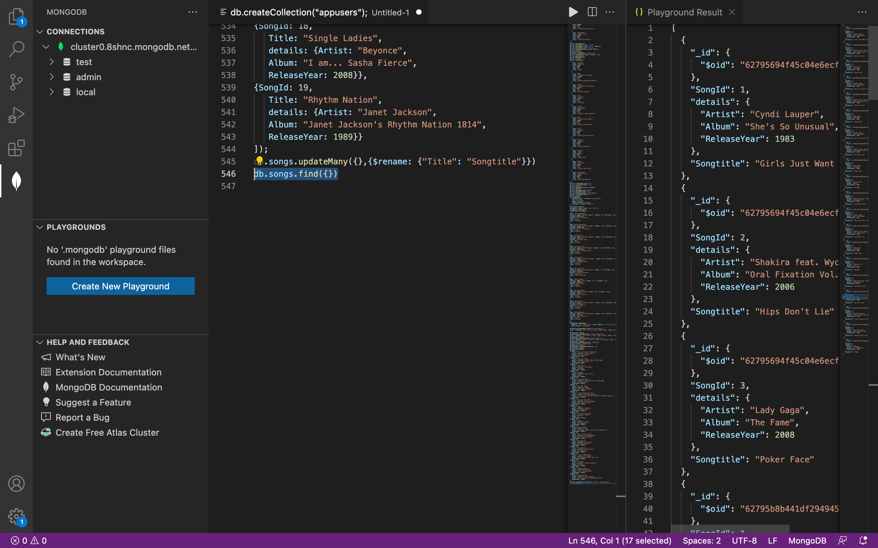
- They would like to have the artist field to be outside the details document but the album and releaseYear should stay within that document.



