Indexes and Project: SQL Final Project

Part 1
- Run a query that creates a table named Authors that has the following columns: AuthorID, FullName, BirthCountry.
  - AuthorID is the primary key and auto increments.

- Add the following Authors table:
FullName | BirthCountry
Jane Austen | England
Charles Dickens | England
Mark Twain | United States

- Run a query to see all of the authors within the database.

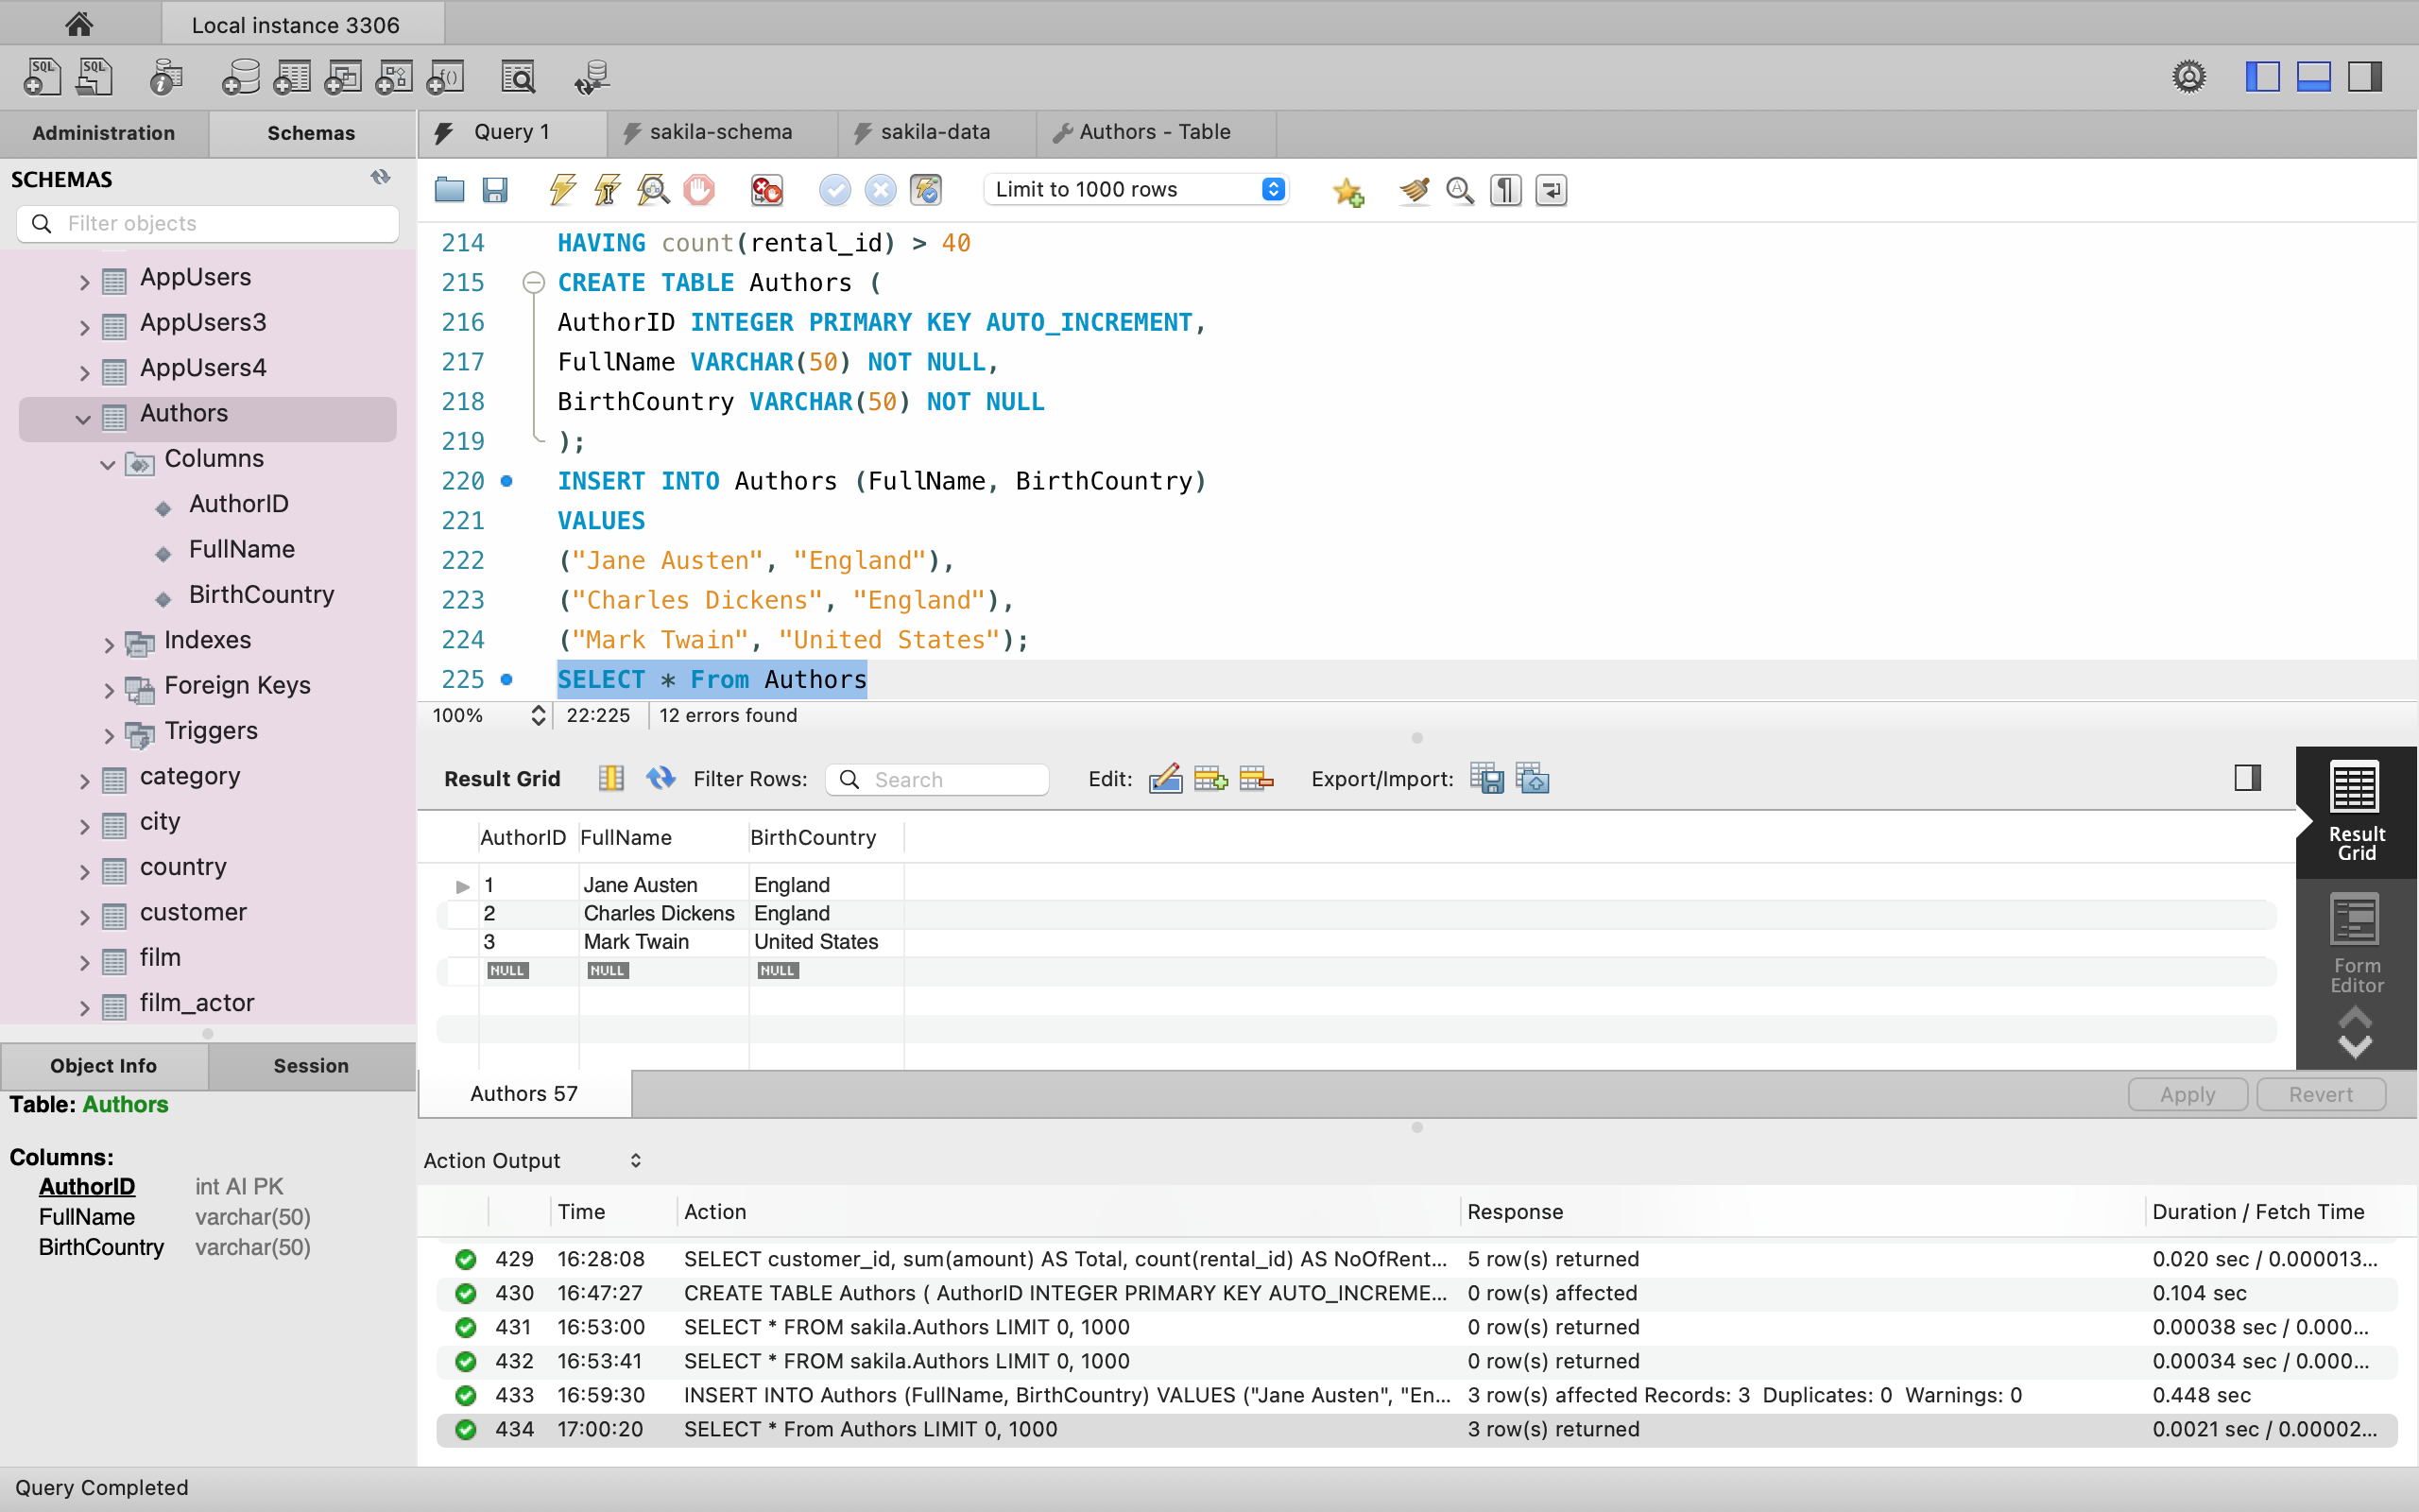

Part 2
- Run a query that creates a table named Books that has the following columns: BookID, Name, AuthorID.
  - BookID is the primary key and auto increments.
  - AuthorID is a foreign key that referenced the Authors table on the AuthorID column.
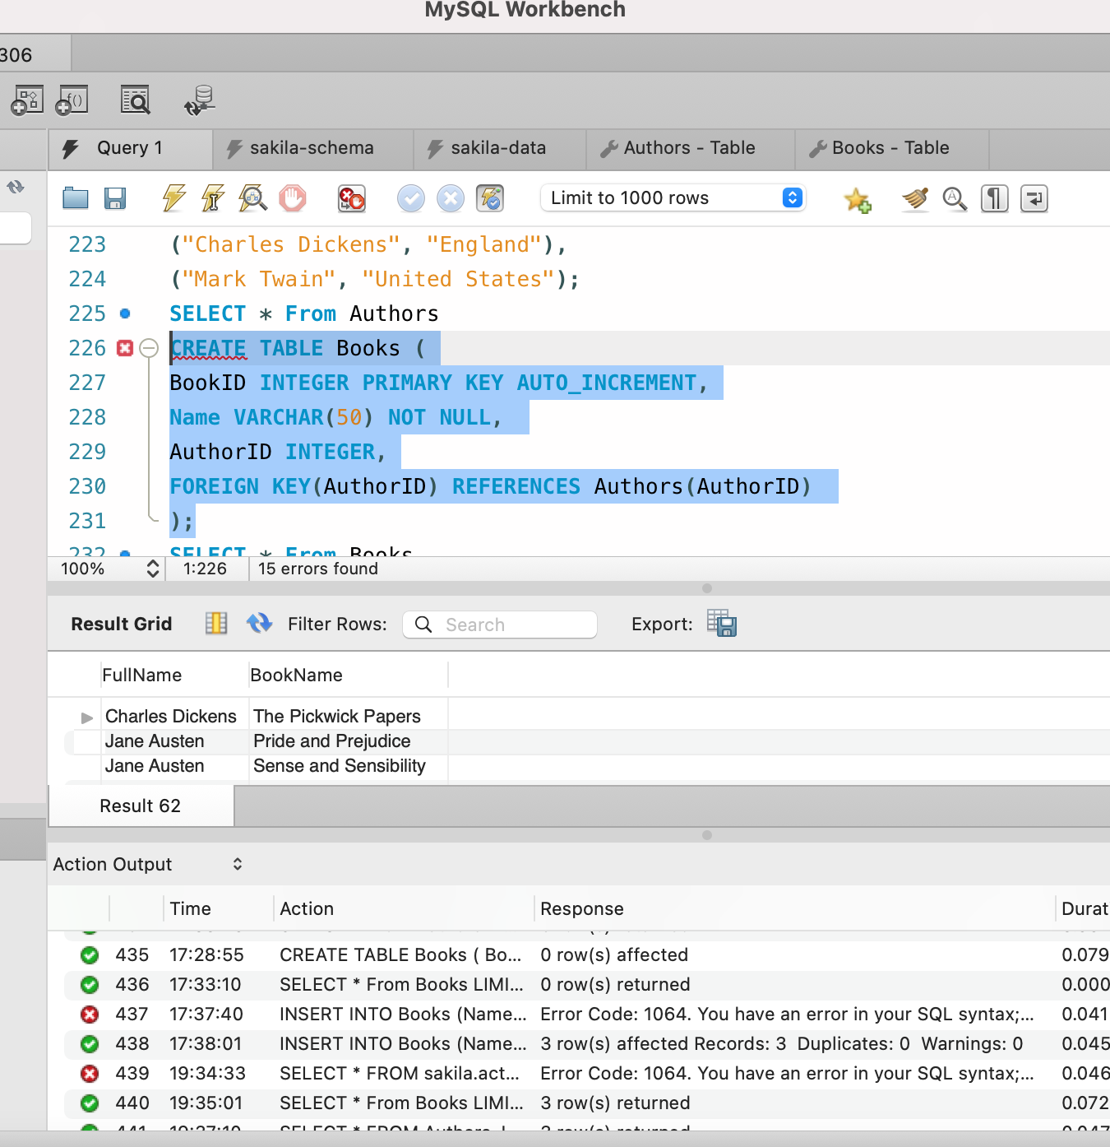

- Add the following the Books table:
Name | AuthorID
Pride and Prejudice | 1
Sense and Sensibility | 1
The Pickwick Papers | 2

- Run a query to see all of the books within the database.

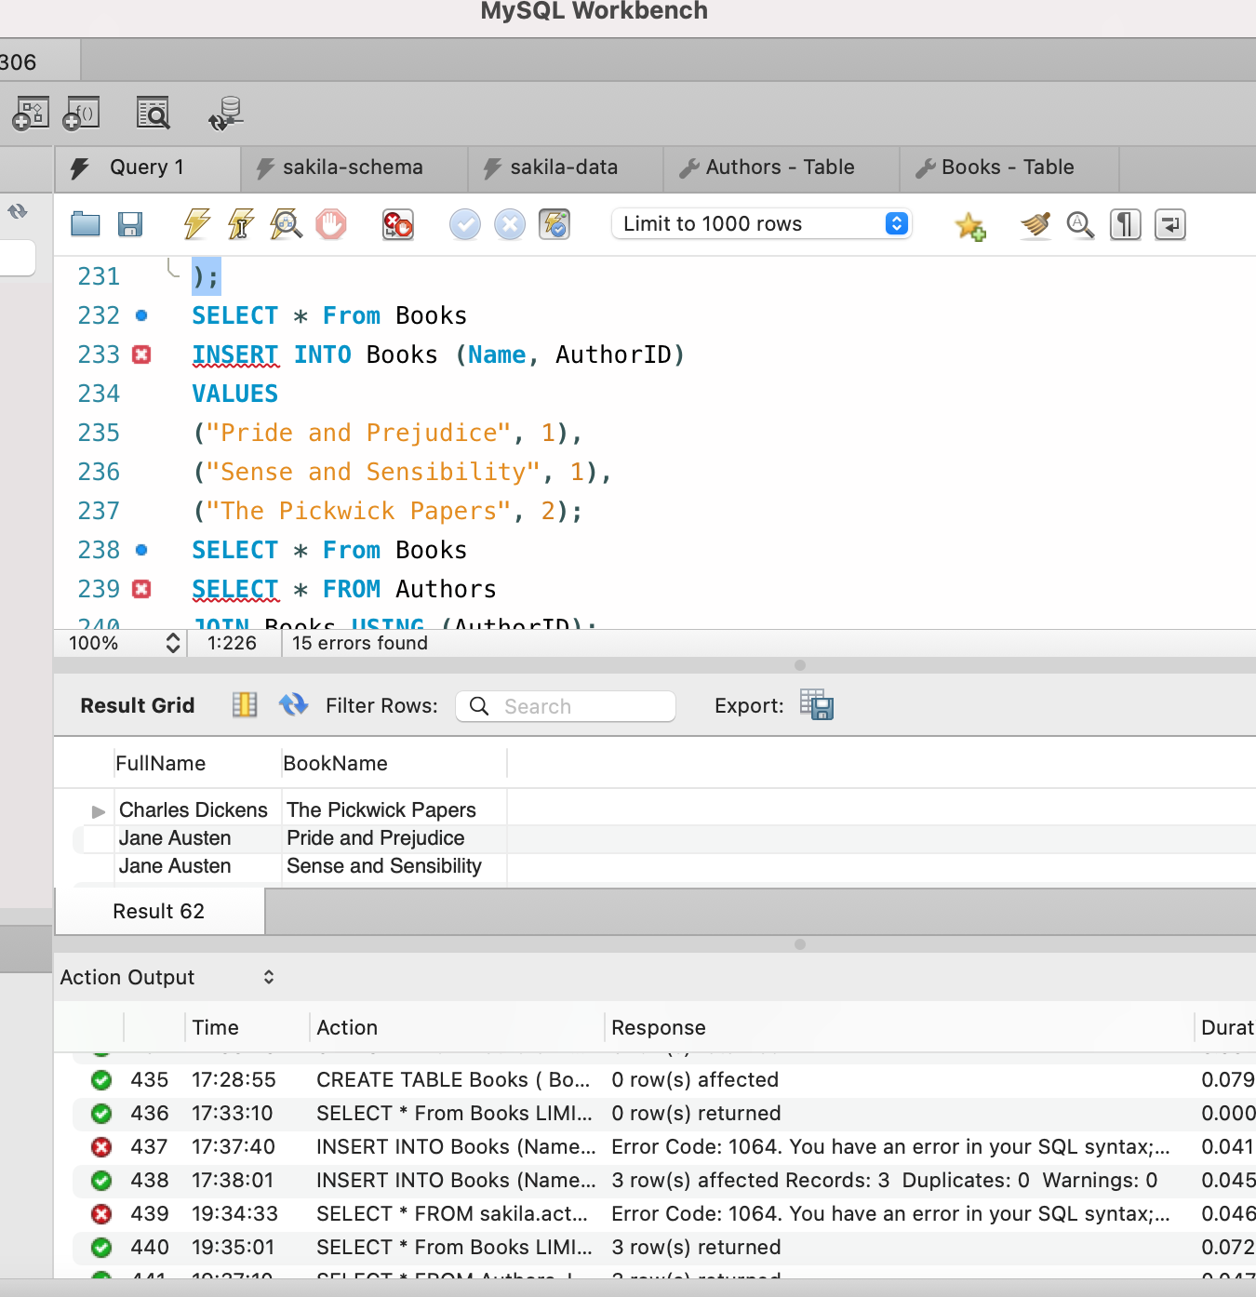

Part 3
- Run a query that joins the Authors and Books table together using the AuthorID foreign key.
- Next, create a view named AuthorBooks using the join query created in step 1 adding the following parameters:
  - Show only the Authors full name and book name.
  - Rename the column name results using the AS keyword.
    - The Authors FullName should display as AuthorName.
    - The Books Name should display as BookName.
  - Order the results alphabetically by the authors full name.
- Lastly, run a query to see the view you just created.

