CiliaGUI – Installation and User Guide

# Installation

To run the toolbox, you need to:

1. Install MATLAB (2021 or later).

- MATLAB is not free; check with your institution for access.

- If you cannot get a license, contact me — we may try a standalone version of the program.

- Installation instructions: https://www.mathworks.com/help/install/ug/install-products-with-internet-connection.html

- During installation, make sure to install the following toolboxes:

• **Statistics and Machine Learning Toolbox**

**• Image Processing Toolbox**

2. Download the code from GitHub:

- Repository: https://github.com/pmgarderes/CiliaDetect2.0

- Click 'Download as ZIP file'.

3. Unzip and place the folder on your hard drive.

- Example: on Windows, I use WinRAR and put the files into a folder named ciliaGUI_demo at the root of C:/.

# Launching a Session

4. Navigate to the folder awhere the code is and find Full_GUI.m.

- Double-click it. If MATLAB was not open, this will automatically launch MATLAB and set the current folder correctly.

⚠️ The correct current folder in MATLAB (shown in the top bar) is the one that contains contains Full_GUI.m. If it doesn’t, choose the folder with this button it manually. ( see pic below)

5. Start a session:

- Go to the Editor panel.

- With Full_GUI.m active (double click Full_GUI in matlab to make sure it’s active)

- click Run.   
  
Should look like this :

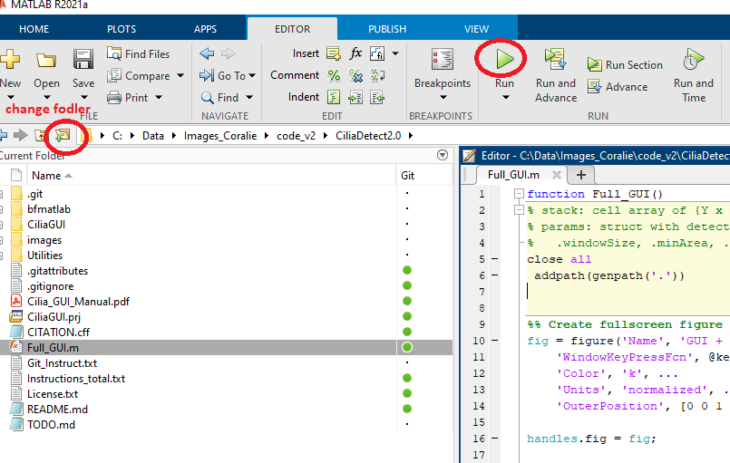

# Preprocessing – Z-Planes

6. Prepare your microscopy images before using the GUI.

- The program only reads *_reduced.mat , i.e. files formatted for matlab. Thus we need to pre-process microscopy image and format them.

- Strategy: reduce the number of frames in a to a few averaged Z-planes (down to a single Z-plane), so multiple Z-planes can be separated from the same Z-stack.

To preprocess:

1. Click the 'Pre-process' button.

2. Enter the downsampling factor (number of frames to average together).

- Example: enter '1000' to collapse the full stack into a single Z-plane.

3. A file browser window will open. Navigate to the folder containing your microscopy files.

⚠️ You will not see the individual files — just select the directory where the files are located.

4. The GUI text box will display messages ('WAIT') and begin downsampling.

Notes:

- Preprocessing large stacks may take a long time. Tip: you can batch-process many files overnight.

- Output: a new folder 'Matlab_quantif' is created. Each original file generates a reduced version with the suffix '_reduced.mat'.

# Loading a File

7. Load files into the GUI:

- Only files ending in '_reduced.mat' can be loaded.

- Click 'Select File', navigate to the directory, and choose the file.

# GUI Display

8. The central panel displays one Z-plane in one channel.

- Adjust fluorescence intensity with numeric keypad: /, *, -, +.

• These settings apply across all Z-planes in the same channel but not across channels.

- Navigate between channels: left/right arrow keys.

- Navigate between Z-planes: up/down arrow keys.

# Detecting ROIs

9. To add a new ROI:

- Left-click directly on the cilium (not beside it).

- Press Space.

- The program segments the cilium around your click.

- If detection fails (e.g., low contrast), it will appear as a single point.

• Delete failed detections by pressing U once (undo).

⚠️ Do not leave empty ROIs.

# Parameters to Adjust Detection

10. Sensitivity is the key parameter.

- Recommended range: 0.3–0.7 (use 0.4–0.5 in most cases).

- Higher sensitivity: easier detection, less accurate ROIs.

- Lower sensitivity: stricter detection, fewer but more accurate ROIs.

# Merging ROIs

11. If a cilium is split across Z-planes or incompletely detected:

- Click near the junction point.

- Press M to merge ROIs (works if they are close enough).

# Deleting ROIs

12. To delete ROIs:

- Single ROI: click near it and press S.

- All ROIs: click 'Clear Detections'.

# Automated ROI detection

**Automatic detection of cilia ROIs (for strong signals).**  
If your images contain strong cilia signals, you can use the automatic detection feature instead of manually clicking each ROI.

**To run auto-detection:**

1. Click the **Auto-detect** button.
2. A pop-up window will ask how many ROIs you want to detect.
   * Provide an approximate number of cilia expected in the current Z-plane.
   * 💡 Tip: start with a small number (e.g., 10).
3. The program will search the brightest N points in the current Z-plane and channel.
   * For each candidate point:  
     • If a cilium-shaped structure is found, the ROI is added to the detection list.  
     • If not, the point is marked as tested and excluded, shown with a **red dot**.

**Notes:**

* Newly detected ROIs can be merged (M) or deleted (S) the same way as manually detected ROIs.
* Excluded points are temporary:
  + They are not saved.
  + They disappear if you close the file or select a new file.
* You can re-run **Auto-detect** in the same Z-plane or in new Z-planes.
  + Additional points will be tested.
* After auto-detection, you may:
  + Manually suppress unwanted auto-detected ROIs with **S**.
  + Add new ROIs near excluded points manually with **Space**.

# Other Useful Buttons

13. Refresh ROI display: press R.

# Saving Detections

14. Save your work:

- Click 'Save Detections' at any time.

- This creates a new file in 'Matlab_quantif' inside 'reduced_stack/'.

- File name format: originalName_reduced_cilia_detections.mat

- Next time you open the reduced file, saved detections load automatically.

⚠️ Only load '_reduced.mat' files. Do not load detection files directly.

# Visualizing Masks

15. To view ROI and background masks:

- Click 'Visualize Masks'.

- Two images will appear:

• Left: cilia mask overlay.

• Right: background mask.

- Images are saved automatically.

- Adjustable parameters:

• Padding: gap between ROI and background (pixels).

• Background mask width (pixels).

# Quantify and Save Fluorescence

16. To export quantified data:

- Click 'Quantify and Save Fluorescence'.

- Creates one Excel file (.xls) per image in 'Matlab_quantif/'.

- Each row = one cilium.

Fluorescence outputs (per channel):

• F_StackSum_ch# – sum across the Z-stack.

• F_plan_ch# – mean in the Z-plane.

Morphological measures (if metadata available):

• Length (µm)

• Width (µm)

• Curviness (length/chord length)

• Length/Width ratio

• Area (µm²)

Notes:

- Both methods correct for background.

- Both are valid for comparisons if exposure and Z-range are similar.

- Recommendation:

• Use stack sum if Z-range > cilium span.

• Use mean method otherwise.

# Editing Parameters

17. Parameters are user-editable:

- Any parameter can be modified.

- Settings are automatically saved and reloaded in the next session.