High-Level Design — Jamming Survival: On-Device Mesh Agent
Project | Jamming Survival — On-Device Mesh Agent
Authors | Prateek Mohan Garg, Jatin Pahuja
Document | High-Level Design (HLD)
Version | 0.6 (draft for review)
Date | 2026-09-08
Status | Draft — pending team sign-off

Change log
Version | Change
0.1 | Initial draft.
0.2 | Froze the baseline network config (6 nodes, 8 channels, OLSRv1) per SDR-domain expert review; restructured the on-device API into Sense / Diagnose / Act plus a routing adaptation interface; added a classical deterministic diagnosis baseline as a comparator; split congestion and hidden-terminal into distinct scenarios; strengthened the failsafe as a controller-enforced hard rule; refined the student definition to a lightweight function-calling model sized to the drone hardware.
0.3 | Diagrams now embedded as pre-rendered images (diagrams/*.png, with .svg and .mmd sources alongside) so they display in any Markdown viewer; the Mermaid source for each is kept in a collapsible block. Regenerate with mmdc -i diagrams/<name>.mmd -o diagrams/<name>.png -b white -s 2.
0.4 | Made "what runs where" explicit: the student runs ON the drone (the only learned model there); the teacher, trace store, distillation, and verifier are offline / ground / lab only. Added §9.0 table; relabelled the context and pipeline diagrams and added an explicit "flash / deploy the bundle" step from distillation to the on-device model.
0.5 | Clarified the routing scope: standing up and configuring ns-3's stock OLSRv1 mesh is in scope (Phase 1); only modifying its internal algorithm or inventing a new protocol is out of scope. Reworded §1.2 (in/out of scope), §3.2, and A3.
0.6 | Named the harness: our own agent loop is a capstone profile of the reused EAG V3 platform (S17Code + glc_v5), pinned as submodules, with unused subsystems gated off (feature flag + CI-enforced import isolation) rather than deleted. Added §1.5 (alignment with the required deliverables), §5.3 (harness architecture + diagram 07), the run_sim / read_result framing in §6, and §10.1–10.5 (task set, deterministic predicates, mutation corpus, raw run records). New assumptions A15–A18; new stack rows; new risks; Appendix D (platform subsystem map).

1. Introduction

1.1 Purpose
This document describes the high-level design of an on-device agent that keeps a drone's mesh radio link alive while that link is under attack, with no ground link available to ask for help. It defines the system boundaries, the major components, the data that flows between them, the decision loop the agent runs, the training pipeline that produces the agent, and the evaluation harness that grades it.
It is written to be implementable by a two-person team as a capstone, and to be defensible to an examiner: every claim of "ground truth" traces back to a peer-reviewed open-source simulator, not to code we wrote ourselves.

1.2 Scope
In scope
- A discrete, function-calling agent that runs on the drone (the "student").
- The harness — our own agent loop, run as a capstone profile of the reused EAG V3 platform (S17Code + glc_v5). No third-party agent framework (LangChain, CrewAI, …); the planner, capability registry, run journal, and eval machinery are the platform's, gated to what this project needs (§5.3).
- A simulation environment (Tier 1) that produces the attack corpus and the ground truth against which the agent is graded. This includes standing up ns-3's stock OLSRv1 mesh, the channel/fading models, the jammers, and the adaptation interface (§6.4) that exposes link/route state to the agent. ns-3 is vendored and pinned and wrapped as the run_sim / read_result capabilities the harness calls (§6).
- A classical deterministic diagnosis baseline the agent is compared against.
- A teacher→student pipeline: a large model runs in simulation, its situation→action traces are captured, and a small model that fits on the drone is distilled from them. The gap between teacher, student, and classical baseline is measured.
- A task set (data files the reviewer owns) with deterministic verifiers — each task's verdict is a predicate over the tool's output plus the ground-truth oracle, never over the agent's prose (§10.1–10.2).
- A mutation corpus — deliberately broken inputs — and the checker-robustness number it produces (§10.4).
- Raw run records written to disk before any scoring, so the scorer can change and be re-run without re-running the model or the simulator (§10.5).
- A verifier that scores detection latency, classification correctness, false positive rate, recovery time, packets lost, actions consumed, and survival.
Out of scope
- Re-implementing planner / capability / eval / journal machinery the EAG V3 platform already provides — we configure and gate it, we do not rebuild it.
- Designing or modifying the fast radio loop — MAC/PHY, carrier sensing, ARQ, and the internal routing algorithm (MPR selection, hello/TC logic, path computation). We run ns-3's stock OLSRv1 as a black box and configure it (topology, timers, metrics); we do not re-engineer it or invent a new protocol. The agent observes this loop and issues coarse commands; it does not replace it.
- Free-form natural-language generation on the device.
- Multi-drone joint optimisation. Neighbours are cooperative but each drone runs its own agent.
- Physical flight dynamics beyond a position model.
- Network scale as a research problem — node count is fixed small on purpose.
Optional / stretch (designed for, not required for a complete capstone)
- Tier 2: a real 2.4 GHz rig of ESP32 mesh nodes plus one ESP32 interferer.
- Tier 3: an RTL-SDR dongle + GNU Radio to observe the spectrum and confirm the jammer, and to check that the diagnosis/recovery approach survives more realistic RF behaviour.

1.3 Definitions
Term | Meaning
Mesh | The multi-hop radio network connecting the drone to its peers.
PDR | Packet Delivery Ratio, per link, over a rolling window.
Noise floor | Measured in-band power with no wanted signal present.
Barrage jamming | Wideband interference covering all usable channels.
Spot jamming | Narrowband interference on a single channel.
Reactive jamming | Jammer transmits only when it senses the victim transmitting.
Sweep jamming | Jammer walks its centre frequency across channels over time.
Fading / multipath | Signal loss from propagation, not an attacker. The false-positive trap.
Hidden terminal | Two nodes that cannot hear each other collide at a common receiver.
Distinguishing test | A cheap action whose result separates two competing hypotheses.
Refusal case | A situation with no recoverable link; correct action is to declare loss and execute the failsafe.
Teacher | A large model, run only in simulation and offline, used to generate training traces.
Student | The small on-device model distilled from the teacher's traces.
Classical baseline | A hand-written deterministic rule set for diagnosis, used only for comparison.
Action budget | The maximum number of costly actions the agent may spend on one incident, enforced by the controller.
Agent controller | The deterministic wrapper around the model that enforces the action space, the budget, and the failsafe.
Harness | Our own agent loop plus the code that runs tasks through it and records the result — a capstone profile of the EAG V3 platform.
EAG V3 platform | The carried-forward agent runtime from the EAG V3 course: S17Code (capability-driven live-graph planner, run journal, coding surface, eval machinery) and glc_v5 (LLM gateway — provider routing, cost/audit). Reused here, not rewritten.
Capstone profile | The subset of the platform this project switches on. Other subsystems stay in source, disabled by feature flag and kept out of the capstone import graph by a CI contract.
Task | One entry in the task set: an id, a scenario config, and a predicate. Data, not code.
Predicate / checker | A deterministic function that reads a run's tool output and the ground-truth oracle and returns pass/fail. It never reads the agent's prose or the model's stated confidence.
Mutation corpus | Deliberately broken inputs (corrupted, contradictory, out-of-range, degenerate). The checker either flags them or does not; the fraction flagged is a reported number.
Run record | The full, machine-readable log of one run — observations, tool calls, outcomes, journal — written to disk before scoring.

1.4 References
- ns-3 network simulator — wifi, spectrum, propagation, olsr, mobility, energy modules.
- ns3-gym / ns3-ai — Python bridge for a per-step decision agent.
- painlessMesh / ESP-NOW — ESP32 mesh stacks (Tier 2 only).
- GNU Radio + RTL-SDR — spectrum observation and RF validation (Tier 3 only).
- Project brief: "Jamming Survival — On-Device Mesh Agent".
- SDR-domain expert review of HLD v0.1 (shared conversation), 2026-09 — source of the frozen baseline config, the API restructuring, and the classical-baseline comparator.
- EAG V3 platform — S17Code (s17code/planner.py, capabilities.py, runtime.py, core/live_graph/, proofs/harness.py, evals/) and glc_v5 (LLM gateway, ClaudeCLIProvider). Reused as pinned submodules. repo-doctor (the EAG V3 Session-17 product) is the structural template for how a project sits on top of the platform.
- import-linter — CI contract that keeps gated subsystems out of the capstone import graph.

1.5 Alignment with the required deliverables
The project must produce five things plus a refusal task. Each is satisfied by a named part of this design, and each reuses a specific part of the EAG V3 platform rather than being built from scratch.
# | Required deliverable | Where in this HLD | Reused from the platform
1 | Your harness — own loop, no agent framework | §5.3; A15 | proofs/harness.py (run → collect checks → write record → exit), planner.py + runtime.py + core/live_graph/ (the loop: model proposes next frontier → Python validates authority/args/deps → executor runs → replan)
2 | The open-source tool, wrapped — run_sim, read_result, vendored + pinned | §6 (lead-in), §6.6; A16 | capabilities.py (declare a tool with a machine-checkable arg contract; model selects, can't invent or bypass), coding/exec.py (no-shell, allowlisted, workspace-confined, timeout + output-capped runner; S17_EXEC_CONTAINER=1 for containerised runs)
3 | A task set with verifiers — predicate reads tool output, never prose | §10.1–10.2 | evals/tasks.py ("a task set is DATA … it never contains one"), proofs/general_agent_live.py::score_contract (domain-agnostic declarative predicate over the run graph/events/artifacts)
4 | A mutation corpus — broken inputs, fraction caught reported | §10.4 | evals/pairs.py (load_pairs + sweep → TP/FP rate at each threshold, takes only floats + booleans)
5 | Raw run records — to disk before scoring, scorer swappable | §10.5; A17 | proofs/harness.py::Proof.finish() (writes out/<name>.json with full checks/facts/detail/journal); p4_trace_export.py ("delete the materialised graph and the trace still builds from the tape alone")
— | Refusal task | §2, §7.6, §10.1, §17 | proofs/p3_denial_of_wallet.py ("an adversarial runaway loop is stopped by the hard controller … refusals are recorded, auditable rather than merely dead")

The one mismatch. The platform's agent is an LLM planner proposing a graph frontier each round; the capstone's deployed agent is a tiny classifier + policy head with no LLM (§9.0). So the platform maps onto the harness, teacher-side and evaluation infrastructure (offline, in the lab) — not onto the on-drone student, which is a separate artifact the harness evaluates.

2. Problem statement
The mesh is failing. The drone must work out why and act, with no ground link to ask for help.
The hard part: several very different causes look almost identical from inside the radio.
What the drone sees | What it might actually be
Packet delivery collapses, noise floor high | Barrage jamming
Delivery collapses on one channel only | Spot jamming
Delivery fine, but everything is a retransmission | Reactive jamming, triggered by your own transmissions
Link up, no traffic | The peer died
Intermittent, correlated with distance | Fading and multipath — no attacker at all
Collisions rising with load | Congestion
Collisions without high local load | Hidden terminal

The primary goal is not merely detecting jamming. It is avoiding incorrect recovery actions — above all, declaring "jamming" when the real cause is fading. That false positive has a real cost: the drone hops channels, loses the mesh, and creates the outage it was trying to avoid. The verifier weights this error the most heavily.
There is also a refusal case: broadband jamming across every available channel with no line of sight to any peer. There is no escape. The only correct action is to declare the link unrecoverable and execute the failsafe: return-to-home on the last known good position. An agent that hops channels forever has failed.

3. Goals and non-goals

3.1 Goals
- Correctly classify the cause of a mesh failure into one of: barrage / spot / reactive / sweep jamming, fading, dead peer, congestion, hidden terminal.
- Keep the false-positive rate low — never declare jamming on the strength of symptoms alone; require a positive distinguishing test first.
- Recover the link quickly and with the fewest costly actions.
- Recognise the refusal case and execute the failsafe instead of thrashing.
- Fit on the drone: a model small enough and fast enough for a companion computer with no GPU and no network.
- Beat the classical baseline on the cost-weighted scorecard, and be honest about the teacher→student gap: measure it, report it per scenario, don't hide regressions.

3.2 Non-goals
- Beating a human RF engineer.
- Handling attackers not in the corpus (documented as a limitation).
- Real-time signal-level DSP on the device.
- Optimising, replacing, or modifying the internals of the mesh routing protocol (configuring and running the stock OLSRv1 module is in scope; changing how it computes routes is not).
- Demonstrating network scale.

4. Assumptions and constraints
These are working assumptions. Where the team has a firm answer it replaces the assumption; where it does not, the assumption stands and is called out in the final report.
# | Assumption
A1 | Tier 1 (simulation) is mandatory and is a complete capstone on its own. Tier 2 (ESP32 rig) and Tier 3 (RTL-SDR + GNU Radio) are optional and will be attempted if time allows, primarily to make the demo more convincing.
A2 | The authoritative environment is a peer-reviewed open-source simulator (ns-3). Ground truth — "was that a jammer or fading?" — comes from ns-3's own scenario configuration, not from code we wrote. If a faster abstract simulator is introduced later to speed up training, it is treated as an approximation and every metric produced on it is re-validated on ns-3 before it appears in the report.
A3 | The fast radio loop stays classical. MAC, PHY, carrier sense, ARQ and the routing protocol run as stock ns-3 modules — configured for our topology but algorithmically unchanged. The agent runs at a slow cadence (assumed ~1 Hz of decision time) on top of it.
A4 | The agent is a function caller over a fixed API (Section 6). It chooses which function, which arguments, and records why. No free-form generation on the device. The model never touches ns-3 or radio objects directly — only the controller does.
A5 | On-device student = a lightweight function-calling model sized to the drone hardware (A6). It emits a structured choice — hypothesis, diagnostic or recovery function, arguments — over the fixed API; no free-form text. The reference realisation is a small classifier (posterior over causes) plus a mostly-tabular, teacher-validated policy head — the lightest and most auditable option, and the one that makes the refusal case easy to certify. A small learned sequence model is permitted instead if it still fits the A6 budget.
A6 | On-device budget: no GPU, no network, model footprint target < 512 KB, inference < 20 ms per decision, deterministic. Target runtime is a small ARM core (Cortex-M/A class). At the low end the same student must also fit an ESP32-S3-class MCU (~512 KB SRAM) for the Tier 2 rig.
A7 | The teacher is a large instruction-tuned model accessed through a constrained function-calling interface, run offline, in simulation only. It never runs on the drone and is never in the deployed loop. The student is fully self-contained.
A8 | Radio context frozen at 8 logical RF channels, one active channel per node, hopping supported, plus a low-rate LoRa fallback on a separate band.
A9 | Mesh routing protocol: OLSRv1 in ns-3 (native module), unmodified. The agent sits above routing through a thin adaptation interface (§6.4) and never changes OLSR's algorithm. batman-adv is at most an optional comparative experiment if time allows, never a branch of the first implementation.
A10 | Each incident has a hard action budget (assumed default 6 costly actions) and a wall-clock recovery timeout, both enforced by the controller, not the model. Exhausting either forces escalation, not another hop.
A11 | move() is available to the agent but is the most expensive test. The refusal decision must be reachable from sensing alone — it must not depend on movement being possible.
A12 | Timeline: roughly one academic semester (~14 weeks), two people.
A13 | Single drone/agent node initially; 5 cooperative peer nodes. A neighbour will transmit a probe on request, but neighbours are not jointly optimised with the drone.
A14 | The baseline is frozen before implementation to stop the project sliding into a generic MANET/SDR effort. The minimum viable research system is: 6 nodes + 8 channels + OLSRv1 + ns-3 + 8 degradation scenarios + agent + diagnostic actions + recovery + verifier. If that works convincingly the capstone is complete; Tier 2/3 strengthen the demonstration, they do not determine success.
A15 | The harness is a capstone profile of the reused EAG V3 platform, not a fork that deletes code. S17Code and glc_v5 are pinned as git submodules. Subsystems this project does not use — durable memory / faiss, A2A / grpc, the economics engine, channel adapters, the semantic cache — stay in source, disabled by a feature flag (S17_PROFILE=capstone) and kept out of the capstone import graph by an import-linter contract. They are still exercised by the platform's own (full profile) CI. Rationale: the same platform carries forward to future projects; the lab has no resource constraint that deleting them would relieve (nothing here runs on the drone). See Appendix D.
A16 | The simulator is vendored and pinned. ns-3 is pinned to a specific commit, its Python bridge vendored, dependencies locked, so the package builds and runs on a clean machine with one command. It is exposed to the harness as two coarse capabilities, run_sim(scenario, seed, config) and read_result(run_id) (§6.6), declared in the platform's capability registry and run through the allowlisted, sandboxed command runner.
A17 | Records first, scoring second. Every run is written to disk as a complete raw record (observations, tool calls, outcomes, journal) before any predicate runs. Scoring is a pure offline function over records; the scorer can change and be re-run without re-running the model or the simulator.
A18 | Every task's verdict is a deterministic predicate over tool output + the ground-truth oracle. It never reads the agent's prose or the model's stated confidence. Tasks are data files a reviewer can replace wholesale; the predicate code is generic and domain-agnostic (§10.2).

5. System context
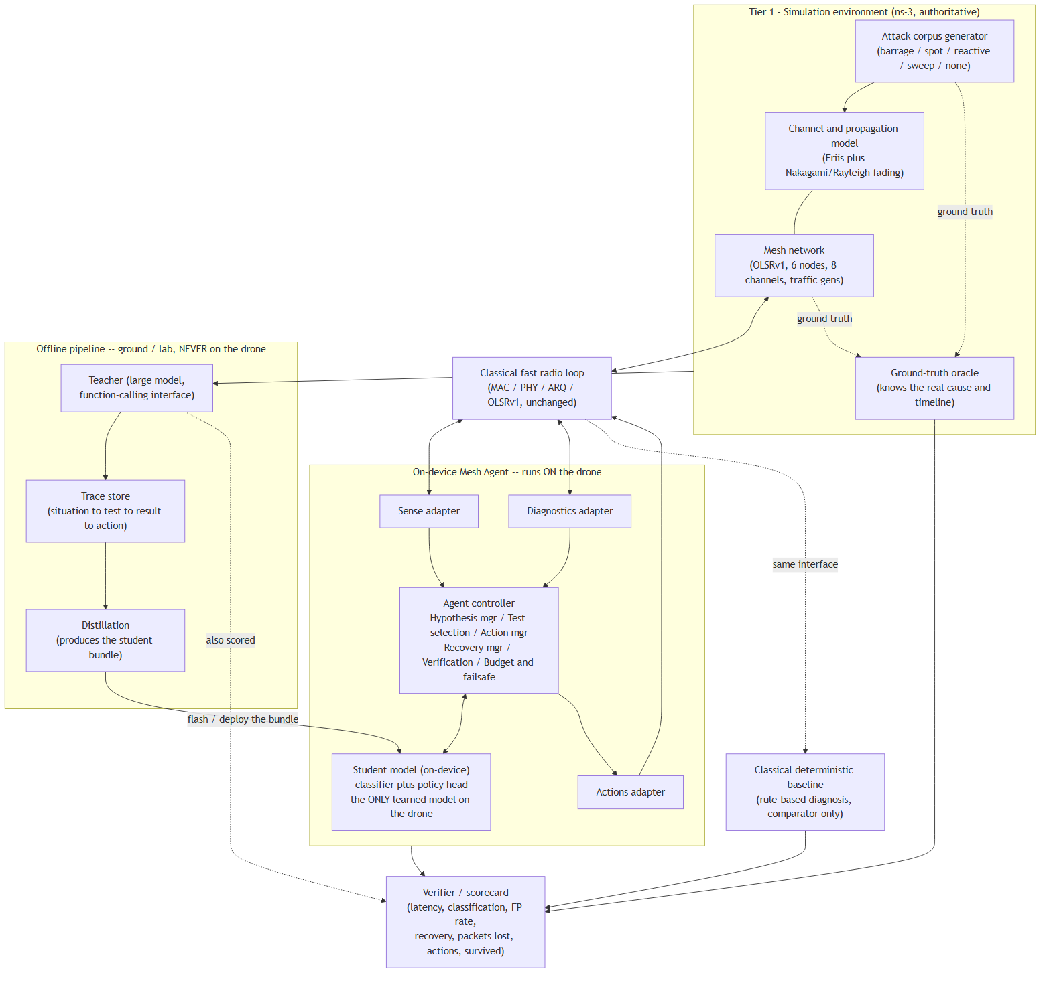

5.1 Actors and external interfaces
Actor / interface | Direction | Notes
Harness (EAG V3 platform, capstone profile) | runs tasks through the agent loop, writes records | §5.3. Not on the drone.
Simulation environment | provides sensing, accepts actions | The "world" during training and evaluation; reached via run_sim / read_result (§6.6).
Classical radio loop | provides raw counters, accepts coarse commands | A thin stub in Tier 1; real firmware in Tier 2.
Ground-truth oracle | read-only, verifier only | The agent never sees it.
Teacher model | offline only | Function-calling interface, simulation-only; routed via glc_v5.
Classical baseline | consumes the same observations as the agent | Runs the same tasks for comparison.
Verifier (predicates + score.py) | consumes run records + ground truth | Deterministic; never reads agent prose (A18). Produces the scorecard and the teacher/student/baseline comparison.
Operator / mission system | receives declare_link_lost() + failsafe | Out of scope beyond the interface.

5.2 Frozen network configuration
Parameter | Value
Total nodes | 6
Drone / agent nodes | 1
Peer mesh nodes | 5
RF channels | 8 logical channels
Active channels per node | 1 (hopping supported)
Routing | OLSRv1, unmodified
Network type | Multi-hop wireless mesh
Mobility | Supported
Channel model | Normal + fading/multipath
Fallback link | Low-rate LoRa on a separate band
Ground truth | Verifier only

Reference topology (large enough to show direct-link failure, alternate routes, multi-hop recovery, node failure, congestion, channel-specific attacks, and fading; small enough to run thousands of scenarios):
N2
/ \
N1 -- N3
| |
N4 -- N5
\ /
N6
The drone is one of these nodes (default N1). Node count is fixed; growing it is explicitly a non-goal (§3.2).

5.3 Harness architecture (reused EAG V3 platform)
The harness is a capstone profile of the EAG V3 platform. S17Code and glc_v5 are pinned git submodules; the project's own code lives in a capstone/ package that sits on top, exactly as repo-doctor sits on the same platform.
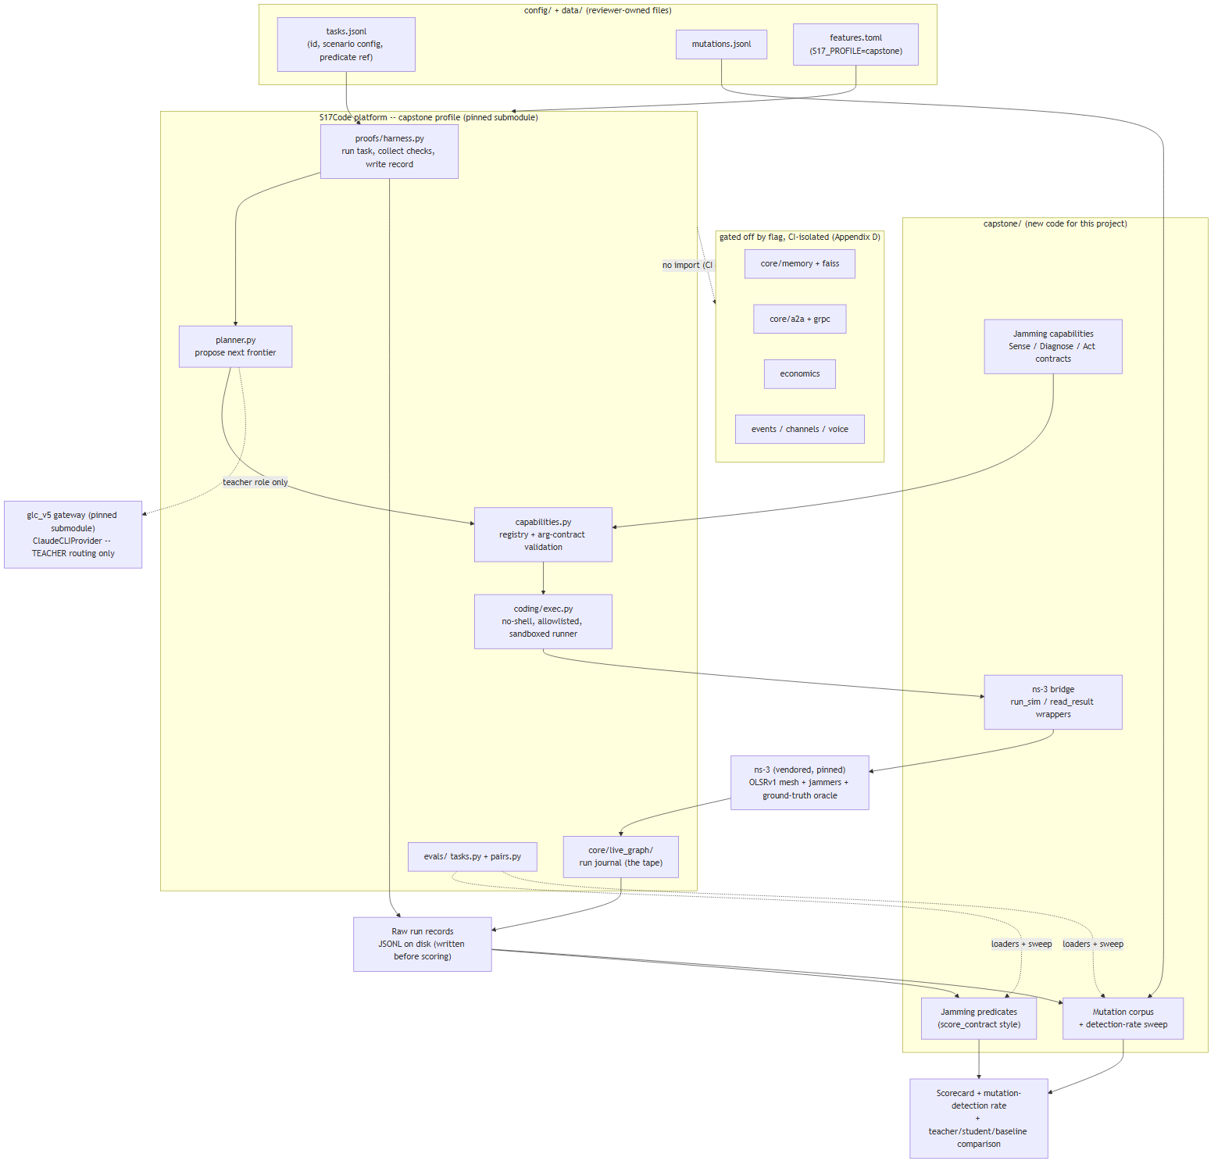
What is reused, unchanged: the planner loop (planner.py — model proposes the next runnable frontier, Python validates authority / arguments / dependencies before anything executes), the capability registry and its argument-contract validation (capabilities.py), the sandboxed command runner (coding/exec.py — no shell, allowlist, workspace boundary, timeout, output cap), the durable run journal (core/live_graph/), the run harness (proofs/harness.py — offline/live transport, run, collect checks, write record) and the eval loaders and threshold sweep (evals/).
What is new, in capstone/: the ns-3 bridge and its run_sim / read_result capabilities; the jamming Sense / Diagnose / Act capability contracts; the jamming predicates (built on the score_contract pattern); the mutation corpus and its detection-rate sweep; the classifier + policy-head student (the platform has no equivalent — its agent is LLM-planner-driven).
What is gated off (A15, Appendix D): durable memory + faiss, A2A + grpc, the economics engine, channel adapters and voice. Present in source, disabled by S17_PROFILE=capstone, and kept out of the capstone/ import graph by an import-linter contract that fails CI if anyone wires them in. Still tested by the platform's own full-profile CI.
Why gate rather than delete: the same platform is meant to carry forward to later projects, and the lab side has no resource constraint that deleting the dormant code would relieve — nothing in this diagram runs on the drone.

6. Interfaces
The model's action space is small and deterministic and is split into three groups plus a routing adaptation interface. Every call goes through the controller; the model never manipulates ns-3 or radio objects. The whole simulation is itself reached through two coarse capabilities the harness calls — run_sim and read_result (§6.6).

6.1 Sense API (read, free)
Function | Returns
get_rssi() | received signal strength per link
get_noise_floor() | in-band noise power, per channel
get_pdr() | packet delivery ratio per link, rolling window
get_retry_rate() | link-layer retransmission rate per link
get_spectrum() | last spectrum snapshot: power vs channel
get_neighbor_status() | per-neighbour reachability / last-heard
get_route_status() | current route to each destination, hop count

Derived context also available: offered load, own-TX active flag, time since last own TX, position (x,y,z), neighbour count, action budget remaining.

6.2 Diagnose API (distinguishing tests)
Function | Cost | What it separates
spectrum_scan() | 1 | jamming vs congestion (energy with no valid packets vs valid packets); barrage vs spot vs sweep (one scan vs a sequence)
listen_test() | 2 | your receiver vs the channel — a neighbour transmits while you listen
transmit_probe() | 2 | your transmitter vs the channel — you transmit while a neighbour reports what it heard
neighbor_probe() | 2 | dead peer vs channel/routing — is a specific peer alive on any channel
silent_listen() | 2 | reactive vs non-reactive — stop own TX for T, re-measure noise and retries
load_test() | 2 | congestion vs jamming — drop offered load / change rate, see if PDR recovers
channel_hop_probe() | 4 (budget) | spot vs barrage — recover on a scan-clean channel, or confirm no clean channel exists (refusal input)
mobility_test() | 8 (budget) | fading vs attacker — move() ~30 m; link changes markedly ⇒ fading, persists/worsens ⇒ attacker

6.3 Act API (recovery)
Function | Effect | Cost class
hop_channel(n) | move the mesh to channel n (of 8) | costly — mesh disruption, counts against budget
set_tx_power(p) | change transmit power | mild
reroute(via) | prefer a route through a given neighbour | mild
change_tdma_slot(s) | change the drone's TDMA slot / duty cycle | mild
move(x,y,z) | reposition the drone | expensive — time, energy, mission impact
fallback_to_lora() | drop to the low-rate LoRa link | costly — throughput collapse, but survivable
declare_link_lost() | declare the link unrecoverable, trigger the failsafe | terminal

The controller records, for every call: the function, the arguments, the hypothesis it was acting on, and the expected observable change ("if this was spot jamming, PDR on the new channel should exceed 0.8 within 3 s").

6.4 Routing adaptation interface (agent ↔ OLSRv1)
The agent operates above a conventional MANET routing protocol. It does not modify OLSR's algorithm; it reads link/route state and requests recomputation.
Read | Control
get_neighbors() | request_route_refresh()
get_route(destination) | request_alternate_route(destination)
get_link_quality(neighbor) | (route metrics update naturally as link quality changes)
get_route_quality()

6.5 Agent → verifier: episode log
{
"episode_id": "…",
"scenario": "reactive_jamming_v3",
"agent": "student",
"attack_onset_t": 12.4,
"first_correct_classification_t": 14.1,
"classification_trace": [
{"t": 12.9, "posterior": {"congestion": 0.4, "reactive": 0.3, "…": "…"}},
{"t": 14.1, "posterior": {"reactive": 0.86, "…": "…"}}
],
"tests_run": [
{"t": 13.2, "test": "spectrum_scan", "cost": 1},
{"t": 13.6, "test": "silent_listen", "cost": 2}
],
"actions": [
{"t": 14.3, "fn": "change_tdma_slot", "args": {"s": 5}, "budget_after": 5}
],
"tests_before_correct_classification": 2,
"recovery_t": 17.0,
"packets_lost": 214,
"actions_consumed": 1,
"survived": true,
"declared_jamming": true,
"false_positive": false
}

6.6 Simulator capabilities (run_sim / read_result)
The ns-3 environment is exposed to the harness as two coarse, contract-checked capabilities, declared in the platform's capability registry and executed through the sandboxed runner (allowlist entry: the pinned ns-3 binary):
Capability | Arguments | Returns
run_sim | scenario (id), seed, config (channels, topology, jammer, fading, onset, budget), agent (student | teacher | baseline | none) | run_id, exit status, path to the raw record
read_result | run_id | the episode log (§6.5) and the run journal, read back from disk

The fine-grained Sense / Diagnose / Act calls (§6.1–6.3) are the interface the agent uses within a running episode, carried over the ns3-gym bridge at ~1 Hz sim time. They resolve to reads and writes on the simulation run_sim started — they are not separate processes. This is the reconciliation between "the tool is run_sim / read_result" (how the harness sees it) and the rich per-step API (how the agent sees it).

7. Agent design

7.1 The loop
detect anomaly
-> form competing hypotheses
-> select the cheapest distinguishing test
-> execute test
-> observe result
-> update belief
-> act (recovery) | more test
-> verify recovery
-> or escalate -> failsafe
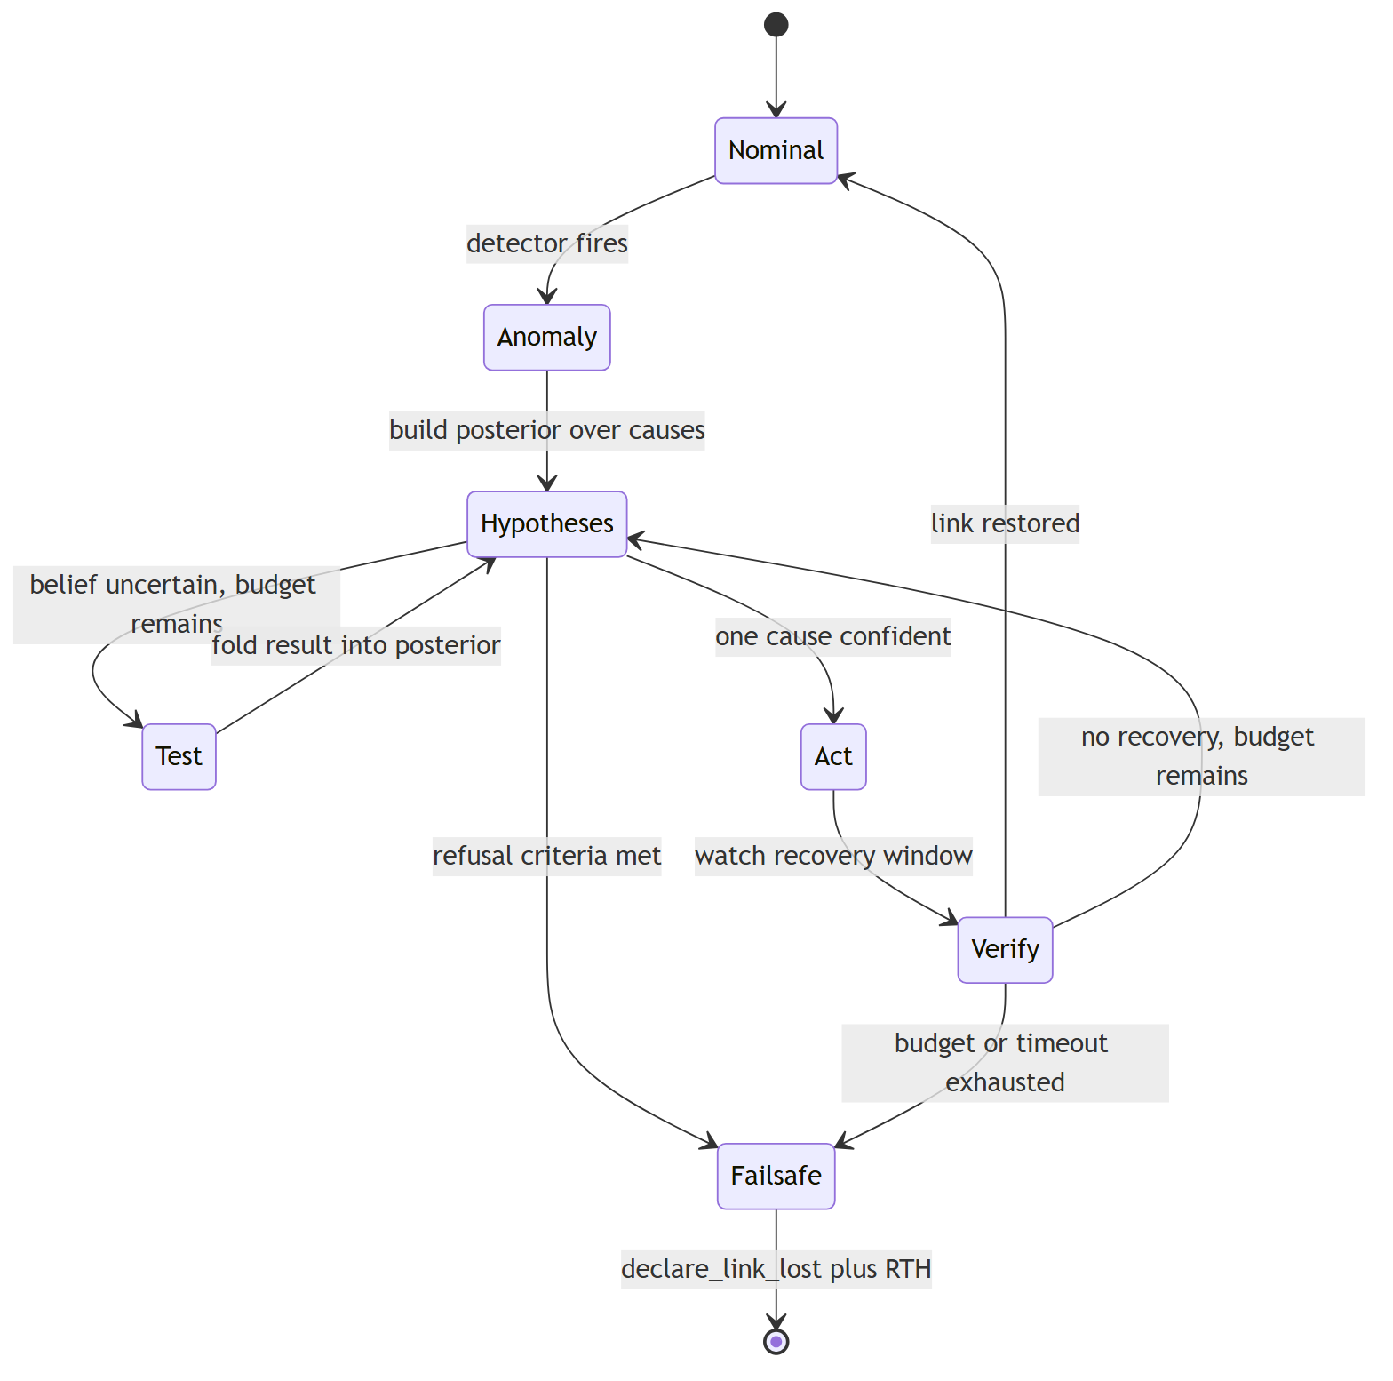

7.2 Anomaly detector
Lightweight, always-on. Trips when windowed statistics leave their nominal band: PDR drop, retry-rate rise, noise-floor rise, or sustained zero-RX on a link. Produces the trigger and a first feature snapshot. Tuned for a low missed-detection rate; false triggers are cheap because the next stage is only a spectrum scan.

7.3 Hypothesis catalogue
ID | Hypothesis | Attacker? | Signature (before any test)
H1 | Barrage jamming | yes | PDR collapse on all links, noise floor high on all 8 channels
H2 | Spot jamming | yes | PDR collapse, noise floor high on one channel only
H3 | Reactive jamming | yes | PDR "fine" but retry rate huge; interference correlates with own TX
H4 | Sweep jamming | yes | Per-channel collapse that migrates across successive scans, roughly periodic
H5 | Fading / multipath | no | PDR intermittent, correlated with position/time, noise floor normal
H6 | Dead peer | no | Link-layer up, zero RX from one peer, no elevated noise, peer beacons absent
H7 | Congestion | no | Collisions and retries rise with offered load, noise floor normal, degrades gracefully, backoff helps
H8 | Hidden terminal | no | Collisions without high local offered load; RTS/CTS or slot separation helps

7.4 Distinguishing-test matrix
Tests (§6.2) are ordered cheapest-first. The planner picks the test with the highest expected information gain per unit cost, given the current posterior.
Situation | Cheapest useful test | Reads as
jamming vs congestion vs fading | spectrum_scan() | in-band energy with no valid packets ⇒ jamming; energy is valid packets ⇒ congestion; no excess energy ⇒ fading or node loss
barrage vs spot vs sweep | spectrum_scan() ×N over a few seconds | all channels hot ⇒ barrage; one hot ⇒ spot; hot channel migrates ⇒ sweep
reactive vs steady jamming | silent_listen() | noise/retries fall to nominal while silent ⇒ reactive
your RX vs the channel | listen_test() | neighbour heard cleanly ⇒ RX fine
your TX vs the channel | transmit_probe() | neighbour reports you clearly ⇒ TX fine
dead peer vs routing vs jamming | neighbor_probe() | no peer on any channel + noise normal ⇒ dead peer; noise high ⇒ jamming on RX
congestion vs jamming | load_test() | PDR recovers when load drops ⇒ congestion
spot vs barrage / refusal input | channel_hop_probe() | recovers on a clean channel ⇒ spot; no clean channel ⇒ refusal input
fading vs attacker | mobility_test() (move() 30 m) | link changes markedly with small position change ⇒ fading; persists ⇒ attacker

7.5 Policy head (classification → action)
Mostly a validated lookup table. Learned weights only where teacher traces disagree with the obvious rule.
Confident cause | Action | Rationale
Spot jamming | hop_channel(cleanest from scan) | a clean channel exists; move to it
Sweep jamming | hop_channel() ahead of the sweep; schedule further hops | stay in front of the jammer
Reactive jamming | change_tdma_slot() / cut duty cycle; set_tx_power down; reroute() | deny the jammer its trigger; do not hop (it follows your TX)
Barrage, clean channel on another band | fallback_to_lora() | trade throughput for a link that survives
Barrage, no escape, no LOS to any peer | declare_link_lost() + RTH failsafe | refusal case — see 7.6
Fading / multipath | set_tx_power() up, or small move(), or reroute(via better link) | never hop_channel() — hopping here is the expensive false positive
Dead peer | reroute(via alternate); if no route, declare_link_lost() for that peer | routing problem, not an RF problem
Congestion | change_tdma_slot() / backoff; set_tx_power down; reroute load | reduce contention
Hidden terminal | change_tdma_slot() / enable RTS-CTS-style separation; reroute | separate the colliding transmitters

After acting, the recovery verifier watches PDR/retry for a recovery window. Restored ⇒ return to nominal. Not restored and budget remains ⇒ fold the failure back into the posterior and continue. Budget or timeout exhausted ⇒ failsafe.

7.6 Failsafe — a hard controller rule
The failsafe is enforced by the controller, not reasoned about by the model. The model may recommend declare_link_lost(); the controller forces it when any of the following holds:
- Refusal criteria met (reachable from sensing alone, per A11):
  - spectrum_scan() shows all 8 channels above the jamming-energy threshold, persistently across scans;
  - neighbor_probe() fails on every channel tried, with noise floor high on each (no receiver-only or routing explanation);
  - no clean channel exists for a hop probe, and the LoRa fallback band is also jammed or offers no reachable peer.
- Action budget exhausted (A10) with the link still down.
- Recovery wall-clock timeout exhausted (A10).
Result: classification link_unrecoverable / broadband_jamming_no_LOS (or recovery_exhausted), action declare_link_lost(), then the failsafe return to home on last known good position. A unit test asserts that the broadband-no-LOS scenario terminates in declare_link_lost() within a bounded number of steps and never emits an infinite hop sequence (hop CH1 → CH2 → … → CH8 → CH1 …).

7.7 Sequence examples
Reactive jamming (the "everything is a retransmission" case)
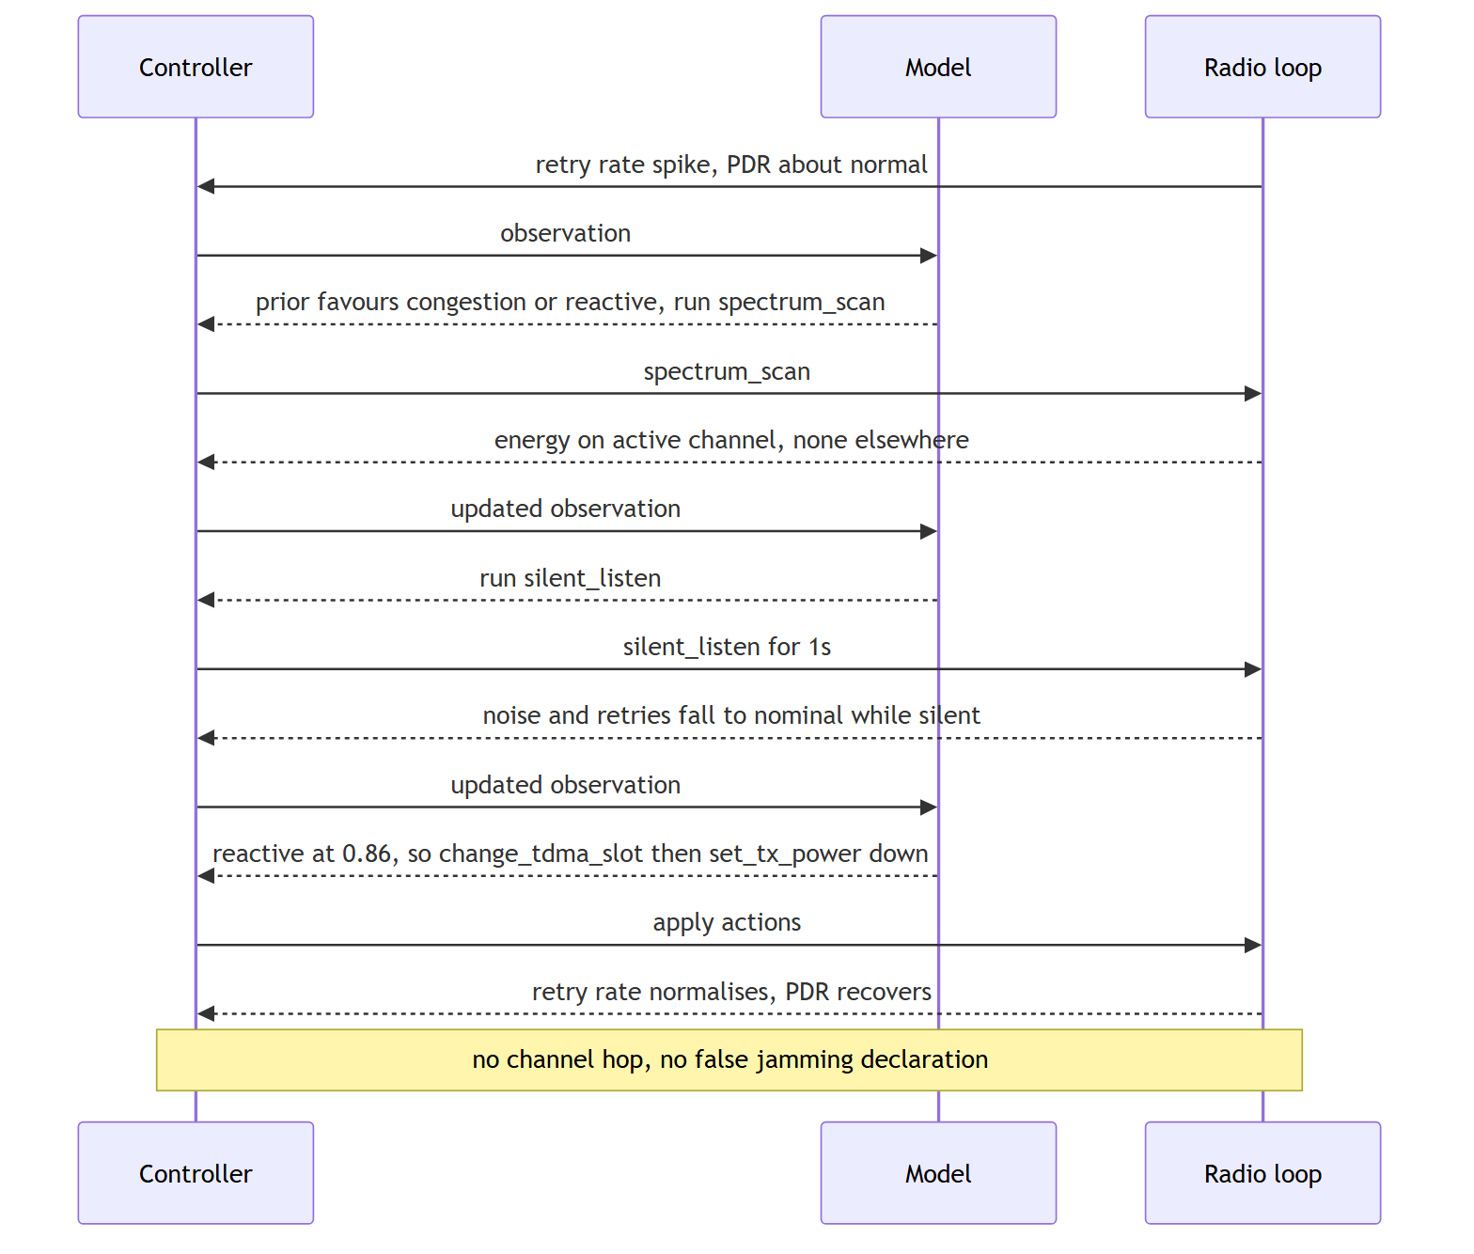
Fading — the false-positive trap
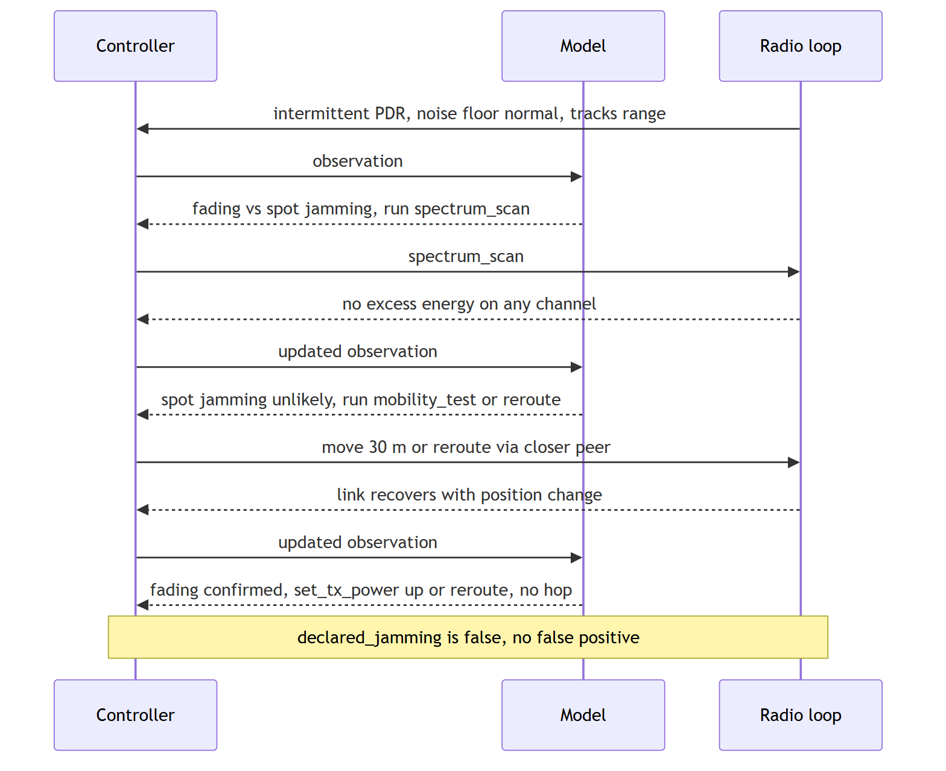
Refusal case
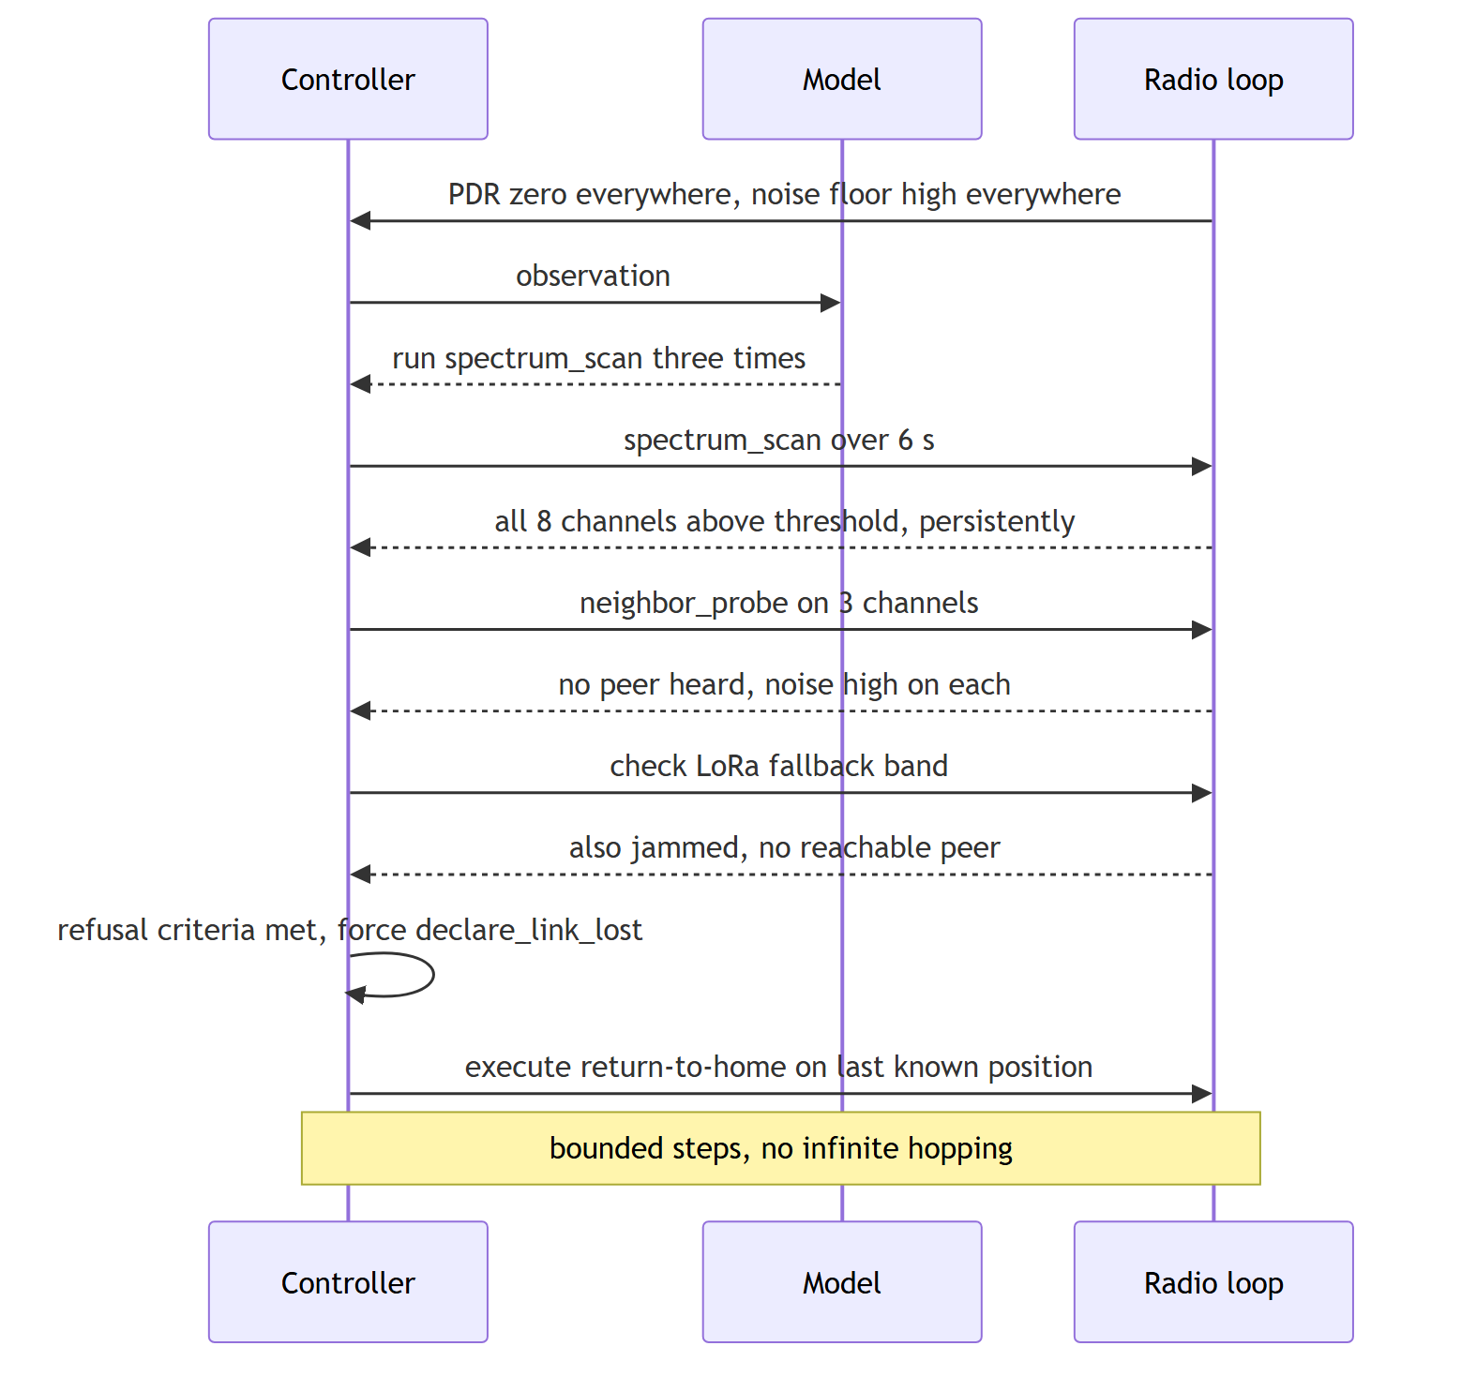

8. Classical deterministic baseline
A hand-written rule set, built in Phase 2 before the agent, that the agent must beat on the cost-weighted scorecard. It uses the same Sense/Diagnose interface and the same episode-log format.
Example rules:
PDR ↓ AND noise ↑ AND all 8 channels affected -> barrage
PDR ↓ AND noise ↑ AND exactly one channel affected -> spot
PDR ~ok AND retry ↑↑ AND degradation only during local TX -> reactive
per-channel collapse migrates across scans -> sweep
PDR intermittent AND noise normal AND correlated with distance -> fading
link up AND zero RX from one peer AND noise normal -> dead peer
retry ↑ AND rises with offered load AND noise normal -> congestion
retry ↑ AND local load low AND RTS/CTS helps -> hidden terminal
The baseline gives three things: a sanity floor for the metrics, a control in the teacher-vs-student comparison, and a concrete answer to "did the learned agent actually add value over rules?"

9. Teacher → student pipeline
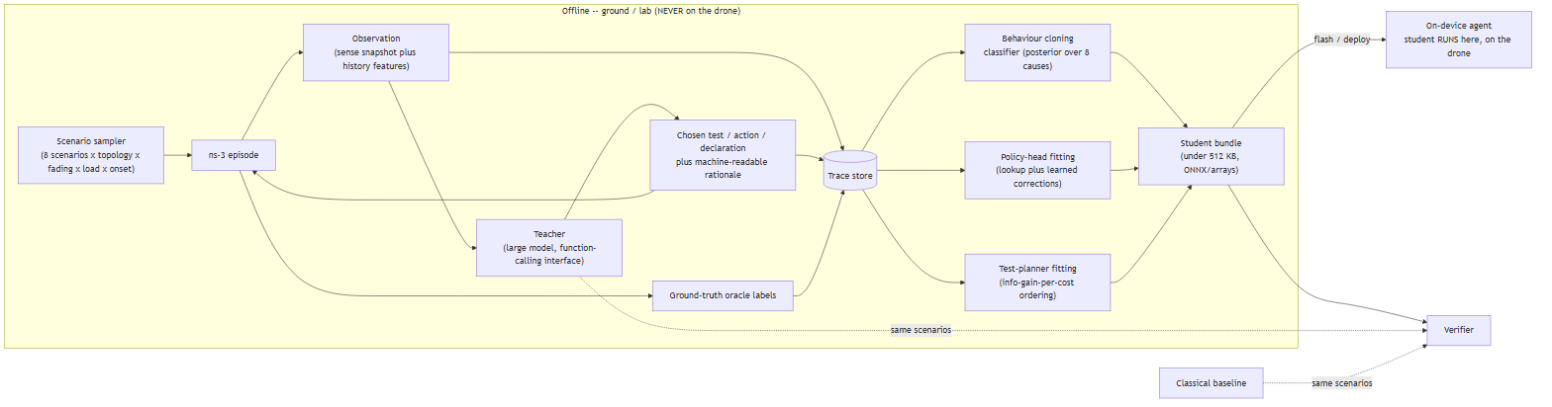

9.0 What runs where
Component | Where it runs | In the deployed loop?
Teacher (large model) | Offline only — ground / lab, in simulation | No. Used once, to generate training traces.
Trace store, distillation | Offline only — ground / lab | No. Produces the student bundle.
Student model (classifier + policy head) | On the drone | Yes. The only learned model on the drone.
Agent controller, Sense / Diagnose / Act adapters | On the drone | Yes.
Verifier, ground-truth oracle | Offline only | No. Grading, never visible to the agent.

The pipeline's output is the student bundle (< 512 KB), which is flashed onto the drone. After that the drone is fully self-contained: no teacher, no network, no ground link.

9.1 Teacher
- Runs only in simulation, only offline. Not part of the deployed system.
- Given the same observation vector the student will see (no ground-truth access), plus the API definitions, and asked to choose one call and state why.
- Output constrained to the fixed function-calling schema so traces are directly usable as student targets.
- Every teacher episode is also scored by the verifier so the teacher→student gap can be computed on identical scenarios.

9.2 Trace schema (per step)
{
"episode_id": "…", "step": 7,
"scenario_label": "sweep_jamming", // ground truth, training only
"observation": { "features": [ … ], "tests_so_far": [ … ] },
"prior_posterior": { "sweep": 0.31, "spot": 0.44, "…": "…" },
"teacher_choice": { "kind": "test|act|declare", "fn": "spectrum_scan", "args": {} },
"teacher_rationale": "spot and sweep both fit; a second scan 3s later separates them",
"outcome_delta": { "…": "…" },
"reward_components": { "latency": -0.2, "fp": 0.0, "recovery": 0.0, "actions": -0.1 }
}

9.3 Student training
- Classifier: gradient-boosted trees or a small MLP. Input = feature vector (windowed sense stats + results of tests run + context). Output = posterior over {H1…H8, unknown}. Target = teacher posterior where available, ground-truth label as an auxiliary signal. Cost-weighted loss that penalises "fading → jamming" confusion the hardest.
- Test planner: a shallow decision tree / ordered rule set fitted to the teacher's test choices, keyed on posterior entropy and which tests remain.
- Policy head: the lookup table of Section 7.5, with learned corrections only on states where teacher actions disagree with the table.
- Domain randomisation: fading parameters, offered load, topology role of the drone, and noise are randomised across episodes; a held-out set of scenarios (especially fading-heavy) is never seen in training.

9.4 Three-way comparison
Run the identical scenario corpus through (a) the classical baseline, (b) the teacher-in-the-loop agent, and (c) the distilled student. Report, per scenario family and overall:
- Detection latency
- Classification accuracy + side-by-side confusion matrices
- False-positive rate
- Recovery time, packets lost, actions consumed, tests before correct classification
- Survival rate
- Every scenario where the student regresses relative to the teacher or to the classical baseline, listed explicitly.

10. Evaluation

10.1 Task set (frozen — 4 attacks, 4 non-attacks)
The scenario corpus is the task set. It lives in a data file the reviewer can replace wholesale (data/tasks.jsonl); each record is {"id": ..., "family": ..., "config": {...}, "predicate": ...}. Nothing branches on the family label — it only groups the report.
Family | Attacker? | What it stresses
Barrage jamming (all 8 channels) | yes | classification + escape logic + refusal
Spot jamming (one channel) | yes | cheapest-test ordering, clean-channel hop
Reactive jamming (fires only on your TX) | yes | silent-listen test, "don't hop" policy
Sweeping jammer | yes | multi-scan reasoning, hop-ahead policy
Fading / multipath, no attacker | no | the false-positive trap
Dead peer | no | routing vs RF separation, neighbour probe
Congestion from a legitimate burst | no | load-change test, no false "jamming"
Hidden terminal | no | collision-related degradation, slot separation

Each family is sampled across topologies, fading strengths, loads, and attack-onset times to produce the concrete task instances.

10.2 Verifiers (deterministic predicates)
Each task carries a predicate: a function that reads the run's episode log (§6.5) and the ground-truth oracle and returns pass/fail with a reason. It never reads the agent's prose or the model's stated confidence. The predicate code is generic (the score_contract pattern from the platform); the per-task input is declarative:
{
"classified_as": "reactive", // must match ground truth
"declared_jamming_allowed": true,
"recovered_within_s": 5,
"max_actions_consumed": 3,
"must_survive": true,
"must_end_in": null // "declare_link_lost" for refusal tasks
}
A task passes only if every clause holds. A predicate that cannot be evaluated (missing field, malformed record) is a harness failure, reported as such — it never silently becomes pass or fail.

10.3 Metrics (the verifier's scorecard, frozen before implementation)
Metric | Definition
Correct classification rate | jamming vs fading vs congestion vs node loss, and sub-type
False-positive jamming rate | (non-jamming scenarios classified as jamming) / (all non-jamming scenarios) — the expensive error, weighted highest
Detection latency | attack onset → first correct classification
Recovery time | seconds to a usable link
Packets lost in recovery | total dropped from onset to recovery
Actions consumed | count, with channel hops weighted
Tests before correct classification | directly tests the "cheapest distinguishing test" hypothesis
Survivability | did the drone keep the mesh (or, in the refusal case, execute the failsafe correctly)

10.4 Mutation corpus
The task set tests whether the agent gets the right answer on well-formed inputs. The mutation corpus tests something else: whether the checker — the agent's input validation and its abstain / "unknown" path — notices when the input itself is broken, instead of confidently classifying garbage.
It is a data file (data/mutations.jsonl) of episode inputs with one deliberate defect each, grouped by family:
Mutation family | Example
Out-of-range | PDR = 1.7, noise floor = +40 dBm, negative retry rate
Contradictory | PDR 0.02 on a link whose RSSI is strong and noise floor is nominal
Stale / frozen | every sense value identical for 30 s while the scenario is changing
Truncated | spectrum_scan() returns 3 of 8 channels
NaN / null | a sensor returns null mid-episode
Degenerate jammer config | jammer at 0 power, or on a channel that does not exist
Duplicated event | the same observation delivered twice with the same timestamp

Metric — mutation-detection rate: the fraction of mutated inputs the checker flags (raises "input invalid" or routes to the abstain path) rather than classifying. Reported per family and overall. The complementary number matters too: the false-flag rate on the clean task set must stay near zero — a checker that flags everything scores 100 % detection and is useless. Both come from the platform's evals/pairs.py::sweep (true-positive / false-positive rate at each abstain threshold); the operating point is chosen the same way the classifier's is.
Mutation families are fixed before the checker is tuned, and a held-out mutation set is never used during development.

10.5 Raw run records
Every run — student, teacher, baseline, mutation probe — writes a complete record to data/runs/<run_id>.json before any predicate executes:
{
"run_id": "...", "task_id": "...", "agent": "student",
"config": { ... }, // exact scenario config + seed
"platform": { "s17code": "<commit>", "glc_v5": "<commit>", "ns3": "<commit>" },
"episode_log": { ... }, // §6.5
"journal": { "nodes": [...], "events": [...] }, // the live-graph tape
"ground_truth": { "cause": "reactive", "onset_t": 12.4 }
}
Scoring is a separate offline pass (score.py <runs-dir> <tasks-file>) that reads records and emits the scorecard. Changing a threshold, adding a metric, or fixing a predicate bug means re-running score.py over the existing records — never re-running the model or ns-3. This is the platform's p4_trace_export property ("delete the materialised graph and the trace still builds from the tape alone") applied to the whole evaluation.

10.6 Pass thresholds (initial targets, calibrated in Phase 1)
Metric | Target
Classification accuracy (8-way) | ≥ 85 % on held-out scenarios
False-positive jamming rate | ≤ 5 %
Refusal-case handling | 100 % terminate in declare_link_lost() + RTH, no infinite hopping
Median recovery time (recoverable scenarios) | ≤ 5 s
Median actions consumed (single-cause scenarios) | ≤ 2
Mutation-detection rate | ≥ 80 % overall, with false-flag rate ≤ 3 % on the clean task set
Student vs teacher survival rate | within 10 percentage points
Student vs classical baseline | strictly better on cost-weighted score

10.7 Ablations
- No spectrum scan available (counters only).
- No move() available (fading vs attacker from sensing alone).
- Action budget halved.
- Classifier only, no test planner (act on first posterior).
- Teacher traces halved (data-efficiency of distillation).

11. Technology stack
Layer | Choice
Harness / platform | EAG V3 platform, pinned submodules — S17Code (planner.py, capabilities.py, runtime.py, core/live_graph/, proofs/harness.py, evals/) run in a capstone profile
Teacher routing | glc_v5 gateway — ClaudeCLIProvider (offline, teacher pipeline only)
Profile & gating | config/features.toml (S17_PROFILE=capstone); pyproject.toml optional-dependency extras so heavy deps (faiss, grpcio, a2a-sdk) are opt-in; import-linter contract; per-profile CI smoke test
Authoritative simulator | ns-3 (vendored, pinned) — wifi, spectrum, propagation (Friis + Nakagami/Rayleigh), olsr, mobility, energy; wrapped as run_sim / read_result capabilities
Custom ns-3 modules | JammerApp (barrage/spot/reactive/sweep; reactive via energy detection on an interferer node), GroundTruthOracle, AgentBridge
Agent ↔ sim bridge | ns3-gym / ns3-ai — per-step Python decision loop at ~1 Hz sim time
capstone/ package | jamming capabilities, jamming predicates (score_contract pattern), mutation corpus + sweep, classifier + policy-head training — Python 3.11: numpy, pandas, scikit-learn / LightGBM, matplotlib
Student export | ONNX / plain weight arrays; reference C or MicroPython inference; footprint < 512 KB
Run records / scoring | JSONL to data/runs/; score.py as a separate offline pass
Optional Tier 2 | ESP32 (painlessMesh / ESP-NOW) mesh nodes + 1 ESP32 interferer; student on an ESP32-S3 or on a host over serial
Optional Tier 3 | RTL-SDR + GNU Radio flowgraph for spectrum observation and RF validation
Repo | Python + C++, pytest, import-linter, scenario/task/mutation configs as JSONL + YAML

12. Project plan
Phase | Weeks | Deliverable | Lead
P0 — Platform + tooling | 1 | Fork/pin S17Code + glc_v5 as submodules; capstone profile + features.toml + import-linter contract + per-profile CI green; vendor and pin ns-3; run_sim / read_result capabilities stub through the sandboxed runner | both
P1 — Build the world | 1–4 | ns-3 env: 6 nodes, 8 channels, OLSRv1, mobility, traffic, normal + fading channel, node failure, congestion, hidden terminal, 4 attacker models, ground-truth oracle. No model yet. Calibrate pass thresholds. | Prateek
P2 — Classical baseline + verifiers | 3–5 | Deterministic rule-based diagnosis (§8); Sense/Diagnose API; episode-log format; task-set loader + predicates (§10.2); raw-record writer + score.py (§10.5) | Jatin
P3 — Agent | 5–8 | Agent controller on the platform loop, anomaly detector, hypothesis manager, test planner, policy head; function-calling model in the loop | Jatin
P4 — Teacher / student | 7–11 | Teacher pipeline via glc_v5; trace dataset over the full corpus; distillation; student bundle (< 512 KB) | both
P5 — Evaluation | 10–12 | Scorecard, three-way comparison (baseline / teacher / student), teacher→student gap report | both
P6 — Hardening + mutation corpus | 11–13 | Refusal-case hardening; mutation corpus + detection-rate sweep (§10.4); ablations; domain-randomisation sweep | Prateek
P7 — Tier 2 / Tier 3 (optional) | 12–13 | ESP32 rig + demo video; RTL-SDR / GNU Radio validation | both
P8 — Write-up | 13–14 | Final report, demo, gap analysis, PLATFORM.md | both

Work split (assumption A12/A13): Prateek owns the world (simulator, RF, attack corpus, optional hardware); Jatin owns the agent (sensing, baseline, classifier, distillation, policy). Both own the teacher pipeline, the verifier, and the report.

13. Risks and mitigations
Risk | Impact | Mitigation
A home-grown simulator is not credible to an examiner | Core results dismissed | ns-3 is authoritative (A2); any fast sim is an approximation, re-validated on ns-3
Scope creep into a generic MANET / SDR project | Never finishes | Baseline frozen before coding (A14); node count, channel count, routing all fixed
ns-3 learning curve; reactive jammer hard to model | Schedule slip in P1 | Prototype the jammer in week 2; fallback = dedicated interferer node with energy-triggered TX
Classifier overfits to sim artefacts | Good numbers, poor generalisation | Domain randomisation, held-out scenario families, fading-heavy validation set
Fading → jamming false positives (the graded error) | Fails the headline metric | Require a positive distinguishing test before declaring jamming; cost-weighted loss; dedicated fading validation set
Agent hops forever in the refusal case | Worst-case real-world failure (flies till battery dies) | Failsafe is a controller rule, not model reasoning (7.6); hard budget + timeout (A10); unit test that the scenario terminates
Learned agent adds nothing over rules | "Why not just use the baseline?" | Classical baseline built first and reported alongside; student must strictly beat it
Teacher dependency (availability, determinism, cost) | Training pipeline stalls | Teacher used offline only; all traces cached and versioned; student fully self-contained
Distillation gap too large | Student not defensible | Allow a slightly larger student within A6, add a few high-value features, iterate; report the gap honestly regardless
Tier 2 hardware procurement / debugging | Demo slips | Tier 2 is optional (A1, A14); Tier 1 alone is a complete capstone
Reused platform reads as "borrowed a big thing" to an examiner | Harness credit disputed | §1.5 maps every deliverable to a named module; capstone profile keeps the live import graph small; PLATFORM.md (Appendix D) states what is active vs dormant; §5.3 spells out what is new in capstone/
Carrying the full platform inflates clone size and CI time | Friction, not failure | Heavy deps are opt-in extras; capstone CI installs only the lean set; dormant subsystems run only in the full-profile job
Mutation-detection metric gamed by a flag-everything checker | Meaningless number | False-flag rate on the clean task set is a paired, capped metric (§10.4); mutation families fixed before the checker is tuned; held-out mutation set
S17Code pinned commit has a latent bug on our path | Lost days | Pin to a commit whose CI is green for the capabilities we use; repo-doctor's fix branches are precedent; our own fixes go back as PRs

14. Open questions
- Exact on-device compute target (specific SoC / RAM ceiling)? — assumed small ARM, < 512 KB model, < 20 ms inference, must also fit ESP32-S3 (A6).
- Decision cadence — is ~1 Hz right, or does the mission need faster? (A3)
- Action budget default and recovery timeout — is 6 actions right? (A10)
- Is the LoRa fallback always physically available on the drone? (A8)
- Is batman-adv wanted as a comparative experiment, or dropped entirely? (A9)
- Are Tier 2 / Tier 3 in or out for the final submission? — assumed optional (A1, A14).
- Timeline confirmation — is ~14 weeks correct? (A12)
- Which node in the topology is the drone — fixed at N1, or varied across episodes? (A13, §5.2)
- Which S17Code / glc_v5 commits do we pin? (default: latest with green CI for the capabilities we use, then track our own fix PRs) (A15)
- Does the teacher route through glc_v5's ClaudeCLIProvider, or call the Claude CLI directly and skip the gateway for this project? (A7, §11)
- Is the full-profile platform CI something we maintain, or do we only run the capstone profile and leave full to the upstream repos? (A15)

15. Appendix A — feature vector (initial)
Windowed over the last N seconds, per link and aggregated:
- PDR: current, delta, variance
- Retry rate: current, delta
- RSSI: current, delta, variance
- Noise floor: per channel (×8), max, spread across channels
- Spectrum scan: per-channel power (×8), count of channels above threshold, whether the hot channel moved since the last scan
- Own-TX: active flag, duty cycle, correlation of retry-rate with own-TX windows
- Context: offered load, load delta, neighbour count, zero-RX duration per link, position delta since anomaly onset, action budget remaining
- Test results: one-hot of tests run + their outcomes

16. Appendix B — actions by cost
Cost class | Calls | Budget impact
Free | all Sense calls | none
Cheap | spectrum_scan | none
Mild | set_tx_power, reroute, change_tdma_slot, listen_test, transmit_probe, neighbor_probe, silent_listen, load_test | none
Costly | hop_channel, channel_hop_probe, fallback_to_lora | −1 each (hop probe −4 in planner cost)
Expensive | move, mobility_test | −2
Terminal | declare_link_lost | ends the episode

17. Appendix C — phase gate checklist
Gate | Must be true to proceed
After P1 | ns-3 reproduces all 8 scenarios with logged ground truth; thresholds calibrated
After P2 | classical baseline scores all 8 scenarios; verifier emits the full scorecard
After P3 | agent completes every scenario without touching ns-3 directly; failsafe unit test passes
After P4 | student bundle < 512 KB, < 20 ms inference; runs the full corpus
After P5 | three-way comparison table complete; every student regression listed
After P6 | mutation-detection rate reported per family; false-flag rate on the clean task set within cap

18. Appendix D — platform subsystem map (PLATFORM.md preview)
Which parts of the EAG V3 platform this project switches on. The full version ships as PLATFORM.md in the repo (P8).
Subsystem | Module(s) | capstone profile | Where it is exercised
Planner loop | s17code/planner.py, runtime.py | active | every run
Capability registry + validation | s17code/capabilities.py | active | every tool call
Sandboxed command runner | s17code/coding/exec.py | active | run_sim
Run journal (the tape) | s17code/core/live_graph/ | active | every run → raw records
Eval loaders + threshold sweep | s17code/evals/tasks.py, pairs.py | active | task set, mutation corpus
Proof/run harness | s17code/proofs/harness.py | active (adapted) | the harness itself
LLM gateway | glc_v5 (ClaudeCLIProvider) | teacher-only | P4 teacher pipeline
Adversarial nested validator | s17code/coding/validate.py | dormant | kept for a possible independent-check experiment; full CI
LLM-as-judge (rubric) | s17code/evals/judge.py | dormant | not used — our verdicts are deterministic predicates (A18); full CI
Durable memory + vector index | s17code/core/memory/, faiss-cpu | gated off | full CI only; import-linter forbids in capstone/
Agent-to-agent (A2A) | s17code/core/a2a/, grpcio, a2a-sdk | gated off | full CI only
Economics / budget engine | s17code/economics/ | gated off | full CI only
Event-driven autonomy / channels / voice | s17code/events/, channel adapters | gated off | full CI only
OpenTelemetry span export | s17code/telemetry/ | optional | on if a collector is configured

active — on the capstone import graph and run every time. teacher-only — imported only by the offline teacher pipeline. dormant — installed, not wired into the capstone path, retained deliberately. gated off — not installed under the capstone extra, and import-linter fails CI if capstone/ or the capstone-profile modules import it.

