**CS551 Adv Software Engg**

**Assignment/Lab: 3**

Poojitha Mittapally,

16157740

**Mashup**

A mashup is an application that provides web services from Yahoo, Google Map and HTML5 Local Storage in various forms.

This is my home screen showing four kinds of services, allowing you to choose any of them to access.

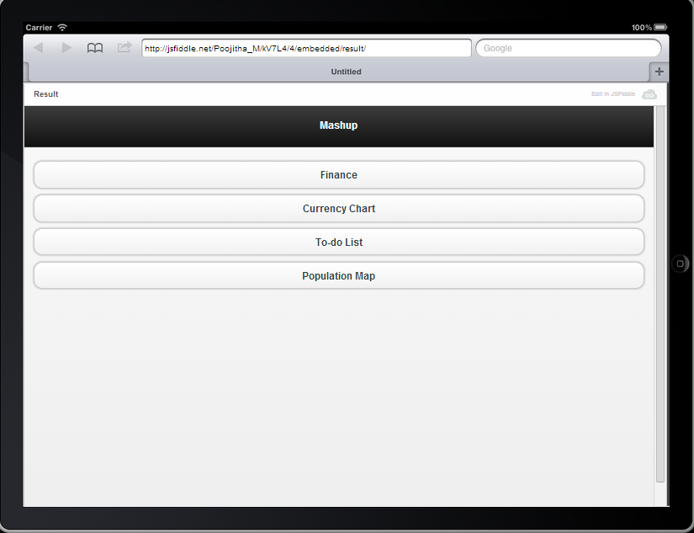

**Screenshot1: Home Page**

**Finance:**

This page shows the top financial stories using the Yahoo RSS Feed Services. I have used the Yahoo Finance stories RSS feed for display.

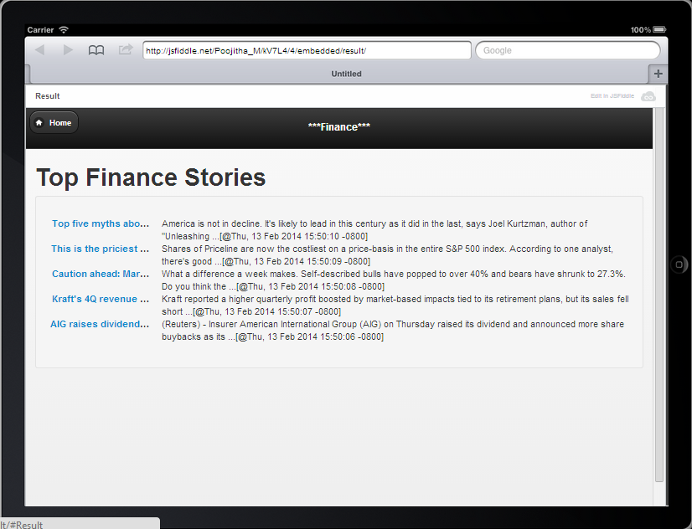

**Screenshot2: Finance Stories**

**Currency Table:**

This page displays the current Exchange value of the other countries Currency with respective to US Dollars. I have used the Yahoo Finance web service for the currency data.

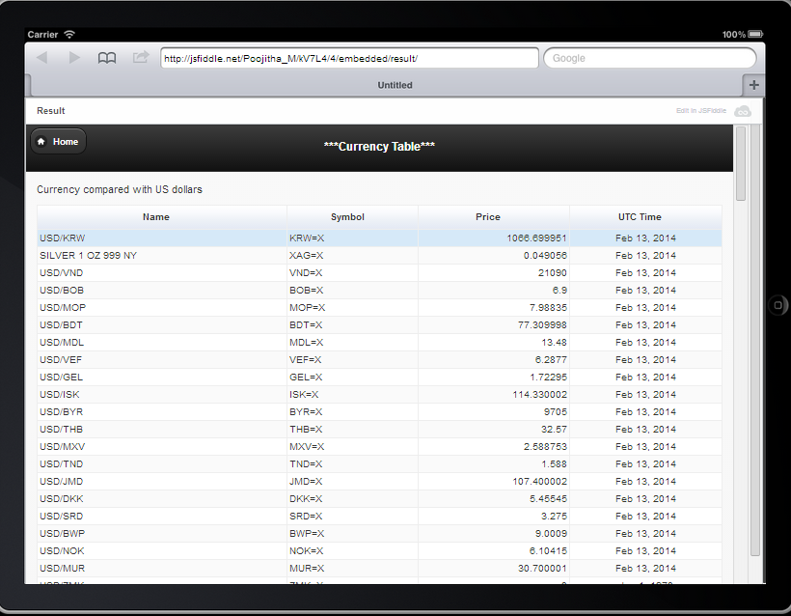

**Screenshot3: Currency Exchange Value**

**To-do List:Using HTML5 Local Storage:**

This page provides the space for a user to save their to-do list and retrieve them whenever they open it again. I made it using HTML5 Local Storage. There are options on how to add and delete the tasks.

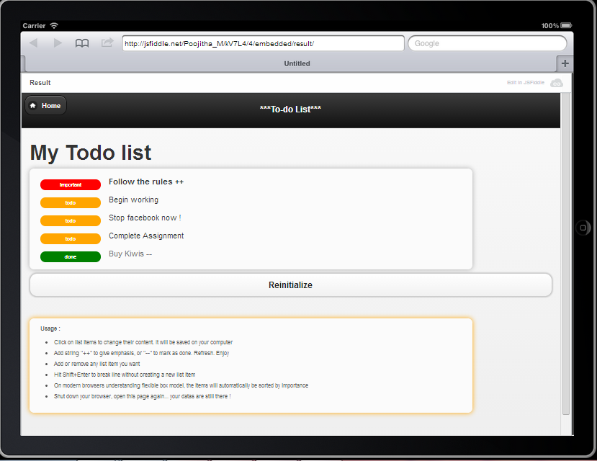

**Screenshot4: To-do List**

**Population Map:**

This page uses the Google web services. Shows the world map with most popular countries marked and the corresponding color shows that the country has approx Population from the scale shown below the map.

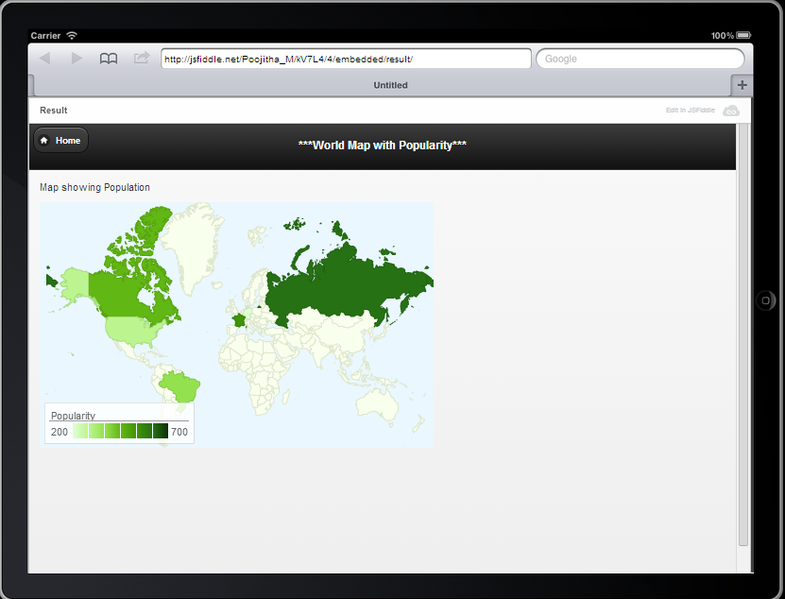

**Screenshot5: Population Map**

Map showing Russia has population of 700cr approx. On placing the cursor on it

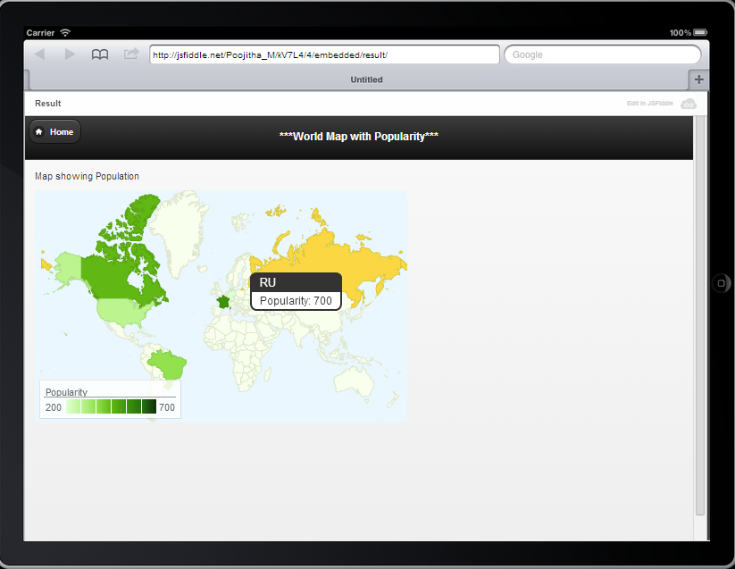

**Screenshot6: Map highlights Russian population.**