**CS551 Adv Software Engg**

**Assignment/Lab: 2**

Poojitha Mittapally,

16157740

**Books and Direction Finder**

I have created a mobile web client application named “Books and Direction Finder”. It has three pages Home page, Books search and Direction Page.

**Home Page:** Here you can select any option Books search or Direction Finder. Then it will navigate to the respective page.

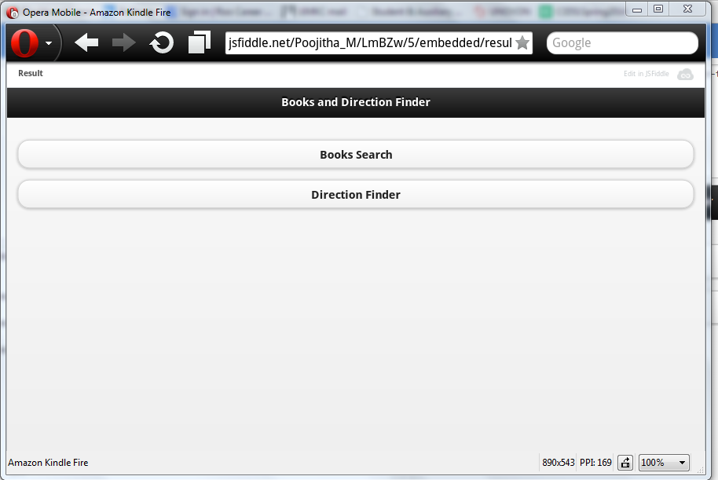

**Screenshot1: Home Page**

**Books Search:**  On clicking Books search button on the home page, you will be redirected to this page. I have used Google Webservices for this search. The HTML5 Google Books Javascript API URL used for this is

[“https://www.googleapis.com/books/v1/volumes?query/”](“https:/www.googleapis.com/books/v1/volumes?query/”)

Here you will find the books related to your query entered in the javascript code.

1. I have set the query as harry potter. The image below shows the keyword “q=harry+potter”. This implies that the books search is done for Harry potter book.

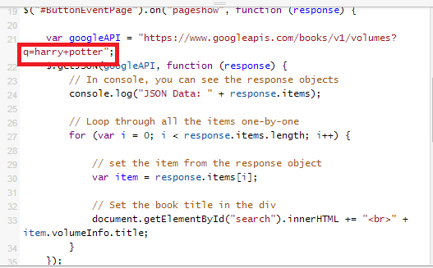

1. After setting the query as harry potter, the result page of Books search is shown below.

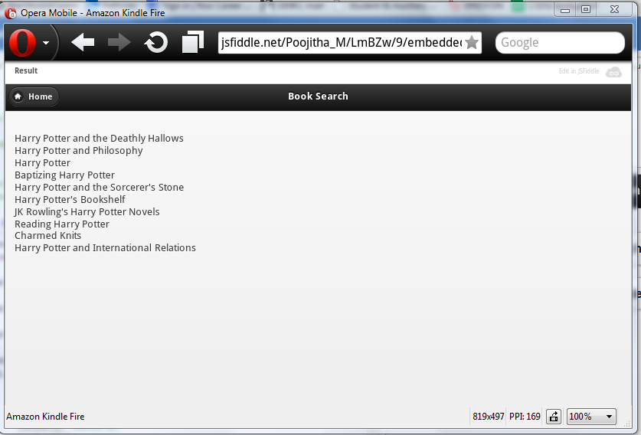

**Screenshot2: Book Search**

**Direction Finder:** Home page redirects to this page by clicking ‘Direction Finder’ button. You can find the direction from Source to destination on the map using the ‘Get Direction’ button. This page provides space for entering origin and destination fields. The result is a map showing the direction from source to destination.

I have used Google Maps API in this application.

URL is: <https://maps.googleapis.com/maps/api/js?v=3.exp&sensor=true>

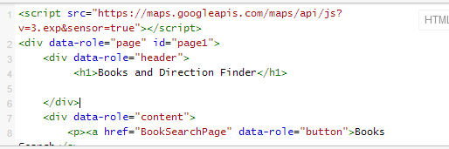

The Direction finder page looks as :

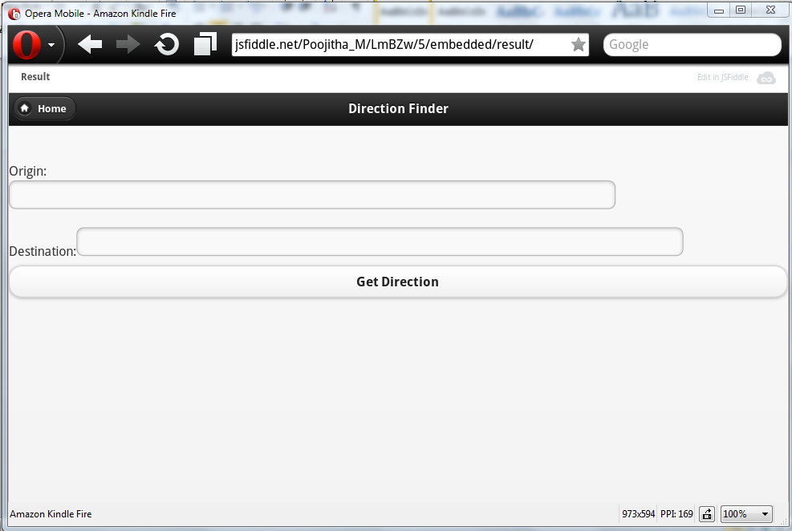

**Screenshot3: Direction Finder**

After entering the origin and destination fields, get direction button will show the map connecting them.

Marker A: Origin

Marker B: Destination.

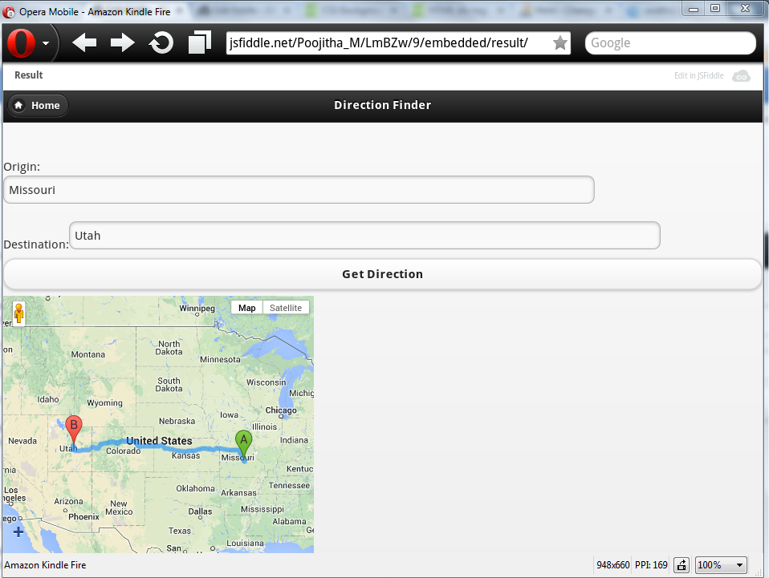

**Screenshot4: Direction Finder**