Design Description

***Reference Box***

Contents

1. Description 4

1.1. Page 16 4

1.2. NTC /PT1000 Calibration 4

1.2.1. All known Values 4

1.2.2. Measure NTC_Raw Values under following conditions 4

1.2.1. PT1000 Calculations 5

1.2.1. NTC Calculations 5

# Description

## Page 16

int16_t O2_Current; // (Val-12480) * 0.004pA , 200pA

int16_t Polarisation_Voltage; // [mV]

int16_t SensorTemp; // Val / 100 [°C]

int16_t Impedance; // [kOhm] 1000

int16_t OPA_Voltage;

int16_t NTC_Raw; // [Ohm] ADC Value on ntc

int16_t Anode_Voltage; // [mV]

int16_t Leakage; // [nA]

## Changes on PCB

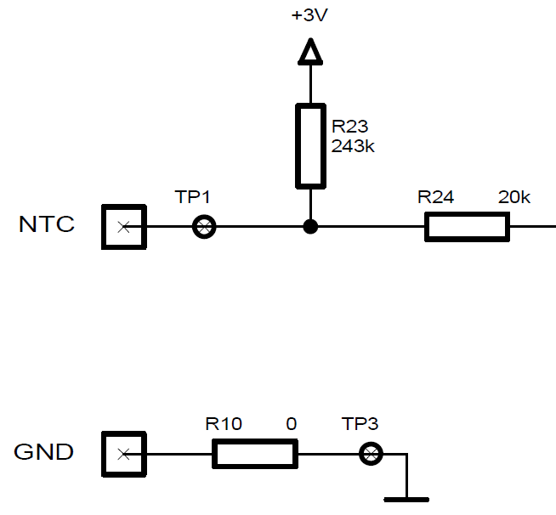

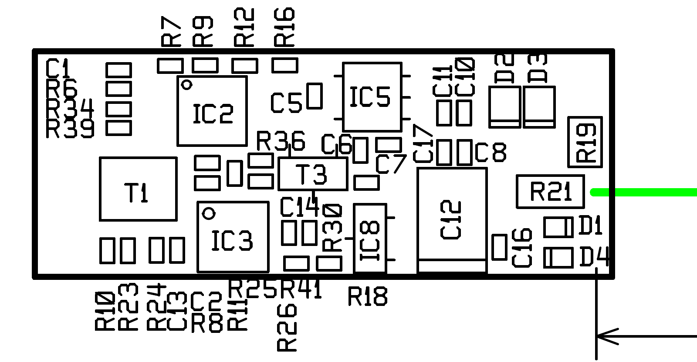

R23=68kOhm / R10=4.7k

## NTC /PT1000 Calibration

### All known Values

#define Uo 3000.0 // mV

#define Rv = R23 im Schema 68000.0 // Ohm

#define R2 = R10 im Schema 4700.0 // Ohm

#define PT1000_Resolution 0.0078125 // mV/incr

#define NTC_Resolution 0.0625 // mV/incr

#define U_PT1000_Soll_Temp1 20.0 // °C

#define U_PT1000_Soll_Temp2 30.0 // °C

#define RNTC 22000.0 // at 25°C

NTC_25Deg_CalculatedSollValue = Uo/(Rv+R2+RNTC)*(R2+RNTC)/NTC_Resolution

#define NTC_25Deg_CalculatedSollValue 13533

### Measure NTC_Raw Values under following conditions

1. Take a Reference Resistance of R=22kOhm 0.5% / 20ppm  
   and plug it to Temperature Input. The measured Value will be written to the Variable NTC_25Deg_MeasuredIstValue.

Example: NTC_25Deg_MeasuredIstValue= 13535

1. Take a Reference Resistance of PT1000 @20°C  
   and plug it to Temperature Input. The measured Value will be written to the Variable U_PT1000_Ist_Temp1.

Example: U_PT1000_Ist_Temp1= 30090

1. Take a Reference Resistance of PT1000 @30°C  
   and plug it to Temperature Input. The measured Value will be written to the Variable U_PT1000_Ist_Temp2.

Example: U_PT1000_Ist_Temp2= 30282

### PT1000 Calculations

PT1000_Gain = (U_PT1000_Soll_Temp2 - U_PT1000_Soll_Temp1)/(U_PT1000_Ist_Temp2 - U_PT1000_Ist_Temp1);

PT1000_Offset = (U_PT1000_Soll_Temp2 - PT1000_Gain*U_PT1000_Ist_Temp2);

Example: PT1000_Gain = 0.052083333

Example: PT1000_Offset= -1547.1875

**T**=(float) NTC_Raw *PT1000_Gain+PT1000_Offset;

### NTC Calculations

**NTC_Offset** = NTC_25Deg_CalculatedSollValue - NTC_25Deg_MeasuredIstValue ;

**Untc2** =( NTC_Raw + **NTC_Offset**)*NTC_Resolution; // measured Untc + Urv

**Intc**=(Uo-**Untc2**)/Rv; // Intc

**pt3** = **Untc2**/**Intc**-R2; // Widerstandsberechnung

**T** = ((3740*298.15)/((3740+log(**pt3**/22000)*298.15)))-273.15;

## Implemented Calibration for Sensoradapter

Execute chapter 1.2.2 and store all measured Values in Page3

On Page3 Byte1 to Byte7 the

Byte 0: CS

Byte 1 + 2 NTC Calibvalue ( NTC_25Deg_MeasuredIstValue )

Byte 3 + 4 PT1000 20°C Calibvalue ( U_PT1000_Ist_Temp1 )

Byte 5 + 6 PT1000 30°C Calibvalue ( U_PT1000_Ist_Temp2 )