1. When the node application is launches in terminal we see the products available in the backend database

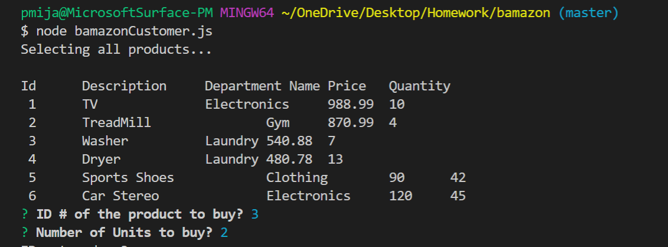

1. User makes the selections for which product to buy and the required quantity. The system picks the record required for the order and based on user selection of quantities reduces the quantity of item and updates the cost for the order

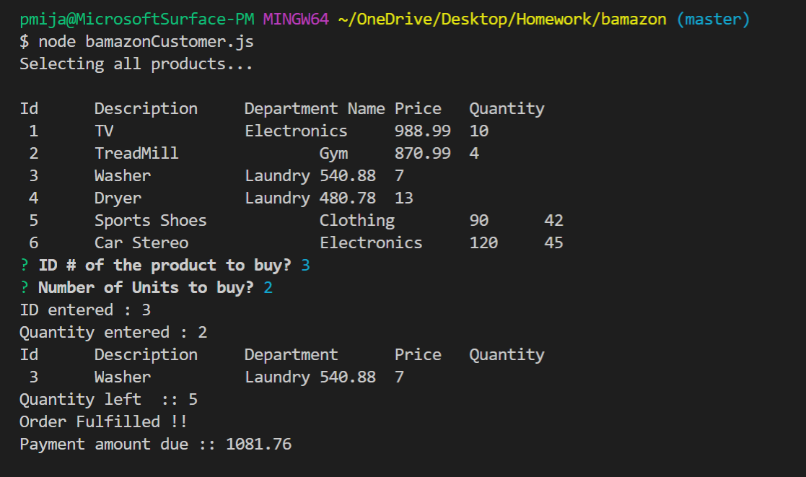

1. If the user makes a selection of item quantity greater than that is available in database, then the system would display to user that “Order cannot be fulfilled, Insufficient quantity!” message.

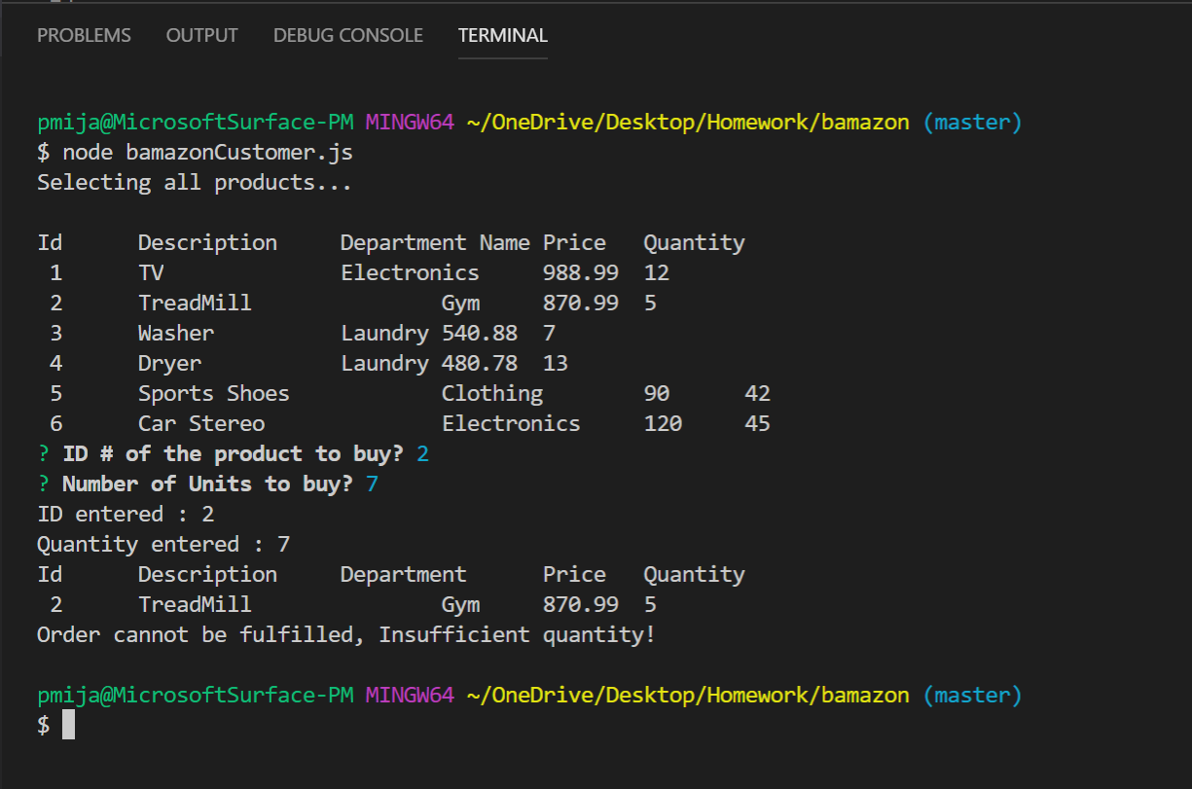

1. Database Snapshot:

