Review
Geometry for the Selfish Herd
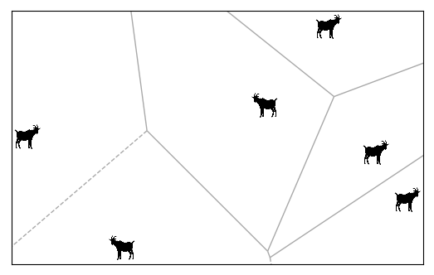
It is hard to not be completely absorbed by a paper that begins with the sentence “Imagine a circular lily pond.” In this seminal essay, Hamilton introduces, perhaps for the first ever time in a coherent manner, the idea of individualistic natural selection leading to the formation of animal groups.
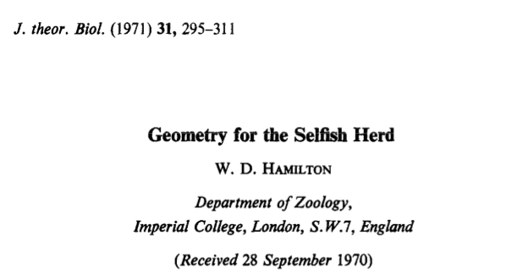
The paper begins with a fairy tale opening. “Imagine a circular lily pond.” Hamilton proceeds to construct a scenario where frogs gather on the margin of a lily pond, in which lives a fearsome snake. Assuming that the frogs and the snake are intelligent and rational, Hamilton elucidates the formation of one-dimensional groups by frogs desperate to save themselves by reducing their domains of danger.

After this interesting toy model, Hamilton moves on to the more formidable two-dimensional case. Here, the domain of danger for each animal is its Voronoi polygon (illustrated in the cover picture for this post). Every minute change in the position of an animal can affect its domain of danger, and thus, animal movement can take interesting forms. Hamilton proceeds to show that, even in this case, groups can, and will, form.

Perhaps to keep the paper accessible to biologists, Hamilton refrains from explicitly doing any maths in the paper (unlike in his more famous papers, The Genetical Evolution of Social Behaviour I and II). All the math in Geometry happens behind the scenes – Hamilton mentions results, shows you numbers, even adds some formulae in the footnotes. He does not, however, actually show you any mathematics. I strongly feel this improves the readability of the paper by leaps and bounds.

To conclude, Geometry for the Selfish Herd will remain a classic read for all time – One of the first attempts to explain gregarious behaviour through non group-selectionist arguments. The writing is lucid and engrossing, the figures are nostalgia inducing, and the arguments are compelling. The paper is full of citations of various real-life animal behaviours, and cannot be at the receiving end of the criticism empirical ecologists throw at their modeller counterparts most often – that the model is too simplistic. No matter what year you’re reading this blog post in, I recommend that you read Hamilton (1971); at least as proof of the fact that scientific writing does not need to be apersonal to be informative.

The next post will deal with how animals can forage for stochastically distributed resources in an optimal manner. Stay tuned for an article on Levy Flights!

