Review
Sync: The emerging science of apontaneous order by Steven Strogatz

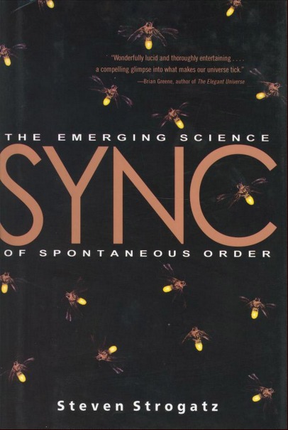

If someone comes up to you one fine day, when you’re strolling though a park, and starts talking to you about a book written by Steven Strogatz, you probably imagine something like `Non-linear Dynamics and Chaos’, Strogatz’s masterpiece that is used for teaching undergrad and grad level courses on dynamics everywhere. Sync is not such a book. Sync is a phenomenon in itself, a book as easily accessible to the layperson as it is unputdownable to the scientist.

