Review
Sync: The emerging science of spontaneous order by Steven Strogatz

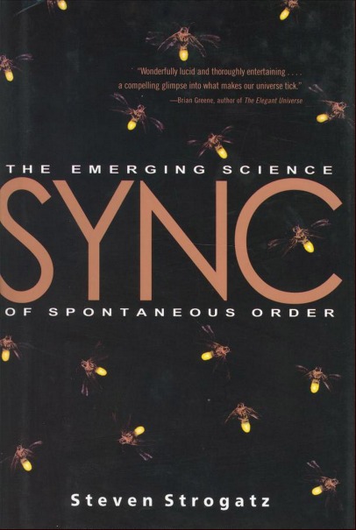

If someone comes up to you one fine day, when you’re strolling though a park, and starts talking to you about a book written by Steven Strogatz, you probably imagine something like `Non-linear Dynamics and Chaos’, Strogatz’s masterpiece that is used for teaching undergrad and grad level courses on dynamics everywhere. Sync is not such a book. Sync is a phenomenon in itself, a book as easily accessible to the layperson as it is unputdownable to the scientist.

In ten chapters divided across three parts, Strogatz tells us the story of the science of synchronisation; beginning with miles of oriental fireflies flickering in perfect synchrony; and ends with a discussion of fads and riots, and other aspects of synchrony that we know not much about. Without writing a single mathematical equation, Strogatz conveys all the intricacies inherent in something like the Kuramoto model of synchronisation, or in Norbert Wiener’s analyses of alpha waves.
In the second part, titled Discovering Sync, Strogatz discusses concepts in modern physics, such as the laser, and Bose-Einstein Condensates, from a synchronisation perspective. I have never encountered writing as lucid, or analogies as apt, as the contents of this book.

Strogatz (2003) touches upon a very broad range of topics: fireflies, neurons, heart-cells, sleeping disorders, lasers, Bose-Einstein condensates, superconductivity, Josephson junctions, shaking bridges, chaos theory and encryption, fads, riots, diseases, topology, and what not. At the same time, every topic Strogatz talks about in every page of the book feels relevant. Strogatz does not ramble. Although a very large contribution to the field is his own, it does not at any point feel like Strogatz brags.

I began reading Sync because it was something I needed to cite in a PhD proposal I wrote a week ago. I read Sync fully, because it is a paragon of science communication. I wholeheartedly advise anyone reading this to pick up a copy, sit back in a chair, and dream of fireflies pulsing in sync.

