
Software Requirements Specification
Version 0.3
April 07, 2019

Web Blog of SoftUni

Table of content
1.0. Purpose ii
1.1. Introduction ii
1.2. Glossary ii
2.0. Overall description 2
2.1. Project Scope 2
2.2. System Constraints 2
2.2.1. User Interface Constraints 2
2.2.2. Hardware Constraints 2
2.2.3. Software Constraints 2
2.2.4. Data Management Constraints 2
2.2.5. Operational Constraints 3
2.3. Page Design and implementation 3
2.3.1. Access Home Page 3
2.3.2. Design of Page 3
3.0. System Features 3
3.1. Home Page 3
3.2. Registration Page 4
3.2.1. Maximum Length of Attributes 4
3.3. Login Page 5
3.4. Navigation bar 5
3.5. Manage Page 6
3.6. Change Password Page 6
3.7. Create Article Page 7
3.8. Edit Article Page 7
3.9. Delete Article Page 8
4.0. Detailed non-functional requirements 7

1.0. Purpose

1.1. Introduction
This Software Requirements Specification provides a complete description of all the functionsError: Reference source not found and specifications of the Softuni BlogError: Reference source not found.
The expected audienceError: Reference source not found of this document is the users of this system - faculty of SoftuniError: Reference source not found, students, and members of the project team that will implement and verify the correct functioning of the system. Error: Reference source not foundIt will also serveError: Reference source not found as a reference for Softuni students.

1.2. Glossary
Term | Definition
DB | DataBase
Article | Blog post
SQAPError: Reference source not found | Software Quality AssuranceError: Reference source not found Plan
SRSError: Reference source not found | Software Requirements Specification
Web Site | A place on the world wide web

2.0. Overall description

This project is for a dedicated blog, designed to allow users to post and read information. An Internet connection is necessary to access the system.

2.1. Project Scope

The Softuni blog is a web-based application hosted on a on a departmental server, that will allow users to create blog posts, update or delete existing posts.

2.2. System Constraints

The systemError: Reference source not found constraints restrict options of design, behavior, appearance or operation.

2.2.1. User Interface Constraints

Web application shall permit complete navigation using the keyboard alone, in addition to using mouse and keyboard combinations.
Using this system is fairly simple and intuitive. A user familiar with basic browser navigation skills should be able to understand all functionality provided by the system.

2.2.2. Hardware Constraints

The system should work on most desktops and laptop computers.

2.2.3. Software Constraints

The system should work on every browser last version– Google Chrome, Firefox, Internet Explorer, Safari, Opera etc.

2.2.4. Data Management Constraints

Every user can read the blog posts. However editing, deleting and creating a post requires log in.

2.2.5. Operational Constraints

The system should be able to support at least 500 connections at a given time.

2.3. Page Design and Implementation

The Project has two active actors, normal user and registered user. All of them are accessing their parts from the internet. The unregistered user can access the basic functionality of the blog. The registered user has access to the full functionality of the system.

2.3.1. Access Home Page
The user must be connected to the Internet and connected to the SoftUni Web blogError: Reference source not found.

2.3.2. Design of Page

The pages should contain Header and Footer, which should be present on each page. Header should contain Register and Login links, which navigates to the respective page, where users can complete these operations. The home page should have a header in dark blue. The logo link should be located on the top left of the page. Footer should read that all rights for this site are reserved by SoftUni Blog.

3. System Features

3.1 Home Page

The page is loaded when the user accesses the URL of the blog. It has links to the blog’s main functionalities. Every user should have access to:
- “Hello World”
- “Pro Blog”
- “Blog Update!’
- Blog posts

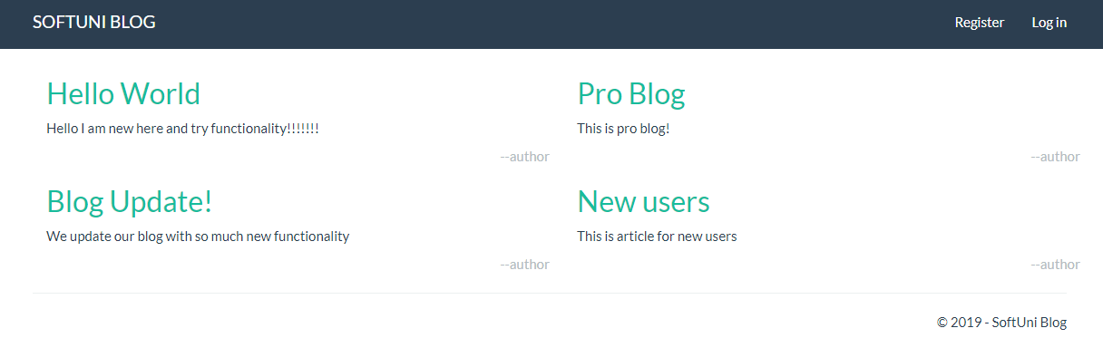
In the top right corner of the header there are links that navigate to Register and Log in pages respectively. In the top left - the logo is a link to the home page.

3.2 Registration page

The registration form contains four fields, three of which are required.
- Email - required
- Full Name - required
- Password - required
- Confirm password - should match the Password field value
There is also a “Register” button.

The required fields can not be null. There is also validation for the validity of the email field value. Register button records the credentials of the user to the DB and leads to the home page of the logged in user.
3.2.1 Maximum length of attributes
Attribute Name | Attribute Type | Attribute Size
FullName | String | 50
Password | String | 20
EmailAddress | String | 50

3.3 Log in Page
The Log in button leads to the log in page. It contains:
- Email- required field. Has validation for the validity of the provided email
- Password - required field
- “Remember me?” option box
- Button “Log in”

If the Remember me box is checked. The last successful log-in credentials are remembered. If the user has filled in valid credentials, the log in button opens the home page of the registered user.
If the username/password is wrong there should be an error message: Invalid login attempt.

3.4 Navigation Bar

The navigation bar has navigational hyperlinks to the Register, Login and Home Pages. When the user is successfully logged in, the Register and Log in links change to Create, Hello [username]! and Log off.

3.5 Manage page

The page is accessible from Hello [username]! Link. Manage page shows the account page of the logged in user. It provides a link to change the password.

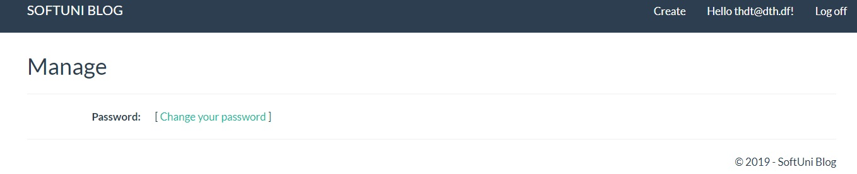

3.6 Change password page

It is accessible through the Manage page, when the change your password link is clicked.
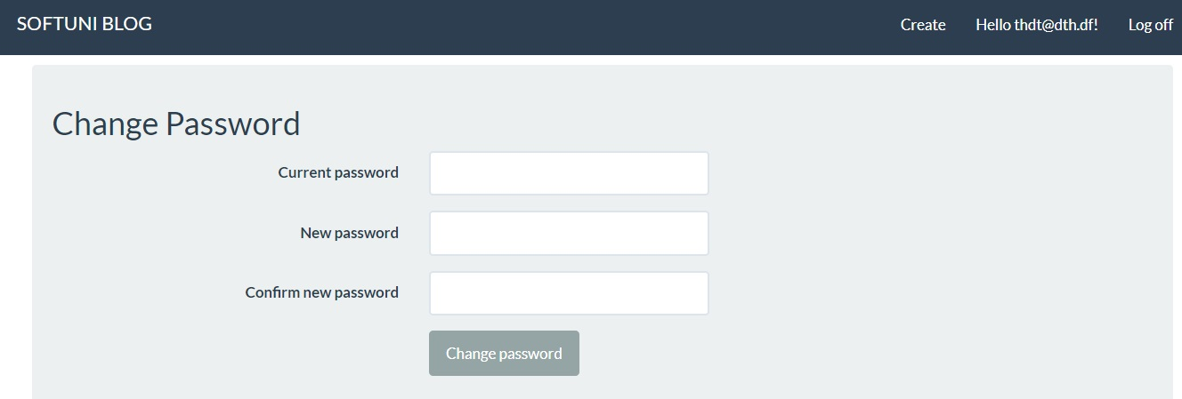

It contains:
- Current password - required field
- New password - required field
- Confirm password field which should match the new password field value
- Change password button
When the button is clicked, the user is taken back to the Manage page that has a message - Your password has been changed.

3.7 Create Article page

It is accessed from the navigation bar of the logged-in user.
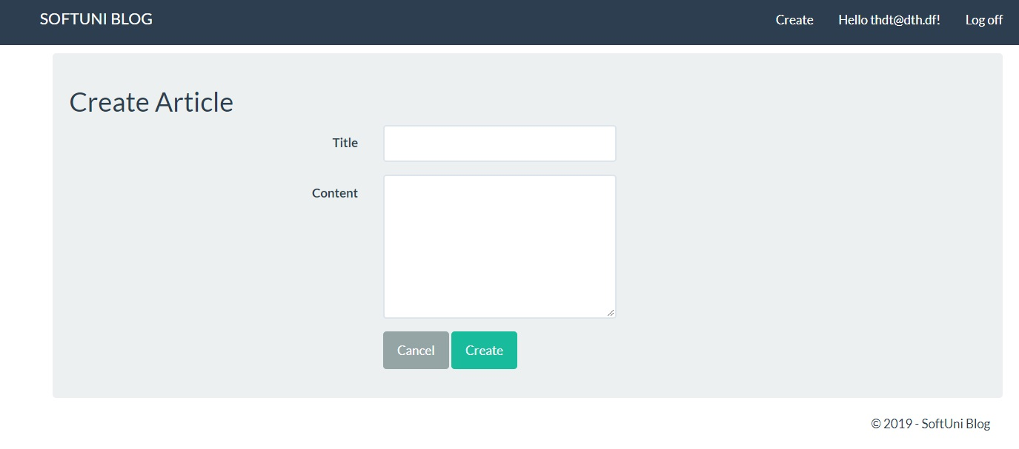
It contains:
- Title - required field
- Content - required field
- Cancel button, that discards the operation and leads to the home page
- Create button - it creates the article and leads to the home page

3.8 Edit article page

When the user clicks the title of the article, the article list contains Edit, Delete and Back buttons. The Delete and Edit article pages are only accessible for the user who created the article.

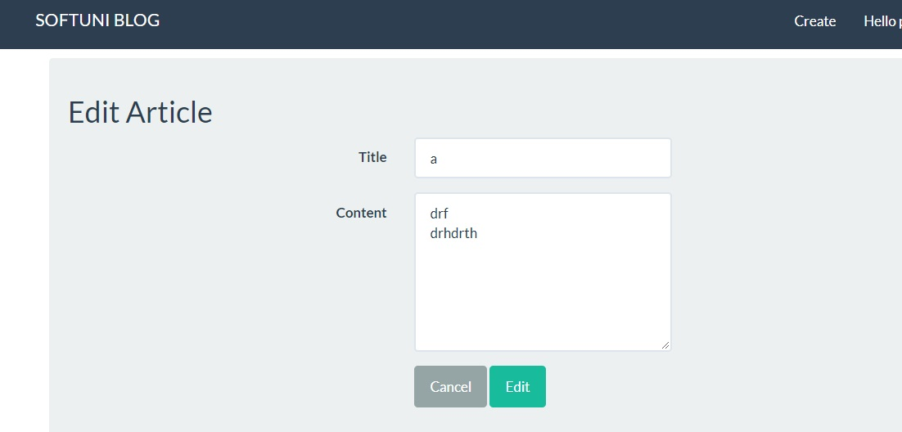
The user has the opportunity to edit the title and the content of the blog post.
Cancel button leads to the home page.
Edit updated the article and leads to the home page.

3.9 Delete article page
The user cannot delete articles created from other users. If they try to delete an article, there will be an error message:
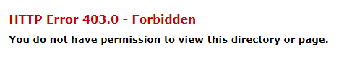
The Delete article page is accessed when the user clicks the name of the article and then clicks on the Delete button.
The page shows the title and content of the article in read-only mode.
Cancel button returns the user to the home page.
Delete button deletes the article and returns the user to the home page.

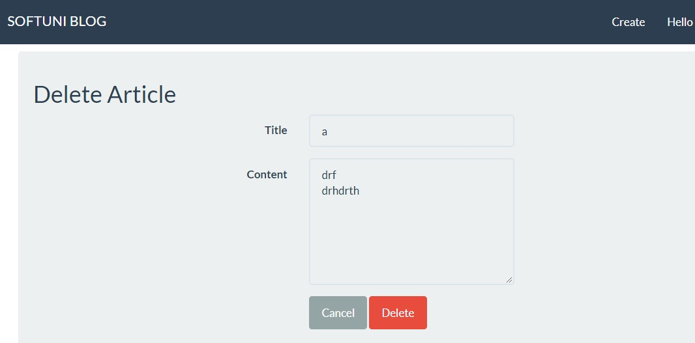

4. Detailed non-functionalError: Reference source not found requirements
4.1 Performance requirements
4.2 Security requirements
4.3 Safety requirements
- Users shall be required to log in to the system for all operations
- The system shall permit only registered users to create or edit posts.
4.4 Software quality attributes
- availability
- maintainability
- usability

